 |  | A/HRC/44/61
 | Advance Unedited Version |  | Distr.: General  2 July 2020  Original: English
Human Rights Council
Forty-fourth session
15 June–3 July 2020
Agenda item 4
Human rights situations that require the Council’s attention
Report of the Independent International Commission of Inquiry on the Syrian Arab Republic*, **
Summary
The present report covers events in Idlib and surrounding areas from 1 November – 1 June, including 52 emblematic attacks by all parties which led to civilian casualties and/or damage to civilian infrastructure. These include 17 attacks impacting medical facilities; 14 attacks impacting schools; 9 attacks impacting markets and 12 other attacks impacting homes, marked by war crimes. They foreseeably led to massive displacement, as civilians had no choice but to flee, and may amount to crimes against humanity. Meanwhile, the UN-designated terrorist organization HTS also committed war crimes outside the immediate context of hostilities, while Government forces engaged in unlawful pillaging.

I. Mandate and methodology
1. Human Rights Council resolution A/HRC/43/L.33 requested the Independent International Commission of Inquiry on the Syrian Arab Republic to conduct urgently a comprehensive and independent special inquiry into recent events in Idlib province and surrounding areas, and to provide a full report of the findings. For this report, the Commission covered recent events which took place primarily between 1 November 2019 and 1 June 2020.
2. Pursuant to its established methodology, based on standard practices of commissions of inquiry and human rights investigations, the Commission relied primarily on 287 interviews conducted in person in the region and from Geneva. Reports, photographs, videos and satellite imagery were collected and analysed from multiple sources, including following the Commission’s call for submissions. The standard of proof was considered met when the Commission had reasonable grounds to believe that incidents occurred as described, and, where possible, that violations were committed by the warring party identified.
3. The Commission’s investigations remain curtailed by the denial of access to the country and protection concerns in relation to interviewees. In all cases, the Commission remained guided by the principle of “do no harm”.
4. The Commission thanks all who provided information, in particular victims and witnesses.
II. Introduction
5. Idlib governorate and its environs – comprising rural northern Ladhiqiyah, north-western Hama, and western Aleppo – is one of the last remaining areas beyond Government control in the Syrian Arab Republic. Prior to the uprising in 2011, it was home to some 1.5 million residents. Amongst the first regions to participate actively in anti-Government demonstrations, armed groups seized control over the area between 2012 and 2014. Amidst heavy infighting between armed groups vying for control over north-west Syria, what would become Haya’t Tahrir al-Sham (HTS) emerged as the main group in control by 2014. Its “Salvation government”, established in late 2017, operates as the quasi civil/administrative authority and exerts control over civilians through local committees. It is estimated that HTS, a United Nations designated terrorist group, has 12,000 to 15,000 fighters in its ranks, including Jabhat Fatah al-Sham and Ansar al Sham.
6. In the first half of 2018, battles in Aleppo, northern Homs, Damascus, Rif Damascus, Dar’a and Idlib governorates collectively displaced more than 1 million Syrian women, men and children, of which more than half relocated to and within Idlib governorate. After hostilities fully ceased and truces were implemented, pro-government forces required certain individuals from previously besieged areas to undergo a “reconciliation process” as a condition to remain.
7. Pursuant to such “evacuation” or “reconciliation” agreements between 2016 and 2018, nearly 100,000 individuals were forcibly displaced, essentially from Aleppo, eastern Ghouta, rural northern Homs and Yarmouk camp in Damascus to Idlib – which became perceived as their last place of refuge. By April 2019 when violence in north-west Syria markedly increased, Idlib governorate and neighbouring north-western Aleppo governorate was home to some 4 million people.
8. Towards the end of 2019, fighting escalated further, particularly in locations south of the M4 and east of the M5 highways (see map Annex II). Schools, hospitals and markets were bombed out of service, while camps for displaced civilians were also struck.
9. Approximately one million people then fled en masse deeper into north-west Syria, crammed in vehicles, as aerial attacks followed them while they desperately searched for safety. The already overstretched humanitarian response in northern Idlib and parts of Aleppo reached breaking point, amidst harsh winter conditions.
10. Against this backdrop, the Security Council reached a last-minute agreement on 10 January to renew until July the cross-border and cross-line aid delivery mechanism. The crossings were reduced from four to two border crossings with Turkey. Shortly afterwards, COVID-19 began to spread around the world. With numerous health facilities rendered non-operational, the estimated 1.4 million people (80% women or children) living in overcrowded displacement sites across northwest Syria had little access to basic health care, and little practical possibility to follow guidance on hand washing and social distancing. Their unfettered access to humanitarian aid remained more critical than ever.
III. Political and military developments
11. As hostilities intensified in December, the Syrian air forces, supported by the Russian Aerospace Forces (jointly denominated pro-government forces), targeted armed groups’ controlled areas in Idlib, Ladhiqiyah and western Aleppo governorates, while Government forces including the Syrian Arab Army (SAA) pushed forward to recapture areas around the M5 highway. Armed groups and HTS terrorists launched counter-attacks against government positions in Idlib, Aleppo and Ladhiqiyah, including the Hmeimim airbase.
12. In the context of the mounting military escalation in north-west Syria, Russia and Turkey agreed to establish a new ceasefire on 9 January, though lower intensity strikes and clashes continued. On 15 January, the ceasefire faltered and pro-government forces resumed attacks in Idlib. By 28 January, the Government had retaken control of Ma‘arrat al-Nu‘man and increased attacks on armed group positions in western Aleppo. In parallel, pro-government forces attempted to re-capture Saraqib, another strategic town, at the junction of the M5 and M4 highways. This heightened tensions between the Government and Turkey, after the latter established new observation posts in response to the Government advances in the de-escalation zone.
13. On 3 February, the Turkish army targeted several Syrian government positions in retaliation for the killing of eight Turkish military personnel following the shelling of a Turkish position near Saraqib. Despite the Turkish intervention, the Syrian government gained control of Saraqib and several surrounding areas on 6 February. Tensions further rose on 10 February when another Syrian Government attack killed five Turkish soldiers in Taftanaz. In the meantime, the Syrian government re-established control over the entire length of the M5 highway for first time since 2012. On 17 February, President Assad declared that the Syrian army defeated militants and liberated Aleppo governorate after consolidating control over Aleppo’s western countryside.
14. Amidst continued attacks on Turkish positions in Idlib governorate, on 19 February President Erdogan stated that a military operation in north-west Syria was imminent. The announcement came following unsuccessful negotiations between Turkish and Russian officials to de-escalate. On 27 February, tensions escalated after at least 33 Turkish soldiers were killed in an airstrike. In response, Turkey launched Operation Spring Shield on the same day. During the first 3 days of the operation, the Turkish army conducted hundreds of strikes against Government forces positions, shot down two Syrian fixed wing aircraft, put Nayrab military airport out of service and enabled the Syrian National Army (SNA) to launch a ground offensive.
15. The killing of Turkish soldiers and the start of Operation Spring Shield further strained relations between Turkey and Russia. Nonetheless, both countries agreed on 5 March to establish a new ceasefire in Idlib following talks between Presidents Erdogan and Putin in Moscow. They agreed to cease all military actions along the line of contact in the Idlib de-escalation zone and establish a security corridor around the M4 highway. The agreement specified that Ankara and Moscow would establish joint coordination centres and patrols. Turkey also clarified that the agreement would not alter previous arrangements and Turkish military observation posts in north-west would remain in place.
16. While the ceasefire agreement led to a decrease in hostilities and a significant drop in civilian casualties, the situation remained volatile. Russia reported ceasefire violations as low intensity shootings persisted and HTS terrorists announced that they would continue attacks against Government positions. By 28 May, Russia and Turkey had conducted 13 joint patrols on the M4 highway, that were often beset by clashes between Turkish forces, HTS and protesters, resulting in casualties. Ceasefire violations continued throughout April and May.
IV. Conduct of hostilities – overview
17. During the period under review, battles over Idlib governorate and western Aleppo left frontline localities near strategic locations in ruins and almost completely depopulated. Attacks were most often characterized by brief ground operations by SAA and allies, coupled with prolonged aerial offensives by pro-government forces. Overflight data obtained by the Commission indicates that at least 1,500 airstrikes, predominantly air-to-ground missiles and barrel bombs, were launched on south-east Idlib and western Aleppo between 1 November and 5 March, in addition to ground attacks and indirect fire, including rockets, artillery and mortars.
18. As they gradually ceded territory to pro-government forces, armed groups and terrorist organizations also launched indiscriminate attacks against residential areas under Government-control in western Aleppo. According to the Russian Federation, over 1,800 instances of shelling and more than 430 attacks involving heavy weapons by militants were reported from 9 January – 27 February.
19. Given the intensive fighting during the period, the Commission could not investigate all alleged unlawful attacks, but focused on 52 emblematic incidents by all parties entailing civilian casualties and/or damage to civilian infrastructure:
Hostilities damaging medical facilities, schools and markets and entailing civilian casualties in Idlib and Western Aleppo, 1 November 2019-30 April 2020
Category | Idlib | Western Aleppo | Total | By actor
 |  |  |  | Pro-gov (total) | (of which GF^{j}) | (of which RF^{j}) | Armed groups  (total)
Number of medical facilities reported damagedª | 19 | 6 | 25 | 25 | - | - | -
Attacks impacting medical facilities investigated by the Commission^{b} | 11 | 5 + 1* | 17 | 16 | 1 | 1 | 1
Number of schools reported damaged^{c} | 49 | 6 + 3* | 58 | 55 | - | - | 3
Attacks impacting schools investigated by the Commission ^{d} | 8 | 6 | 14 | 14 | 6 | - | -
Number of markets reported damaged ^{e} | 14 | - | 14 | 14 | - | - | -
Attacks impacting markets investigated by the Commission ^{f} | 6 | 1 + 2* | 9 | 7 | 1 | - | 2
Other attacks impacting civilians or civilian objects investigated by the Commission ^{g} | 8 | 2 + 2* | 12 | 10 | 2 | 1 | 2
Number of civilian deaths reported ^{h} | 509 | 167 | 676 | 641 | - | - | 35
Civilian casualties in the 52 incidents investigated by the Commission ^{i} | 474 | 60+48* | 582 | 534 |  |  | 48
ª OHCHR, S/2020/141 para 18 and S/2020/327 para 16
^{b} The Commission has reasonable grounds to believe that 16 attacks impacting medical facilities were conducted by pro-government forces, while one attack was conducted by armed groups.
^{c} OHCHR, S/2020/141 para 17 and S/2020/327 para 15.
^{d} The Commission has reasonable grounds to believe that 14 attacks on schools and other educational facilities were conducted by pro-government forces. 16 additional attacks remain under investigation.
^{e} OHCHR, S/2020/141, para 19, and S/2020/327, Annex.
^{f} The Commission has reasonable grounds to believe that 7 such attacks were conducted by pro-government forces, two by armed groups.
^{g} The Commission has reasonable grounds to believe that ten such attacks were conducted by pro-government forces, two by armed groups.
^{h} Number of civilian deaths in incidents tracked by OHCHR, see also S/2020/141 para 13 and S/2020/327 para 11. The total number of civilian casualties during the period is likely much higher.
^{i} Number of confirmed civilian casualties (deaths and injuries) in the 52 incidents entailing attacks by pro-government forces and 5 attacks by armed groups that the Commission investigated. The total number of civilian casualties in these incidents is likely higher.
^{j} Overflight data, images of weapon remnants and testimony indicated reasonable grounds to believe that the Syrian Government forces or the Russian Aerospace Forces were responsible for these attacks.
* Attacks by armed groups.
V. Attacks by pro-government forces and the ensuing displacement
“We didn't choose to leave - there was no other alternative. The attacks were barbaric."

Man, Ma‘arrat al-Nu‘man, December, 2019
A. Attacks impacting civilians in Idlib
20. Starting from early December, pro-government forces began advancing towards Ma‘arrat al-Nu‘man town on the M5 highway, known as one of the first locations where peaceful protests started in 2011. Owing to its location, parties have fought for control over Ma‘arrat al-Nu‘man since the early days of the conflict.
21. In their efforts to regain control over the area, pro-government forces carried out attacks consistent with clear patterns previously documented by the Commission, affecting markets and medical facilities. Overflight data documents at least 433 airstrikes between 1 December and 1 February on and near Ma‘arrat al-Nu‘man.
22. Consistent with overflight data, residents reported that aerial bombardment, including reportedly with barrel bombs, increased in mid-December. Attacks reached a peak on 18 and 19 December when 36 airstrikes were recorded near Ma‘arrat al-Nu‘man, near Jarjanaz and Kafr Nbul. In response to the influx of fleeing civilians, local humanitarian actors facilitated transportation and subsequent evacuation of those otherwise unable to leave, including children, elderly women and persons with disabilities. Civilians mostly used the M5 highway to escape, often with their vehicle lights off to avoid being targeted. Interviewees recalled that – as aerial attacks on the M5 intensified toward the end of December – many were compelled to flee via parallel routes instead, often on foot, with only as many personal belongings they could carry.
23. By the end of December, over 100,000 civilians had left Ma’arrat al Nu’man town and surroundings, with interviewees reporting that residential areas were largely destroyed, basic services virtually non-existent and attacks affecting escaping civilians had become commonplace. To illustrate, in the late evening hours on 21 December, two airstrikes hit a residential area in northern Ma’arrat al Nu’man, injuring 6 civilians who were gathering their belongings to leave. On the following day, on 22 December, at around 12:20 p.m., while a local organization was preparing to evacuate residents from an assembly point nearby, pro-government forces carried out one precise airstrike with a guided munition on the M5 that struck a slow-moving tractor with three men heading northward. The attack killed a father and his two sons. Later that evening, at 10:00 p.m., one airstrike hit a residential area in Ma‘arrat al-Nu‘man, located 1 kilometre from the main road to Ariha. Two men were killed, and 4 others injured, including 2 elderly women, who had also returned to gather their belongings. In another attack, on 30 December, Government forces reportedly launched barrel bomb strikes that impacted a residential house in northern Ma‘arrat al-Nu‘man, while a team of rescuers was helping a displaced family to leave. One 11-month-old baby boy and one rescuer were killed.
24. Pro-government forces also intensified efforts to recapture Ariha. On 5 January, at around 2 p.m., 6 aircraft-launched munitions impacted an area of approximately 200 meters in its western parts, to which displaced civilians from Ma‘arrat al-Nu‘man, Khan Sheikhoun had recently fled. The attack damaged a water distribution point, where civilians had gathered to collect water, in addition to residential homes, a kindergarten and a mosque. Interviewees who observed the impacted site described seeing dismembered bodies, some badly burnt, near a large crater of approximately 200 meters in diameter. At least 13 civilians were killed, including 4 children, and 30 others were injured.
25. Other areas of strategic importance, such as Saraqib, were also struck by pro-government forces, with devastating impact. For example, on 2 February, between 9:30-10 a.m., pro-government forces launched a series of airstrikes, reportedly also with barrel bombs that struck a home in Sarmin, near Nayrab town – a gateway for gaining control over Saraqib. The attack killed 1 man as well as 3 women and 4 children, including a two-month old baby, from the same family, who had gone back to their home only to collect their belongings and were preparing to flee again.
26. Pro-government forces also conducted airstrikes on locations further away from the frontline, such as Idlib city, which exacerbated fears amongst the civilian population that an offensive, even more violent, was imminent (see sections V.C and D below). In one such incident, on 5 March between approximately 2:00-2:30 a.m., information gathered by the Commission indicates reasonable grounds to believe that Russian Aerospace Forces conducted two consecutive airstrikes employing guided munitions on an isolated poultry farm in Marat Misrin, where displaced civilians had recently relocated (see Annex III). At least 16 civilians were killed, including 8 women and 3 children, and 25 others injured, including 5 women and 7 children.
Attacks on markets
27. Consistent with a previously established pattern, airstrikes by pro-government forces reportedly struck at least 13 markets during the period. The Commission documented seven such attacks.
28. On 2 December, pro-government forces carried out two such attacks: One airstrike impacted a market and adjacent residential building in Saraqib town at around 9 a.m., killing one man and injuring 7 others. Two hours later, the other airstrike consisting of two munitions hit al-Hal wholesale market located in a residential area in eastern Ma‘arrat al-Nu‘man. Interviewees described that the munitions fell some 3 meters from each other, impacting numerous commercial shops and civilian vehicles. The attack killed 9 civilians, including 2 women, and injured at least 13 others, including a 16-year-old boy who lost a limb.
29. Towards the end of the month, on 21 December, at 10:35 a.m., one airstrike consisting of three munitions struck another market in Saraqib damaging adjacent residential buildings, including a medical clinic, within an area between 400 to 600 meters. The attack killed at least 8 civilians, including one female laboratory technician, and injured over 25 others.
30. On 11 January in the early afternoon, pro-government forces launched an airstrike consisting of at least 4 munitions on a local market in Binish, killing 9 civilians, including 5 women and 3 children, and injuring 29 others, including 13 children and 4 women.
31 Four days later, on 15 January, between 12:30-2 p.m., the Commission has reasonable grounds to conclude that Government forces airstrikes struck the densely populated al-Hal market and adjacent area in Idlib city, located approximately 200 from each other (see Annex III). The attack killed at least 19 civilians, including 2 children, and injured 60 others.
32. The commercial area was hit again, at midday on 11 February, when pro-government forces carried out two airstrikes that struck the main street and adjacent al-Jala street, killing at least 11 civilians, including 5 boys aged between 10 and 16, and injuring 20 others.
B. Attacks impacting civilians in Western Aleppo
33. By early February, when aerial bombardments reached western Aleppo desperate civilians began fleeing towards Idlib governorate. Overflight data indicate that at least 217 airstrikes were launched on western Aleppo between 20 January and 5 March. During that time, daily aerial bombardment affected civlians in Atarib town and its surroundings (see Annex III).
34. According to overflight data, 14 airstrikes were carried out on Kafr Nouran town, near Atarib, on 9 February alone, compelling almost everybody to leave. At least 14 civilians were killed and 9 others injured, whereas, by the end of the day, Kafr Nouran was all but razed to the ground. Two civilians were reportedly killed in an airstrike while collecting their belongings in preparation to leave Kafr Nouran. Information obtained by the Commission suggests that around 25 armed group fighters, including Falaq al Sham and HTS, were present in Kafr Nouran town in January and early February. The Commission was not able to assess the presence of military objectives in Kafr Nouran at the time of the attack.
35. In another attack on nearby Ibbin Saman town, at around 2 a.m. on 10 February, pro-government forces launched two consecutive airstrikes in a span of 3 minutes against civilian-inhabited areas in western Ibbin Saman, near an intersection connecting the town to Idlib governorate. As rescuers rushed to the scene, pro-government forces conducted a second attack injuring several first responders. A few minutes later, another airstrike, reportedly from a different aircraft, impacted the outskirts of the town where a large number of residents, primarily women and children, had fled to earlier. Approximately 15 residential houses were destroyed as a result, and at least 15 civilians were killed, including 3 women and 8 children between 1 and 5 years of age. Another 8 were also injured, including 2 women, 3 boys and 2 girls. Nearly 25,000 civilians left following this attack.
C. Attacks impacting medical facilities
36. Consistent with a pattern previously documented by the Commission, pro-government forces reportedly struck 25 medical facilities in Idlib and western Aleppo between November and February.
37. Ten such incidents in Idlib were investigated by the Commission.
38. Four medical facilities were damaged in the span of three days between 4 and 6 November in Jisr al-Shughur, Kafr Nubl and Ariha. Among them was the Ikhlas maternity and paediatric hospital in Shinan, south of Ariha (the only maternity hospital in the area). On 6 November, at around 1.30 a.m., pro-government forces carried out two air strikes that destroyed the facility and injured at least 2 medical workers. Later that day, at around 4.15 p.m., a series of air strikes conducted by pro-government forces struck the de-conflicted surgical “cave” hospital in Kafr Nubl, by then the only facility servicing the area, damaging its western entrance and vital medical equipment. Doctors interviewed by the Commission described how, following the attacks on medical facilities in Kafr Nubl and Shinan, the number of staff reduced significantly while vital equipment was moved to hospitals in northern Idlib.
39. On 8 January, the central hospital in Mar’arrat al Numan - by then the only hospital able to provide basic care in the area – was hit in a ground attack by Government forces that caused extensive damage to the facility. Most of the staff left soon thereafter due to fears of further attacks. The Commission notes that interview accounts obtained from witnesses to this attack are consistent with the use of BM-21 “Grad” MBRL rocket system, reportedly from the area of Government-controlled Khan Sheikhoun, located 13 kilometres south, and within the range of this weapon.
40. On 29 January, after taking over Ma‘arrat al-Nu‘man and Kafr Nubl, 3 consecutive airstrikes on residential areas in northern Ariha disabled the last medical facility servicing southern Idlib. The Commission has reasonable grounds to believe that the strikes were carried out by Russian aircraft (see Annex III). At least 14 civilians, including one doctor, 5 women and 5 children, were killed and 30 to 65 others were injured.
41. On 4 February, two consecutive airstrikes hit a medical dispensary and adjacent hospital in Sarmin, causing significant damage to both facilities, rendering both non-operational. Though some residents departed earlier, most civilians, including medical staff, left Sarmin following these attacks.
42. Towards the end of the month, on 23 February, the dentistry building adjacent to the maternity and children hospital in Baloyun, Idlib governorate, was hit in an airstrike that destroyed parts of the building, rendering it non-operational. Two days later on 25 February, an airstrike impacted near the Idlib surgical hospital – located some 500 meters from al-Barahim school (section V.D below), causing damage to the facility and injuring at least 3 medical staff.
43. While vying for control in western Aleppo, pro-government forces intensified attacks on medical facilities, in an apparent effort to erode the viability of the last functioning medical facilities in Atarib and its environs. The Commission investigated 5 such incidents in Aleppo.
44. On 1 February, at around 10:00 p.m., pro-government forces carried out two airstrikes in the span of 10 minutes, against the al-Huda surgical hospital in al-Hour village, damaging the entrance of the hospital and a generator, and injuring one of the guards. The hospital, the main health provider in western and northern parts of rural Aleppo, was subsequently rendered non-operational.
45. On 10 February, at around 8 p.m., pro-government forces carried out an aerial attack on Atarib maternity and children hospital, killing a 17-year-old boy and causing damage to the facility.
46. On 17 February, at around 11:40 a.m., pro-government forces launched two consecutive airstrikes that struck Kinana and nearby al-Fardous maternity hospitals in Darat Azza. At least 2 medical staff were injured and both facilities were rendered out of service, leaving residents with no other operational hospital in western Aleppo.
47. As medical facilities in towns and villages along the M5 axis were rendered non-operational, pro-government forces continued attacks on adjacent localities, with minimized opportunities for the wounded and sick to seek and receive treatment in their immediate areas of residence.
D. Attacks impacting educational facilities
48. Attacks on schools have emerged as one of the most vicious patterns in the Syrian conflict. Hostilities adversely affected educational institutions throughout Idlib and western Aleppo, where just under half of civilians are children under the age of 15. At least 58 educational facilities in Idlib and western Aleppo were reported damaged during the period, 55 by attacks launched by pro-government forces.
49. The Commission investigated 12 such attacks in Idlib:
50. In an attack on Sarmin, on 1 January, a ground attack by Government forces consisting of cluster munitions hit the Abdo Salam primary school, killing 12 civilians, including 5 children including one female teacher.
51. Seven educational facilities were hit on 24 and 25 February alone. Teachers interviewed by the Commission described that the attacks commenced in the late evening hours of 24 February, when two munitions struck the yard of al-Houraya high school for girls in Idlib, causing damage to the facility and nearby residential homes.
52. The following day, at around 5 a.m., two munitions struck the yard of al- Rissala School for boys, located in Binish educational compound near the local market and Idlib central hospital. The attack caused partial damage to the building, and killed one man while injuring 4 others.
53. At 8 a.m., 8:30 and 9:30 a.m. on 25 February, Government forces fired rockets on densely populated parts of Idlib, damaging three schools. Witnesses to these attacks described hearing a loud blast followed by secondary explosions, in sequence of few seconds that affected the yards of the three schools. At least 2 teachers were killed and 6 injured while inside al-Barahim school, and one 17 year-old girl was killed in front of al-Izza Ibd Abdelsalam school. Munition remnants left at the scene indicate that the attack that struck Khaled Shaar, al-Barahim and al-Izza Ibn Abdelsalam schools in Idlib city was carried out likely using URAGAN 9M27K-type cluster-munition fired from BM-30 “SMERCH” multiple-barrelled rocket launcher system (MBRL). The “SMERCH” MBRL is an unguided area weapon, able to fire a salvo of up to 12 three-metre-long rockets over a distance of 90 kilometres, known to be in the Syrian repertoire. By selecting a rocket-type that releases sub-munitions from the main cargo rocket, Government forces increased the lethal area, thereby making this system even less discriminate.
54. On 25 February, at around 4 p.m., pro-government forces launched an aerial attack that struck Muneeb Qmayshah primary school, located in the eastern parts of Marat Misrin. The attack killed at least 11 civilians, including 6 children, and wounded 30 others, including 14 children and 6 women. It also severely damaged the school walls, windows and doors, rendering it non-operational.
55. Education facilities throughout western Aleppo were also severely affected. The Commission investigated 6 attacks on schools in Western Aleppo:
56. The boys’ school in Atarib was impacted on four occasions on 3, 4, 14 February and 5 March, resulting in the death of at least 2 women and injury to 8 children. Of those attacks, airstrikes on 14 February caused the most severe damage to the school, putting it out of service. Government forces had taken control over the Regiment 145 base, facilitating ground-to-ground attacks. Interviewees described how pro-government forces shelled Atarib for hours on 14 February, impacting densely populated areas, including a market, and numerous residential homes. The intensive bombardment on Atarib on that day pushed at least 70.000 residents to flee their homes.
57. In the afternoon hours on 6 February, Government forces carried out a ground attack on Anadan, impacting residential areas, including the Adanan health center and a boys’ high school, where at least 300 students had registered. A teacher who visited the site recalled that at least 3 munitions had impacted the facility, causing damage to the fence, ceiling and school yard. The school was subsequently closed, and many civilians left the town as ground forces advanced further towards the city.
58. On 24 February, Government forces launched a ground attack on Kafrantin that struck directly the Yarmouk School (still operational) and a mosque located nearby. In the morning of 24 February, at least 75 students attended classes and 3 teachers were present at the school premises. The attack caused severe damage to the school building, including the ceiling and main entrance, while windows and doors had been shattered.
E. Displacement resulting from conduct of hostilities
“Will you stay in a place where there is no education for your children? Will you stay in a place where there is not a single doctor or clinic? Will you stay in a place where you know that that you will be killed at the bakery? Will you stay in a place where you are afraid of doing anything? Afraid of doing your groceries, afraid of sending your children to school, afraid of going to the doctor, afraid of staying at home. We live in fear because there is no safe place.”
Man, displaced from Atarib, western Aleppo, January/February 2020
59. As a result of the intense hostilities, Idlib and western Aleppo witnessed displacement on a massive scale. Approximately 560,000 people fled to Idlib’s north-west, into a small area along the Syrian-Turkish border already hosting hundreds of thousands of displaced people. Some 400,000 civilians moved to areas in northern Aleppo governorate, including A’zaz, Afrin, Jandairis and Al Bab.
60. Displacement across Idlib and western Aleppo rapidly increased month by month from November to February, in correlation with the intensification of hostilities, but slowed considerably following the ceasefire on 6 March, as indicated in the below graph showing the number of displacement movements per month in the Idlib and Aleppo governorates.

Data source: information as reported by CCCM, OCHA Syria, Jordan, Turkey, and HNAP
61. Consistent accounts from civilians fleeing Ma‘arrat al-Nu‘man and Ariha described how aerial bombardment followed them as they were displaced towards northern Idlib and parts of Aleppo. Many explained how their decision to leave was involuntary, and that they had no other option but to flee to save their lives.
62. The assault on Ma‘arrat al-Nu‘man intensified in mid-December (section V.A). Interviewees reported continuous shelling and aerial bombardment of residential areas, described as “horrific”. While around 40 vehicles facilitated the evacuation of civilians, many described their departure as chaotic and complicated due to damage to roads out of the city. Interviewees who briefly returned to Ma‘arrat al-Nu‘man in early January, described it as a “ghost town”, with no services available, including water and electricity, in addition to large-scale destruction of civilian infrastructure.
63. In Ariha, interviewees noted that the last hospital was damaged and stopped working on 29 January (section V.C and Annex III). By 31 January, there were hardly any civilians left in the town. One family noted how they rented a small truck and paid 150 USD to take the four family members to stay with relatives in Al Bab as transport fees significantly increased during the displacement – bringing only personal documents, clothing, bedding and medicine. They travelled for 18 hours due to overcrowded roads.
64. Waves of displacement also ensued from western Aleppo, with nearly 160,000 civilians fleeing Atarib and its environs by mid-February (see Annex III). One interviewee described how her mother and sister decided to escape during the night of 10 February due to the continued attacks on their neighbourhood, which destroyed several houses near theirs (see section V.B). By mid-February, almost all residents decided to flee as Government advance seemed imminent . A chaotic situation ensued, with large queues of fleeing civilians on the main escape roads. Some recalled fleeing at night to avoid being targeted while on the run. When pro-government forces did not advance as far as expected, some returned as they were unable to find shelter elsewhere. By mid-May, approximately 30,000 civilians had returned.
65. In Daret Azza, residents reported leaving after being terrified by heavy bombardment. One resident stated his family could no longer cope with the terror and rushed to leave on 18 February (section V. C). Another civilian described leaving at 6 a.m. on 20 February with his family, a total of 35 persons. They packed their valuables and clothes and left their home after days of shelling, including of hospitals. He outlined how it took the family more than 24 hours to enter Afrin due to crowded roads, as well as lengthy SNA crossing registration and body screening procedures performed by NGOs.
66. Early in the reporting period, humanitarian corridors were opened for IDPs to return to Government-controlled areas. According to the Russian Centre for the Reconciliation of Opposing Sides in Syria, checkpoints started operating on 13 January and were in Abu al-Duhur in Idlib, Al Hader (Aleppo) and Habit (Hama). Reportedly, 72 persons passed through the Al Hader checkpoint the first three days. Numerous interviewees described that few utilized these routes, fearing conscription or detention. Those who did cross used indirect routes to get to Aleppo city, as well as Latakia and Tartous.
67. Displaced persons often considered Afrin to be the safest area in the north-west. Movements between HTS and Olive branch/Euphrates Shield areas were however frequently subject to fees charged by HTS, as they inspected cars and charged 200 USD depending on the items found. Clothes and other personal items were allowed, however items such as livestock were either subject to a fee or confiscated. Generators were also taken from departing IDPs. Civilians noted that HTS checkpoints at Bab al Hawa, Dayr Ballut, Darret Azza and southern areas in Jabal al-Zawiya all had similar procedures and the inspections resulted in civilians experiencing long delays.
68. Areas in northern Bab el Hawa, Sarmada, Hazano, Ma’aret Tamasarin, Idlib city center, Kafr Takharim, Salqin, Basateen, were described as overflowing with displaced persons, given the huge scale and pace of displacement. The needs of IDPs were and continue to be, at the time of writing, enormous. Despite the presence of some NGOs, tents, heating and sanitation are sorely lacking. Multiple families have been forced to share a single tent, or to sleep in abandoned buildings or in the open. Interviewees noted that this displacement was about mere survival, with everyone running away to save their lives, bringing only basic personal items. Children have been particularly vulnerable and prone to diseases given lack of heating, medicine, food and clothes. Those in camps faced similar situations, including in the Atma and Batabo camps in Idlib. At Batabo camp, close to Atarib, residents reported that the camp was often flooded, and lacking basic services, such as hygiene facilities and no sewage system.
69. This was all concurrent to the emergence of COVID 19 across the world and in Syria, raising serious challenges for the already depleted and overstretched healthcare system in Idlib and western Aleppo.
F. Findings
70. As documented in numerous instances by the Commission, the civilian population in Idlib has over the past years been subjected to indiscriminate attacks on civilian areas, schools and deliberate attacks on protected objectssuch as hospitals, killing and injuring thousands of civilians, in acts amounting to war crimes.
71. Turning now to the findings from this reporting period, the Commission has reasonable grounds to believe that pro-government forces committed the war crimes of deliberately attacking medical personnel and facilities by conducting airstrikes and that, on one occasion, Government forces committed the same crimes by launching a ground-to-ground rocket attack (Section V.C). The consistently repeated attacks on medical facilities suggest that pro-government forces continued its policy to target hospitals, as part of its warring strategy.
72. Concerning the attacks with cluster munitions on densely populated civilian areas impacting the Khaled Shaar, al-Barahim and al-Izza Ibn Abdelsalam schools in Idlib city (Section V.C.), the Commission has reasonable grounds to believe that Government forces committed the war crime of launching indiscriminate attacks resulting in death or injury to civilians, which may also amount to a direct attack against civilians.
73. In relation to the six attacks on markets detailed in Section V.A., the Commission assesses that each location was civilian in nature and by all witness accounts without nearby military objectives; was located in areas away from active fighting at the time of the attacks, and was impacted by airstrikes occurring during the day when civilians were likely to be present. Consequently, the Commission has reasonable grounds to believe that in each incident, pro-government forces did not direct the attacks at a specific military objective, amounting to the war crime of launching indiscriminate attacks resulting in death or injury to civilians.
74. For each incident referred to in Section V.A-D. above the Commission sought but did not receive information suggesting that a military objective was located near the impacted areas at the time of the investigated attacks. The Commission was unable to confirm the presence of armed actors or other legitimate military objectives in areas specifically affected, except in the case of the described attacks on Kafr Nouran (Section V.B.), and notes that failing to direct attacks at a specific military objective amounts to the war crime of launching indiscriminate attacks resulting in death or injury to civilians.
75. The particular offensive carried out on Ma’arrat al-Nu’man during the second half of December, on Ariha on 29 January, on Atarib between 10 and 14 February (see also Annex III) and Darat Azza on 17 February (Sections A-D and Annex III), was comprised of a series of unlawful attacks, not directed at a military objective, as well as deliberate attacks on specially protected objects, such as hospitals.
76. The means and methods of warfare deployed not only killed and injured civilians, but also rendered parts of Idlib governorate and western Aleppo uninhabitable. The extensive bombardment from mid-December onwards on Ma‘arrat al-Nu‘man; the attacks on the last remaining hospitals in Ariha and Darat Azza on 29 January and 17 February; and the offensives between 10 and 14 February on Atarib, left inhabitants with no other choice but to flee. Residents consistently described how the near constant bombardment was the direct reason that forced them to flee, leaving towns and villages almost completely depopulated.
77. Notwithstanding a parallel campaign to reclaim Syrian territory by pro-government forces against HTS and armed groups, pro-government forces’ consistent use of unguided air-delivered munitions, artillery and rockets, including with cluster munitions in densely populated civilian areas, the number of civilians killed or wounded, the extensive damage to homes and civilian infrastructure, including medical facilities, and the high number of civilians forced to flee indicate that the offensive was carried out in an unlawful indiscriminate way, amounting to a widespread and systematic attack against the civilian population.
78. The mass wave of displacement that ensued from the above mentioned attacks was therefore a foreseeable consequence of the widespread unlawful attacks of pro-government forces. Large scale destruction of civilian housing by airstrikes, as well as looting in re-taken areas (section VII B) further undermined the ability to return.
79. The Commission notes that, while some civilians went back to their areas of origin following the cease-fire agreement, such returns were documented in their vast majority in areas that remained under the control of armed groups. For example, some 140,000 people who were displaced since December went back to areas in Idlib and western Aleppo governorates from which they were displaced. This included some 120,000 people who returned to their areas of origin and some 20,000 IDPs who returned to their previous location of displacement. Ariha and Atarib, both beyond Government control, recorded the most arrivals amounting to approximately 30,000 people per town. Fears of arbitrary detention by pro-government forces remained one of the factors impeding return to areas re-taken by the Government (section VII B).
80. Based on the above, the Commission finds that there are reasonable grounds to believe that, through the widespread and indiscriminate bombardment on Ma’arrat al-Nu’man during the second half of December, and Ariha on 29 January, in addition to Atarib between 10 and 14 February and Darat Azza on 17 February, pro-government forces may have perpetrated the crime against humanity of forcible transfer.
81. In the context of the overall offensive as described above, pro-government forces also likely perpetrated the war crime of spreading terror among the civilian population, and may have further committed murder and other inhumane acts as crimes against humanity.
VI. Attacks by armed groups and terrorist organizations
82. The foregoing attacks were often met with acts of brutal violence by armed groups, including HTS, which impacted civilians in Government-controlled parts of western Aleppo. Coinciding with the renewed offensives by pro-government forces described above, civilians recounted increasing incoming fire emanating from armed groups who controlled adjacent Rashideen, Dawwar El-Maliyyeh, Lairamoun in western rural Aleppo. Armed groups utilized long-range artillery systems which could reach positions in parts of western Aleppo controlled by the Government. Information obtained by the Commission indicate that at least 202 civilians were killed, including 56 women and 53 children, and 456 others injured, including 117 women and 121 children in attacks by armed groups on government-controlled areas between November 2019- 1 May 2020. From 6 February onwards, the data also include casualties from improvised explosive devices (IEDs).
83. On 21 November, for example, armed groups carried out a mortar attack on a market area in Salah el-Din neighbourhood, in Aathamiyyeh, western Aleppo. The attack damaged at least 5 shops, and killed 5 civilians, including one woman and one 8-year-old boy, and injured 12 others. A 14-year-old girl who was injured along with her mother, later perished from her wounds.
84. In response to the escalated campaign on Saraqib, armed groups also intensified attacks on government-controlled parts of western Aleppo. On 16 January, at around 3 p.m., at least 4 mortar bombs struck a local market in Sukhari neighbourhood, western Aleppo, impacting numerous commercial shops. Interviewees described witnessing dead bodies scattered on the ground, while civilians were desperately looking for wounded relatives in the ensuing chaos. Eight civilians were killed, including 3 women and a child, and at least 15 were injured. Less than a week later, on 21 January, a 9-year-old boy was reportedly killed in Zahra neighbourhood of new Aleppo, in a mortar attack likely emanating from HTS-controlled parts of Aleppo, including Lairamoun, Dawar el-Maliyyeh or Rashideen.
85. Interviewees described how, subsequently, civilians in Hamadaniyyeh, Zahraa, Halab el-Jadida and Shahba neighbourhoods of Aleppo were compelled to remain in their homes and opted to venture outside only in cases of absolute necessity. School exams throughout Aleppo, Shahbaa and Qurdoba were cancelled, while schools in Zahraa, Halab El-Jadida, Shahba, Masakin el-Sabil, Khalidein, Tishreen and Neil also closed down.
86. In one particularly violent attack on 5 February, at around 7:30 p.m., armed groups fired three rockets impacting a densely-populated area in the government controlled Hamdaniya 1st neighbourhood of western Aleppo. One witness described how she heard three consecutive explosions, originating from HTS-controlled Rashideen neighbourhood, which shattered the windows of her home. One of the rockets hit a residential house, while two others impacted near a local hospital and adjacent agricultural field. Interviewees recalled seeing ambulance vehicles evacuating dismembered bodies of the victims, while civilians attempted to help the wounded. A family of 5 was killed, including a teenage pregnant girl, and 2 other civilians were injured.
87. Imagery obtained by the Commission revealed the use of BM-21 “GRAD” multiple-barrel rocket launcher system (MBRL), the remnants of which were visible at the impacted site. While no information suggests that a legitimate military objective was located nearby, fighting was on-going in western Aleppo, some 10 kilometres away from Hamadaniyyeh residential area. The BM-21 is an indirect wide-area weapon, which is not suitable for engaging a point-target, with disproportionate effect on civilians due to its inaccuracy and high number of fired projectiles.
Findings
88. The foregoing attacks were characterized by indiscriminate, indirect artillery fire of area weapons into densely populated civilian areas, with no apparent legitimate military objective. By conducting these attacks, armed groups did not direct the attack at a specific military objective, and may have perpetrated the war crime of launching an indiscriminate attack resulting in death or injury to civilians, and also may have committed the war crime of spreading terror among the civilian population.
VII. Violations committed outside the conduct of hostilities
“They were asking me about having been in the ‘protests’ against the Salvation government, why do you question HTS, why don’t you like us, and similar questions... I believe they were just looking for information to just charge me with something, anything.”
Humanitarian worker, escaped HTS detention in February 2020
89. The Commission has previously documented a systematic practice by the HTS to unlawfully detain, torture and murder civilians living in areas under their control, in acts amounting to war crimes or crimes against humanity as well as recruitment and use children in their forces. Similarly, following Government forces’ re-taking of areas previously controlled by armed groups and terrorist organisations elsewhere in Syria, the Commission has documented their extensive use of arbitrary detention, torture and enforced disappearance, as well as unlawful property confiscation.
A. Areas under the control of Hay’at Tahrir al-Sham (HTS)
90. During the reporting period, alongside bombardment, civilians endured abuses of their basic rights, as HTS continued trying to control towns and villages. Interviewees reported that HTS monopolised the provision of internet and fuel, as well as the supply of electricity. The attempts to ascertain control impacted all areas of civilian life, including commercial activities where shop owners described being asked by HTS to pay 1,500 USD per month to ensure their “protection”. While such taxes were collected across areas under the group’s control, including in IDP camps and ad hoc gatherings of displaced persons, HTS provided little in the way of services to the civilian population, with minimal electricity available and non-existent waste collection.
91. HTS also attempted to control and interfere with the delivery of humanitarian assistance, in violation of international humanitarian law. For example, on 14 March, the offices of SARC in Idlib and Ariha were occupied by armed individuals. During the incident, SARC personnel were allegedly detained and harassed and SARC-owned items were removed and destroyed. In response, the UN and ICRC issued strong condemnation of the interference in humanitarian work. HTS “criminal security branch” also entered Idlib Central Hospital on 29 January and forcibly installed wireless communication equipment on the roof, prompting protests from. hospital staff who stopped work. On 15 March, SAMS and 17 other Syrian NGOs issued a joint statement condemning the act by HTS. The equipment was removed on that day by HTS. In other instances, HTS requested a share of food packages, cash payments and housing developments that were intended by NGOs for beneficiaries. This resulted in humanitarian organizations reducing their activities or redirected them to other parts of the country.
92. HTS continued previous patterns of brutally oppressing local populations for expressing dissent in the areas under their control. During demonstrations held by civilians, HTS used tear gas, beat and detained some participants. At the end of April, during a demonstration against the opening of a commercial crossing into Government-controlled parts of western Aleppo, one man was reportedly killed and others were injured.
93. As previously documented by the Commission, journalists, NGO workers and other civilians were often detained when criticising HTS activities. Some of those detained were held for weeks and months in solitary confinement, in cells measuring 1.5 meters by 1.5 meters. Multiple interviewees reported being subjected to the use of stress positions, electric shocks, beaten with pipes, and punched and kicked. Due to ongoing fighting and repeated ground and aerial attacks, detainees were frequently moved between locations, including Oqab Prison, Idlib Central Prison, Rif Muhasidim, Prison, Harem Prison and Sarmada prison, as well detention facilities in towns such as Darat Azza, Qasimiah, Binnish and Maarat Misrin. Interviewees recounted how HTS shot at and killed prisoners who were trying to escape during airstrikes and ground attacks by pro-government forces on Idlib Central Prison on 2 December 2019 and on Qasimiah detention facility on 17 January 2020.
94. HTS carried out executions of persons in detention, with the Commission documenting at least four such incidents and receiving reports on approximately 10 others. For example, a male teenager was executed by HTS in mid-April. The victim had been condemned to death after being accused by HTS of apostasy. A few months prior to the execution, he was arrested while entering Syria from Turkey, his phone was searched and messages critical of HTS were reportedly found. Others were executed by HTS after being accused of spying. For example, on 1 April, HTS executed a former member of parliament, Rifat Mahmoud Daqqa, for allegedly sharing information with pro-government forces. Audio-visual material showed him sitting on the floor surrounded by men in military fatigues. Subsequently, he was shot in the head and twice in the chest with a colt 45 pistol. Executions were frequently carried out in secret, usually in buildings occupied by HTS’ security apparatus. One family was asked to go to the morgue at Idlib National Hospital, where they found that their executed relative had been shot once in the head and twice in the chest.
95. Looting was also undertaken in areas controlled by HTS. In Atarib, a family refused to sell their possessions. When they returned to their house in March, as the town had not fallen to Government forces, the family found their homes looted of furniture and other items. Upon raising this issue with local HTS commanders, HTS fighters pointed their weapons at the men and threatened to kill them.
Findings
96. The Commission finds that there are reasonable grounds to believe that members of HTS committed the war crimes of murder and of passing sentences and carrying out executions without previous judgment pronounced by a regularly constituted court as well as the war crime of cruel treatment, ill-treatment and torture. In instituting makeshift courts whose procedures fall far short of fair trial standards, HTS violated due process principles. Moreover, HTS also committed the war crime of pillage.
B. Areas under Government control
97. Where hostilities halted in retaken areas across southern Idlib, looting and pillaging was rife, including in Ma’arrat al-Nu’man and Saraqib. Houses were stripped of their contents by pro-government forces, including the 25th Special Mission Forces Division, as well as affiliated militia such as local defense forces and National Defense Forces. Audio-visual evidence and testimony indicated that looting was carried out systematically and in phases. First the valuable chattel was taken, followed by doors, windows, electric cables, sanitary fittings, tiles and steel bars. Private companies were then engaged to transport items to Government-controlled areas to be processed and resold. The money paid by these private entities was sometimes considered as a reward for members of the armed forces who retook the area.
98. In Ma’arrat al-Nu’man in March a civilian, found his parents’ house looted, with doors and windows removed. In Saraqib, a civilian indicated that his house was looted and emptied of appliances, fixtures and fittings and furniture in early April. During Government forces’ temporary loss of control in February, journalists and other civilians visiting the town observed items, including windows and kitchen tools that were collected from various houses and piled up in preparation for their transportation out of the area. The Commission also received reports of looting in other areas of southern Idlib by pro-government forces, including of pistachios and grapes.
99. Despite retaken areas being almost depopulated, the Commission received reports of civilians being killed, shot at and detained by pro-government forces. In late January, an elderly man with mental health problems was allegedly killed by members of the SAA in Ma’arrat al-Nu’man. He was subsequently burnt and pictures were taken by pro-government soldiers with the body. In another incident, a group of women that had returned to Kfar Halab in western Aleppo on 11 February to retrieve some belongings were allegedly shot at by the 25th Special Mission Forces Division. Reportedly, the soldiers were ordered to shoot at the women, who they described as elderly, in spite of their personal reservations. The Commission is currently investigating incidents of arbitrary detention allegedly by the SAA in Anadan, Aleppo.
Findings
100. The Commission finds that there are reasonable grounds to believe that members of pro-government forces, and in particular the 25th Special Mission Forces Division, committed the war crime of pillage in southern Idlib in the reporting period.
VIII. Gendered impact
101. Syrian women, men, girls and boys have witnessed myriad violations and abuses since the beginning of the war that have been deeply gendered. Gender roles, and the inequalities that underpin them, have fuelled and amplified the impact of these violations, inflicting multifaceted harms upon survivors and shaping their negative experiences.
102. Throughout areas under its control, HTS continued to employ measures that systematically discriminated against women and girls, subjugating their status in both the private and public sphere. In parts of Idlib governorate, women and girls had to be accompanied by male members of their immediate family (mahram). HTS continued to deny access to public events to unaccompanied women, while infringement of the rules were punished by detention. HTS further interfered with the freedom of movement of women including by chasing them when venturing outside by themselves, and when deemed to be wearing makeup or “indecent clothing”. In order to avoid public scrutiny and stigmatization by HTS, many women consciously stopped visiting public places.
103. HTS has been detaining civilians in a systematic effort to stifle political dissent (see section IV). Female activists and media workers have thus been doubly victimized for exercising freedom of expression or daring to speak out against the group’s fragile rule. On at least two occasions, female journalists in Idlib were denied permission to film and subsequently threatened with detention. In one case, the male relative of one media worker was asked at the HTS “security office” to sign a “loyalty oath” prohibiting his sister from venturing outside in his absence.
104. Female media workers also resorted to self-censoring or hiding their cameras when conducting media work, to avoid threats or harassment by members of HTS. One female journalist described concealing her identity in public reporting and abstaining from critical reporting, including on public demonstrations or violations of women’s rights.
105. In southern Idlib and western Aleppo, large-scale offensives by all parties affected the service provision and often rendered it non-operational. Maternity and children’s hospitals have been disabled or closed down for fears of further attacks, thereby preventing pregnant women and new mothers from accessing adequate natal and post-natal care. One woman described how she was compelled to give birth in a moving vehicle when fleeing Saraqib with her family. Between January and February, at least 3 other women gave birth in similar conditions while attempting to escape southern Idlib.
106. As the humanitarian situation deteriorated, women and girls continued to bear the brunt of the brutal violence waged by the parties to the conflict, with women and children comprising 80 percent of those living in IDP sites. Many were forced to sleep in the open, while others were crammed in makeshift camps, subsisting without adequate access to water, sanitation or privacy, exposing them to further vulnerabilities. In the overwhelmed and undersupplied health facilities in camps along the Syrian-Turkish border, doctors reported increasing cases of birth complications, miscarriages and pre-mature birth due to stress, anaemia, malnutrition and vitamin deficiency.
107. The Commission is currently investigating reports of rape and sexual violence against women and children, including boys, in displacement camps. In the absence of protective mechanisms in northern Idlib and amidst a climate of pervasive insecurity, intimate partner violence has intensified, including spousal physical, psychological and sexual violence against women. Doctors recalled observing marks of beatings on the bodies of their female patients. Financial constraints and the absence of the rule of law throughout Idlib complicated survivors’ ability to seek redress for violations.
108. The Commission continued to receive reports of parents engaging their daughters in early marriage for “protection” concerns or to alleviate financial burdens further compounded by the conflict. Interviewees, including health personnel, reported that girls as young as 13 are routinely removed from school and many had been subsequently married off, including on occasions to older men. In displacement camps, medical staff described instances of young girls with vaginal bleeding and serious health complications due to of early or teenage pregnancies.
IX. Recommendations
109. The Commission reiterates the recommendations made in previous reports, in particular its call on all parties to cease attacks on civilians and civilian objects.
110. Recalling and supporting the Secretary-General’s and the Special Envoy’s call for a lasting cease-fire, especially in light of COVID-19, the Commission recommends all parties to ensure the protection of displaced persons wishing to return to their homes, including through preventing looting or destruction of civilian property; protecting the enjoyment on a non-discriminatory basis of basic economic, social and cultural rights such as health and education; and guaranteeing respect for civil and political rights including protection from arbitrary detention.
111. The Commission further recommends that all parties as well as the international community take measures to expand critical humanitarian aid to the long suffering civilian population in northwest Syria, including by securing increased access to or presence in the area, to provide protection and humanitarian assistance; ensuring effective access through both cross-line and cross-border modalities; and removing any obstacles to such aid, including those unintentionally caused by sanctions with overly cumbersome humanitarian exemption procedures.
112. In light of its findings on violations in this report, the Commission finally repeats the Secretary-General’s and the Commission’s recommendations for all Member States to continue seeking accountability, including through ensuring effective legislation enabling the prosecution of individuals suspected of war crimes and crimes against humanity in Syria; and investing in related investigative, judicial and prosecutorial infrastructure. The Commission stands fully ready to continue to assist Member States in this endeavour, in close cooperation with the IIIM.
Annex I
Map of the Syrian Arab Republic
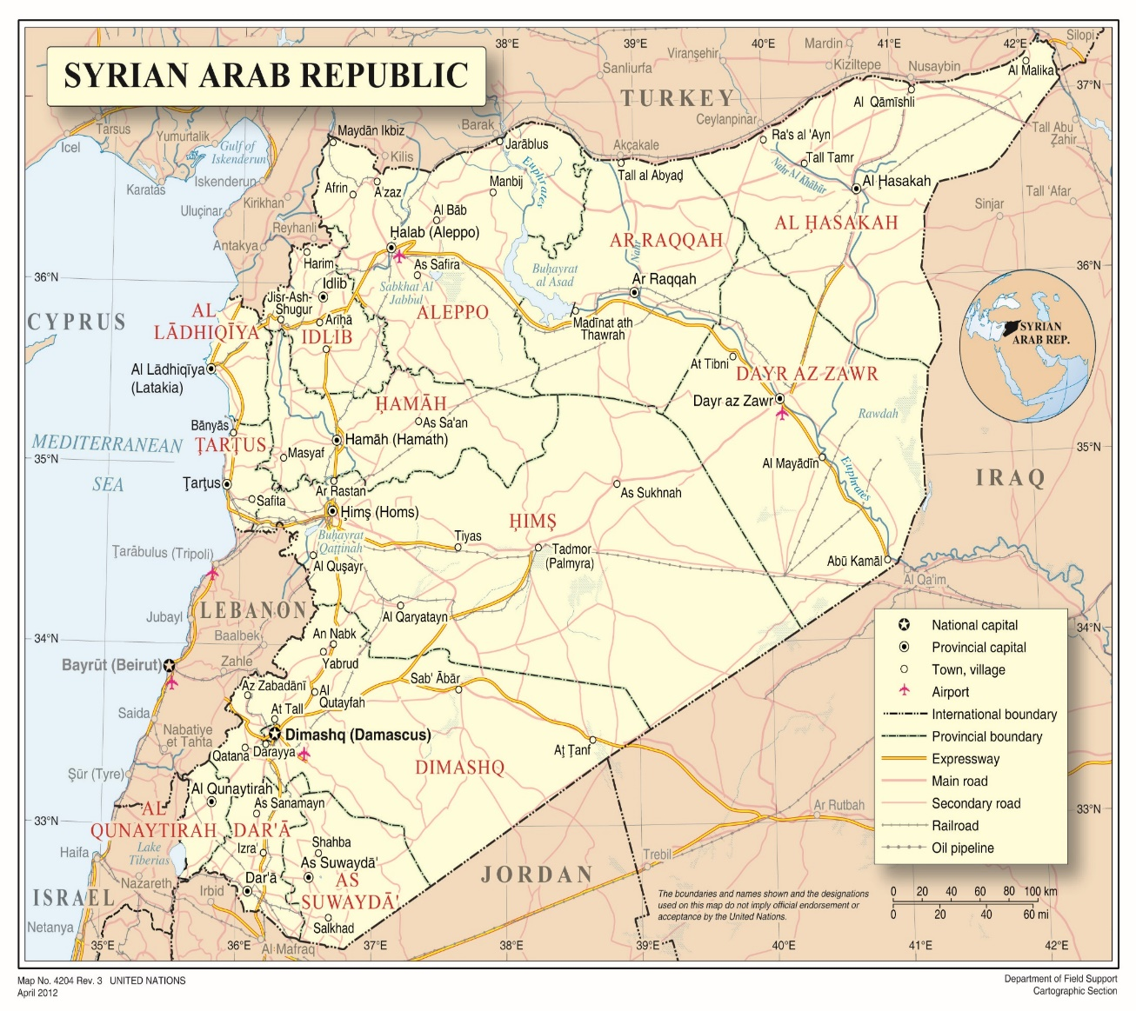

Annex II
Map of the Idlib and Western Aleppo Governorates of the Syrian Arab Republic

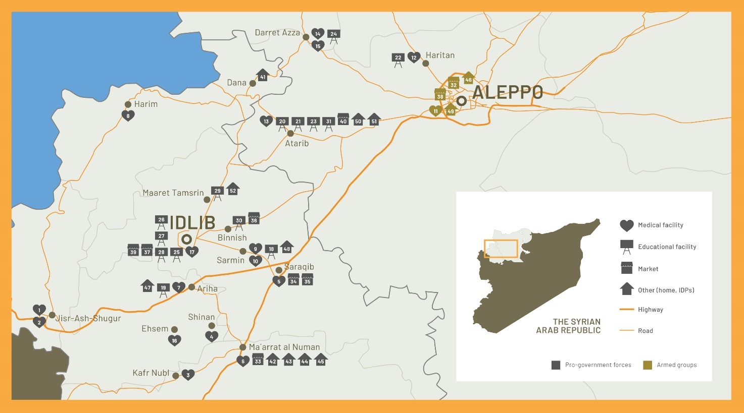
Annex III
Satellite imagery, including in relation to specific incidents investigated
- 29 January, al-Shami hospital, Ariha town, Idlib governorate

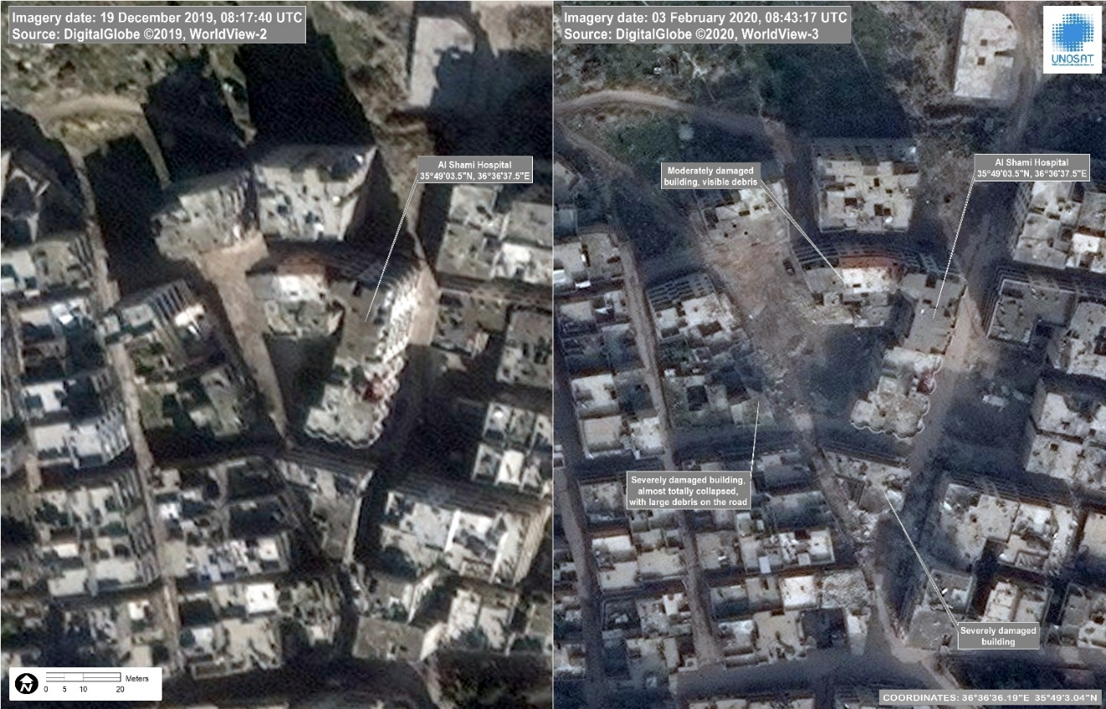

1. On 29 January, at approximately 10:30 p.m., pro-government forces launched three airstrikes that struck a residential area in close proximity to al-Shami surgical hospital, killing the hospital’s director and severely damaging the emergency and x-ray units, in addition to the hospital’s laboratory and vital medical equipment (see section V. C.). Subsequent to this attack, the hospital was rendered non-operational, thus leaving civilians with no other operational medical facility in southern Idlib.
2. Approximately 12 residential homes located near the hospital, in addition to numerous commercial shops, a bakery, civilian vehicles and one ambulance, were also damaged. At least 14 civilians, including one doctor, 5 women and 5 children, were killed and dozens injured. Residents interviewed by the Commission recalled that following this attack, some 80.000 women, men and children fled Ariha.
3. Interviewees described that, earlier that day, doctors were busy treating the casualties from another attack that took place earlier on 29 January on Kafr Latt town. At around 10 a.m., as health personnel was providing care to the wounded, flight spotters reported that aircraft had been observed heading towards Ariha town. Fearing attacks, medical staff began evacuating the patients. Two ambulance vehicles were sent to al-Shami to collect the patients and transport them to other hospitals in the area.
4. Medical staff who witnessed the attack recalled how, at around 10:30 p.m., they heard the first airstrike that caused a loud explosion and shook the hospital. Windows and doors were shattered, while a civilian vehicle stationed nearby caught fire. As civilians sought shelter in the basement and under hospital beds, two consecutive airstrikes hit the hospital’s immediate vicinity and impacted nearby residential homes. The airstrikes caused significant damage to vital medical equipment inside the hospital, subsequently rendering it out of services.
5. Consistent with interview accounts, video footage, picture material and satellite imagery (see image below) showed large-scale destruction inside the facility and surrounding residential areas. The three points of impact were situated very close to each other and impacted the immediate vicinity of the hospital building on three sides, indicating a precise attack likely carried out by missiles, which appeared to have targeted the hospital.
6. The Commission notes that, during the time of the attack, there was no ground fighting and the front line was more than 10 kilometres away to the south-east. Interviewees consistently described the area as civilian, without military objectives located nearby.
7. Credible information obtained by the Commission, including flight spotters’ reports and overflight data, indicate that at least one Russian aircraft departed from Hmemim Air Base between 10:17 and 10:20 p.m., and was observed in the vicinity of Ariha town at 10:30 p.m. Witness statements subsequently confirmed that the airstrikes were launched out at 10:30 p.m., and were carried out in sequence within an interval of 10 minutes.
8. The Commission received no information suggesting that a Syrian aircraft was present in the area, or was part of a coordinated aerial operation, during the time of the attack. The Russian Ministry of Defence denied that a Russian aircraft had been involved in a combat mission in Ariha that resulted into the destruction of al-Shami hospital.

- 15 January, commercial area in Idlib city, Idlib governorate

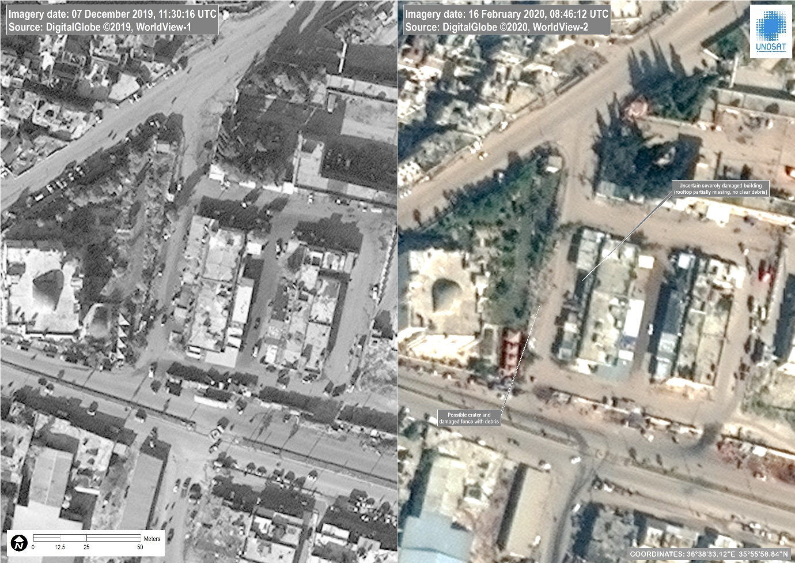

9. On 15 January, at around 2 p.m., pro-government forces carried out a series of airstrikes that struck the densely populated al-Hal market and adjacent commercial area in Idlib city (see section V.A.). The attack killed at least 19 civilians, including 2 children, and injured 60 others. Two of the airstrikes struck a gas cylinder in a commercial shop which subsequently set a number of other shops and vehicles on fire.
10. Interviewees described the area as civilian in nature, a well-known location, regularly visited by residents, including displaced civilians, as it was affordable for the vast majority of disadvantaged families in Idlib and surrounding areas. The market is situated some 200 meters from the Idlib commercial area, approximately 2 kilometres from Idlib city. The Commission did not receive information indicative of the presence of military objective in or near the market.
11. Witnesses recalled how they saw aircraft over Idlib city, and heard explosions in the early afternoon hours, followed by ground spotters’ informing civilians that an attack was carried out on al-Hal market and adjacent commercial area. Rescuers who went to the scene after the attack described seeing dismembered bodies scattered on the ground, while civilians were helping others at the market to retrieve bodies from under the rubble. As the wounded were rushed to the hospital, doctors who treated victims from both incidents recalled how most of the victims suffered severe shrapnel injuries, while others were badly burnt or had lost limbs.
12. Credible information, including video footage, pictures and satellite imagery (see image below) show the destruction of the market area. Consisting with witness statements, flight spotters’ reports and overflight data obtained by the Commission, indicate that a Syrian MiG 23 (Flogger) departed from Hama Military Airbase at 2:06 p.m. hours and was observed flying towards Idlib city at the time of the attack on al-Hal market.
13. The Commission notes that the Russian Aerospace Forces do not operate such aircraft in Syria, and that only Syrian aircraft operate from Hama Air Base. The Commission received no information suggesting that a Russian aircraft was present in the area, or was part of a coordinated aerial operation, during the time of the attack.

- 5 March, poultry farm in Marat Misrin town, Idlib governorate

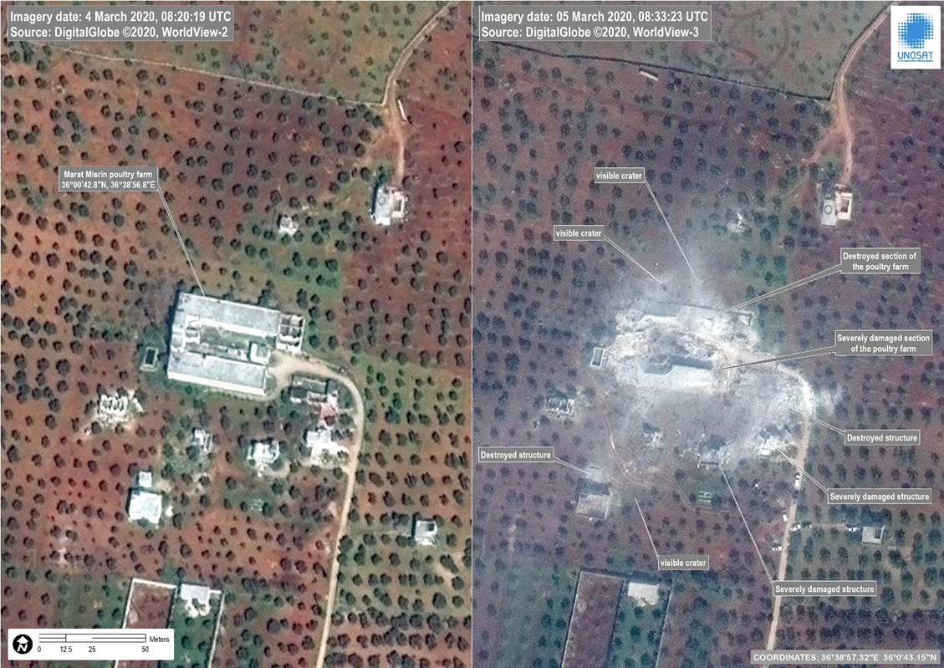

14. On 5 March, between 2 and 2:30 a.m., pro-government forces carried out two consecutive airstrikes that struck directly a poultry farm in Marat Misrin, where around 100 displaced individuals had settled after fleeing Hama and southern Idlib, including Ariha and Ma’arat al Numan between December and January (see section V. A.). The attack destroyed the farm in its entirety, and killed at least 16 civilians, including 8 women and 3 children, and injured 25 others, including 5 women and 7 children.
15. The farm was located an in a remote agricultural area approximately 2 kilometres west from Marat Misrin town. It was a large, distinctive building located amid farmlands of olive threes. Interviewees described that displaced families were accommodated in 4 warehouse-like facilities, while the closest residential houses were located between 20 to 50 meters away. Interviewees further described the area as civilian in nature, without military objectives located nearby.
16. Airstrikes commenced at around 2 a.m., while most of the families were still sleeping. Interviewees recalled being awoken by a large explosion at 2:15 a.m., and running outside to escape further attacks, while others remained stuck under the rubble for hours. Shortly afterwards, at around 2:30 a.m., pro-government forces launched a second airstrike that struck an open area near the farm, killing 1 girl and 2 men who were trying to hide outside. As the farm was completely destroyed, almost all of the displaced families left the next day.
17. Most of the victims suffered severe injuries, with some brought to Marat Misrin hospital with severe shrapnel injuries or without limbs. Family members were forced to identify their lost loved ones based on birth marks, clothing or other similar features.
18. Consistent with interview accounts, video footage, picture material and satellite imagery (see image below) obtained by the Commission show the complete destruction of the farm, in addition to crater impacts in its vicinity. The first airstrike hit the farm directly while the second struck its vicinity, indicating a precise and intended targeted attack on the facility and civilians as they fled.
19. Credible information obtained by the Commission, including flight spotters’ reports and confidential submissions, indicate that at least one Russian aircraft was observed leaving Hmemim Air Base at 1:23 a.m., with frequent sightings along the general route to Marat Misrin town. This flight path is consistent with the capabilities of several different aircraft operated by the Russian Air Force from Hmemim Air Base. Overflight data further indicates that, a Russian aircraft was present between 2:01 and 2:27 a.m. over Marat Misrin, during the time when the attack took place.
20. The Commission received no information suggesting that a Syrian aircraft was present in the area, or was part of a coordinated aerial operation, during the time of the attack.

D. Additional Satellite Imagery:
Atarib, western Aleppo, damage between 3 and 16 February (section V.B and V.E.):
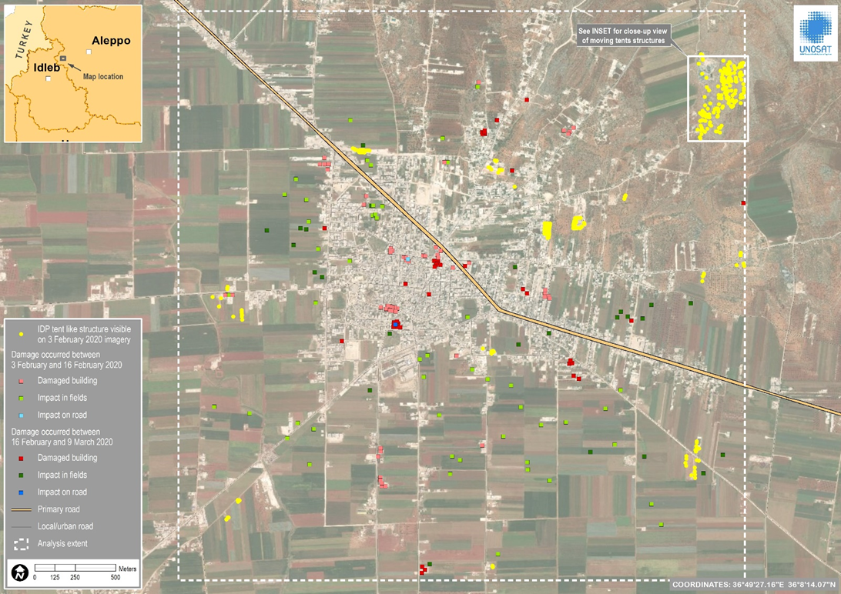
Atarib, western Aleppo, tent-like settlements between 3 and 16 February (section V.E.).
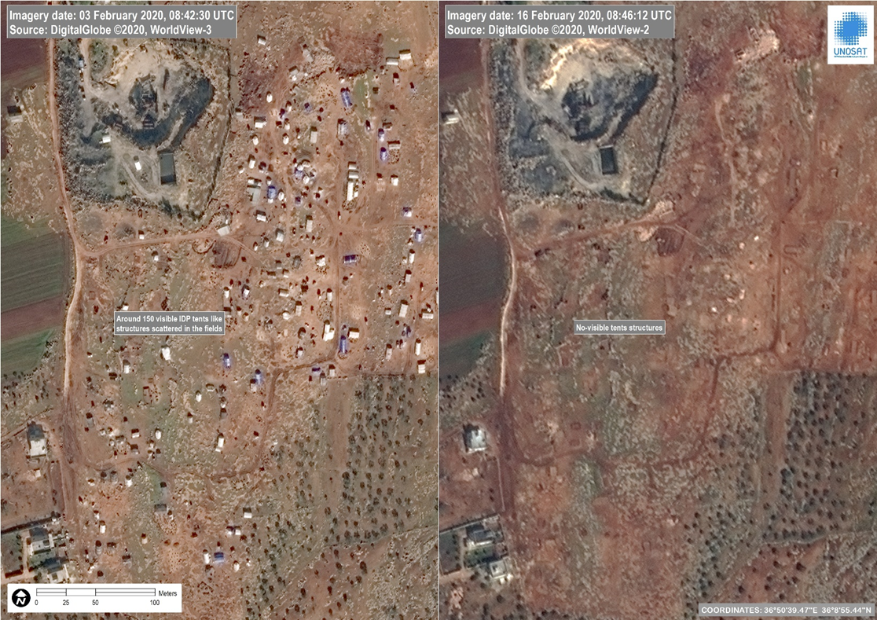

* The present report was submitted after the deadline in order to reflect the most recent developments
** The annexes to the present report are circulated as received, in the language of submission only.
The commissioners are Paulo Sérgio Pinheiro (Chair), Karen Koning AbuZayd, and Hanny Megally.
With the COVID-19-related travel limitations, the majority of interviews were undertaken remotely.
www.ohchr.org/coisyria .
A/HRC/34/CRP.3, 10 March 2017, para 9.
The Commission continues to regard the group as a terrorist entity, as designated the Security Council resolution 2170 (2014) and subsequent list entries, https://scsanctions.un.org/consolidated/.
S/2020/53.
A/HRC/39/65 para. 86.
“Sieges as a weapon of war: encircle, starve, surrender, evacuate”, 29 May 2018, paras. 18 – 25.
A/HRC/36/55, paras. 20–22.
A/HRC/39/65 para. 24.
A/HRC/39/65 at paras. 73-76 and 79.
A/HRC/43/57, para 7.
E.g. A/HRC/45/57, para 24-26 and Annex II.
OCHA, https://reliefweb.int/report/syrian-arab-republic/recent-developments-northwest-syria-flash-update-29-may-2020.
A/HRC/31/68 ft. 3.
A/HRC/42/51, para. 16 and A/HRC/43/57, para 12.
OHCHR and S/2020/327.
S/2020/499.
Briefing by the spokesperson of the Foreign Ministry of the Russian Federation, 27 February.
Ma‘arrat al-Nu‘man has historically had a strong civil society presence, along with Saraqib, Salqin, and Atarib cities. The local council reportedly entered into an agreement with HTS in 2019, prohibiting armed presence inside the town.
A/HRC/28/69, Annex II, paras. 2–8; A/HRC/30/48, paras. 34–35; A/HRC/31/68, para. 77 and A/HRC/43/57, paras. 22-23, and Annex II paras. 1-8.
See A/HRC/27/60, paras. 109-111; A/HRC/33/55, paras. 42-65; A/HRC/34/64, paras. 30-40, A/HRC/34/CRP.3, paras. 15-19
Humanitarian Needs Assessment Programme for Syria (HNAP)
HNAP.
A/HRC/28/69, Annex II, paras. 2–8; A/HRC/30/48, paras. 34–35; A/HRC/31/68, para. 77 and A/HRC/43/57, paras. 22-23, and Annex II paras. 1-8.
S/2020/141 para 19 and S/2020/327, Annex.
The main market was previously hit in July 2019, see A/HRC/43/57 para. 21-23, and Annex II, para. 1– 8.
A/HRC/28/69, Annex II, paras. 2–8; A/HRC/30/48, paras. 34–35; A/HRC/31/68, para. 77 and A/HRC/43/57, paras. 22-23, and Annex II paras. 1-8.
A/HRC/43/57 para 28-29.
Kafr Nubl “cave” hospital has been hit previously, see A/HRC/42/51, Annex II, at paras. 1-3 and the Summary of the Secretary-General of the report of the United Nations Headquarters Board of Inquiry into certain incidents in northwest Syria since 17 September 2018.
A/HRC/27/60, paras. 109-111; A/HRC/33/55, paras. 42-65; and A/HRC/34/64, paras. 30-40; A/HRC/34/CRP.3, paras. 15-19; A/HRC/28/69 at para. 68; A/HRC/21/50 at paras. 18-19; A/HRC/34/64 paras. 48 – 50; A/HRC/37/72 para. 76; A/HRC/27/60, at paras. 86-88.
HNAP.
https://www.humanitarianresponse.info/en/operations/stima/idps-tracking.
In December, 80,288 residents and 20,257 IDPs reportedly left the city, HNAP.
In January, 43,596 residents and 20,860 IDP reportedly left the city, HNAP.
88,732 residents and 31,132 IDP fled in January, HNAP.
During February, 98,595 residents and 116,110 IDP were reported to have left the area, HNAP.
https://reliefweb.int/report/syrian-arab-republic/recent-developments-northwest-syria-situation-report-no-14-15-may-2020
http://eng.mil.ru/en/news_page/country/more.htm?id=12270700@egNews, accessed on 14 May 2020
HNAP.
The Commission has previously documented how detentions of civilians perceived as opposition sympathisers have entailed war crimes and crimes against humanity. e.g. A/HRC/31/CRP.1, para 99.
HNAP.
A/HRC/43/57, January 2020, paras. 18.29, A/HRC/42/51, paras. 44-52; A/HRC/40/70, paras. 24-29; A/HRC/39/65, para 63-64; A/HRC/37/72, paras. 72-79.
A/HRC/28/69, Annex II, paras. 2–8; A/HRC/30/48, paras. 34–35; A/HRC/31/68, para. 77 and A/HRC/43/57, paras. 22-23, and Annex II paras. 1-8.
The use of cluster munitions in densely populated areas is inherently indiscriminate (given the typically wide dispersal pattern and high dud rate) and therefore prohibited by customary international humanitarian law. See Henckaerts and Doswald-Beck, Customary International Humanitarian Law (hereafter, ICRC Rule), Rules 1, 7, 11, 12, 14 and 71; and Convention on Cluster Munitions, CCM/7, Dublin, 30 May 2008, at art. 2.
Prosecutor v. Galic, ICTY, IT-98-29-T, 5 December 2003, at para. 57. ICRC Rule 1 and 156, and ibid at para. 19, See Prosecutor v. Martić , IT-95-11-I, Decision, (Martić Rule 61 Decision), paras. 23-31.
Note verbales sent to Syria and the Russian Federation on 29 April and on 5 June 2020.
Prosecutor v. Gotovina, ICTY, IT-06-90-T, para. 1745; on the absence of genuine choice, see eg. Prosecutor v Blagoje Simić et al. ICTY, IT-95-9-T, 17 October 2003, at para. 126.
Prosecutor v. Galic, ICTY, IT-98-29-T, 5 December 2003, at para. 144. See also Prosecutor v. Mile Mrkšić, ICTY, IT-95-13/1-T, 27 September, 2007, at para. 472.
ICTY, Prosecutor v. Galic, ICTY, IT-98-29-T, 5 December 2003, para. 142.
Prosecutor v. Milosevic, IT-02-54-T Decision on Motion for Judgment of Acquittal, Rule 98bis decision, 16 June 2014, para. 78;Prosecutor v. Stakic IT-97-24-A, 22 March 2006, paras 304-7., ICRC Rule 129 and Guiding Principles on Internal Displacement, Principle 5.
ICC, Trial Chamber, Judgement, Ntaganda, at 1061.
On intent to displace permanently see Prosecutor v. Stakic, above, para. 306.
https://reliefweb.int/report/syrian-arab-republic/syrian-arab-republic-recent-developments-northwest-syria-flash-update-08?
https://reliefweb.int/report/syrian-arab-republic/recent-developments-northwest-syria-flash-update-24-april-2020.
https://reliefweb.int/report/syrian-arab-republic/recent-developments-northwest-syria-situation-report-no-14-15-may-2020
Prosecutor v. Gotovina et al., ICTY, IT-06-90-T,15 April 2011, paras. 1743-1745.
Prosecutor v. Galic, ICTY, IT-98-29-T, 5 December 2003, para. 594. See A/HRC/42/51 para. 43 and A/HRC/38/CRP.3 para 71.
Prosecutor v. Stanislov Galić, ICTY, IT-98-29-A, 30 November 2006, para. 598-600, A/HRC/38/CRP.3 para 72.
Interview code 10/793, S/2020/74, S/2020/447, briefing by Russian Federation’s foreign ministry spokesperson of 27 February.
Section V.F. See also A/HRC/43/57, para. 31.
E.g. A/HRC/40/70, para. 57, A/HRC/43/57, para 38.
A/HRC/40/70, para 62.
A/HRC/42/51 paras. 67-70, A/HRC/40/70 para 73 and paras 9, 80-82.
ICRC Rule 32.
https://reliefweb.int/report/syrian-arab-republic/un-resident-coordinator-and-humanitarian-coordinator-syria-imran-riza and https://www.icrc.org/en/document/syria-humanitarian-aid-workers-and-property-must-be-respected-and-protected.
https://www.facebook.com/Idlib.Central.Hospital/posts/2489309307995430.
A/HRC/43/57, para 37-38.
Common Article 3 of the Geneva Conventions.
ICRC Rule 156 and Rule 90.
Common Article 3 of the Geneva Conventions, ICRC Rule 100. See also https://reliefweb.int/sites/reliefweb.int/files/resources/POE_Report_Full.pdf, para. 188.
ICRC Rule 100.
ICRC Rule 52. See International Criminal Court, Prosecutor v. Germain Katanga, Case No. ICC-01/04-01/07, Judgment, 7 March 2014, paras. 925–957.
Known as the “Tiger Forces”.
https://www.youtube.com/watch?v=VNJxPzM_sY0#action=share.
ICRC Rule 52, and supra note 74.
A/HRC/42/51, paras. 89-95.
A/HRC/37/72/CRP.3, at ft. 6
A/HRC/40/70, para. 54-57.
https://reliefweb.int/report/syrian-arab-republic/recent-developments-northwest-syria-flash-update-29-may-2020.
Most recently A/HRC/43/57 paras 100-103.
A/HRC/39/65 para 8 and A/HRC/39/54 section IV.A., A/HRC/36/55 para 90.
E.g. S/2020/366 para 62, A/HRC/43/57 para 103, A/HRC/34/64, para 109.
The boundaries and names shown and the designations used on this map do not imply official endorsement or acceptance by the United Nations.
This is a preliminary map indicating the subdistrict of each governorate in which the hostilities-related incidents investigated by the Commission took place. It will be replaced by a final version in the edited version of this report. The boundaries and names shown and the designations used on this map do not imply official endorsement or acceptance by the United Nations.
See https://iz.ru/970319/2020-01-30/minoborony-oproverglo-udar-aviatcii-po-grazhdanskim-obektam-v-sirii and https://tass.ru/armiya-i-opk/7643795. In note verbales addressed to the Russian Federation and the Syrian Arab Republic of 29 April and 5 June respectively, the Commission sought but did not receive information on potential military objectives located near the hospital and adjacent residential areas in Ariha town during the time of this attack.

