 |  | A/HRC/46/55
 | Advance Edited Version |  | Distr.: General  11 March 2021  Original: English
Human Rights Council
Forty-sixth session
22 February–19 March 2021
Agenda item 4
Human rights situations that require the Council’s attention
Report of the Independent International Commission of Inquiry on the Syrian Arab Republic*, **
Summary
Pursuant to Human Rights Council resolutions 44/21 and 45/21, the Commission of Inquiry summarizes the key trends in arbitrary imprisonment and detention in the Syrian Arab Republic from March 2011 to December 2020, including in relation to enforced disappearance and incommunicado detention, torture, inhuman or degrading treatment, sexual violence and death in detention. The scope of the mandate given by the Council entailed wide-reaching investigations and the gathering of testimonies and material that the Commission aims to present in greater detail in future reporting.
The present report complements the report containing an overview of the key recurrent human rights concerns and trends over the course of the conflict in the Syrian Arab Republic (A/HRC/46/54), also submitted to the Council at its forty-sixth session.
I. Introduction
1. Over the past decade, no warring party in the Syrian Arab Republic has respected the rights of detained persons in accordance with international legal obligations. The use of arbitrary detention, torture and ill-treatment, including through sexual violence, involuntary or enforced disappearance and summary executions, has been a hallmark of the conflict.
2. Violations and abuses have been perpetrated with such consistency, particularly by the Government of the Syrian Arab Republic, and have been reported so widely by the Commission of Inquiry and others that it is impossible to claim that they were committed without the knowledge of the relevant chains of command. In the case of the Government, the data on the transfer of detainees from other governorates to the capital reflect a high degree of centralized control, in addition to other evidence that shows a detailed bureaucracy with records of those detained and where they were held.
3. The detention-related violations described in the present report were used by the parties to intimidate and punish. Whether by hostage-taking for monetary gain, bribery or the payment of intermediaries for information on the fate of a family member, detention also developed into an extortion racket.
4. Parties to the conflict have, with very few exceptions, failed to conduct investigations into the activities of their own forces. Attempts to subject perceived or actual opponents to some form of criminal justice have consistently resulted in violations and abuses of the rights of those alleged perpetrators and, in many cases, the commission of international crimes. Meanwhile, States with influence over the conduct of the parties have clearly not done enough to change abusive behaviour by those parties on the ground, and in some cases appear to have been complicit in abuses.
II. A decade of detention and related violations
“The boy was lying on the floor, completely blue. He was bleeding profusely from his ear, eyes and nose. He was shouting and calling out to his parents for help. He fainted after being hit with a rifle butt on the head.”
A witness, himself tortured, describing 14-year-old Thamir al-Sharee in May 2011
5. Arbitrary detention and related violations have been among the root causes, triggers and persistent features of the conflict that emerged in the Syrian Arab Republic 10 years ago. Long-standing practices of arbitrary detention of dissidents and activists were among the main grievances that inspired protests in early 2011, during which the population called for the release of political prisoners. The initial heavy-handed response of the Government to the protests – from the mass arrest of demonstrators to torture and numerous deaths in detention, including of children – contributed to the rapid spiral into an armed conflict in February 2012. That year, armed groups, and later groups designated by the United Nations as terrorist, gained influence over increasing numbers of Syrian population centres, initiating the ebb and flow of territorial control that would continue between belligerent parties in ensuing years (see A/HRC/46/54).
6. Most prominent among these groups have been the groups and factions formerly affiliated with the Free Syrian Army prior to their consolidation under other umbrellas and other groups, such as Jaysh al-Islam and Ahrar al-Sham; Hay’at Tahrir al-Sham (previously Jabhat al-Nusra) and Islamic State in Iraq and the Levant (ISIL); the Syrian National Army, supported by Turkey; and Kurdish-led forces, including the Kurdish People’s Protection Units that, as of 2015, operated with the Syrian Democratic Forces, supported by the United States of America.
7. Over time, armed groups and terrorist organizations adopted detention-related practices in the areas under their control that were strikingly similar to those of government and pro-government forces. Enforced disappearance and incommunicado detention, torture, inhuman or degrading treatment, sexual violence and death in detention were documented in detention facilities operated by all parties across the country (see annex II). These ranged from makeshift places of detention in basements, schools, military bases or at checkpoints to purpose-built prisons (operated by different warring parties as territorial control shifted) or heavily guarded displacement camps. The lack of basic habeas corpus across the Syrian Arab Republic facilitated the multitude of violations many individuals suffered in detention by all duty bearers.
III. Prevalence of detention-related violations since 2011
8. Pursuant to its established methodology, which is based on standard practices of commissions of inquiry and human rights investigations, the Commission, comprising Paulo Sérgio Pinheiro (Chair), Karen Koning Abu Zayd and Hanny Megally, relied primarily on 7,874 interviews conducted from 2011 to 2020 in preparing the present report. To supplement the information collected in interviews, official documents, reports, photographs, videos and satellite imagery were analysed from multiple sources, including following the Commission’s call for submissions, issued in October 2020. The standard of proof was considered met when there were reasonable grounds to believe that incidents had occurred as described, and, where possible, that violations had been committed by the warring party identified.
9. Given the mandate to cover nearly a decade of detention in the Syrian Arab Republic, a quantitative analysis was undertaken of the Commission’s own 2,658 interviews relating to arbitrary detention by forces belonging to main groups of parties to the conflict noted in the previous section.
10. While the resulting data provide a basic overview of trends over the entirety of the conflict, it is subject to a number of important considerations (see annex III). Specifically, the Commission conducted interviews for almost a decade without a view to undertaking such quantitative statistical analysis; and the sample collected was subject to the investigative priorities of the respective investigation period. Moreover, safe access to victims and witnesses of detention-related violations became increasingly difficult in recent years owing to protection concerns, often related to their dwindling possibilities to flee the country. The statistics presented therefore do not provide a comprehensive analysis of detention-related violations committed during the conflict.
11. In the said data set, 85 per cent of identified victims of violations in detention were adults and 6 per cent children; 73 per cent were male and 20 per cent female; 73 per cent were from majority religions, ethnicities or sects, which broadly matches United Nations demographic estimates, while 21 per cent were from minority groups; the remaining percentages were undetermined. Victims came from all governorates (see fig. 1 below).
Figure 1. Origin of victims documented in interviews
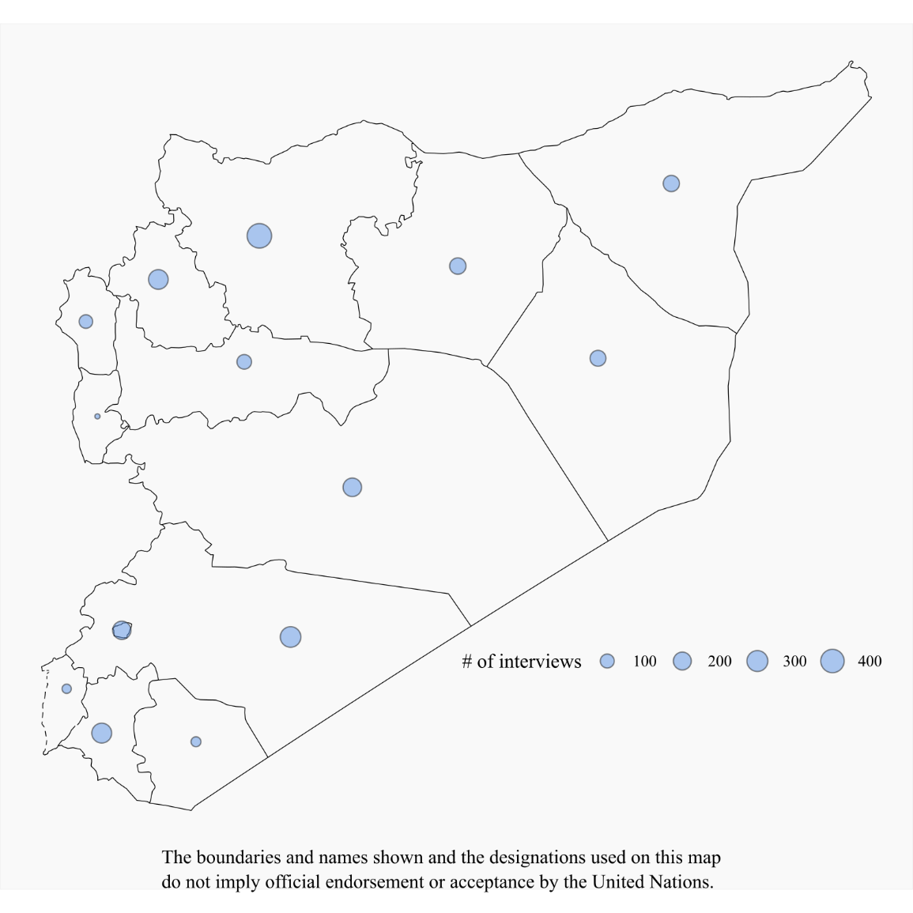
12. The table below shows the number of interviews conducted on arbitrary detention concerning each of the six main parties to the conflict, and the number of additional detention-related violations identified per interview (of the five foremost violations, namely enforced disappearance and incommunicado detention, torture, inhuman or degrading treatment, sexual violence, and deaths in detention).
Table 1. Detention based on interviews (2011–2020)
Duty bearers | Number of relevant interviews on arbitrary detention | Overall percentage of interviews (rounded percentage) | Number of additional detention-related violations identified | Average number of additional detention-related
Government and pro-government forces | 1 577 | 59 | 3 210 | 2.04
ISIL | 409 | 15 | 927 | 2.27
Hay’at Tahrir al-Sham | 211 | 8 | 405 | 1.92
Syrian Democratic Forces and related entities | 198 | 7 | 234 | 1.18
Free Syrian Army and other armed groups | 177 | 7 | 286 | 1.62
Syrian National Army | 86 | 3 | 144 | 1.67
Total | 2 658 | 100 | 5 206 | 1.96
13. The tables below show the yearly percentages for the period 2011–2020 based on an analysis of the 2,658 testimonies, concerning the six main duty bearers and the five foremost detention-related violations. The percentages shown provide only a basic indication of trends, since they were calculated on the basis of the number of testimonies, not the number of documented violations. For example, one testimony concerning deaths in detention may contain corroborated information of the deaths of several named and identified detainees; in the data set and related statistics, however, this is reflected as only “one” (testimony/interview or violation).
Table 2. Testimonies on violations by year by duty bearer

Table 3. Types of violation in testimonies by year

Table 4. Detention (data based on interviews 2011–2020)
Custody-related violation | Duty bearers | Number of interviewees experiencing the violation when held | Percentage of interviewees who experiencing the violation in relevant duty bearer data set | Number of interviewees witnessing/reporting the violation (suffered by others) | Percentage of interviewees witnessing/reporting the violation in relevant duty bearer data set
Enforced disappearance/  incommunicado  detention | Government and pro-government forces | 409 | 26 | 861 | 55
 | ISIL | 81 | 20 | 218 | 53
 | Hay’at Tahrir al-Sham | 64 | 30 | 77 | 36
 | Syrian Democratic Forces and related entities | 31 | 16 | 55 | 28
 | Free Syrian Army and other armed groups | 38 | 21 | 76 | 43
 | Syrian National Army | 17 | 20 | 33 | 38
Torture | Government and pro-government forces | 474 | 30 | 595 | 38
 | ISIL | 82 | 20 | 177 | 43
 | Hay’at Tahrir al-Sham | 44 | 21 | 65 | 31
 | Syrian Democratic Forces and related entities | 20 | 10 | 27 | 14
 | Free Syrian Army and other armed groups | 34 | 19 | 36 | 20
 | Syrian National Army | 16 | 19 | 29 | 34
Inhuman and/or degrading treatment | Government and pro-government forces | 463 | 29 | 575 | 36
 | ISIL | 93 | 23 | 166 | 41
 | Hay’at Tahrir al-Sham | 69 | 33 | 88 | 42
 | Syrian Democratic Forces and related entities | 57 | 29 | 69 | 35
 | Free Syrian Army and other armed groups | 45 | 25 | 39 | 22
 | Syrian National Army | 21 | 24 | 33 | 38
Rape and other forms of sexual violence | Government and pro-government forces | 91 | 6 | 211 | 13
 | ISIL | 28 | 7 | 51 | 12
 | Hay’at Tahrir al-Sham | 6 | 3 | 4 | 2
 | Syrian Democratic Forces and related entities | 2 | 1 | 5 | 3
 | Free Syrian Army and other armed groups | 4 | 2 | 4 | 2
 | Syrian National Army | 3 | 3 | 10 | 12

Table 5. Deaths in detention
Duty bearers | By reports or through witnesses (percentage) | Saw body or witnessed death in detention (percentage) | With death certificate (percentage) | Received body and with death certificate(percentage)
Government and pro-government forces | 249 (15) | 146 (9) | 56 (4) | 11 (1)
ISIL | 113 (28) | 118 (29) | N/A | N/A
Hay’at Tahrir al-Sham | 50 (24) | 23 (11) | N/A | N/A
Syrian Democratic Forces and related entities | 13 (7) | 0 | N/A | 1 (0.5)
Free Syrian Army and other armed groups | 38 (21) | 11 (6) | N/A | N/A
Syrian National Army | 5 (6) | 0 | N/A | N/A
IV. Government and pro-government forces
“They tortured me […], then the interrogator told me ‘We can kill you here and now, nobody will ever know’.”
A former prisoner of the Government’s security forces in Homs
14. Data collected have shown that the Government and pro-government forces committed arbitrary detention and related violations on a massive scale during the first years of the conflict.
15. Starting in Dar’a and then across the country, the Government made mass arrests during demonstrations and military operations, which were followed by arbitrary detention at checkpoints and borders. Government forces targeted various groups, particularly in restive areas, including human rights defenders, health and rescue workers, relatives of wanted individuals and military aged men. A vast network of detention centres was used (see annex II); individuals were subjected to numerous violations, such as torture, inhuman and degrading treatment and sexual violence, and held incommunicado. Tens of thousands of men, women, boys and girls taken into government custody remain forcibly disappeared, 10 years after the first mass arrests. A total of 91 per cent of victims of violations identified in interviews were from majority religions, sects or ethnicities, while 4 per cent were from minorities – possibly indicating that restive areas inhabited predominantly by Sunni Muslims may have been targeted, as previously reported.
Table 6. Government and pro-government forces: types of violation by year

16. Habeas corpus was disregarded in almost all instances. Of the more than 500 former detainees interviewed, almost none had been afforded the opportunity to present their case before the judiciary within a reasonable time. Those arrested were typically not given any information regarding the reason for their arrest nor, if informed of the charges, presented with evidence supporting the allegations. Detainees were routinely tortured to extract confessions or forced to sign or fingerprint declarations that they were not been allowed to read. Detainees eventually referred to parts of the court system on criminal charges were invariably subjected to multiple violations of the right to a fair trial. Proceedings of the counter-terrorism court and field military courts were of particular concern owing to the general lack of evidence utilized and the imposition of death sentences. Eyewitness accounts from counter-terrorism court proceedings indicate that hearings were brief, with scant (if any) evidence presented to support serious charges. In field courts, sessions would last only minutes, with no witnesses or lawyer present. Some defendants were only informed of the verdict years after their trial. Others learned that they had been sentenced without ever being present at a hearing.
17. As government forces recaptured territory in more recent years, thousands of civilians fleeing besieged areas, such as eastern Aleppo Governorate and eastern Ghutah in Rif Damascus, were subject to internment in so-called “IDP” shelters. Continuing arbitrary detention has also been documented in recaptured areas following truces or “reconciliation” agreements.
18. Widespread enforced disappearance was deliberately perpetrated by government security forces throughout the decade on a massive scale, to spread fear, stifle dissent and as punishment. The first few years of the uprisings witnessed the highest rates of disappearances. In a strikingly consistent pattern, arrests were mostly made without a legal warrant, and security forces did not inform arrestees, nor their families, about where they would be taken. Since 2011, 63 per cent of testimonies relating to detention by the Government provided information on incidents of enforced disappearance. The whereabouts of tens of thousands of those arrested throughout the conflict are still unknown.
19. Individuals who were released from detention often either paid a bribe, served their sentence, were subject to an “amnesty” or were released pursuant to a combination of the afore-mentioned. For example, one man, arrested in 2011 and transferred to Sednaya Miltiary Prison, only learned of the verdict rendered against him four months after it was issued by the field court when he was transferred to a prison in Suwayda’ Governorate. After spending nine years in prison, he was released in 2020 by presidential amnesty, but only after paying a bribe. Many others were not informed of the reason for their release.
20. Men, women, boys and girls in detention were subjected to inhuman treatment and torture, including rape and other forms of sexual violence. A total of 474 interviewees were direct victims of torture and 463 of inhuman treatment, and 1,170 individuals witnessed or had credible reports of such violations. At least 20 different horrific methods of torture used by the Government have been extensively documented; they include administering electric shocks, burning body parts, pulling out nails and teeth, mock executions, folding detainees into a car tyre (dulab) and crucifying or suspending individuals from one or two limbs for prolonged periods (shabeh), often in combination with severe beating with various tools such as sticks or cables. Torture methods were both physical and mental, and had severe long-term consequences for detainees, and frequently led to their death. Inhuman conditions documented across government detention centres often in and of themselves amounted to torture.
21. Although sexual violence is significantly underreported for a variety of reasons (including social and cultural stigma, which deters survivors from disclosing sexual violence they have endured), 91 survivors of sexual violence were interviewed and a further 211 individuals either witnessed or gave information regarding credible reports of sexual violence while in government detention. Rape and other forms of sexual violence, including sexual assault and sexual humiliation, were used against women, girls, men and boys, including some as young as 11 years of age, to extract information, as punishment, or to humiliate them and their families.
22. In hundreds of documented cases, violations resulted in death in detention, including of children and elderly persons. Former detainees described how cellmates were beaten to death during interrogations and in their cells, or died from severe injuries caused by torture or ill-treatment. Others perished from the inhuman living conditions, including severe overcrowding, lack of food and unclean drinking water. Prisoners were given inadequate or no medical care, and died from preventable conditions, such as diarrhoea or other contagious infections that spread in the unhygienic and overcrowded cells. Information provided to family members on deaths was typically extremely limited, and often provided only after bribes or extortion by State authorities, including civil registries, military hospitals and military police. In total, the Commission gathered 462 testimonies on deaths in government detention. Some 32 per cent of interviewees saw bodies or directly witnessed deaths, 12 per cent were provided with a death certificate, and 2 per cent received the body and a death certificate, while 54 per cent of information was received through reports or from witnesses.
23. The exact number of detainees who have died in detention is unknown. Conservative estimates indicate that tens of thousands of individuals have died while in custody of government agencies since 2011. Such estimates are supported by accounts obtained from multiple defectors from the security apparatus. Multiple sources indicate that, following the registration of deceased detainees at military hospitals, the bodies were transported and buried in mass graves.
24. Two specific mass burial sites in Najha and Qutayfa on the outskirts of Damascus were identified using information from defectors, satellite imagery collected over the past decade and the family members of deceased persons. Bodies were transported from the Tishreen, Harasta and Mezzeh 601 military hospitals in Damascus, and included detainees who had died in the custody of the four main intelligence agencies and those who died in custody or were executed at Sednaya Military Prison following convictions by military field courts. Although it cannot be excluded that other burials could have led to the earth disturbance observed on multi-year satellite imagery in both locations, there are reasonable grounds to believe that detainees who died or were extrajudicially killed while in State custody are buried at these locations. Other locations used as mass graves for detainees, and other means of disposing of bodies of those killed in detention, including the alleged used of incinerators, remain under investigation.
25. All parts of the Syrian security forces have been involved in the above-described violations since 2011. Former officers of the Syrian intelligence apparatus have described how torture and ill-treatment against detainees was systematic and involved high-ranking officers. Any arrest, detention or release of detainees in a given security branch required the approval of the head of directorate. Likewise, all deaths of detainees were reported to the head of agency.
26. Moreover, data have clearly shown how individuals were moved to Damascus in a centralized manner. The figure below shows that many victims were transferred to or ended up in facilities in Damascus.
Figure 2. Transfers of victims
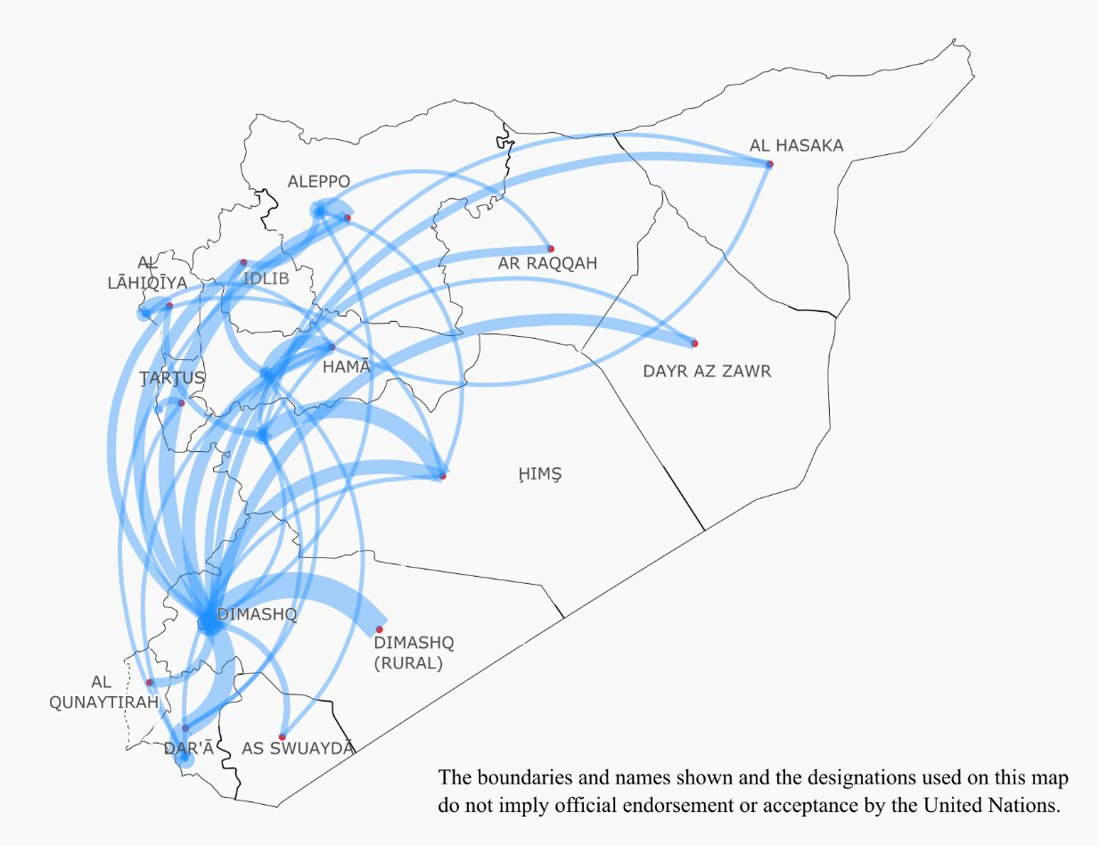
27. Government forces meticulously kept registers of detainees, as international standards prescribe, but failed to inform families of the fate of detainees, as also required by international law. Tens of thousands of families have anxiously awaited news for nearly a decade.
V. Non-State (anti-government) armed groups
28. Anti-Government armed groups began unlawfully depriving individuals – including journalists, human rights activists, perceived political opponents and other civilians, such as relatives of government soldiers or members of religious minorities – of their liberty as early as 2011, without any semblance of due process. Individuals were often taken hostage as pawns when negotiating the release of their captured fighters. Captives and detainees were treated abominably, held in inhumane conditions or subjected to torture or cruel and degrading treatment.
A. Free Syrian Army and other armed groups
“The Free Syrian Army has captured soldiers from the Syrian army, too many […] They are brought to trial, to the Imam, and if the person is found guilty, we call his parents so he can say goodbye, then we kill him.”
Free Syrian Army fighter on summary executions of captured soldiers in Jisr ash Shugur, Idlib
29. At the early stages of the conflict, most armed groups came together under the banner of the “Free Syrian Army”, established by Syrian soldiers who had defected from government forces. Armed groups within it differed in capability, composition and tactics, which in turn influenced their detention-related practices. Detention-related violations by the Free Syrian Army and related anti-government groups, including Jaysh al-Islam and Ahrar al-Sham, have been documented from 2011, with levels remaining steady until 2018 (see fig. 8 below). In 2019, there was a decrease that may be due to a number of factors, including the emergence of the Syrian National Army as a coherent body in late 2017, and the general loss of territory by smaller armed groups.
Table 7. Free Syrian Army: types of violation by year

30. Initially, armed groups affiliated with the Free Syrian Army and other anti-government armed groups engaged in hostage-taking and kidnapping of captured government soldiers, their family members, or foreign nationals, for ransom or exchange for government-held detainees. In other instances, persons belonging to ethnic or religious minorities were taken hostage to settle sectarian scores, often due to perceived government support. As the conflict evolved, groups affiliated with the Free Syrian Army received international support from tactical operations centres in Turkey and Jordan, which increased their capacities to hold territory and to develop their own police forces and justice systems.
31. Acts tantamount to enforced disappearances by the armed groups, which were documented from November 2013 onwards, targeted civilians perceived to be supportive of the Government, human rights activists or other individuals publicly expressing criticism of the armed groups. The Commission collected 114 testimonies on enforced disappearance and incommunicado detention by the Free Syrian Army and other related groups, one third from former detainees.
32. Persons deprived of their liberty were held in dire conditions, mistreated and tortured, also confirmed in 89 interviews with victims of torture and/or inhuman treatment and by 85 individuals who witnessed or credibly reported on such violations.
33. Incidents of sexual and gender-based violations have been perpetrated by armed groups since late 2011 in Damascus and Aleppo, primarily against women and girls for motives related to exploitation, sectarianism or revenge. As noted above, the eight documented testimonies of rape and other forms of sexual violence should not be regarded as indicative of the frequency of sexual violence in detention.
34. Detainees were killed primarily in the context of the capture and detention of government soldiers and fighters of rival groups. Dozens of cases of extrajudicial and summary executions of captured fighters by opposition armed groups have been documented, including pursuant to decisions of makeshift bodies purportedly following their own interpretation of sharia law. The Commission documented several accounts of captives being judged by military commanders, and by community and religious leaders, indicating that such courts and mechanisms were not regularly constituted courts. The functioning of these courts varied depending on the armed group controlling the area. Forty-nine interviews provided information on summary executions or other deaths of individuals held by the Free Syrian Army and other armed groups.
B. Syrian National Army
“They punched me and whipped me with cables. The interrogator said ‘Yazidis are infidels. We will kick you out from our land. You will die in here’.”
Yazidi woman detained at the Syrian National Army military police headquarters in Afrin in 2020
35. In August 2016, numerous factions previously affiliated with the Free Syrian Army participated alongside Turkish armed forces in the cross-border Operation Euphrates Shield, gaining control over northern parts of Aleppo, including I’zaz. By late 2017, these groups unified under the banner of the Syrian National Army. In 2018 and 2019, the Syrian National Army participated in two additional operations alongside Turkish armed forces: Operation Olive Branch (in 2018) and Operation Peace Spring (in 2019). The operations ultimately allowed Syrian National Army forces to gain control over parts of Afrin district and east of the Euphrates River, including Ayn al-Arab, Tall Abyad and Ra’s al-Ayn (Hasakah).
36. The Syrian National Army operates in three legions with multiple brigades under a single command. As hostilities ceased in the Euphrates Shield areas, Afrin region, and in the Ra’s al-Ayn area, the court system and a network of prisons and detention sites were consolidated into a joint structure under the “Syrian interim government”, with judges reportedly appointed by Turkey and paid in Turkish lira. In parallel, associated brigades ran makeshift detention facilities in smaller towns and villages under their control, including an unidentified number of undisclosed detention sites.
37. Documented violations in detention were highest in 2018 and 2019, with a majority committed by members of the Syrian National Army military police. A total of 87 per cent of identified victims were from minority religions, sects or ethnicities.
Table 8. Syrian National Army: types of violation by year

38. After the capture of Afrin, declared in 2018, residents described new patterns of arrests, beatings, kidnappings and, on occasion, disappearances. As hostilities ceased, a security vacuum emerged, creating a permissive environment for fighters to engage in abduction, hostage-taking and extortion.
39. A similar pattern, albeit to a lesser extent, was also observed in Ra’s al-Ayn following Operation Peace Spring, mostly affecting returnees of Kurdish origin, including women.
40. When abducted, victims – mostly of Kurdish origin – were typically taken to the headquarters of the brigade after being initially held in smaller towns or villages. Victims often saw their property or livestock confiscated, and threats, extortion and beatings persist after their release. Several civilians were kidnapped multiple times by different brigades and, while some were released upon ransom payments, others went missing or their bodies were found days after their abduction. When families approached Syrian National Army fighters to ask about the whereabouts of their loved ones, they were often provided with no information, threatened or themselves beaten.
41. As the Syrian National Army gradually expanded control and its operations evolved, detention became widespread. Though hostage-taking for monetary reasons persisted, the Syrian National Army attempted to systematize its detention practices through its vast network of detention facilities in Afrin and Ra’s al-Ayn (annex II). As in the case of abductions and hostage-taking, members detained civilians, primarily of Kurdish and Yazidi origin, alongside other practices such as systematic confiscation of the victim’s property, extortion and beatings, which ultimately coerced many to leave their homes. Victims were interrogated by Syrian National Army members, often regarding alleged links to the self-administration and, occasionally, by or in the presence of Turkish officers. In numerous instances, civilians who had fled the Operation Peace Spring hostilities were detained upon return. Many found their homes looted and were forced to pay to recover household items.
42. Victims of arbitrary detention were most often held in military police headquarters, Afrin central prison and Hawar Kilis Prison in Afrin city, as well as Masara prison in I’zaz (Aleppo) and Senaii military prison in Ra’s al-Ayn (Hasakah) (see annex II).
43. Detainees described being subjected to frequent and severe beatings during interrogation, often to extract confessions regarding alleged links to the Kurdish administration. Torture was most often perpetrated by members of the military police, civil police, Division 21 (Sultan Murad Division), Division 22 (Al-Hamza Division), Al-Shami front, Division 11 and Brigade 111 (Northern Brigade).
44. As Syrian National Army detention practices rapidly evolved, women were increasingly rendered vulnerable to abduction (some for the purposes of forced marriage), and detained at checkpoints or during home and village raids. While detained, Kurdish (and, on occasion, Yazidi) women were also raped and subjected to other forms of sexual violence, including degrading and humiliating acts, threats of rape, performance of “virginity tests”, or the dissemination of photographs or video material showing the female detainee being abused.
45. Accounts indicated that Turkish forces and officers were regularly present in Syrian National Army detention facilities, including in the military police headquarters and the prison in Hawar Kilis, locations where ill-treatment of detainees was rampant. Four former detainees reported that Turkish officials were present during interrogation sessions when torture was used.
46. Information also indicated that Syrian nationals, including women, who were detained by the Syrian National Army in Afrin and Ra’s al-Ayn were subsequently transferred to Turkey. While some have been released or returned to Syrian National Army custody in the Syrian Arab Republic, most of the transferred detainees remain in detention facilities in Turkey.
C. Syrian Democratic Forces and related entities
“Nothing is going to change. You are going to stay here […]until you die.”
Woman, Al-Hawl camp, Hasakah
47. Documented cases of arbitrary detention steadily grew from 2013 to 2016, during the period that saw the emergence of the Syrian Democratic Forces and related entities as those holding territory. The largest number of detention-related incidents was documented in 2017. Numbers remained at relatively high levels in 2018 and 2019.
48. The camps established in the north-east of the Syrian Arab Republic during that period held approximately 90,000 individuals, mostly women and children, deprived of their liberty by late 2020. Their situation is not fully reflected within the data set on which figure 10 below is based.
Table 9. Syrian Democratic Forces and related entities: types of violation by year

49. As members of the Kurdish People’s Protection Units, and later the Syrian Democratic Forces, expanded their territorial control, patterns of detention carried out by their members developed differently.
50. In attempting to assert their de facto authority, the Kurdish People’s Protection Units arbitrarily detained and, on occasion, tortured activists, workers of non-governmental organizations, political opponents (such as members of the Kurdish National Council) and other individuals who expressed opposing views. Thirty such cases were documented between 2013 and 2020.
51. Former detainees reported that they were denied access to a defence lawyer and held incommunicado for long periods without being informed of any charges against them. Victims described being held in overcrowded cells and being confined for days without being able to undertake activities outside. Thirty-one individual testimonies were received of incommunicado detention or enforced disappearance, and 55 of persons who had witnessed or received credible accounts of such acts.
52. A total of 29 per cent of former detainees interviewed who were held by the Syrian Democratic Forces and related entities reported experiencing inhuman or degrading treatment, 10 per cent reported experiencing torture, and 1 per cent reported incidents of sexual violence. Fourteen interviewees provided information on death in detention. Violations were reported in a number of different facilities, including a “black site” prison in Al-Malkiya (Hasakah), Ayed prison (Raqqah), Al-Shadadi prison and Al-Sinaa detention facility (Hasakah) (see annex II).
53. The Syrian Democratic Forces have played a pivotal role in the battles against ISIL since early 2014 – offering the group legitimacy among States allied against ISIL – and has detained thousands of suspected ISIL fighters and interned others, including family members, in that effort.
54. Following the battles in Raqqah and Dayr al-Zawr governorates between 2017 and 2019, men and boys, including foreigners, aged 12 and above with alleged links to ISIL, were taken to detention facilities run by the Syrian Democratic Forces in the east. Since then, many Syrian nationals suspected of having links with the terrorist group have been sentenced by the self-administration’s “people’s defence court”. Others, including foreign fighters, have been kept in detention, in substandard conditions conducive to detainee abuse. Some foreign ISIL suspects have been repatriated or otherwise transferred outside the Syrian Arab Republic, including to stand trial in their home countries, or in Iraq where some were reportedly sentenced to death. The vast majority, however, remain in detention or internment, without prospects for being tried locally, since the self-administration has announced its preference for repatriation by countries of origin of these individuals, to subject them to their respective jurisdictions, or for an ad hoc international court to be established for this purpose. Some 110 boys with alleged links to ISIL were, as at mid-2020, held in a juvenile rehabilitation centre, while others were held together with adults at certain periods in other detention facilities.
55. The spouses and children of suspected former ISIL fighters, many of whom foreigners, were taken to displacement camps in areas under the control of the Syrian Democratic Forces. Though some of those camps are now closed, others such as Al-Hawl and Al-Roj remain functioning, with encamped residents enduring inadequate living conditions, including limited medical care and food. While some Syrian nationals with alleged links to ISIL were released under tribal agreements in 2019 and 2020, most foreign women and children remain interned for more than two years, under the pretext that they posed a security threat. In the annexed sections of Al-Hawl camp, many live in appalling conditions, without access to medical care. ISIL sympathizers have established a morality police and a makeshift sharia court inside the camp that sowed fear among disaffected residents. Several instances of attacks by radicalized men and women on encamped residents have been reported, including killings, beatings, harassment and the burning of tents of women perceived to be “infidels”. Gender- and age-sensitive rehabilitation and reintegration programmes are sorely lacking. While some women in the camps may bear various degrees of responsibility for crimes based on their roles in ISIL, some were also victims of abuse, trafficking or sexual exploitation after having been coerced or groomed to join the group. Few foreign women have been repatriated. Child protection actors reported that only 200 foreign children had been repatriated from camps in the north-east in 2020, down from 685 in 2019.
VI. United Nations-designated terrorist organizations
56. Hay’at Tahrir al-Sham and ISIL, both designated by the Security Council as terrorist groups, unlawfully detained individuals and engaged in an array of detention-related violations and abuses.
A. Hay’at Tahrir al-Sham
“For two years, two months and 21 days I didn’t see sunlight. I felt like I was inside a grave.”
Former detainee, Ouqab prison, 2016–2018
57. Between 2012 and 2014, Jabhat al-Nusra was influential in several governorates, particularly in Idlib. By 2014, amid heavy infighting between armed groups vying for control over north-western regions, they and other groups that would later join to form Hay’at Tahrir al-Sham increased their influence.
58. After defeating Ahrar al-Sham in 2017, Hay’at Tahrir al-Sham cemented its control over parts of Aleppo, Hama and Idlib governorates and subsequently established a de facto quasi-administrative authority there, including its “salvation government”, the “ministry of justice” of which runs the detention facilities.
59. The Commission documented detention-related violations by Hay’at Tahrir al-Sham and related groups (including in their previous incarnations) starting in 2011. While incidents peaked in 2014, similar levels of violations were documented from 2013 to 2019. Some 63 per cent of victims were from the majority religions, sects of ethnicities, while 36 per cent were from minorities.
Table 10. Hay’at Tahrir al-Sham, Jabat al-Nusra and related armed groups: types of violation by year

60. As Hay’at Tahrir al-Sham gradually expanded its areas of influence, it took over government prisons and established new detention facilities that progressively evolved into an extensive prison system, known as ouqab (punishment) prisons. Facilities notorious for the ill-treatment and torture of detainees include the Shahin section of the Idlib central prison, Harem central prison and the main Ouqab prison (also known as the “cave prison”) (see annex II).
61. In the early days of the conflict, armed groups, including Jabhat al-Nusra, regularly took civilians, often women and children, as hostages, usually for prisoner exchanges or to extract a ransom. In many cases, individuals belonging to minority groups were victims of these violations, indicating also a sectarian motivation for abduction or kidnapping. Hostages were used in prisoner exchanges with government forces, while others died in custody or remain missing.
62. Hay’at Tahrir al-Sham has also been arbitrarily detaining civilians in a systematic effort to stifle political dissent. Hay’at Tahrir al-Sham denounces democracy and secularism, and arrests and detains those civilians who speak out against it; 73 cases of detention of activists, journalists and media workers who criticized the group have been documented. As it ceded territory to government forces, the group accelerated detention campaigns in an effort to subjugate populations in the remaining areas under its control in Idlib Governorate. It targeted dissenting civilians, and routinely tortured and subjected them to ill-treatment in detention facilities, including in Ouqab and Harem prisons.
63. Hay’at Tahrir al-Sham also detained women and girls, for instance for travelling without a male member of their family or for being “inappropriately dressed”. Female activists and media workers have been doubly victimized for exercising freedom of expression or daring to speak out against the group’s rule.
64. Though conditions varied in detention facilities run by Hay’at Tahrir al-Sham, victims described detention in overcrowded and unhygienic cells that, compounded by the lack of medical care, allowed for the spread of communicable diseases among detainees. Torture and ill-treatment were widespread. Torture was most common in Idlib central prison and its Shahin section, in Harem central prison and Ouqab prison, with methods including severe beatings, placing detainees in a “coffin” or in a dulab (tyre) or suspending them by their limbs. Victims were frequently tortured during interrogation sessions, and held incommunicado to ultimately extract confessions. Some detainees were told to write a testimony dictated to them by the interrogators, or forced to sign or thumbprint a document, with no knowledge of its content. Some detainees died as a result of injuries sustained from torture and the subsequent denial of medical care. In this regard, the Commission acquired 113 direct accounts of torture and or inhuman treatment, and interviewed 153 individuals who had witnessed, or received credible reports, of such violations.
65. Several male former detainees described being sexually harassed, forced to strip naked, electrocuted on their genitals and raped in Hay’at Tahrir al-Sham facilities. Female detainees reported being threatened with rape; one woman was raped in 2014 at a Jabhat al-Nusra’s checkpoint in Hama. As noted earlier, documenting violations of sexual and gender-based violence are accompanied by various challenges. The Commission collected 10 testimonies, including from six individuals who directly experienced sexual violence in the group’s facilities.
66. Hay’at Tahrir al-Sham also frequently resorted to incommunicado detention, refusing to acknowledge the detention of individuals when their families or relatives sought information on their whereabouts. The ability of families to secure any information on loved ones was further compromised when group members transferred detainees from one facility to another. Since 2011, the Commission has interviewed 64 individuals who had been subjected to enforced disappearance or incommunicado detention, while another 77 had witnessed such violations or received credible reports.
67. Hay’at Tahrir al-Sham furthermore carried out executions without due process. The Commission gathered 83 individual accounts, including from former detainees, about the death of individuals deprived of their liberty. Early in the conflict, Jabhat al-Nusra carried out summary executions of enemy combatants. Detainees were also subjected to summary executions on the battlefield, and civilians were executed pursuant to sentences pronounced by sharia courts, in blatant violation of due process rights. Civilians were summarily executed for, inter alia, apostasy, espionage, affiliation with ISIL or other armed groups, drug trafficking and homosexuality.
B. Islamic State of Iraq and the Levant
“They performed a mock beheading on me. This was the most painful and horrific part, even worse than the beating.”
Male survivor of ISIL detention
68. ISIL was initially a faction of hundreds of other armed groups, but rapidly developed into a well-organized dominant armed force in control of large populated areas in the Syrian Arab Republic and Iraq. The group pursued the establishment of a theocratic State in accordance with its own interpretation of sharia law, and created its own “law enforcement infrastructure”, comprising the Hisbah (religious police), the Emni (intelligence forces), a police force, courts, and entities managing recruitment. The Hisbah also operated an all-female division (Al-Khansa’a brigade), established to ensure compliance with restrictions and to impose punishments on women and girls throughout ISIL-controlled areas.
69. By publicizing its brutality, ISIL aimed to subjugate populations across areas under its control and to intimidate any individuals, groups or States challenging its ideology. Civilians living in ISIL-controlled areas feared the consequences of speaking out against the group. The Commission encountered numerous challenges in its access to sources in these areas, particularly when ISIL was at its height, owing to both these serious protection risks and because Internet use was prohibited. Detailed information on the suffering of those held by ISIL emerged after the group’s territorial defeat in March 2019. Investigations remain ongoing.
70. In terms of yearly incidents, most documented detention-related violations started in 2014, coinciding with the emergence of ISIL as a territorial force. Consistent with the group’s ideology and territorial aspirations, half of its victims were from minority religions, sects or ethnicities – indicating the deliberate persecution of minorities.
Table 11. ISIL: types of violation by year

71. ISIL resorted to various forms of deprivation of liberty, ranging from hostage-taking to detention for violations of their strict interpretation of sharia law, to more severe forms of deprivation of liberty, such as enslavement, including sexual enslavement, of Yazidi women and girls, pursuant to an explicit ideological policy. As ISIL strived to maintain dedicated followers who lived by its rules, it also detained scores of children, primarily boys, to train them forcibly.
72. ISIL systematically targeted and held journalists, activists, fleeing civilians and others perceived to hold dissenting views, as well as other perceived enemies, including alleged supporters or members of armed opposition groups or the Government and its forces. To punish those who transgressed or refused to accept its self-proclaimed rule, ISIL used an extensive network of detention facilities (see annex II), including the Qadi Askar children’s hospital (Aleppo), the notorious Point 11 prison (Raqqah) where many journalists and human rights defenders were held, and various other facilities run by the Hisbah, such as the Moawiya School (Raqqah).
73. Former detainees described suffering various forms of torture in detention, including beatings with sticks or cables, whipping, electrocution and suspension by their limbs from walls or ceiling, leaving them in stress positions. Nearly 200 accounts described experiencing torture (82) and inhuman treatment while in ISIL custody (93), in addition to 343 accounts from individuals who had witnessed, or received credible reports of, such violations.
74. Sexual and gender-based violence was a regular practice specifically targeting women and girls, and ultimately confined many to their homes. Over time, the Al-Khansa’a brigade became increasingly responsible for monitoring the dress code, including by ensuring that women and girls covered not only their bodies and faces but also their hands and feet. Yazidi women and girls deprived of their liberty survived unfathomable abuse by ISIL as fighters held them in captivity, including sexual slavery, rape, gang rape and other forms of sexual violence.
75. To enforce loyalty among civilians under its control, ISIL carried out executions in public squares, or outside detention facilities, and forced local residents, including children, to attend. ISIL publicized horrific executions of hors de combat fighters and summary executions of civilians following sentencing by unauthorized courts, including the execution of individuals accused of prohibited sexual conduct. Numerous instances of women being stoned to death were documented between 2013 and 2017. In total, 231 accounts of death in detention were collected.
76. ISIL used incommunicado detention widely, with acts akin to enforced disappearance increasing from November 2013 onwards. Eighty-one former detainees reported how they experienced enforced disappearance or incommunicado detention by ISIL, corroborated by a further 218 interviewees who witnessed or had credible reported of such violations.
77. In late 2020, the Commission learned through human rights organizations that four mass grave sites had been identified close to ISIL detention centres in Raqqah Governorate, where detainees might have been forced to dispose of fellow detainees’ bodies. Investigations are ongoing.
VII. Impact of detention on survivors
78. The impact of detention on Syrian women, men and children is multifaceted, and comprises a range of physical and mental harm. The families of tens of thousands of individuals also continue to suffer from a pervasive sense of anguish, distress and uncertainty, as numerous detainees have never returned to their families and remain missing.
79. Most former detainees described suffering from chronic physical pain resulting from the brutal torture they endured in captivity. Victims often suffer from headaches, neck, shoulder and joint pain as a result of beatings and stress positions, or due to cramping in confined and unsanitary conditions.
80. Psychological methods of torture has caused severe emotional suffering and post-traumatic stress disorder, attack the dignity of individuals by depriving them of a sense of self-worth or integrity, or the capacity to control decisions affecting their well-being.
81. Survivors of both forms of torture in detention have described suffering from impaired bodily functions, often coupled with psychological distress, even several years after their release.
82. Those released from custody struggled moreover to secure housing, access to education for their children, civil documentation and employment. For many, the palpable fear emanating from the prospect of being re-detained confined them to their homes, while others were unable to carry out basic civic activities owing to clearance procedures imposed by security services.
VIII. Legal findings and accountability
83. No warring party in the Syrian Arab Republic has respected the rights of detained persons in accordance with international legal obligations. The Government has arbitrarily arrested and detained individuals, and committed war crimes and crimes against humanity in the context of detention. ISIL, Hay’at Tahrir al-Sham, the Free Syrian Army, the Syrian National Army and the Syrian Democratic Forces have all unlawfully and arbitrarily deprived individuals of their liberty and also committed war crimes in that context, and engaged in detention practices contrary to fundamental human rights. ISIL and Hay’at Tahrir al-Sham have also engaged in crimes against humanity in connection with the deprivation of liberty, while ISIL carried out a genocide, in part through detention. Third States have supported different parties to the conflict in the context of detention despite pervasive violations and abuses by parties to the conflict documented by the Commission, which may amount to violations of their own obligations under common article 1 of the Geneva Conventions (to “ensure respect” for the Conventions).
A. Human rights law
84. There are reasonable grounds to believe that the Government has engaged in widespread and systematic arbitrary imprisonment and unlawful detention practices, and is responsible for violations of the right to life as well as various other human rights violations under the International Covenant on Civil and Political Rights (arts. 7, 9, 10 14 and 26), the Convention on the Rights of the Child (arts. 2, 3, 37 (a) and (b), and 40) and the Convention against Torture (arts. 1, 2, 4, 6, 11, 12, 13 and 15).
85. State forces continue to inflict cruel, inhuman or degrading treatment on the next of kin of those forcibly disappeared, including through the deliberate practice of concealing the fate and whereabouts of such persons. The effective removal of such persons from the protection of the law, insofar as such protection exists in this context, and the failure to account for the fate of such persons also amount to a violation of the right to life.
86. Furthermore, by its failure to provide appropriate medical care or assistance to detainees, the Government also violated the prohibition of cruel, inhuman or degrading treatment, as well as the right to health.
B. Crimes against humanity
87. There are reasonable grounds to believe that the Government has continued to carry out a widespread or systematic attack against the civilian population, in pursuance of a firmly established policy to commit such acts, comprising the crimes against humanity of murder, extermination, imprisonment, enforced disappearance, sexual violence and torture, and other inhumane acts.
88. For its part, ISIL directed and organized the multiple commission of acts of violence amounting to an attack on a civilian population, in pursuance of its organizational policy to commit such acts. In the context of detention, the Commission previously found that ISIL had perpetrated the crimes against humanity of murder, torture, severe deprivation of liberty, enforced disappearance, enslavement, rape, sexual violence, sexual slavery, and mutilation as a form of corporal punishment, and other inhumane acts. These and other violations amounted to the crime of genocide against the Yazidi minority.
89. The Commission previously found that the arbitrary detention of political dissenters by Hay’at Tahrir al-Sham constituted a systematic attack against a civilian population, and that there were reasonable grounds to believe that it had perpetrated the crime against humanity of persecution on political grounds. In addition, the Commission has documented, since at least 2014, torture in detention facilities under the control of Hay’at Tahrir al-Sham where such practices were consistently conducted as a means of extracting information from detainees, such as former fighters, but also from a large number of civilians detained on the basis of their political affiliation, their exercise of freedom of expression, or their explicit criticism of Hay’at Tahrir al-Sham. In the light of the consistent documented use of torture against detainees over the course of six years, and the failure of the group’s leadership to take effective steps to prevent such practices, there are reasonable grounds to believe that Hay’at Tahrir al-Sham may be engaging in such conduct in pursuance of an organizational policy. Such conduct may therefore be part of a systematic attack against the detainee population in its custody, amounting to the crime against humanity of torture.
C. International humanitarian law and war crimes
90. The Government has committed war crimes on a massive scale, of murder, torture and ill-treatment, rape and sexual violence, outrages upon personal dignity, and the passing of sentences and the carrying out of executions without previous judgment pronounced by a regularly constituted court, affording all judicial guarantees which are generally recognized as indispensable.
91. Anti-government armed groups, including the Free Syrian Army, the Syrian National Army and the Syrian Democratic Forces, as well as United Nations-designated terrorist groups ISIL and Hay’at Tahrir al-Sham, unlawfully deprived individuals of their liberty and engaged in detention practices contrary to international humanitarian law, which became applicable after February 2012, and related fundamental human rights. This included sentencing alleged suspects without affording them essential judicial guarantees.
92. Furthermore, anti-government armed groups, including the Free Syrian Army and the Syrian National Army, as well as the Syrian Democratic Forces, Hay’at Tahrir al-Sham (including when operating under its former aliases or iterations) and ISIL perpetrated the war crime of torture and ill-treatment in places of detention under their control. Anti-government armed groups, including the Free Syrian Army, as well as Hay’at Tahrir al-Sham and ISIL, also committed the war crimes of murder, hostage-taking and the passing of sentences and the carrying out of executions without previous judgment pronounced by a regularly constituted court, affording all judicial guarantees which are generally recognized as indispensable. ISIL and the Syrian National Army committed the war crimes of rape and sexual violence in the context of detention; ISIL also committed sexual slavery as a war crime.
93. Although not to the same degree as government forces, ISIL, Hay’at Tahrir al-Sham, the Free Syrian Army, the Syrian National Army and the Kurdish People’s Protection Units/Syrian Democratic Forces refused to reveal the fate or whereabouts of persons taken into their custody, thereby also engaging in acts tantamount to enforced disappearance, in violation of international humanitarian law and fundamental human rights principles.
94. The Commission also notes that, in areas under effective Turkish control, Turkey carries a responsibility to, as far as possible, ensure public order and safety and to afford special protection to women and children. Turkey remains bound by applicable human rights obligations vis-à-vis all individuals present in such territories. By failing to intervene to prevent torture when present or otherwise aware that torture would be employed, Turkish forces may have violated their obligations under the Fourth Geneva Convention. Furthermore, the transfers of Syrian nationals, detained by the Syrian National Army, to Turkish territory (see para. 46 above) may amount to the war crime of unlawful deportation of protected persons.
95. In addition to those detained unlawfully in other circumstances, the Syrian Democratic Forces are also holding thousands of men and boys suspected of former membership of or association with ISIL, often incommunicado, without access to adequate judicial guarantees. Those who have not been charged under criminal provisions or undergone an individual assessment by an impartial and independent body as to whether their internment is justified on grounds of imperative reasons of security are being unlawfully deprived of their liberty.
96. Notwithstanding the security threat posed by many alleged former ISIL members, blanket internment of civilians by the Syrian Democratic Forces who originally resided in areas where ISIL imposed its rule by violent means cannot be justified. In particular, the civilians interned since at least 2018 include tens of thousands of children, elderly, infirm and disabled persons, and others who do not represent any imperative security threat. Therefore, in many instances, the ongoing internment of these individuals continues to amount to unlawful deprivation of liberty. The failure to provide appropriate medical care or assistance to encamped residents also constitutes a violation of the prohibition of cruel, inhuman or degrading treatment, and contravenes the right to health.
D. Accountability efforts
97. Customary international law and international humanitarian and human rights law require States to investigate allegations of serious violations, to prosecute suspected perpetrators, and to provide effective remedies for violations, including through compensation. The Government has consistently failed to fulfil such obligations. The Commission sent requests for information to the parties concerning efforts to hold their own forces accountable for detention-related violations and abuses; it has yet to receive such information, with the exception of information received from the “Syrian interim government” and the Syrian Democratic Forces.
98. While certain parties have subjected captured members of opposing forces to criminal accountability processes, these proceedings have mostly been seriously deficient and even led to further crimes, violations and abuses. No party to the conflict appears to be either willing or able to meet their obligations to investigate and hold perpetrators accountable, or to provide effective remedies, including reparations for victims.
99. The Commission is therefore encouraged to note that, since 2016, individual Member States have begun to hold perpetrators to account for detention-related violations in the Syrian Arab Republic. On 24 February 2021, a former member of the Syrian intelligence services was sentenced for aiding and abetting crimes against humanity through torture and the deprivation of liberty in a first trial on State torture in the Syrian Arab Republic, held in Koblenz, Germany. In September 2020, the Netherlands announced its intention to hold the Government responsible for gross human rights violations and torture, in particular under the Convention against Torture.
IX. Conclusions and recommendations
100. For nearly a decade, the Government of the Syrian Arab Republic then all parties have resorted to arbitrary detention, torture and ill-treatment, including through sexual violence, and to involuntary or enforced disappearance to intimidate and punish perceived political opponents and dissenting civilians and their families. Such violations were meted out with sectarian overtones in some cases, and in the case of ISIL, with deliberate genocidal intent. Groups designated as terrorist by the United Nations and some armed groups used unlawful detention to enforce draconian restrictions on daily life.
101. While government detention practices where implemented on a vast scale and ISIL practices garnered near universal condemnation, the present report shows that no party in the Syrian Arab Republic can claim the moral high ground. Despite the existence of easily ascertainable and consistent patterns of conduct over the years, as detailed in the Commission’s public reports, individuals within each duty bearer’s chain of command at a minimum knew or should have known that such practices continued, and failed to take appropriate action.
102. The sheer volume, scale and consistency of government policies and acts that the Commission has found to amount to crimes against humanity have continued unabated for nearly 10 years, without any sign that the Government intends to discontinue them.
103. The fate of tens of thousands of victims subjected to arbitrary and incommunicado detention and enforced disappearance by government forces, and to a lesser extent, by ISIL, Hay’at Tahrir al-Sham and other armed groups, remains largely unknown. Those who have survived describe executions and deaths from neglect and appalling prison conditions, suggesting that those still in incommunicado custody may slowly die unless released expeditiously.
104. The Government and other parties are intentionally prolonging the suffering of hundreds of thousands of families of those forcibly disappeared by withholding information on their fate. The evidence shows that the Government is aware of the fate of most of those it has detained. Rather than investigate the crimes committed in its detention facilities, the Government continues to withhold information. This has had, and continues to have, a devastating impact on families.
105. The victims of enforced disappearances are not limited to the persons who were forcibly disappeared, but also comprises their families. Given the extent of enforced disappearances in the Syrian Arab Republic, the issues of detainees represent a national trauma that will affect Syrian society for decades to come.
106. On the cusp of the eleventh year of the conflict, and in the midst of a pandemic, the Government of the Syrian Arab Republic, Hay’at Tahrir al-Sham, the Syrian National Army and the Syrian Democratic Forces continue to hold a vast number of detainees incommunicado and in appalling detention conditions, where detainees in fragile health may not survive a COVID-19 outbreak. Torture, sexual violence and summary executions continue in many places of detention across the country.
107. Men and women, boys and girls have been targeted on the basis of sex by all parties, albeit often for divergent reasons, and the resulting impact, including in relation to sexual violence and rape in detention, has been and will remain long-lasting and deeply gendered.
108. Perhaps illustrative of the increasingly desperate economic situation in the country, elements and force members from all sides have over time engaged in violations for monetary gain, ranging from hostage-taking for ransom and detaining people to appropriate their property, to extortion or bribery, exploiting family members’ desperate pursuit of information on their loved ones.
109. Member States that support the warring parties have had knowledge of these violations and could and should have acted more decisively to prevent them. This applies particularly to States whose forces have been present in detention facilities where violations were perpetrated, including during their commission.
110. While the decade has seen fluctuating waves of arbitrary detention campaigns of varying kinds by the six main duty bearers – from the mass arrest of demonstrators in the early days to mass internment of men, women and children today – this has been the constant fact: tens of thousands of people in the Syrian Arab Republic are being unlawfully deprived of their liberty.
111. The Commission recommends that the Government of the Syrian Arab Republic and other parties holding people in custody:
- Cease all torture, ill-treatment, sexual abuse and execution of detainees;
- Cease incommunicado detention and allow all detainees to contact their family and a lawyer;
- Allow access to all places of detention to independent and humanitarian organizations, and improve conditions in them;
- Release infirm, disabled and elderly persons, women, children and those arbitrarily detained;
- Support victims, survivors and their families, including with psychosocial support, and identify those missing and disappeared;
- Take measures to discipline or dismiss individuals responsible for violations against detainees, and ensure that all deaths in custody and enforced disappearances are promptly, thoroughly, transparently and independently investigated in accordance with international standards, and hold perpetrators to account.
112. The Commission reiterates the more than 130 recommendations on arbitrary detention that it made in its previous reports.
113. The Commission recommends that States Members of the United Nations:
- Put pressure on the parties to implement the above recommendations;
- Facilitate the creation of an independent mechanism with an international mandate to coordinate and consolidate claims regarding missing persons, including persons subjected to enforced disappearance; task the mechanism with defining the elements required to efficiently and effectively track and identify those missing and disappeared; help consolidate claims filed with a wide variety of non-governmental and humanitarian organizations; and coordinate overtures to parties to the conflict to locate missing persons or their remains, including those found in mass graves, which meanwhile must be protected;
- Support organizations that provide assistance to victims, survivors and their families, including with psychosocial support, including through the United Nations Voluntary Fund for Victims of Torture;
- Refrain from providing support to the forces of any party identified by the Commission as responsible for war crimes, crimes against humanity or gross violations of human rights, unless support is aimed at preventing such violations and abuses and at assisting in the implementation of the present recommendations;
- Consider adopting sanctions targeting those persons, entities and groups reasonably suspected of being responsible for or complicit in violations described in the present report;
- Repatriate civilian nationals residing in the Al-Hawl and Al-Roj displacement camps, in particular children with their mothers, in accordance with the best interests of the child and in the light of the dire camp conditions, unless they thereby risk arbitrary detention or physical harm, including the death penalty.
114. The existing judicial systems of the Government and other parties to the conflict are not willing or able to hold perpetrators to account in a manner that respects international standards. The Commission therefore reiterates its recommendation to the Security Council to refer the situation in the Syrian Arab Republic to the International Criminal Court, and also that Member States continue to seek accountability, including by ensuring effective legislation enabling the prosecution of individuals suspected of war crimes and crimes against humanity in the Syrian Arab Republic and investing in related investigative, judicial and prosecutorial infrastructure to ensure that proceedings adhere to international standards. The Commission stands ready to continue to assist Member States in this endeavour, in close cooperation with the International, Impartial and Independent Mechanism to Assist in the Investigation and Prosecution of Persons Responsible for the Most Serious Crimes under International Law Committed in the Syrian Arab Republic since March 2011.
Annex I
Map of the Syrian Arab Republic
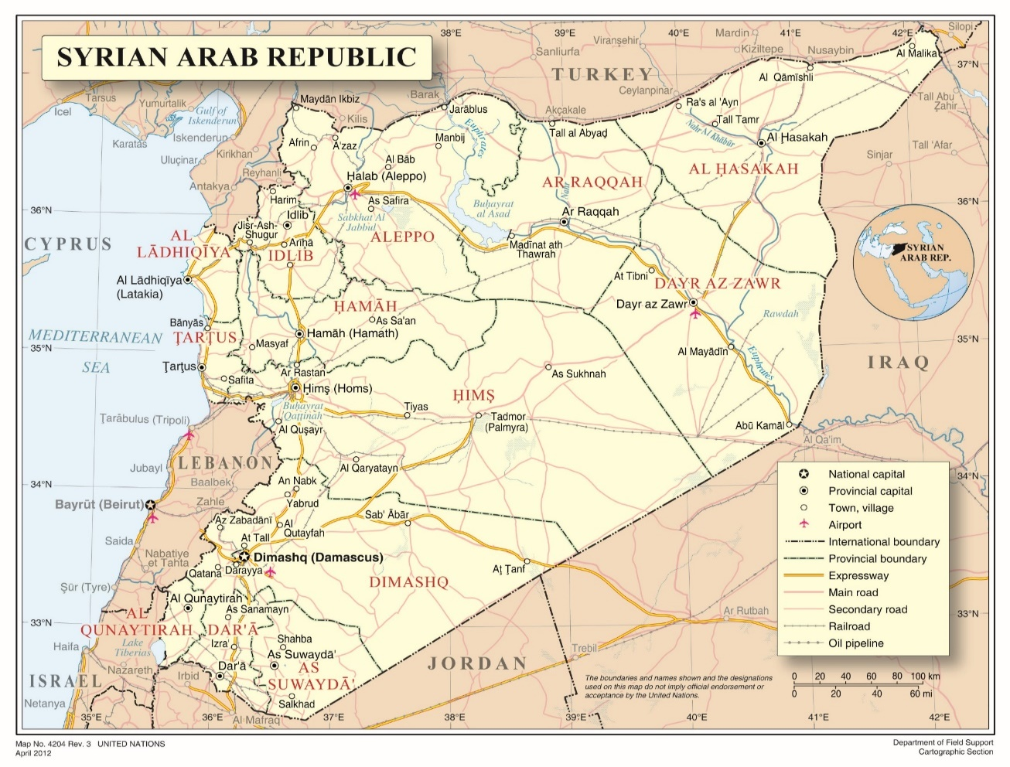
Annex II
Main detention facilities in the Syrian Arab Republic where the Commission has verified violations
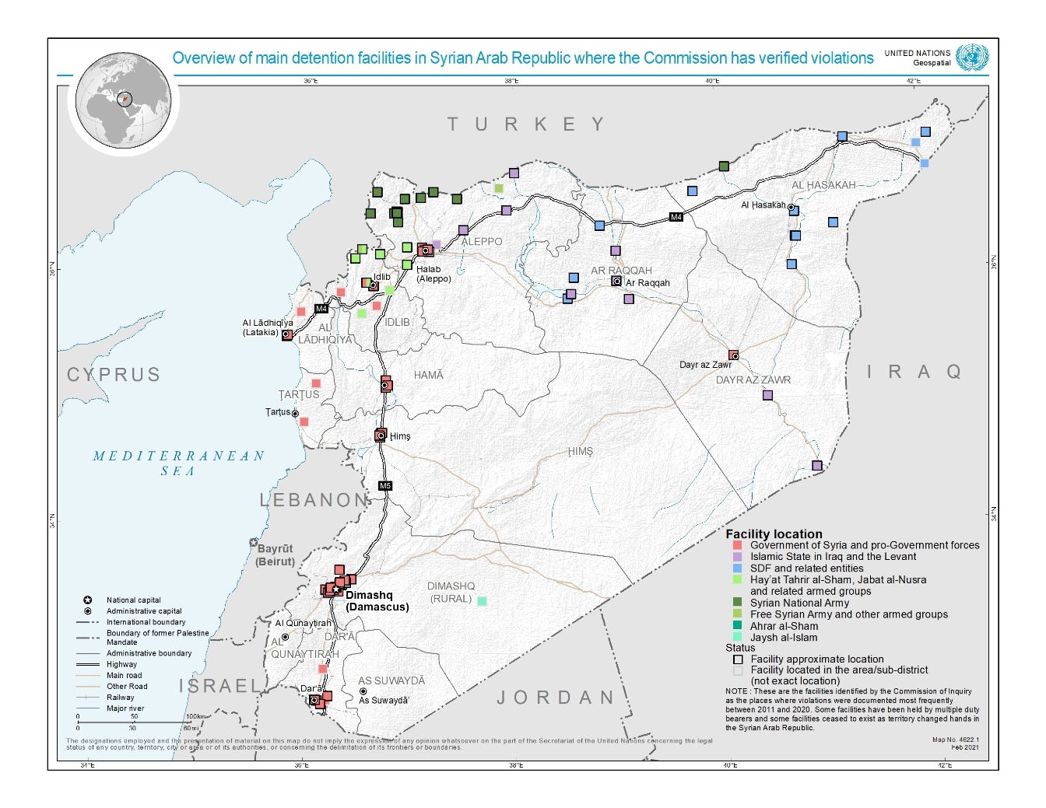
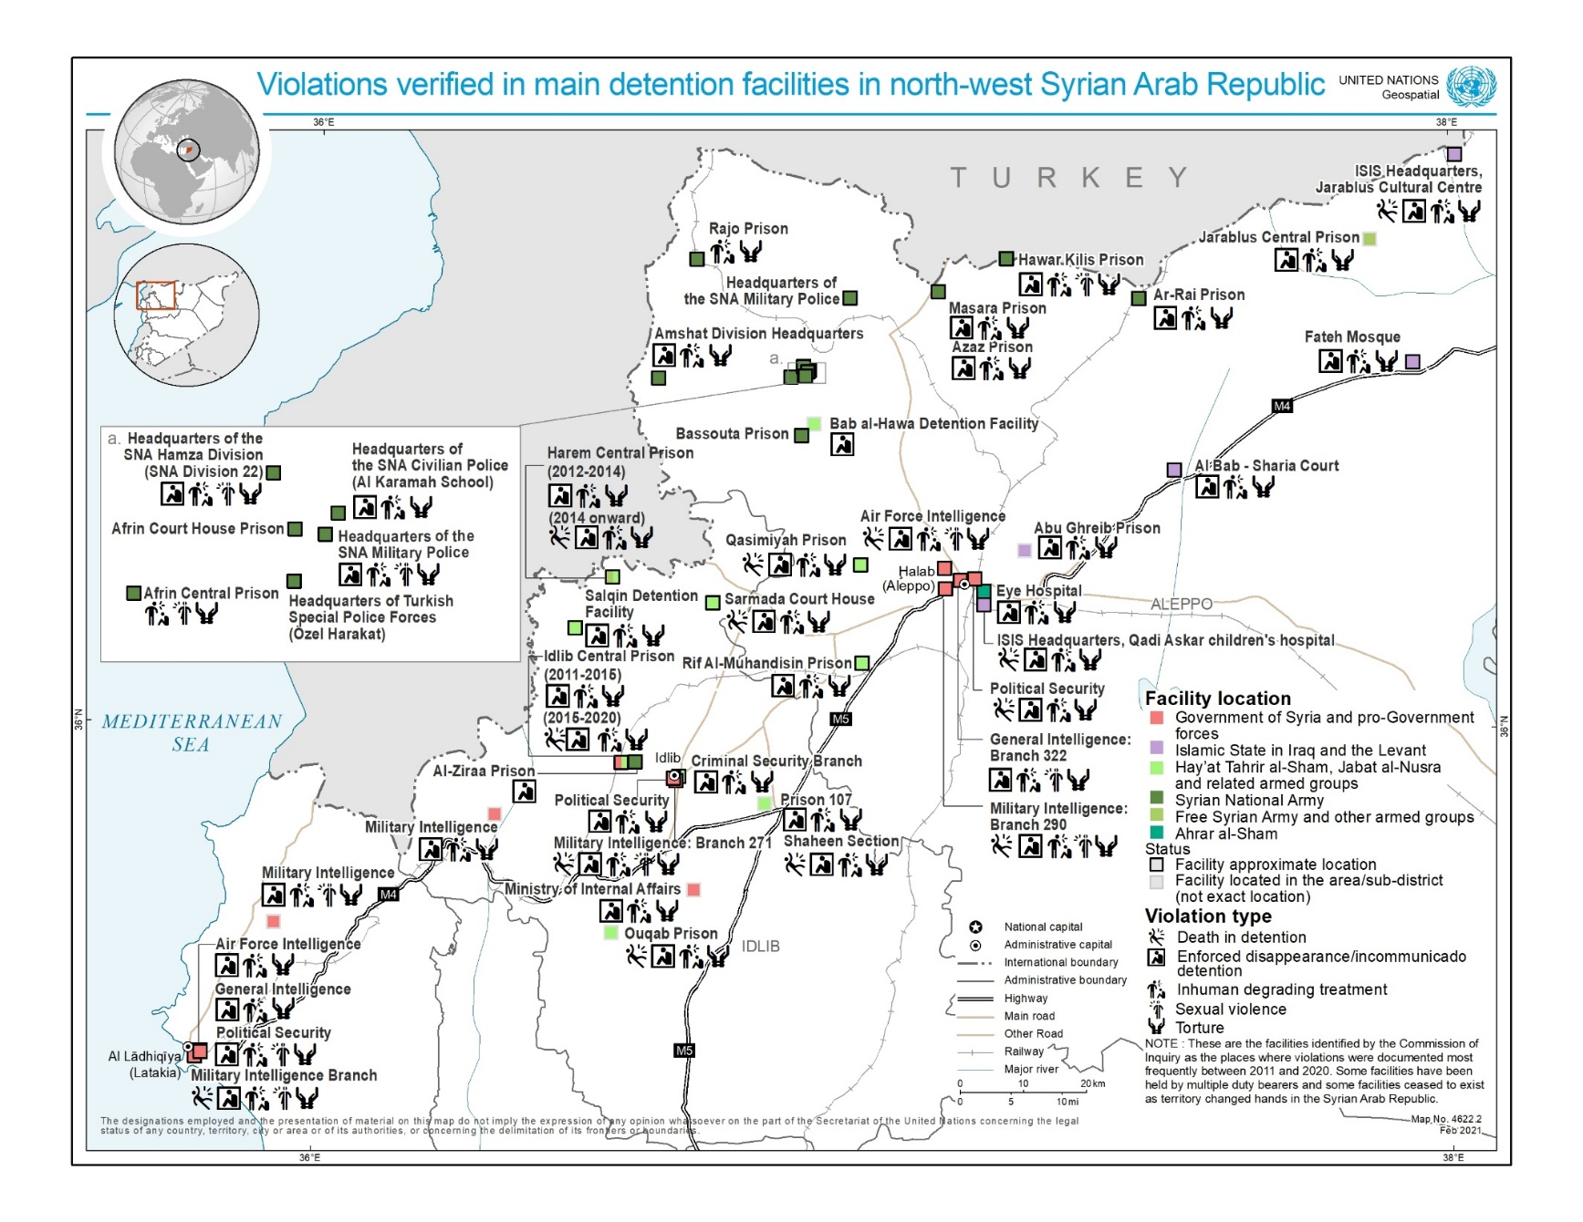
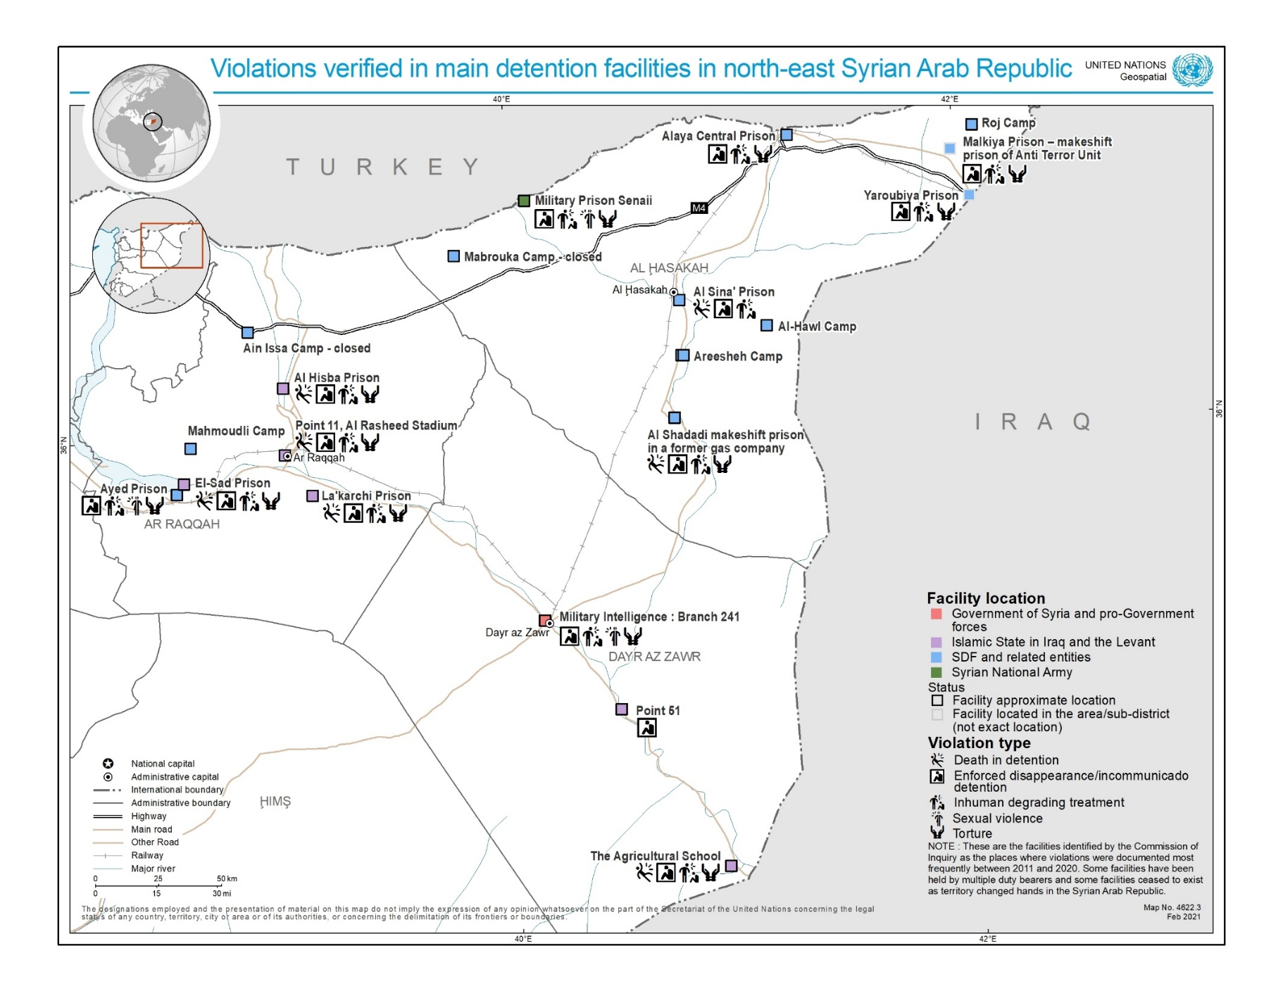

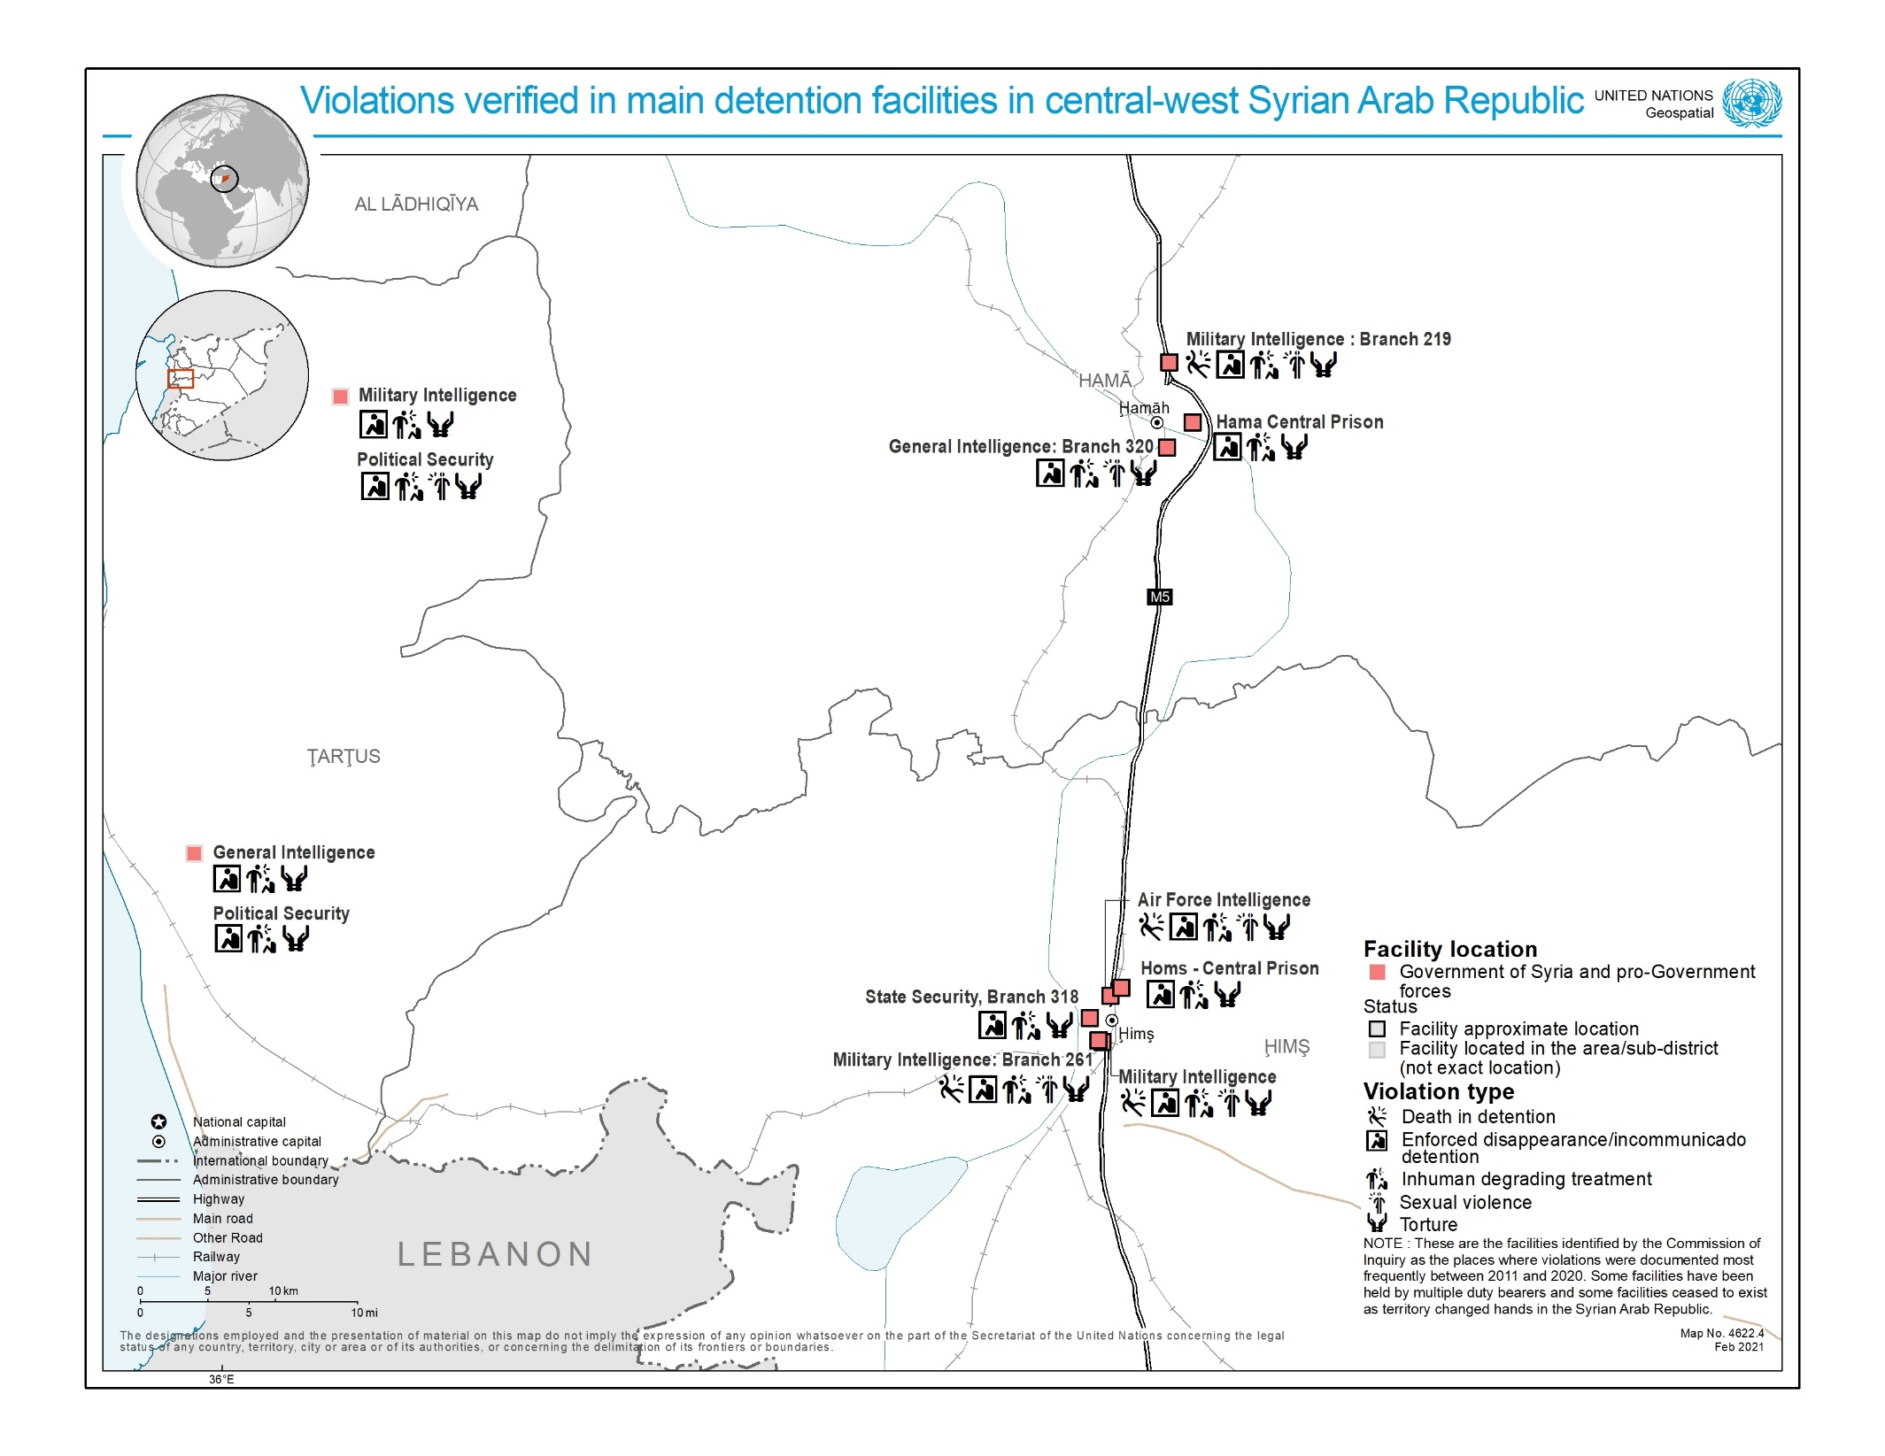
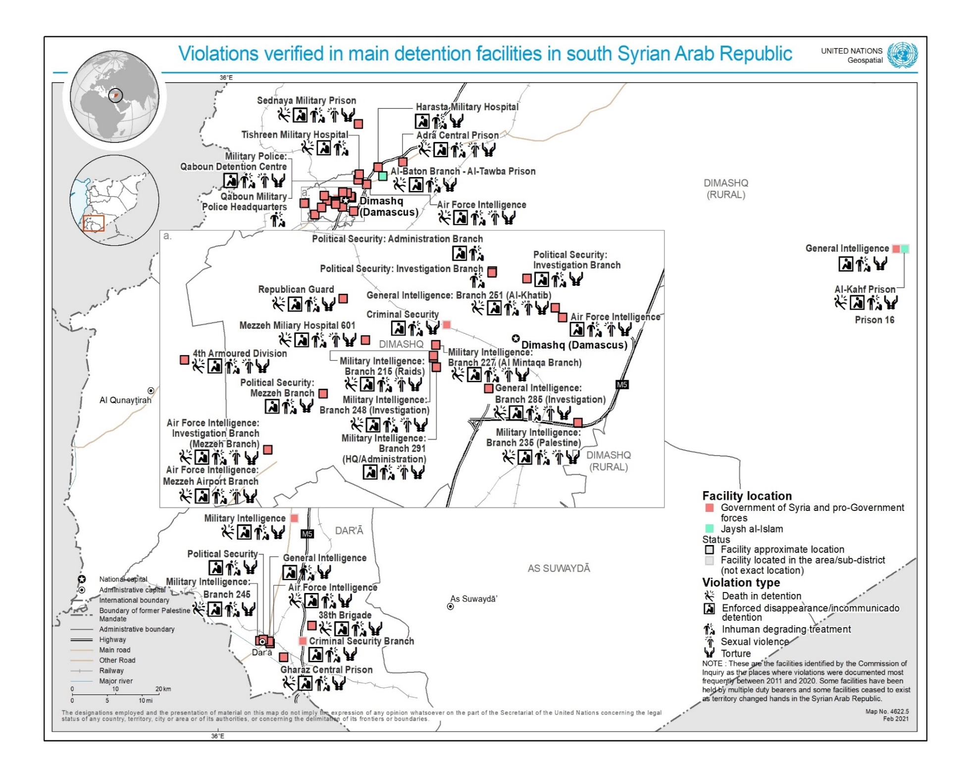
Annex III
Methodology of the data collection
1. Given that this present report covers nearly a decade of detention and related violations in the Syrian Arab Republic, the Commission issued a general call for submissions and sent out specific requests for information to entities having reportedly deprived people of their liberty in Syria since 2011, including United Nations Member States, in order to request data on the prevalence of arbitrary detention, and the related violations covered by this report, in the Syrian Arab Republic. Requests were also sent to other United Nations entities.
2. In view of the mandate to cover nearly a decade of detention in the Syrian Arab Republic, a quantitative analysis of the Commission’s own interviews related to detention was also undertaken, to provide a basic overview of trends over the entirety of the conflict.
3. To this end, the Commission analysed its own database of interviews and information that comprises over 7,874 separate interviews with victims, witnesses and other sources conducted since March 2011.
4. Following a review by Commission staff, the analysis revealed that 2,658 interviews were relevant to the issue of arbitrary detention and related violations committed by nearly all parties in the Syrian Arab Republic. In reviewing its own collection of interviews, staff members of the Commission took note of information related to the violations of enforced disappearance and incommunicado detention, torture, inhuman or degrading treatment and sexual violence through a basic methodology. This methodology was to note if the interviewee has either experienced a violation or had knowledge of an incident that took place, either through witnessing it directly or receiving credible reports of the incident. A third category was used when both apply, i.e. the person being interviewed had personally experienced the violation and, in addition, had either directly witnessed or received credible reports of similar violations suffered by others.
5. This methodology allowed the Commission to create a dataset of those who it has interviewed over nearly 10 years that had directly experienced a violation, as well as another category of those who had first or second hand knowledge of such violations. The methodology for death in detention was more nuanced due to the obstacles surrounding the reporting of this issue. In this regard, the data set was completed by analysing whether information regarding death in detention had been received via reports or through witnesses of the death, through the provision of a death certificate, if the interviewee say the saw body and, lastly, when the interviewee had received the body and a death certificate.
6. It should be noted that the interviews of the Commission were conducted over almost a decade without a view to undertaking such quantitative statistical analysis. Therefore, inferences taken from the data were limited in the following ways. Where an interview covered a specific violation, this has been recorded. However this methodology cannot take into account instances where a person was not asked about a specific violation during a given interview, notwithstanding that some interviewees may have had such additional information. In this regard, where the percentages reported do not add up to 100, the unmentioned quantity relates to an “unknown” category. Worth noting also is that testimonies focussing on severe violations, such as rape or torture, may have been less inclined to also cover comparatively less severe violations related to, for instance, detention conditions. In addition, the sample collected by the Commission was subject to the investigative priorities of the period during it was conducted. Lastly, in terms of caveats, most interviews identified multiple victims and it was not possible to record this information within the restrictions of the data review, therefore the data is limited by just examining one interview as one entry. The information therefore gives an indication of how often an issue was reported during interviewees, but does not attempt to give an indication of the full scale of violations documented by the Commission.
7. Compounding this, the brutal oppression of a vast number of communities living under the control of both the Government and armed groups has led to a palpable fear of reprisals against individuals for speaking out on arbitrary detention and related violations. In recent years, the reduced prospects for Syrians to leave the country, or areas controlled by armed actors, has in turn impaired the Commission’s and other organisations’ ability to interview victims and witnesses and document violations due to protection risks.
8. The statistics are presented to give a broad overview of trends over the entirety of the conflict and are not intended to be a comprehensive analysis of all detention related violations that have taken place in that time. In this regard, the legal and factual findings within this report are based on individual cases noted in the individual duty bearer chapters that have been assessed to meet the Commission’s standard of proof of reasonable grounds to believe.

* The present report was submitted after the deadline in order to reflect the most recent developments.
** The annexes to the present report are circulated as received, in the language of submission only.
A/HRC/S-17/2/Add.1, para. 62.
See A/HRC/21/50, annex II. With that determination, the Commission applied international humanitarian law, as well as customary international humanitarian law alongside international human rights law.
The Commission continues to regard Islamic State in Iraq and the Levant (ISIL), Hay’at Tahrir al-Sham, Hurras al-Din and other Al-Qaida-aligned groups as terrorist entities, as designated by the Security Council pursuant to its resolutions 1267 (1999), 1989 (2011), 2170 (2014) and 2253 (2015).
Formed as an alliance primarily comprising forces of the Kurdish People’s Protection Units and their allies among Arab, Assyrian and other opposition armed groups.
See A/HRC/46/54, paras. 3-21 and annex II.
Ibid., para. 19, footnote 27.
See www.ohchr.org/coisyria.
Many testimonies covered detention-related violations by multiple duty bearers. However, only one duty bearer responsible for the most significant violations for the interviewee was reflected in the overall data set.
A/HRC/24/46 para. 57. See also “Out of Sight, Out of Mind: Deaths in Detention in the Syrian Arab Republic” (available from www.ohchr.org/EN/HRBodies/HRC/IICISyria/Pages/Documentation.aspx), para. 88.
See “The siege and recapture of eastern Ghouta” (available from www.ohchr.org/EN/HRBodies/HRC/IICISyria/Pages/Documentation.aspx), sect. IX. B.
These include the military and civil police forces and four intelligence agencies: the Military Intelligence Directorate, the Air Force Intelligence Directorate, the General Intelligence Directorate and the Political Security Directorate.
Each node corresponds to either the victim’s origin (in blue) or the detention facility location (in red). Width of lines between victim origins and detention locations reflects number of victims moved.
A/HRC/24/46, paras. 49 and 89–93.
“Out of Sight, Out of Mind”, para. 65.
A/HRC/24/46, paras. 47–48.
“Human rights abuses and international humanitarian law violations in the Syrian Arab Republic, 21 July 2016–28 February 2017” (available from www.ohchr.org/EN/HRBodies/HRC/IICISyria/Pages/Documentation.aspx).
See A/HRC/39/65 and A/HRC/43/57.
A/HRC/46/54, paras. 12 and 18.
A/HRC/45/31, para. 46.
A/HRC/39/65, para. 25.
A/HRC/43/57, paras. 39–40; A/HRC/45/31, paras. 46 and 52–56.
A/HRC/43/57, paras. 39–41; A/HRC/45/31, paras. 46 and 52–58.
See A/HRC/45/31, para. 12.
A/HRC/45/31, para. 50.
A/HRC/43/57, para. 57.
A/HRC/45/31, paras. 59–62.
A/HRC/40/70, para. 10.
Some witnesses held by the Syrian Democratic Forces on suspicion of affiliation with ISIL described being interrogated also by officials of member States allied against ISIL, including of the United States.
A/HRC/46/54, para. 17.
A/HRC/45/31, para 77.
Ibid., para. 78.
Both Ain Issa and Mabrouka camps closed after Operation Peace Spring in October 2019. While some encamped women escaped, others were transferred to Abu Khasab and Mahmouldi camps in Raqqah Governorate, and yet others were reportedly apprehended by armed groups.
A/HRC/45/31, para. 74.
See A/HRC/37/72, annex III.
A/HRC/43/57, para. 61; A/HRC/45/31, para. 72.
A/HRC/42/51, paras. 83–85.
See https://reliefweb.int/report/syrian-arab-republic/repatriation-foreign-children-syria-slowed-covid-19-new-footage-emerges.
A/HRC/28/69, paras. 31–32; A/HRC/46/54, annex II.
Including the Ansar al-Din Front, Jaysh al-Sunna, Liwa al-Haqq and the Nour al-Din al-Zenki Movement.
A/HRC/37/72, para. 28; A/HRC/39/65, para. 52.
A/HRC/44/61, para. 5; A/HRC/39/65, para. 60.
A/HRC/27/60, para. 61; A/HRC/28/69, para. 22; A/HRC/30/48, para. 129. See also “‘I lost my dignity’: Sexual and gender-based violence in the Syrian Arab Republic” (available from www.ohchr.org/EN/HRBodies/HRC/IICISyria/Pages/Documentation.aspx), para. 57.
A/HRC/31/68, para. 105; “Human rights abuses and international humanitarian law violations in the Syrian Arab Republic, 21 July 2016–28 February 2017”, para. 70.
A/HRC/36/55, para. 41.
A/HRC/40/70, paras. 54–57.
See A/HRC/44/61.
“I lost my dignity”, para. 69.
Ibid., para. 67.
A/HRC/44/61, paras. 103-104. See also “I lost my dignity”, footnote 6.
A/HRC/44/61, para. 93.
A/HRC/28/69, para. 104; A/HRC/30/48, para. 97.
A/HRC/44/61, para. 94.
“Rule of Terror: Living under ISIS in Syria” (available from www.ohchr.org/EN/HRBodies/HRC/IICISyria/Pages/Documentation.aspx), paras. 5–18.
Ibid., para. 72.
“Out of Sight, Out of Mind”, para. 75.
See A/HRC/46/54, annex II.
See A/HRC/25/65, para. 46 and A/HRC/40/70, para. 43.
“‘They came to destroy’: ISIS Crimes Against the Yazidis” (available from www.ohchr.org/EN/HRBodies/HRC/IICISyria/Pages/Documentation.aspx), para. 125.
Ibid., para. 122.
“Rule of Terror”, para. 20.
Ibid., para. 38.
See A/HRC/43/49, para. 19.
A/HRC/45/31, para. 32.
Human Rights Committee, general comment No. 36 (2018), para. 58.
See “Out of Sight, Out of Mind”.
See “Rule of Terror” and “They came to destroy”.
See “They came to destroy”.
A/HRC/40/70, para. 57.
Common article 3 of the Geneva Conventions. See also International Committee of the Red Cross (ICRC) Study on Customary International Humanitarian Law, Rules 87, 89, 90, 93, 99, 100 and 156.
“Out of Sight, Out of Mind”, paras. 101–102.
Common article 3 of the Geneva Conventions. See also ICRC Rules 87, 90 and 156.
ICRC rules 89, 96, 100 and 156.
ICRC rules 93 and 156.
ICRC rules 93, 94 and 156.
ICRC Rule 98. Enforced disappearances are also characterized as composite war crime by ICRC; see Rule 156.
“Human rights abuses and international humanitarian law violations in the Syrian Arab Republic, 21 July 2016–28 February 2017”, para. 103.
A/HRC/45/31, paras. 67–69.
Fourth Geneva Convention, arts. 49, 146 and 147; ICRC Rule 129.
A/HRC/40/70, para. 10.
A/HRC/37/72, para. 59.
See ibid., annex II, sect. B.
A/HRC/40/70, para. 92.
A/HRC/45/31, para. 46 and A/HRC/46/54, paras. 73–77.
A/HRC/46/54, paras. 69 – 94.
www.government.nl/latest/news/2020/09/18/the-netherlands-holds-syria-responsible-for-gross-human-rights-violations.
Human Rights Committee, general comment No. 36 (2018), para. 58.
The boundaries and names shown and the designations used on this map do not imply official endorsement or acceptance by the United Nations.
This overview does not exhaustively list facilities in which the Commission has verified violations. It represents a small sample of the facilities at which recurrent violations by duty bearers were documented since 2011. The true number of detention facilities where violations have taken place is far higher than indicated here.
First-hand witness reports and credible second-hand witness reports were counted in the same data set, to facilitate methodological consistency during data entry, also for cases that could otherwise reasonably be interpreted to fall into either category (such as interviews with health workers seeing and documenting fresh injuries caused by torture first-hand, but without having been present in the cell where the victim was tortured).

