 |  | A/HRC/48/20
 | Advance Edited Version |  | Distr.: General  13 September 2021  Original: English
Human Rights Council
Forty-eighth session
13 September–1 October 2021
Agenda item 2
Annual report of the United Nations High Commissioner
for Human Rights and reports of the Office of the
High Commissioner and the Secretary-General

Situation of human rights in Yemen, including violations and abuses since September 2014

Report of the Group of Eminent International and Regional Experts on Yemen*, **
Summary
The Yemen conflict is moving into its seventh year against the backdrop of an intolerable lack of political will towards its peaceful resolution. With Yemen experiencing an unparalleled humanitarian crisis, the Group of Eminent International and Regional Experts regrets that the conflicting parties continue to engage in serious violations of international human rights law and international humanitarian law, and that third States continue to provide arms and military support to parties to the conflict, with little regard for the immense suffering caused to the people of Yemen.
In the present report, the Group of Eminent Experts, pursuant to Human Rights Council resolution 45/15, presents an overview of its findings concerning violations and abuses committed in Yemen from 1 July 2020 to 30 June 2021, as well as providing a select retrospective analysis. The Group also recommends avenues to ensure accountability and secure truth, justice and reparations for victims.

I. Introduction
1. In resolution 45/15, the Human Rights Council renewed the mandate of the Group of Eminent International and Regional Experts for a further period of one year. The Group was mandated to, inter alia, monitor and report on the situation of human rights in Yemen and to carry out comprehensive investigations into all alleged violations and abuses of international human rights law and all alleged violations of international humanitarian law committed by all parties to the conflict since September 2014, including possible gender dimensions of such violations. The Council also broadened the scope of the Group’s mandate, which also includes to collect, preserve and analyse information, and to explore and report on recommended approaches and practical mechanisms of accountability to secure truth, justice and redress for victims.
2. In October 2020, the United Nations High Commissioner for Human Rights reappointed Kamel Jendoubi (Tunisia) (Chair), Melissa Parke (Australia) and Ardi Imseis (Canada) as experts. They accepted the responsibility in the knowledge that this mandate in particular would face expected operational difficulties occasioned by the continued global pandemic and access restrictions. However, they also accepted this responsibility in the reasonable expectation that they would receive the requisite resources to discharge the expanded mission given to them by the Council. Regrettably, this was not the case. The Group is the only United Nations independent entity investigating and issuing detailed public reports on human rights violations in Yemen. It cannot succeed in its increasingly complex mission without the proper support from the international community.

II. Methodology and legal framework
3. Access restrictions to Yemen, restrictions related to the coronavirus disease (COVID-19) pandemic, and significant limitations in investigation time and human resources have had a considerable impact on the work of the Group of Eminent Experts and its secretariat, who were obliged to narrow the range of their work and substantially alter their working methods. The Group deeply regrets that its work was deleteriously affected during this mandate period by the United Nations recruitment freeze, which significantly delayed the formation of its secretariat and limited its effective period of activity, including in relation to the collection, preservation and analysis of information. In addition, key posts were cut (e.g., child rights specialist and reporting officer) and no gender specialist was recruited before the completion of the drafting of the report. As a result, the Group was constrained in its investigations and compelled to adopt a strong retrospective focus, particularly in the gender and child rights-related segments of the present report. Moreover, the secretariat’s move from Beirut to Addis Ababa delayed the Group’s operations. To their credit, the members of the secretariat discharged their functions with the highest professionalism and commitment despite the difficulties.
4. The Group of Eminent Experts’ findings in the present report should not be construed as suggesting that other violations and abuses did not occur, that some parts of the country not mentioned in the report were not similarly affected, or that parties have ceased committing particular violations. The Group continued to apply the “reasonable grounds to believe” standard of proof.
5. The Group of Eminent Experts conducted 152 interviews (mainly remotely) with victims, witnesses and other individuals, and it reviewed documents, open-source material and additional secondary sources. It also relied on a professional satellite-imagery analysis conducted by the United Nations Satellite Centre. The Group paid particular attention to integrating gender into its methodology. In November 2020, the Group issued an online call for written submissions.
6. Where possible, the Group of Eminent Experts identified the individuals and/or armed forces or armed groups responsible for violations and abuses and prepared a strictly confidential list of individual alleged perpetrators for submission to the High Commissioner for Human Rights.
7. The Group of Eminent Experts has continued to conduct its investigations within the framework of all relevant international legal norms, including international human rights law, international humanitarian law and international criminal law.
8. Following its previous practice, the Group of Eminent Experts addressed requests for submissions to the Government of Yemen, the de facto authorities and the southern transitional council, as well as to the Governments of Saudi Arabia and the United Arab Emirates, and reviewed the comments received from some parties on the Group’s previous report.
9. The Group of Eminent Experts regrets that for a third consecutive year, it was not able to access Yemen and other coalition countries despite its repeated and unanswered requests. While the de facto authorities indicated their willingness for the Group to visit areas under its control, the Government of Yemen did not respond to the Group’s requests for access to the country.
10. The Group of Eminent Experts holds the utmost concern about the protracted climate of fear and lawlessness in Yemen. Even when the Group adopted methodologies aimed at ensuring the safety and security of victims, witnesses and organizations, fear still deterred many from engaging with the Group, or giving consent to the use of information. As a former detainee stated: “I don’t want this to be public, I feel constantly at risk… There is no State presence.”
11. The Group of Eminent Experts once again expresses its deepest gratitude to those who shared their traumatic experiences with the Group, and for the assistance provided by governmental and non-governmental entities and by United Nations agencies and partners.

III. Over six years of unceasing suffering
12. The conflict that has been raging in Yemen for over six years did not reduce in intensity in the 2020–2021 period covered by the present report. Notwithstanding considerable international and regional efforts to reach a ceasefire and to embark upon a peace process, the conflict remains intractable owing to a continued lack of political will of the parties to the conflict and relevant external actors. The previously signed power-sharing deal between the Government of Yemen and the southern transitional council remains largely dysfunctional, and negotiations between the de facto authorities and the coalition have not achieved any tangible progress. Moreover, military confrontations have escalated over a myriad of fronts within Yemen and outside its borders.
13. In late October 2020, the Houthis started a mobilization phase to enhance their preparedness for battle over Ma’rib. In February 2021, the Houthis began their attack on Ma’rib Governorate. Within weeks, the Ta’izz and Hajjah fronts became active once more. Other fronts in Hudaydah, Dhale’, Jawf, and Bayda’ governorates also witnessed fighting. Heavy fighting has continued across frontline areas in Ma’rib Governorate, with hostilities particularly dominant in the Sirwah area, specifically in Mashjah, Kassarah, Zour and Tala’ah Hamraa. Currently, the frontlines are only a few kilometres away from the city of Ma’rib. The coalition provides critical close air support to the Yemeni armed forces. The Houthi offensive has led to large waves of displacement within the Ma’rib Governorate, especially after the sites hosting internally displaced persons were shelled. Since the beginning of the year, the Houthis have also carried out multiple cross-border aerial attacks on Saudi Arabia. While most of the targets have been of a military nature, civilian infrastructure has also been hit.
14. In December 2020, the southern transitional council agreed to join a newly formed government with the Government of Yemen. On 30 December 2020, an attack was launched on Aden airport, moments after the plane carrying members of the new government had landed. As a sign of the continued fractured relationship between the southern transitional council and the Government of Yemen, on 16 March 2021, supporters of the council stormed the Maasheq presidential palace in Aden.
15. The former Special Envoy of the Secretary-General for Yemen, Martin Griffiths, promoted a joint declaration with the Government of Yemen and the de facto authorities, encompassing a nationwide ceasefire, measures concerning humanitarian and economic relief, and resumption of the political process. The de facto authorities, however, have insisted on a stand-alone agreement concerning the seaports in Hudaydah and the Sana’a airport as a precondition for any further negotiations. In a positive development, in October 2020, the Special Envoy succeeded in implementing the exchange of 1,056 prisoners held by the Government of Yemen and the Houthis in a deal facilitated by the International Committee of the Red Cross as part of the Stockholm Agreement.
16. In February 2021, the new administration of the United States of America announced changes in the country’s policy towards Yemen, including ending the designation of the Houthis as a foreign terrorist organization and declaring an end to its support for what it called the coalition’s “offensive operations” in the conflict. It remains unclear what that terminology means in practical terms.
17. Protracted conflict, disease outbreaks, the COVID-19 pandemic, flooding, import restrictions, an economic and fuel crisis, and limited humanitarian aid have made everyday life in Yemen unbearable for many. According to the Office for the Coordination of Humanitarian Affairs, around 20.7 million people in Yemen currently require some form of humanitarian and protection assistance. More than 16.2 million of them will face significant food insecurity this year. Additionally, international funding has fallen far short of the required levels to address the humanitarian crisis.
18. A potential environmental catastrophe looms for Yemen and the whole of the Red Sea, should there be a spill of the Safer oil tanker, which is loaded with approximately 1.1 million barrels of oil. While the United Nations has sought to undertake assessment and salvage operations, the Houthis have not yet provided the necessary written security guarantees.
19. Notwithstanding the strong recommendations by the Group of Eminent Experts in its previous reports, third States, including Canada, France, Iran (Islamic Republic of), the United Kingdom of Great Britain and Northern Ireland and the United States, continued their support of parties to the conflict, including through arms transfers. Furthermore, some States, such as Italy, have loosened previous restrictions. As the Group has previously noted, arms sales are fuel that perpetuates the conflict.

IV. Findings of the Group of Eminent Experts

A. Conduct of hostilities and their impact on civilians: unremitting violence, death and fear

1. Airstrikes
20. Since March 2015, over 23,000 airstrikes have been launched by the coalition in Yemen, killing or injuring over 18,000 civilians. Living in a country subjected to an average of 10 airstrikes per day has left millions feeling far from safe. Although the frequency and intensity of airstrikes have fluctuated over the last four years, the Group of Eminent Experts has continued to observe their devastating impact on civilians. One paramedic, after visiting an airstrike site in Sana’a, stated: “One week later, I was in the area and, in the drainage of the hotel, we found more bodies. The dogs had started eating those bodies. One month later, I smelled around the area and when I went to the building, I found a leg in the drainage.”
21. Since 2018, the Group of Eminent Experts has investigated some 30 airstrikes that killed and injured civilians, including civilians shopping at markets, receiving care in hospitals, or attending weddings and funerals; children on buses; fishers in boats; migrants seeking a better life; individuals strolling through their neighbourhoods; and people who were at home.
22. The coalition has largely rejected the previous findings of the Group of Eminent Experts, characterizing them as being based on assumptions. The Group regrets that the coalition has justified not sharing targeting-related intelligence with the Group on the basis of “internationally common practice”, and the potential danger to sources, while sharing such information with its own investigation mechanism. The Group also regrets the failure of the Joint Incident Assessment Team to either provide detailed information in case summaries, or share supporting evidence. Notwithstanding these factors, the Group, on the basis of properly corroborated information and satellite imagery, has been able to draw conclusions about failures in specific airstrikes to respect the principles of distinction, proportionality and precautions in attack as required by international humanitarian law. There is little evidence to suggest that the coalition has taken these findings seriously.
23. During this mandate period, the Group of Eminent Experts investigated four coalition airstrikes or series of airstrikes that killed and injured civilians and damaged civilian infrastructure (see paras. 34 and 35 below). One example concerns an airstrike that occurred on 12 July 2020, around 1 p.m., in the village of Beit Qateeb, Washha District, Hajjah Governorate, that killed seven children (three boys and four girls) and two women in their house. A boy and a woman breastfeeding her baby were also injured. The house was in a remote area and was destroyed by the air raid. The Joint Incident Assessment Team concluded that a “technical error” had caused those deaths and injuries, with the intended target being a Houthi command and communications centre some 780 metres away. The Joint Incident Assessment Team recommended that assistance be provided for the “human losses and material damage”. The frequency with which the Team finds a “technical error” to be responsible for civilian losses without it leading to apparent changes in coalition procedures itself raises significant concerns as to the coalition’s commitment to meeting the requirements of international humanitarian law.
24. On 15 July 2020, at around 6.30 a.m., an airstrike hit a house in the Musa’fa village, Hazm District, Jawf Governorate, killing four men, two women, three girls and three boys, and injuring one woman, three girls and two boys, all belonging to the same family. It was followed by a second airstrike that hit a house approximately 200 to 300 metres away from the first one. The second airstrike caused property damage but no casualties, as the family living there had recently fled. The Group of Eminent Experts received information that the nearest frontline or Houthi military bases were located approximately five kilometres from the impact site. It was unable to complete its investigation at the time of finalizing the present report.
25. In each of its reports, the Group of Eminent Experts has repeatedly reminded the coalition of its obligations to take all feasible measures to protect civilians from the effects of hostilities, and to abide by the principles of distinction, proportionality and precautions in attack. The Group remains concerned that the coalition is failing to meet those obligations. Disproportionate attacks constitute war crimes under customary international law.

2. Shelling attacks
26. The launching of missiles, rockets and shells by parties to the conflict into densely populated civilian areas, markets, prisons, camps for internally displaced persons and homes have been found to constitute indiscriminate attacks, prohibited under international humanitarian law. Over the past four years, the Group of Eminent Experts has investigated more than 15 shelling attacks that have devastated civilian lives in this conflict. The majority of these attacks have been undertaken by the Houthis, with a small number attributed to the Government of Yemen and the coalition. In their response to the Group’s last report, the Houthis denied responsibility for these attacks, attributing them to the aggression coalition and their mercenaries. One shelling survivor in Dhale’ Governorate said: “Maybe a request for you, to help the innocent civilians, to ask the two sides to spare the civilians.” Another shelling survivor stated: “I fainted at the scene and later I went from hospital to hospital to find my son, and I found him. The doctor told me he had arrived dead. I am very distressed, but I usually keep quiet.”
27. During the reporting period, the Group investigated a further three shelling incidents (see para. 34 below). On 30 December 2020, between 1.24 and 1.26 p.m., three consecutive munitions, most likely medium-ballistic missiles, hit Aden airport, shortly after a plane carrying members of the newly formed government had landed. As the officials were exiting the plane, the first missile struck the western side of the airport hall, creating a crater in the wall of the VIP lounge. The second missile hit a square allotted for the parking of incoming planes. A third missile hit the journalists’ area, just east of the hall. The attacks reportedly killed at least 25 people and wounded 110 others, including journalists. Analysis of the impact craters and blast radii indicated that the munitions had been fired from the area north of the airport, an area reportedly controlled by the Houthis (see annex II). Further investigation of the case is warranted. As one journalist who survived the Aden airport shelling stated: “This is not a battlefield where, as a journalist, I would expect such missiles to fall ... I have been in situations while I was reporting live, such as in the west coast, and shelling would take place ... But in a civilian airport? This has certainly caused fear among journalists.”
28. Two days later, on 1 January 2021, at around 9.30 p.m., a wedding was taking place in the al-Mansoura Wedding Hall in Airport Street, Hawak District, Hudaydah Governorate, when the area in front of the hall, where several wedding guests were waiting, was attacked. Two boys and one man were killed, and three boys and three men were injured. A minibus used to transport wedding guests was also damaged. Satellite imagery and video footage of the area, analysed by the Group of Eminent Experts, indicated the presence of roadblocks within 30 to 40 metres of the site. The wedding hall appears to have been located close to the frontline between the opposing military forces in Hudaydah Governorate, that is, the Houthis and the Joint Forces. Due to its limited resources, the Group was not able to independently identify the party that had carried out the attack. Further investigation is required.
29. On 3 April 2021, at around 4.30 p.m., a rocket – most likely a Katyusha – struck the residential Rawdha neighbourhood, in the city of Ma’rib, in Ma’rib Governorate. Children were playing football in the sandy street of Haret Fateh when the rocket attack occurred. One boy was killed, and one man and three boys were injured. The rocket was allegedly launched from a western direction, in an area said to have been under the control of the Houthis. No military presence was reported at or near the site before or during the attack.
30. The Group of Eminent Experts reiterates its concern that parties to the conflict, in particular the Houthis, continue to launch indiscriminate attacks prohibited under international humanitarian law. These are attacks not directed at a specific military objective, and/or attacks involving a means of warfare not capable of being directed at a specific military objective. These acts constitute war crimes under customary international law. Such incidents also reflect a failure to take all feasible precautions to minimize civilian casualties.

B. Violations related to the humanitarian situation: the hunger for survival in the midst of war
31. As the conflict moves into its seventh year, the intensification of hostilities, the COVID-19 pandemic and the occurrence of natural disasters have left two-thirds of the population in Yemen in need of humanitarian assistance for their very survival. The violations of international law committed by parties to the conflict have played a major role in creating and/or exacerbating the crisis. The civilian population is sinking deeper into hunger and poverty.
32. Several cities in Yemen remain under siege or are impacted by blockades. Restrictions by parties on freedom of movement and the siege-like warfare used by the Houthis around the city of Ta’izz since August 2015 and in Hajjah since the end of 2018 have significantly impeded humanitarian access and aid delivery. Cumbersome and overly restrictive bureaucratic measures imposed by parties have delayed relief operations and programmes. The Group of Eminent Experts has verified cases of humanitarian personnel being targeted, harassed, detained and even killed.
33. The protracted closure of Sana’a international airport since August 2016 by the Government of Yemen and the coalition precludes civilians from accessing life-saving health care unavailable within the country. Its reopening, together with access to Hudaydah port, is currently being held hostage by the peace negotiations. Restrictions on imports imposed by the coalition continue to contribute to shortages of fuel and food, causing price increases. During this reporting period, the Group of Eminent Experts documented the obstruction of imports into Hudaydah by the coalition. From March to June 2021, for instance, 13 vessels carrying a total of more than 350,000 metric tons of fuel derivatives were denied entry despite possessing relevant clearances. Similarly, on 27 June 2021, a vessel carrying 8,867 metric tons of liquefied petroleum gas was denied entry. As at 30 June 2021, two other vessels carrying fuel derivatives had been held up for 191 and 212 days, respectively. In addition to impacting critical services, including the production of food, such actions diminish the potential revenues to be used under the Stockholm and Hudaydah Agreements for the payment of outstanding salaries to civil servants, compounding the loss of purchasing power of many Yemenis.
34. The Group of Eminent Experts has previously investigated attacks by parties to the conflict that, in a context of acute food insecurity, reflected a reckless disregard for the impact of their operations on the civilian population and its access to food. During this reporting period, the Group has continued to investigate military operations impacting on food production and farms in areas known to be affected by food insecurity. In the early hours of 21 March 2021, two consecutive coalition airstrikes hit the Salif Grains Port, in Hudaydah Governorate. As a result, five male employees were injured, and the workers’ accommodation and warehouse of the Yemen International Food Industries Co. Ltd. were partially damaged. On 14 June 2021, missiles, most likely from coalition airstrikes, hit two commercial poultry farms in Khamir District, Amran Governorate. One of the farms was destroyed. The Group is not aware of any military presence in the vicinity of either location. The Group also investigated the military use of the Thabet Brothers Group Complex, since 2018, by the Joint Forces. The complex comprises 16 companies, which include companies involved in the production of food and dairy products, and is located in Hudaydah Governorate. The use of the complex by the Joint Forces rendered it a military target, although any attack would still be subject to limitations imposed by international humanitarian law. The Group documented three incidents of shelling on the complex, on 3 December 2020, and on 6 and 19 June 2021, by the Houthis, causing civilian deaths and injuries, material damage to food production and water supplies, and the suspension of related activities. Due to limited resources, the Group was unable to conclude its investigations into those incidents.
35. Over the last four years, the Group of Eminent Experts has also investigated attacks by the parties on, or attacks affecting, hospitals and medical facilities, in violation of the special protection afforded to these facilities under international humanitarian law. In a country in which the provision of adequate health care is already scarce, civilians continue to pay a high price every time a hospital is destroyed, closed or used for military purposes. A joint non-governmental organization report identified 81 incidents in 2020 alone in which health facilities had been destroyed or damaged in Yemen, and indicated that in all the years of war, only half of the country’s health facilities remained functional. The Group previously documented that, in November 2018, the Houthis had set fire to three operating theatres in the 22 May hospital in Hudaydah and had destroyed all laboratory machines with gunfire. In June 2018 a coalition airstrike destroyed a newly constructed Médecins sans frontières cholera treatment centre in Abs, and in March 2019, an airstrike caused severe damage to the Kitaf rural hospital, Sa’dah Governorate. In February 2020, a Katyusha rocket exploded in the yard of the Jafrah hospital in Majzar District, Ma’rib Governorate, resulting in extensive damage to the building, interrupting medical services and necessitating the transfer of hundreds of patients to the Ma’rib hospital.
36. Based on its findings during the last four years, the Group of Eminent Experts restates its condemnation of acts by parties to the conflict that impede humanitarian operations and the population’s access to food, necessary supplies and health care. The Group reiterates that the dire humanitarian situation in Yemen could be substantially mitigated if parties to the conflict began to respect and comply with their obligations under international law.

C. Enforced disappearances, arbitrary detention, torture and other forms of ill-treatment: perpetual anguish
37. Away from the frontlines, families are condemned to ongoing mental anguish by being deprived of knowledge as to the fate and whereabouts of their loved ones as parties to the conflict deny families’ right to the truth. Over the last four years, the Group of Eminent Experts has investigated numerous cases in which detention was the precursor to torture, sexual violence and the denial of fair trial rights.
38. Over the past four years, the Group of Eminent Experts has further investigated disappearances, arbitrary detention and/or torture of journalists, human rights defenders (see paras. 55–61 below) and religious minorities (see paras. 52–54 below), practices designed by parties to the conflict to silence their perceived opposition or to punish them for their religious beliefs, and to legitimatize their power through the spread of fear. The son of a disappeared person stated: “I swear each day felt like a year.”
39. During the reporting period, the Group regrettably observed parties to the conflict continuing to perpetrate those intolerable practices.

1. Government of Yemen
40. The Group of Eminent Experts received credible allegations regarding the arbitrary arrest and detention of a group of six medical workers (two doctors, three nurses and one hospital guard) by armed men affiliated with Government of Yemen forces. In late 2020, for instance, the house of one of the medical workers was raided by a group of 15 armed men, wearing white uniforms with blue stripes, who took him to the Criminal Investigation Department of Shabwah Governorate. He was held there for eight days and was accused of “smuggling a group of injured men escaping justice” who had been patients in the hospital where he worked.
41. During the same period, in the Shabwah Governorate, four members and supporters of the southern transitional council were reportedly arbitrarily detained for nearly a week, owing to their political affiliation, by armed men allegedly connected to the Government of Yemen. The brother of one of the disappeared stated: “We can’t even know if he is still alive or dead.”
42. The Group of Eminent Experts received allegations relating to the enforced disappearance of a man in Aden in early May 2021, whose whereabouts remained unknown as at 30 June 2021. Friends were with him when he was taken away by a group of armed men in a white car. Sources told the Group that he had been detained by the “anti-terrorism forces controlled by the southern transitional council”. His family have searched for him in all southern detention centres but have received no official acknowledgement of his detention. The Group also received allegations that in early 2021, two men had been arbitrarily detained in Aden by armed men from the southern transitional council. The two men were accused of cooperating with foreign organizations to criticize the southern transitional council.

2. De facto authorities
43. During the reporting period, the Group of Eminent Experts investigated the case of a woman who was allegedly forcibly disappeared and arbitrarily detained by the Houthis in a western governorate for three months in 2018, under false accusations of “working with the aggression”. She was taken from her workplace by a group of five Houthi armed men and two Houthi armed women, held in solitary confinement for three days without food, water or access to a toilet, and then transferred to a cell with inmates accused of murder. During this period, she was subjected to daily interrogation. Torture was inflicted through repeated beatings and threats made with respect to her family, as she was forced to confess she worked for the “aggression”. Her family repeatedly sought information from the authorities, who denied any knowledge of her detention. Since her release, she has lived in constant fear that it could happen again.
44. The Group of Eminent Experts investigated the case of a woman who, in early 2020, received threats aimed at stopping her from speaking out against the Houthis. Days later she went missing from her home. Her family searched for her in vain for nine months, approaching authorities who denied holding her. In late 2020, her family received a call from a stranger informing them that she was in a hospital. They found her there, paralysed by a stroke, which had left her unable to speak.
45. The Group of Eminent Experts also investigated the case of a man in a northern governorate who was taken away by six masked armed men who were wearing khaki uniforms, and arbitrarily detained in a Houthi Security and Intelligence Service prison. He was denied the ability to communicate with his family, leaving them with no information as to his whereabouts for eight months. When his family finally learned where he was being held, the Security and Intelligence Service informed them that he had been sentenced to over two years’ imprisonment. However, information collected by the Group indicates that he had not been charged, tried or sentenced. The Group has received credible accounts indicating that Houthi Security and Intelligence Service personnel have given false information to the families of disappeared persons to dissuade them from making further inquiries.
46. The Group of Eminent Experts continues to have reasonable grounds to believe that parties to the conflict have engaged in enforced disappearance, arbitrary detention and torture, in violation of international human rights law and, depending on the level of nexus with the conflict, international humanitarian law. Such acts may amount to war crimes, including cruel treatment and torture, and committing outrages upon personal dignity.

D. Situation of internally displaced persons, migrants and minorities: intersecting and compounded vulnerabilities
47. The actions of the parties to the conflict continue to exacerbate the vulnerability of those already marginalized in Yemen. Hostilities, violence and patterns of attack often force civilians to leave their homes (see paras. 20–30 above). Many displaced persons, most of whom are women and children, have had to flee repeatedly, enduring the risks that each new displacement entails. As a shelling survivor, who was forced to flee, stated: “These are real crimes. We’ve been displaced.” Notwithstanding the war, migrants continue arriving in Yemen as a transit point in search of a better future – in 2020, more than 37,000 migrants arrived – only to be caught in deadly crossfire or subjected to arbitrary detention and torture, including sexual violence. Minorities continue to live under threat of persecution.

1. Internally displaced persons
48. Throughout March 2021, internally displaced persons camps in the northern outskirts of the city of Ma’rib were shelled. The camps of Meel, Tawasol, and Khair were located around 1 to 3 kilometres away from clashes between the Government of Yemen forces and the Houthis. The Houthis, who were positioned in the Haylan mountains to the west of the three camps, were allegedly firing rockets, mortars and heavy machine guns in an eastern direction towards the Yemeni armed forces.
49. Based on information collected by the Group of Eminent Experts, in March 2021, nine internally displaced persons (six women and three children) were injured, and tents and water tanks in the camps sustained significant damage. The shelling of the camps intensified in the second half of March. By the end of March, camp residents were forced to flee once again. This resulted in the reported displacement of around 460 families. One internally displaced man stated: “I was first displaced to al-Khaneq, then to Medghal, then to al-Meel, and then to al-Suwayda. Only God knows how bad the situation in which we’re living is … We went by foot … I carried two children on my back, and my wife carried one … when I remember, I cannot help but tear up. It was just so sad.”
50. The Group of Eminent Experts reviewed statements by senior Houthi officials who claimed that Yemeni armed forces were using camps in the northern and western parts of the Ma’rib Governorate for military purposes. Owing to a lack of resources, however, the Group was unable to complete its investigations into those incidents.

2. Migrants
51. Since 1 February 2021, the de facto authorities have reportedly detained hundreds of migrants, mostly Ethiopian and Somali nationals, holding them for months in overcrowded wards within the Immigration, Passports and Naturalization Authority’s so-called “holding facility” in Sana’a. On 7 March 2021, migrants at the facility were on a hunger strike, protesting their arbitrary detention and the conditions of their detention. A skirmish broke out between the protestors and several Houthi security guards. Migrants were pushed into a hangar-like building and locked up. Houthi anti-riot police arrived at the facility and launched several projectiles, one of which was said to have started a fire in the hangar-like building that was holding over 350 migrants. As a result, at least 46 adult migrant men were killed, and more than 202 others injured. That same day, the Houthi Ministry of Interior sought to deflect responsibility by issuing a statement claiming that the International Organization for Migration and the United Nations bore the responsibility, owing to their failure to provide shelter for “illegal migrants”. On 20 March, the Ministry of Interior stated that, according to their preliminary investigations, the anti-riot police had used three tear gas grenades to control the riot, and one of those grenades had fallen on mattresses, thereby causing the fire. He added that, as a result, they had arrested 11 Houthi soldiers in connection with the incident and that investigations were ongoing. A male migrant survivor stated: “When people rushed to the door, those who were strong enough were able to make it. Those who were sick and weak were stepped over. It was a fight for survival. No one remembered anything other than saving his own life. I thought that was the last day of my life, but thank God, I managed, but sadly many others couldn’t. I didn’t know that the life of human beings would be so cheap and worthless.”

3. Minorities
52. In July 2020, the Houthi Supreme Political Council “pardoned” Hamed bin Haydara and other five Baha’i men, who had been imprisoned for years without due process, and expelled them from Yemen. The six men were denied the opportunity to communicate with their families prior to being exiled. In August 2020, a local court started a trial in absentia against 24 Baha’is, including five of the six men expelled. In April 2021, the court proceedings were adjourned. During the reporting period, the Houthis have confiscated and frozen the assets of more than 70 members of the Baha’i community.
53. The Group of Eminent Experts reviewed statements by the Houthi leader, AbdulMalik al-Houthi, inciting violence and discrimination against religious minorities, including the Baha’i and Jewish communities. For instance, on 10 March 2021, he stated: “They don’t want to coexist … they want to take away the sovereignty of Islam.” The Group confirmed that in 2018, Houthi authorities introduced into the mandatory curriculum at Sana’a University a publication that is discriminatory against the Baha’i community. Similarly, a Yemeni Jewish man has been detained since March 2016, despite a number of judicial rulings requiring his release.
54. The Group of Eminent Experts concludes that internally displaced persons, migrants and minorities continue to face a heightened level of violations of their rights.

E. Silencing of journalists and human rights defenders
55. Journalists and human rights defenders have told the Group of Eminent Experts of the dangers they face in undertaking their work in Yemen. Many of them stopped working after surviving arbitrary detention and torture. Others stopped owing to threats to their liberty and physical security or to that of their families, and to fear of reprisals. Some have left the country entirely. A Yemeni human rights defender affirmed: “I was forced to close my organization’s office as a result of a series of direct attacks against my staff.” A Yemeni journalist, who is also a former detainee and torture survivor, stated: “I have been asked by interrogators about spying for an international organization as a journalist … They told me: ‘we know everyone in your family, and if you mess with us, you know what we can do’.”
56. Over the past four years, the Group of Eminent Experts has documented cases of expression and activism being “punished” by the parties to the conflict, who have subjected journalists and human rights defenders – perceived as dissidents or opponents – to enforced disappearances, arbitrary detention, torture and even death.
57. The Group of Eminent Experts investigated the killing in Aden in June 2020 of a male photojournalist who had previously covered the war in the southern governorates. The Group regrets that during this reporting period, the investigation into his death did not progress substantially. Several months after the killing, a television journalist was killed, and nine other journalists were injured during the shelling attack on the Aden airport (see paras. 26–30 above).
58. The Group of Eminent Experts also continued to investigate the case of the 10 journalists detained by the de facto authorities in 2015 on charges of “spying”. In April 2020, four of them were sentenced to death by the Specialized Criminal Court in Sana’a, and one was released. As at 30 June 2021, the four sentenced individuals remained on death row awaiting appeals. On 28 February and 29 March 2021, the Specialized Criminal Appeals Court in Sana’a reportedly held hearings without the presence of the journalists. The Group reiterates its concerns about this case and, more generally, about the use of the death penalty in Yemen in contravention of international law. The Group welcomes the release, on 15 October 2020, of the remaining five journalists as part of a prisoner-exchange agreement, and calls for the release of all journalists who remain arbitrarily detained.
59. Further to its previous investigations into cases of arbitrary detention and sexual violence against women activists by the Houthis, during the reporting period the Group of Eminent Experts verified a case of enforced disappearance, arbitrary detention and torture, including sexual violence, against a female human rights defender. She was held in prolonged solitary confinement for four months in an underground cell with no light, and was only removed from the cell every two days to be raped. Two Zainabiyat officers would take her to another room, take off her clothes and call a man, saying: “she is ready”. As she stated: “I lost everyone. All my friends refused me when I was released, as the Houthis spread rumours that I was accused of prostitution. I am having problems with my family too … I need justice.”
60. During the reporting period, the Group of Eminent Experts received allegations concerning attempts by the southern transitional council to control and censor journalists and the media in Aden. The Group verified a case of enforced disappearance, arbitrary detention and ill-treatment of a journalist who now resides in exile. In 2020, he was held arbitrarily for several months by the council. After his family learned of his whereabouts, his lawyer was told by the authorities that there were orders not to release him. Owing to a lack of prosecutorial evidence, he was recently released.
61. The Group of Eminent Experts continues to have reasonable grounds to believe that parties to the conflict have continued to violate the rights of journalists and human rights defenders, including women human rights defenders. They have suffered violations, including to the right to life; the right to liberty and security; the right to freedom of expression; the right not to be subjected to torture, including sexual violence; the right to work; and the right to fair trial guarantees.

F. Irreparable harm to children
62. The Group of Eminent Experts remains deeply concerned about the irreparable harm parties continue to inflict on children and the realization of their rights. During this mandate period, the Group continued to investigate cases of children killed and injured by indiscriminate shelling and airstrikes. In addition, children presently account for 54 per cent of the 20.7 million people in need of humanitarian assistance or protection in Yemen, including basic health care.
63. Since its creation, the Group of Eminent Experts has extensively investigated the recruitment and use in hostilities of children under the age of 18, and sometimes under the age of 15, by all parties to the conflict. The Group has noted the wide-scale and pervasive nature of recruitment of boys and girls by the Houthis. The Group has also investigated cases of children being recruited in Yemen, trained in Saudi Arabia and used in hostilities in Yemen by the coalition and the Government of Yemen. The Group has further investigated the detention of children for their alleged association with parties to the conflict. Due to limited resources available during this reporting period, the Group had reduced capacity to undertake further investigations, but it documented the recruitment and use of two 16-year-old boys at the Ma’rib fronts by the Houthis. One of the boys allegedly died in combat. In 2020, the report of the Secretary-General on children in armed conflict reported 163 verified cases of children being recruited and used by parties to the conflict.
64. Economic hardship wrought by the conflict has exacerbated some pre-existing traditional harmful practices against children in Yemen, such as forced and early marriage. Additionally, during the course of its investigations, the Group of Eminent Experts has noted accounts of children having to leave school and assume a breadwinner’s role after their parents or guardians were killed, disappeared or displaced. The Group has previously noted that 21 per cent of households in Yemen are led by girls under the age of 18.
65. Today, over two million children in Yemen are not attending school for various reasons, one of them being the conflict itself. Parties to the conflict use schools for military purposes, rendering them military objects subject to attack. During this reporting period, the Group of Eminent Experts documented attacks against two schools that, since around 2018, have been used for military purposes in the Hudaydah and Ta’izz Governorates, preventing students from accessing education in those locations and jeopardizing access by future generations.
66. In the light of its findings over the last four years, the Group of Eminent Experts reiterates its concerns about the blatant disregard by parties to the conflict of the rights to which children are entitled under international human rights law and international humanitarian law.

G. Widespread gender-based violence
67. Yemen ranks second to last in the world in terms of gender equality. Parties to the conflict have committed acts of gender-based violence, including sexual violence; have persecuted persons seen as transgressing gender norms; and have compounded existing inequalities.
68. The Group of Eminent Experts previously investigated widespread cases of rape and other forms of sexual violence against migrant women, girls and boys committed by the Security Belt Forces backed by the United Arab Emirates in Aden. It documented the increase of violations of the rights of persons with non-conforming sexual orientation and/or gender identity by the Houthis and the Security Belt Forces. The Group also investigated cases of women and girls arbitrarily detained and sexually abused by the Houthis in secret detention facilities in and around Sana’a between December 2017 and December 2019. In those cases, the detained individuals were often accused of prostitution and immorality, supporting the coalition, spying and affiliation with enemies.
69. The Group of Eminent Experts continued to investigate the arbitrary detention and denial of fair trial rights to Asmaa Omeissy by the de facto authorities. Her initial sentence of flogging, following her conviction on “morality” charges, was commuted to 15 years’ imprisonment. Since her detention, she has spent most of her time in solitary confinement. A request for her to undertake medical treatment outside prison – owing to her deteriorating health condition – was allegedly denied. As at 30 June 2021, her request for appeal before the Supreme Court remained pending.
70. Another example of the de facto authorities’ abuse of the justice system to reinforce traditional gender norms is the arbitrary detention of 20-year-old Yemeni actress and model, Intisar al-Hammadi, and a female colleague. On 20 February 2021, in the Shamlan area, in western Sana’a, a group of around 10 armed men in civilian clothes searched the two women and took them to a criminal investigation unit in Sana’a without informing them of any charges. They remained in incommunicado detention for 10 days, without receiving any food. During that time, they were subjected to ill-treatment and continued interrogation while blindfolded, and coerced to sign confessions for cannabis possession and prostitution. The Group of Eminent Experts was informed that in late February 2021, the specialized criminal prosecution service refused to receive the case for lack of evidence and referred it to the public prosecution in western Sana’a. The latter allegedly issued an order to extend their detention for 45 days and to transfer them to the Central Prison in Sana’a. As at 30 June 2021, Ms. al-Hammadi’s lawyer had not been able to access her case file and had unsuccessfully requested her unconditional release, while himself being subjected to threats.
71. In late 2020, a woman was taken by a large group of Zainabyat to the Security and Intelligence Prison in Sana’a where she was held in solitary confinement for several months while hearing the screams of babies and children who were reportedly in detention with their mothers. She was shocked daily with electric batons and deprived of sleep, being left to stand on one leg for periods of more than eight hours under the monitoring of Zainabyat officers. Each time she fell she was beaten. When she was not being beaten, she was taken to a room where she was regularly raped by groups of men. She stated: “Every time they raped me, I kept silent to survive … hoping to be released.” Her experience reflects almost identical patterns of violations to those previously documented by the Group.
72. The already limited capacity to address sexual and gender-based violence in the Yemeni criminal justice system collapsed with the outbreak of the conflict. The Group of Eminent Experts has received reports that law enforcement agencies within the Government of Yemen and the de facto authorities have refused to investigate and prosecute cases of gender-based violence. Therefore, survivors continue to be revictimized and denied any measure of solace and redress.
73. The Group of Eminent Experts reiterates its strong condemnation of the commission by parties to the conflict of gender-based violence, including sexual violence, in contravention of international human rights law and international humanitarian law. Such acts may amount to war crimes, including rape and other forms of sexual violence, cruel treatment and torture, and the commission of outrages upon personal dignity. The Group also abhors the abuse of the justice system to reinforce traditional gender roles.

V. Accountability
74. Urgent remedial action is required if victims are to regain any hope that their rights to truth, justice and reparation will be realized. As a shelling survivor stated previously to the Group of Eminent Experts: “We are in a time of war, there is no investigation and civilians are targeted by all parties.” The small developments in the field of accountability have by no means been adequate or sufficient to quell the “pandemic of impunity” that the Group has previously described in relation to the serious violations of international human rights law and international humanitarian law being committed in Yemen, some of which may amount to international crimes.
75. During this reporting period, the Group of Eminent Experts understands that the National Commission of Inquiry of the Government of Yemen has continued to monitor and to document a large number of violations, notwithstanding the challenges posed by the COVID-19 pandemic and the security environment. However, there has been no increase in the total number of criminal prosecutions instituted. The 19 cases reported to be before the courts in 2020 remain pending. At the forty-fifth session of the Human Rights Council, held in September 2020, the Government of Yemen announced its intention to establish a specialized court to prosecute human rights violations. As at 30 June 2021, no formal action had been taken to establish such a court. While welcoming the expressed commitment of the Government of Yemen to ensure accountability, the Group notes that such an initiative alone will not relieve the need to address deep-seated weaknesses in the justice system, including compromised levels of judicial independence and politicization, inadequate victim and witness security, frequent violations of fair trial rights and gender bias.
76. In relation to the coalition, the Group of Eminent Experts notes that the Joint Incident Assessment Team has completed a further 18 investigations during this reporting period (bringing the total to more than 200 investigations), primarily relating to airstrikes. A further two cases have been referred to military prosecutors for breaches of the rules of engagement. Of the eight cases previously referred, it is understood that a first instance trial has been completed in only one case, with two other cases described as nearing completion in late 2020. No public information is yet available in relation to the proceedings. However, the Group continues to have concerns that coalition members are not acting with appropriate speed, diligence and transparency in pursuing investigations and prosecutions and that the prosecutions may not reflect the seriousness of the international humanitarian law violations and potential international crimes involved.
77. The de facto authorities have not been willing to admit to potential violations and take remedial action. They have repeatedly characterized allegations against their personnel as being based on unreliable or hostile sources. In July 2021, the de facto authorities informed the Group of Eminent Experts of their intention to establish an independent national investigation committee. They reported that the allegations in the Group’s reports had been referred to relevant authorities, despite their critique of the sources and methods employed by the Group. Little specific action has, however, been apparent. The continuing failure by the de facto authorities to undertake appropriate investigations, notwithstanding several years of consistent reporting by the Group of Experts, indicates either an alarming neglect or wilful blindness as to the seriousness of violations being committed by their personnel.
78. Accountability extends beyond the criminal justice field to incorporate all aspects of victims’ rights to truth, justice and reparation. While many aspects of a comprehensive response may need to await a post-conflict period, it is urgent that authorities, on the basis of consultations with victims, take steps to alleviate the harm that is currently being experienced. There is a pressing need to provide, for instance, immediate medical aid; psychosocial support; assistance with employment, housing and food; and other material support. As one interlocutor said to the Group of Eminent Experts in describing the victims of an airstrike: “This was a very poor family, which barely had any food to eat. They did not receive any help from anyone after the incident, apart from some food products from [a humanitarian organization], which lasted them only a month.”
79. Available information on the fate and whereabouts of disappeared relatives can and must be shared pursuant to victims’ right to truth. Acknowledgment can be given of the violations that have occurred. Changes to procedures can be instituted to minimize the likelihood of the repetition of violations.
80. At present, the coalition has a programme to provide some relief. Financial assistance is provided to those affected by airstrikes through the Joint Committee mechanism. By late 2020, the coalition reported having made payments to those affected by six airstrikes. This, however, is only a fraction of the 18 cases referred for “accountability action” or in which “technical error” had been conceded by that time. The precise mechanisms for the choice of airstrikes or identification of beneficiaries remains opaque.
81. Neither the Government of Yemen nor the de facto authorities appear to have any current redress schemes.
82. In the light of the ongoing significant accountability gap in Yemen, the Group of Eminent Experts reiterates its call for greater and immediate international action. The Group once again urges the Security Council to refer the situation in Yemen to the International Criminal Court as a priority. While welcoming the Council’s designation of the former Director of the Criminal Investigations Department in Sana’a (now deceased) as subject to the sanctions regime under its resolution 2140 (2014) on human rights grounds, it encourages further designations across the spectrum. The creation of an international criminal investigative body similar to that established for Myanmar and the Syrian Arab Republic could practically support future prosecutions, whether at the national, regional or international level. Third States are encouraged to use all potential forms of jurisdiction, including universal jurisdiction. Equally, the Group reiterates its grave concerns about third States transferring arms to parties in the conflict, given the context of documented patterns of violations.
83. For peace to be sustainable in Yemen, it is imperative that it be based on respect for human rights, including the core principle of accountability. Even at this stage, measures can be undertaken to increase “peace preparedness”. Four areas in particular merit attention. First, there is a need to enhance the inclusiveness of the peace process. Further modalities should be adopted to ensure that the voices of underrepresented groups – including women, young people and minorities – and civil society are heard and can influence any potential peace agreement. Second, encouraging an explicit principled commitment to accountability at an early stage of discussions would significantly assist the way in which issues of accountability and transitional justice are later conceptualized and operationalized. Third, it is vital to create and preserve space for discussions on a comprehensive transitional justice response, prioritizing the involvement of victims. Fourth, targeted initiatives could strengthen the capacity of Yemeni civil society in areas such as documenting violations, integrating gender, considering comparative models of transitional justice mechanisms, and navigating and influencing peace processes.

VI. Conclusions and recommendations

A. Conclusions
84. The findings of violations presented by the Group of Eminent Experts in the present report, and over the last four years, represent only a sample of those causing extreme suffering for civilians every day in Yemen.
85. The Group of Eminent Experts continues to have reasonable grounds to believe that the Governments of Yemen, Saudi Arabia and the United Arab Emirates, as well as the southern transitional council, to the extent they exercise jurisdiction, and as applicable to each party, are responsible for human rights violations, including arbitrary deprivation of life, enforced disappearance, arbitrary detention, gender-based violence, including sexual violence, torture and other forms of cruel, inhuman or degrading treatment, the recruitment and use in hostilities of children, the denial of fair trial rights, and violations of fundamental freedoms and economic, social and cultural rights.
86. The Group of Eminent Experts continues to have reasonable grounds to believe that the de facto authorities are responsible for human rights violations in the areas over which they exercise effective control, including arbitrary deprivation of life, enforced disappearance, arbitrary detention, gender-based violence, including sexual violence, torture, and other forms of cruel, inhuman or degrading treatment, the recruitment and use in hostilities of children, the denial of fair trial rights, and violations of fundamental freedoms and economic, social and cultural rights.
87. The Group of Eminent Experts continues to have reasonable grounds to believe that the parties to the armed conflict in Yemen have committed a substantial number of violations of international humanitarian law. Subject to a determination by an independent and competent court, the Group finds that:
(a) Individuals in the coalition, in particular from Saudi Arabia, may have conducted airstrikes in violation of the principles of distinction, proportionality and precaution, acts that may amount to war crimes;
(b) Individuals in the Government of Yemen and the coalition (in particular from Saudi Arabia and the United Arab Emirates) and the southern transitional council have committed, as applicable to each party, acts that may amount to war crimes, including murder of civilians, torture, cruel or inhuman treatment, rape and other forms of sexual violence, outrages upon personal dignity, denial of fair trial, and enlisting children under the age of 15 or using them to participate actively in hostilities;
(c) Individuals in the Government of Yemen and the coalition have conducted indiscriminate attacks using indirect-fire weapons, acts that may amount to war crimes;
(d) Individuals in the de facto authorities have conducted indiscriminate attacks using indirect-fire weapons and have used anti-personnel landmines, acts that may amount to war crimes;
(e) Individuals in the de facto authorities have committed acts that may amount to war crimes, including murder of civilians, torture, cruel or inhuman treatment, rape and other forms of sexual violence, outrages upon personal dignity, denial of fair trial, impeding humanitarian relief supplies, and enlisting children under the age of 15 or using them to participate actively in hostilities.

B. Recommendations
88. Over the past three mandates, the Group of Eminent Experts has made recommendations addressed to the parties to the conflict, States and regional and international organizations. The Group regrets that, to a large extent, these recommendations have not been acted upon. As a result, all of the recommendations remain relevant and must be implemented if there is to be any reasonable prospect of ending the deep suffering of the civilian population. All that is required to implement the recommendations is political will.
89. The Group of Eminent Experts recommends that the parties to the conflict:
(a) Agree to a full cessation of hostilities and achieve a sustainable and inclusive peace, through a comprehensive and inclusive peace process with the full involvement of women, young people and minority groups;
(b) Immediately cease all acts of violence committed against civilians in violation of applicable international human rights and international humanitarian law and take all feasible precautions to protect civilians and civilian infrastructure;
(c) Immediately end any measures that worsen the humanitarian crisis, in particular remove all restrictions on the safe and expeditious entry into Yemen and distribution to civilians of humanitarian supplies and other goods indispensable to the civilian population, cease attacks affecting hospitals and objects indispensable to the survival of the civilian population, and take appropriate steps to ensure the realization of the right to an adequate standard of living of the population;
(d) Immediately review, through a competent judicial authority, the legality of detention of all inmates in both official and non-official detention facilities, release those who are arbitrarily detained and ensure respect of all rights of detainees, including the right not to be subjected to torture, including sexual violence and ill-treatment, and the right to a fair trial;
(e) Respect and protect the rights to freedom of expression and religion or belief, as well as other fundamental rights and freedoms, and cease arbitrary arrests and acts of harassment aimed at preventing the free exercise of these rights, including those directed at journalists, human rights defenders and minorities.
90. Respecting human rights requires parties to the conflict to do considerably more to ensure accountability for violations and effective remedies for victims. To that end, the Group of Eminent Experts recommends that the parties to the conflict:
(a) Conduct prompt, transparent, independent, impartial, thorough, credible, effective and gender-sensitive investigations of all violations and crimes committed during the conflict, and ensure accountability of the perpetrators and justice for the victims and take measures to ensure the protection of victims and witnesses in such processes;
(b) Cooperate fully with and effectively support the National Commission of Inquiry to investigate allegations of violations and abuses committed by all parties to the conflict in Yemen;
(c) Strengthen the capacity of local organizations and international non-governmental organizations for monitoring human rights and humanitarian law violations, including gender-based violence and violations of children’s rights;
(d) Cooperate fully with the Group of Eminent Experts.
91. The Group of Eminent Experts recommends that other States and regional and international organizations:
(a) Promote and support all efforts, notably by the Special Envoy of the Secretary-General for Yemen, to reach a cessation of hostilities and achieve a sustainable and inclusive peace;
(b) Take all reasonable measures to ensure respect for international humanitarian law and international human rights law by all parties to the conflict, in particular, by ceasing to provide arms and military support to the parties;
(c) Provide support to parties in strengthening accountability mechanisms, and take specific initiatives at the international level or in third States, as appropriate, in pursuant of accountability;
(d) Provide appropriate funding of humanitarian aid to support the fulfilment of human rights in Yemen;
(e) Keep the situation of human rights in Yemen on the agenda of the Human Rights Council and provide necessary support to the Office of the United Nations High Commissioner for Human Rights to ensure that the renewal of the mandate of the Group of Eminent Experts is accompanied with the necessary human and financial resources for the effective delivery of its mandate, including by extending its temporal mandate beyond one year.
92. Finally, the Group of Eminent Experts reiterates that the Security Council should integrate the human rights dimensions of the conflict in Yemen more fully into its agenda and ensure there is no impunity for the most serious crimes by, inter alia, referring the situation in Yemen to the International Criminal Court, and expanding the list of persons subject to Security Council sanctions under its resolution 2140 (2014).

Annex I

Airstrikes and shelling attacks documented by the Group since its establishment – nowhere safe
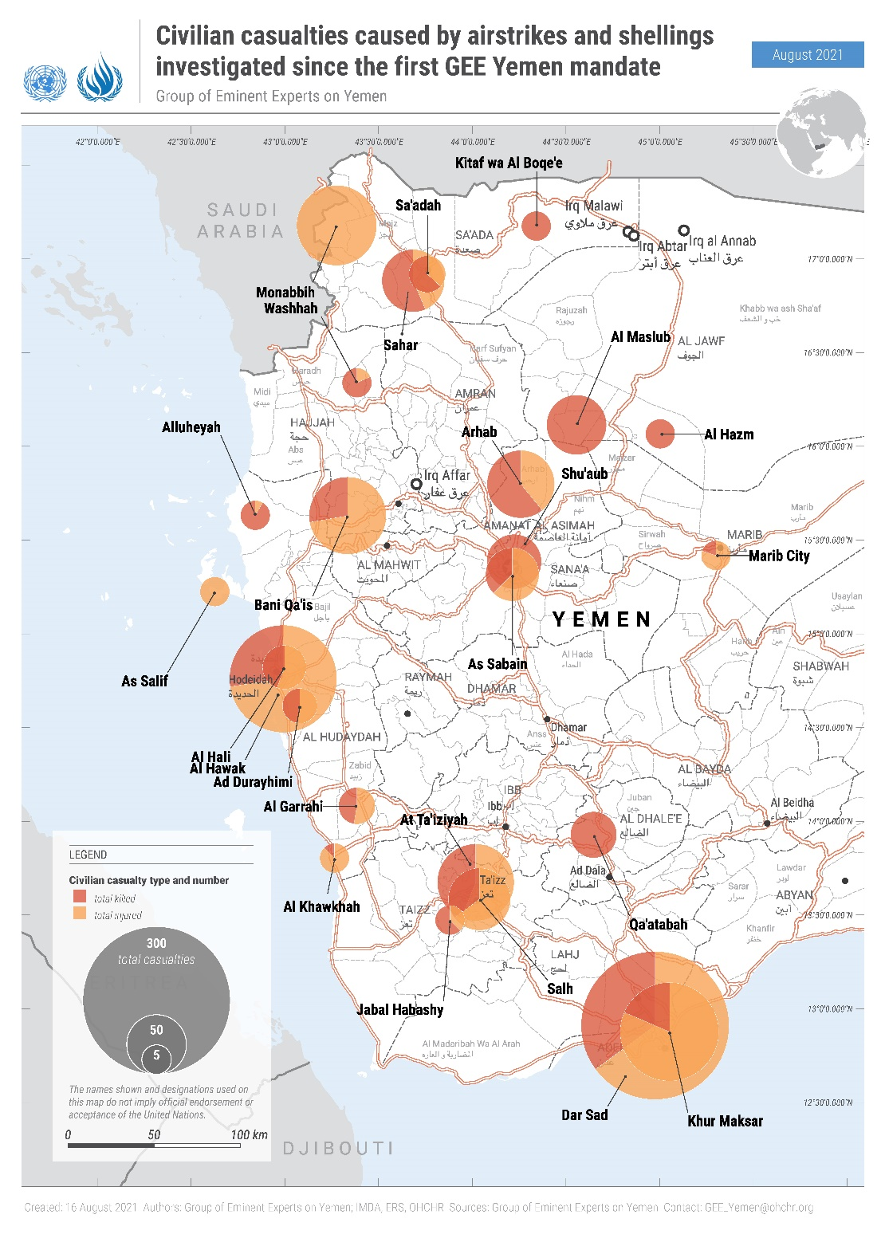

Annex II

Satellite imagery analysis

A. Shelling in Aden International Airport, 30 December 2020
(para. 27)
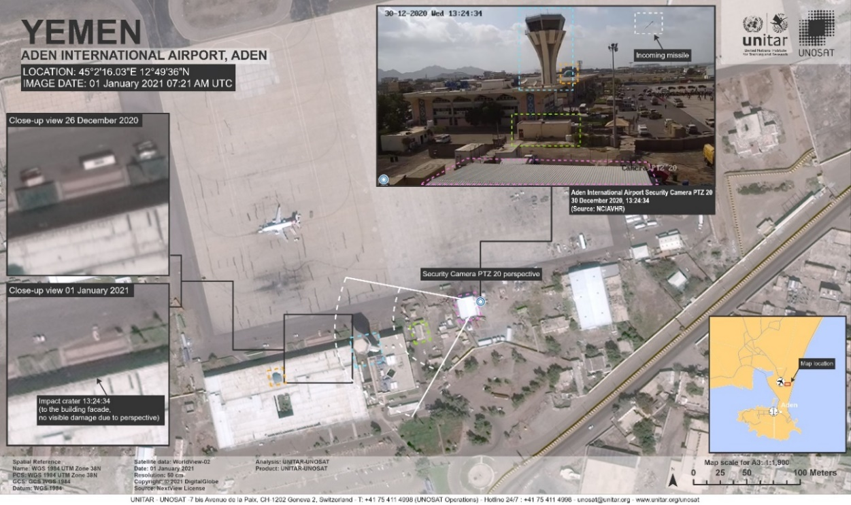
1 January 2021 DigitalGlobe WorldView-2 image © 2021 DigitalGlobe Inc. / US Department of State, Humanitarian Information Unit, NextView License / Analysis conducted by the United Nations Satellite Center (UNOSAT).
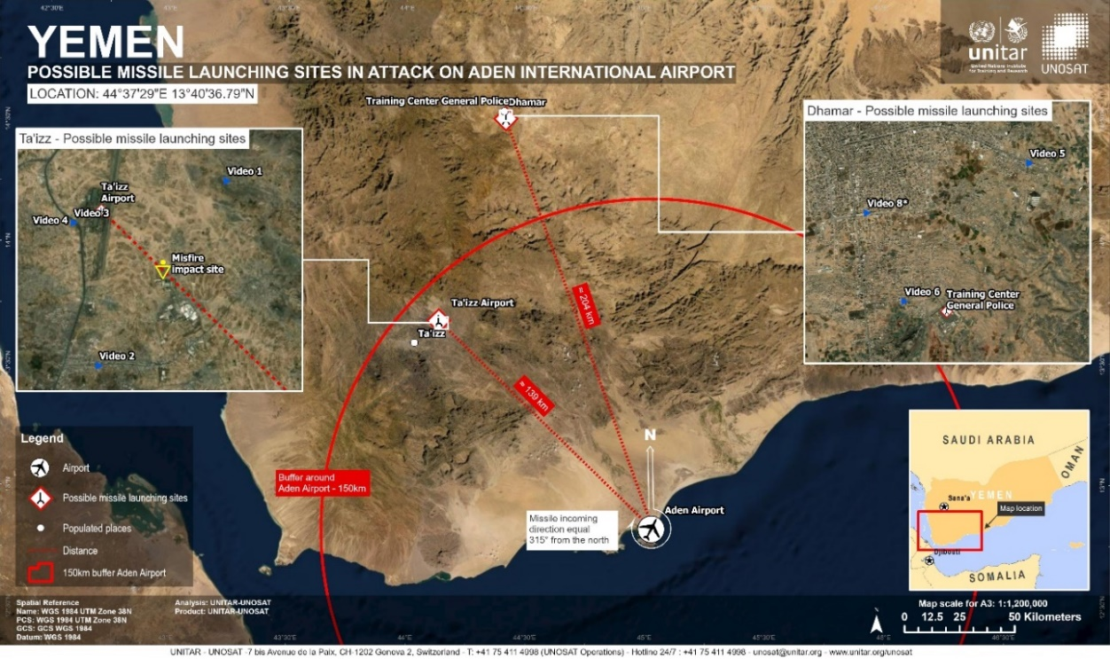
1 January 2021 DigitalGlobe WorldView-2 image © 2021 DigitalGlobe Inc. / US Department of State, Humanitarian Information Unit, NextView License / Analysis conducted by the United Nations Satellite Center (UNOSAT).
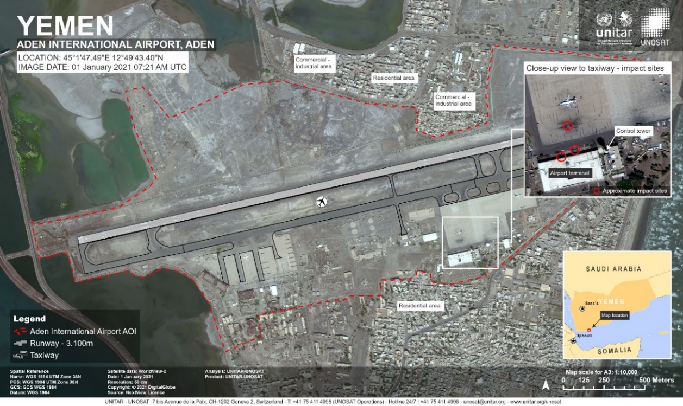
1 January 2021 DigitalGlobe WorldView-2 image © 2021 DigitalGlobe Inc. / US Department of State, Humanitarian Information Unit, NextView License / Analysis conducted by the United Nations Satellite Center (UNOSAT).

B. Airstrike in Salif Grains Port, 21 March 2021 (para. 34)
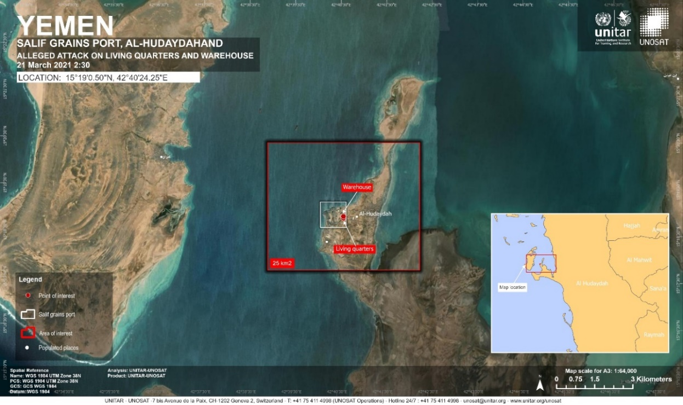
25 March 2021 Pléiades image © 2021 Airbus D&S / Analysis conducted by the United Nations Satellite Center (UNOSAT).
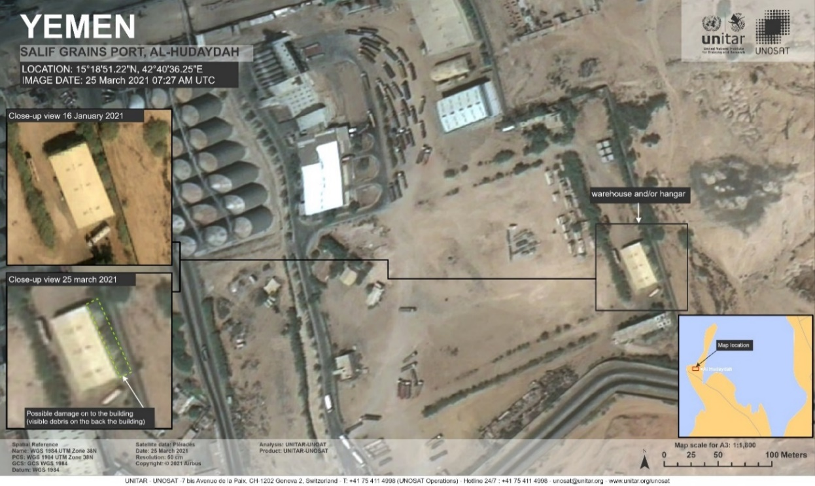
25 March 2021 Pléiades image © 2021 Airbus D&S / Analysis conducted by the United Nations Satellite Center (UNOSAT).
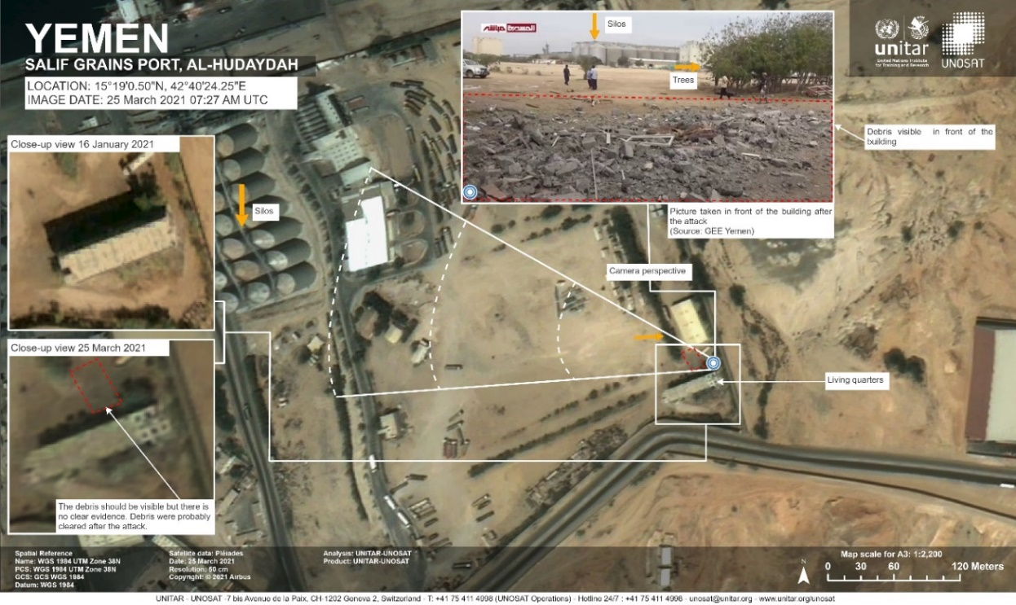
25 March 2021 Pléiades image © 2021 Airbus D&S / Analysis conducted by the United Nations Satellite Center (UNOSAT).

Annex III

Map of Yemen
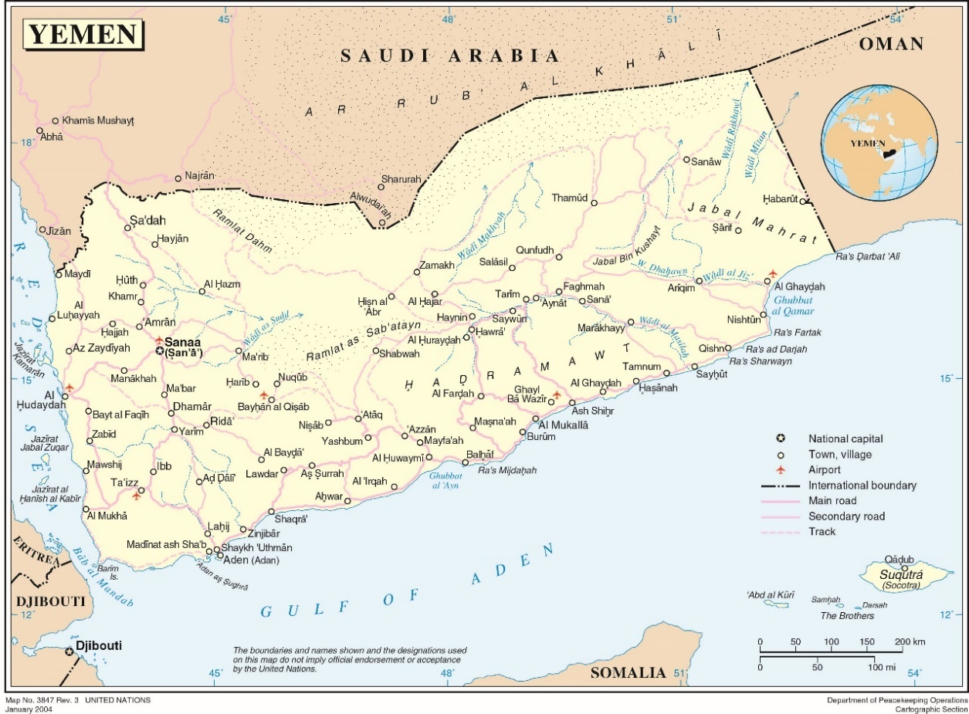

Annex IV

Mapping of the main actors

A. Kingdom of Saudi Arabia
Serial | Name | Position | Remarks
1 | Crown Prince Mohammad Bin Salman  الامير محمد بن سلمان | Minister of Defence | 23 January 2015
2 | General Fayyadh al-Ruwaili  فريق اول ركن فياض بن حامد الرويلي | Chairman of the Joint Chiefs of Staff | 27 February 2018
3 | Lieutenant General Mutlaq bin Salim bin Mutlaq Al-Azima  فريق ركن مطلق بن سالم بن مطلق الازيمع | Joint Forces Commander | 31 August 2020
4 | Lieutenant General Fahd bin Abdallah al-Mtair  فريق ركن فهد بن عبدالله المطير | Land Forces Commander | 27 February 2018
5 | Prince Lieutenant General Turki bin Bandar bin Abdalazeez al-Saud  الامير فريق ركن تركي بن بندر بن عبدالعزيز آل سعود | Air Force Commander | 27 February 2018
6 | Admiral Fahd bin Abdulla al-Ghufaili  فريق ركن فهد بن عبدالله الغفيلي | Naval Commander | 4 November 2017
7 | Lieutenant General Mazyad Sulaiman al-Amro  فريق ركن مزيد بن سليمان العمرو | Air Defence Commander | 27 February 2018
8 | Lieutenant General Jarallah bin Mohammed bin Jarallah al-Elwait  فريق ركن جار الله بن محمد العلويط | Strategic Missile Force Commander | 27 February 2018
9 | Major General Pilot Abdullah al-Ghamdi  لواء ركن طيار عبدالله الغامدي | Air Operations Director | Coalition Deputy Commander
10 | Major General Majed Hamdi al-Harbi  لواء ركن ماجد بن حمدي الحربي | Task Force 7070 Commander (Jazan Task Force) | Saudi Southern Border, Jazan
11 | Brigadier General Abdullah bin Haseed al-Inezi  عميد ركن عبدالله بن حصيد العنزي | Task Force 1501 Commander | Coalition HQs in the 6th Yemeni Military District
12 | Brigadier General Abdulrhman bin Suliman al-Haji  عميد ركن عبدالرحمن بن سليمان الحجي | Task Force 808 Commander | Socotra
13 | Brigadier General Hani bin Abdulateef bin Abid  عميد ركن هاني بن عبداللطيف بن عابد | Task Force 808 Commander | Socotra, since August 2020
14 | Brigadier General Nafia’ al-Harbee  عميد ركن نافع الحربي | Task Force 808 Commander | Socotra, since 24 February 2021
15 | Brigadier General Pilot Mujahed al-Outaibi  عميد ركن طيار مجاهد العتيبي | Task Force 802 Commander | Aden
16 | Brigadier General Naif bin Munif al-Outaibi  عميد ركن نايف بن منيف العتيبي | Task Force 802 | Aden
17 | Brigadier General Mukhtar el-Mtairi  عميد ركن مختار المطيري | Task Force 800 Commander | Saudi Southern Border, Samtah, Jazan
18 | Major General Yusef al-Shahrani  لواء ركن يوسف الشهراني | Task Force Commander | Ma’rib, 8 July 2020
19 | Major General Mohammad bin Ali al-Amri  لواء ركن محمد بن علي العمري | South Military Regional Commander | Saudi Southern Border
20 | Brigadier General Hassan Abdullah al-Shihri  عميد ركن حسن عبدالله الشهري | Sharurah Operations Centre Commander | Saudi Southern Border
21 | Major General Saad al-Jaber  لواء ركن سعد الجابر | The Saudi official in charge of the Mobilization Committee | Saudi Southern Border
22 | Brigadier General Ahmed Rashid al Shihri  عميد ركن أحمد راشد الشهري | 4th Armoured ‘King Khaled Force’ Brigade | Saudi Southern Border
23 | Brigadier General Fahd bin Daham al-Markhan  عميد ركن فهد بن دهام المرخان | 11th Brigade Commander | Saudi Southern Border

B. United Arab Emirates
Serial | Name | Position | Remarks
1 | Sheikh Mohammed bin Zayed al-Nahyan  الشيخ محمد بن زايد آل نهيان | Deputy Supreme Commander
2 | Mohammed bin Rashid al-Maktoum  الشيخ محمد بن راشد آل مكتوم | Minister of Defence
3 | Lieutenant General Hamad Mohammed Thani al-Romaithi  h فريق ركن حمد محمد ثاني الرميثي | Chief of Staff of the Armed Forces | 3 January 2005
4 | Major General Eisa Saif al-Mazrouei  لواء ركن مهندس عيسى سيف المزروعي | Deputy Chief of Staff | Joint Operations Commander until 4 March 2021
5 | Major General Saleh Mohammad Saleh al-Ameri  لواء ركن صالح محمد صالح العامري | Joint Operations Commander | 4 March 2021
6 | Major General Rashid Saeed al-Shahi  لواء ركن سعيد راشد الشحي | Commander of Ground Forces | 4 March 2021
7 | Major General Ibrahim Nasser Mohammed al-Alawi  لواء ركن طيار ابراهيم ناصر محمد العلوي | Commander of Air Force and Air Defence
8 | Major General Sheikh Saeed Bin Hamdan Bin Mohammad al-Nahyan  لواء ركن الشيخ سعيد بن حمدان بن محمد آل نهيان | Commander of Navy | 11 October 2017
9 | Brigadier General Ali Ahmed el-Tanjee  عميد ركن علي احمد الطنيجي | Coalition Commander | Aden, May 2015–January 2016  Hudaydah,  2018–2019
10 | Brigadier General Ali el-Nuaimee  عميد ركن علي سيف النعيمي | Coalition Commander | Aden, January 2016–July 2016
11 | Brigadier General Sultan el-Habsee  عميد ركن سلطان الحبسي | Coalition Commander | Aden, July 2016–January 2017
12 | Brigadier General Naser el-Otaibee  عميد ركن ناصر مشبب العتيبي | Coalition Commander | Aden, January 2017–July 2017
13 | Brigadier General Ahmed el-Blushee  عميد ركن احمد البلوشي | Coalition Commander | Aden, July 2017–January 2018
14 | Brigadier General Muhammad el-Hasani  عميد ركن محمد الحساني | Coalition Commander | Aden, January 2018–July 2018
15 | Brigadier General Awad Saeed al-Ahbabi  عميد ركن عوض سعيد الاحبابي | Coalition Commander | Aden, July 2018–January 2019
16 | Brigadier General Rashed Saeed al-ghafli aka Abu Mohammed  عميد ركن راشد سعيد الغفلي المكنى ابو محمد | Coalition Commander | Aden January 2019–July 2019
17 | Brigadier General Abd el-Salam al-Shahi  عميد ركن عبد السلام الشحي | Coalition Commander | Western Coast, 2015–2019
18 | Abu Khalifa Said el-Mahri  ابو خليفة سعيد المهري | Coalition Intelligence Officer | Aden, Abyan, Lahj, 2015–2019
19 | Brigadier General Matar Abu Said,  عميد ركن مطر أبوسعيد | Coalition Commander | Western Coast since 2019

C. Government of Yemen (International Recognized Government)

1. The Government of Yemen Armed Forces
Serial | Name | Position | Location | Remarks
1 | President Abd Rabbu Mansour Hadi  الرئيس عبد ربه منصور هادي | Supreme Commander of the Armed Forces | Riyadh, KSA | February 2012
2 | Major General Ali Mohsen al-Ahmar  لواء ركن علي محسن الاحمر | Vice President | Riyadh, KSA | 3 April 2016
3 | Lieutenant General Mohammad Ali al-Maqdashi  فريق ركن محمد علي المقدشي | Minister of Defence | Ma’rib | 8 November 2018
4 | Lieutenant General Zghair Hammoud Aziz  فريق ركن صغير حمود عزيز | Chief of the General Staff | Ma’rib | 28 February 2020
5 | Major General Tahir Ali al-Aqaili  لواء ركن طاهر علي العقيلي | Adviser to the Supreme Commander | Ma’rib | 8 November 2018
6 | Major General Adel al-Qumari  لواء ركن عادل هاشم القميري | General Inspector | Ma’rib
7 | Major General Ahmad Mohsen Salem al-Yafa’ay  لواء ركن أحمد محسن سالم اليافعي | Chief of Intelligence Staff | Ma’rib | 22 January 2019
8 | Major General Nasser al-Tibabani  لواء ركن ناصر الذيباني | Chief of Operations Staff | Ma’rib
9 | Major General Ahmed al-Wali  لواء احمد الولي | Chief of Logistic Staff | Ma’rib
10 | Major General Ahmed al-Marzouki  لواء ركن أحمد المرزوقي | Chief of Human Resources Staff | Ma’rib
11 | Major General Mohammed al-Radvani  لواء ركن محمد الردفاني | Chief of Training Staff | Ma’rib
12 | Major General Saleh Mohammad Timis  لواء ركن صالح محمد طميس | 1st Military District Commander | Sayun, Hadramaut | 22 November 2016
13 | Major General Faraj Salamin al-Bahasani  لواء ركن فرج سالمين البحسيني | 2nd Military District Commander | Mukalla, Hadramaut | Since 2015
14 | Major General Mansour Thawabah  عميد ركن منصور ثوابه | 3rd Military District Commander | Ma’rib | 14 November 2020
15 | Major General Fadhl Hasan  لواء ركن فاضل حسن | 4th Military District Commander | Aden | 21 November 2016
16 | Major General Yahya Hussien Salah  لواء ركن يحيى حسين صلاح | 5th Military District Commander | Midi, Hajjah | 17 February 2018
17 | Major General Omar Yahya Sjaf  لواء ركن عمر يحيى سجاف | 6th Military District Commander | Jawf | 27 March 2021
18 | Major General Ahmad Hassan Gubran  لواء أحمد حسن جبران | 7th Military District Commander | Nihm | 27 January 2020
19 | Brigadier General Sanad Al-Rahwa  عميد ركن سند الرهوه | Commander of 1st Presidential Protection Brigade | Shaqra, Abyan | Brigade has been located in Shaqra since August 2019
20 | Brigadier General Abdulhakeem Dawkam  عميد ركن عبد الحكيم دوكم | Commander of 2nd Presidential Protection Brigade | Abr, Hadramaut | Responsible for protecting Vice President Ali Mohsen al-Ahmar
21 | Brigadier General Louay Awad Mohamed Zamiki  عميد لؤي عوض الزامكي | Commander of 3rd Presidential Protection Brigade | Lawdar and Shaqra, Abyan | Previously stationed in Khur Maksar district of Aden, in the Jabal Hadid camp
22 | Brigadier General Mahran Qubati  عميد مهران القباطي | Commander of 4th Presidential Protection Brigade | Shaqra, Abyan | Located in Dar Sad, Aden. Then in the “Reception” military camp in Ma’rib Governorate.
23 | Brigadier General Abdullah al-Subaihi  عميد ركن عبد الله الصبيحي | Commander of 39th Armoured Brigade | Shaqra, Abyan. Since 3 September 2019 | Before 10 August 2019 was stationed in Bader Camp, Khur Maksar, Aden
24 | Brigadier General Mohammad Ali Jaber  عميد محمد علي جابر | Commander of 89th Infantry Brigade | Shaqra, Abyan. Since 3 September 2019 | Before 10 August 2019 was stationed in Bader Camp, Khur Maksar, Aden
25 | Major General Abu Baker Hussien Salim  لواء ابو بكر حسن سالم | Commander of Abyan Axis | Abyan Axis, Zingibar | 11 March 2017
26 | Brigadier General Mohammad Ahmed Mulhem  عميد ركن محمد أحمد ملهم | Commander of 111th Infantry Brigade | Ahwar, Abyan | 6 July 2015
27 | Brigadier General Saif Ali Mohammed al-Qefish  عميد ركن سيف علي القفيش | Commander of 115th Infantry Brigade | Shaqra, Abyan | On 15 May 2020, STC captured BG Saif
28 | Brigadier General al-Hamzah Ali Salim al-Jadani  عميد ركن الحمزه علي الجعدني | Commander of 119th Infantry Brigade | Abyan | Died in June 2020
29 | Brigadier General Abd al-Qader al-Jaari  عميد ركن عبد القادر الجفري | Commander of 103rd Infantry Brigade | Hajeen, Abyan | August 2020
30 | Brigadier General Azeez Naser al-’Atiqi  عميد ركن عزيز ناصر العتيقي | Atiq Axis commander and 30th Infantry Brigade commander | Atiq, Shabwah | January 2017
31 | Brigadier General Jahdal Hanash al-Awlaki  عميد جحدل حنش العولقي | Commander of 21st Brigade | Bayhan–Atiq, Shabwah | Since 2015
32 | Brigadier General Mahdi Mashfar al-Qomishi  عميد مهدي مشفر القميشي | Commander of 2nd Mountain Infantry Brigade | Atiq, Shabwah | January 2019
33 | Major General Khaled Qassem Fadhal  لواء ركن خالد قاسم فاضل | Ta’izz Axes Commander and 145th Infantry Brigade | Ta’izz | November 2019
34 | Brigadier General Abdelmalik al-Ahdal  عميد ركن عبد الملك الاهدل | Commander of 17th Infantry Brigade | Ta’izz | 5 September 2020
35 | Brigadier General Mohammed Al-Mahfadi  عميد ركن محمد المحفدي | Commander of 22nd Armoured Brigade | Ta’izz | 20 December 2020
36 | Brigadier General Abdul Rahman Thabet Shamsan  عميد ركن عبدالرحمن ثابت شمسان | Commander of 35th Armoured Brigade | Ta’izz | July 2020
37 | Abu Bakr al-Jabuli  أبو بكر الجبولي | Commander of 4th Mountain Infantry Brigade | Ta’izz | Not a military officer
38 | Brigadier General Amin Abdo Hassan Jaish  عميد أمين هبده حسن جعيش | Commander of 170th Air defence Brigade | Ta’izz | 10 July 2020
39 | Adnan Rozaiq  عدنان رزيق | Commander of 5th Presidential Protection Brigade | Ta’izz | Head of Ta’izz Axis Operation Branch
40 | Brigadier General Amjad Khalid  عميد ركن امجد خالد | Commander of the Transportation Brigade | Mukha, Hudaydah | The brigade was stationed in Aden till December 2019
41 | Brigadier General Khaled Yaslam  عميد ركن خالد يسلم | Commander of 107th Infantry/Safe Brigade | Safer, Ma’rib | August 2013
42 | Brigadier General Ali Mohammad al-Houri  عميد ركن علي محمد الحوري | Commander of 13th Infantry Brigade | Ma’rib
43 | Brigadier General Ali Ammar al-Jaifi  عميد علي عمار الجائفي | Commander of 14th Armoured Brigade | Sahn al Jin, Ma’rib | September 2019
44 | Brigadier General Mujahid al-Shaddadi  عميد ركن مجاهد الشدادي | 180th Air Defence Brigade | Sahn al Jin, Ma’rib
45 | Brigadier General Mohammed al-Asoudi  عميد محمد العسودي | Commander of 203rd Infantry Brigade | Sirwah, Ma’rib | Killed on 14 February 2021 in Ma’rib fronts
46 | Major General Mufreh Muhammad Bahih  لواء مفرح محمد علي بحيبح | Commander of 26th Infantry Brigade and Bayhan Axis | Harib, Ma’rib | March 2018
47 | Colonel Yahya Tamah  عقيد يحيى تامه | Commander of 29th Infantry Brigade | Ma’rib
48 | Brigadier General Hamid Muhammad al-Theifani  عميد محمد أحمد الذيفاني | Commander of 310th Armoured Brigade | Mass, Ma’rib | Killed on 4 April 2020
49 | Brigadier General Ahmed Al-Barihi  عميد ركن أحمد البريهي | Commander of 139th infantry brigade | Nihm
50 | Brigadier General Aidroos al-Dumani  عميد عيدروس الدميني | Commander of 312th Armoured Brigade | Sirwah, Ma’rib | Mashjah

(a) Brigades deployed to the 5th Military District Area of Responsibility in Hajjah Governorate at the Saudi Southern Borders, which are supported by SLC
Serial | Name | Position | Location | Remarks
1 | Brigadier General Abdo Suleiman  عميد عبده سليمان | Commander of 25th Mika Brigade | Hajjah | Also, Chief of Staff of the 5th Military District (MD)
2 | Brigadier General Taha al-Amiri  عميد طه العامري | Commander of 105th Infantry Brigade | Hajjah | 5th MD
3 | Brigadier General Abdullah al-Malaji  عميد عبدالله الملاحي | Commander of 2nd Brigade, Border Guard | Hajjah | 5th MD
4 | Brigadier General Muhammad Salman عميد محمد سلمان | Commander of 82nd Infantry Brigade | Hajjah | 5th MD
5 | Brigadier General Fayez al-Tahesh  عميد فايز الطاهش | Commander of 3rd Brigade, Border Guard | Hajjah | 5th MD
6 | Brigadier General Brigadier Faris al-Rubadi عميد فارس الربادي | Commander of 7th Brigade, Border Guard | Hajjah | 5th MD
7 | Brigadier General Mohammed al-Salami  عميد محمد السلمي | Commander of 10th Brigade, Commandos | Hajjah | 5th MD
8 | Brigadier General Mohammed al-Hajjouri  عميد محمد الحجوري | Special Forces Brigade Commander | Haradh Hajjah | Died in June 2020
9 | Brigadier General Abdo Tarmoum  عميد عبده طرموم | Commander of Special Security Brigade | Hajjah | Deployed in the 5th MD AoR
10 | Zaid al-Hajouri  زيد الحجوري | Al Fursan Brigade Commander | Hajjah | Salafist

(b) Brigades deployed to the 6th Military District Area of Responsibility in Jawf and Sa’ada Governorates at the Saudi Southern Borders
Serial | Name | Position | Location | Remarks
1 | Brigadier Hadi Shalfat  عميد هادي شلفط | Commander of Al-Dhafer Brigade, Border Guards | Khabb wa ash Sha’af | Jawf fronts
2 | Brigadier General Muhammad bin Rasiya عميد محمد بن راسية | Commander of 101st Brigade | Jawf | Jawf fronts
3 | Brigadier Heikal Hanaf  عميد هيكل حنتف | Commander of 1st Brigade, Border Guards | North Axis | Jawf fronts
4 | Brigadier Abdullah al-Dawi  عميد عبدالله الضاوي | Commander of 127th Infantry Brigade | Jawf | Jawf fronts
5 | Brigadier General Mutti Al-Damini  عميد مطيع الدميني | Commander of 161st Infantry Brigade | Jawf | Jawf fronts
6 | Colonel Dhafer Haqqan al-Juaidi  عقيد ظافر حقان الجعيدي | Al Hasm Brigade Border Guard | Jawf | Jawf fronts
7 | Major General Amin al-Okimi  لواء أمين العكيمي | Jawf axis battalions | Jawf | Governor
8 | Brigadier Manea Abu Saeed  عميد مناع ابو السعيد | Al Amal Brigade | Hazm | Jawf fronts
9 | Colonel Hamad Rashid al-Azmi  عقيد حمد راشد الحزمي | Al Izz Brigade | Jawf | Defected from the Yemeni forces and joined the Houthis
10 | Brigadier Taher Zemam  عميد طاهر زمام | Commander of 9th Infantry Brigade | Kitaf wa Al Boqe’e | Sa’ada fronts
11 | Brigadier Abdo al-Mikhlafi  عميد عبده المخلافي | Commander of 122nd Infantry Brigade | Kitaf wa Al Boqe’e | Merged with Al Fateh brigade
12 | Radad al-Hashimi  رداد الهاشمي | Commander of Al Fateh Brigade | Kitaf wa Al Boqe’e | Salafist
13 | Abd al-Rahman Alloom  عبد الرحمن اللوم | Commander of Al Tawhid Brigade | Kitaf wa Al Boqe’e | In May 2020 merged with Al Tahrir Brigade
14 | Brigadier General Saleh al-Majeedi  عميد صالح المجيدي | Commander of 6th Brigade, Border Guard | Razih | Sa’ada fronts
15 | Brigadier General Abdullah Al-Ashraf  عميد عبدالله الاشرف | Commander of 7th Brigade, Border Guards | Razih | Sa’ada fronts
16 | Amin Yahya Hassan al-Suwaidi  أمين يحيى حسن السودي | Commander of the 2nd Special Forces Brigade | Razih | Sa’ada fronts
17 | Brigadier General Adeeb al-Shuhab  عميد اديب شهاب | Commander of the 9th brigade, Border Guard | Baqim | Sa’ada fronts
18 | Brigadier General Yaser al-Harthi  عميد ياسر الحارثي | Commander of the 102 Special Forces Brigade | Baqim | Sa’ada fronts
19 | Brigadier General Yaser Hussien Mujali  عميد ياسر حسين مجلي | Commander of the 63rd Brigade | Elb and Baqim | Sa’ada fronts
20 | Brigadier General Abdul Karim al-Sadie  عميد عبد الكريم السدعي | Commander of the Third Brigade, Ourouba | Malaheet, Dhahir | Sa’ada fronts
21 | Brigadier General Mohammed al-Ajani  عميد محمد العجاني | Commander of the Third Brigade, Storm | Shada Front, Sa’ada | Sa’ada fronts

2. Intelligence, Security, Political, and Civil Administration Actors
Serial | Name | Position | Location | Remarks
1 | Major General Abdo Mohammed al-Huthaifi  لواء عبده محمد الحذيفي | Political Security Organization | Aden
2 | Major General Ahmed Abdullah al-Musabi  لواء أحمد عبدالله المصعبي | Head of National Security Bureau | Aden | 29 August 2016
3 | Major General Mohammad Musleh Eidah,  لواء ركن محمد مصلح العيضه | National Security Bureau | Aden | Head of the Yemeni governmental team, RCC
4 | Moeen Abdul Malik Saeed  معين عبد الملك سعيد | Prime Minister | Riyadh | 15 October 2018. On 29 July 2020 he was charged with reforming the cabinet.
5 | Major General Ibrahim Ali Ahmed Haydan  لواء ركن إبراهيم علي أحمد حيدان | Minister of Interior |  | December 2020
6 | Dr. Ahmed Awad Bin Mubarak  د. احمد عوض بن مبارك | Minister of Foreign Affaires | Riyadh | December 2020
7 | Salem Saleh Salem bin Brik  سالم صالح سالم بن بريك | Minister of Finance | Riyadh | September 2019
8 | Dr. Ahmed Obaid al-Fadhli  الدكتور احمد عبيد الفضلي | Central Bank Governor | Aden | September 2019
9 | Ahmed Hamed Limlis  أحمد حامد لملس | Governor | Aden | 29 July 2020
10 | Ahmed Abdullah al-Turky  احمد عبدالله التركي | Governor | Lahj | 24 December 2017
11 | Abu Baker Hussien Salim  ابو بكر حسن سالم | Governor | Abyan | 13 March 2017
12 | Mohammed Saleh bin Adio  محمد صالح بن عديو | Governor | Shabwah | 26 November 2018
13 | Nabil Abdu Shamsan  نبيل عبده شمسان | Governor | Ta’izz | 31 December 2018
14 | Amin al-Okimi  أمين العكيمي | Governor | Jawf | 12 August 2016
15 | Sultan bin Ali al-Aradah  سلطان بن علي العرادة | Governor | Ma’rib | Since 2012
16 | Ali Moqbel Saleh  علي مقبل صالح | Governor | Dhale’ | 24 December 2017
17 | Nasser Al-Khidr al-Sawadi  ناصر الخضر السوادي | Governor | Bayda’ | 6 June 2018
18 | Faraj Salamin al-Bahasani  فرج سالمين البحسيني | Governor | Hadramaut | 29 June 2017
19 | Mohammad Ali Yasser  محمد علي ياسر | Governor | Maharah | 23 February 2020
20 | Ramzi Mahrous  رمزي محروس | Governor | Socotra | 12 April 2018
21 | Brigadier Mathar al- Shuaibi  عميد مطهر الشعيبي | Director of General Security | Aden | Replaced Major General Shallal al-Shaye, 29 December 2020
22 | Major General Saleh Ahmed Mohammed Al Sayed  لواء صالح أحمد محمد السيد | Director of General Security | Lahj | 20 November 2016
23 | Colonel Ali Naser Abu Zaid Ba’azab Abu Mashal al-Kazmi  عقيد علي ناصر بو زيد ابو مشعل الكزمي | Director of General Security | Abyan | 20 June 2019
24 | Brigadier General Awad Massod al-Dahboul  عميد عوض مسعود الدحبول | Director of General Security | Shabwah | 3 June 2016
25 | Brigadier General Mansour Abdul Rab al-Akhali  عميد منصور عبد رب الاكحلي | Director of General Security | Ta’izz | 1 January 2018
26 | Brigadier General Murad Abu Hatim  عميد مراد ابو حاتم | Director of General Security | Jawf
27 | Brigadier General Yahya Ali Abdullah Hamid  عميد يحيى علي عبدالله حميد | Director of General Security | Ma’rib | 23 May 2019
28 | Brigadier General Ahmed Mohamed el-Haddad  عميد محمد الحداد | Director of General Security | Bayda’ | 25 April 2019
29 | Major General Saeed Ali Ahmad Naseeb al-Amri  عميد سعيد علي احمد نصيب العمري | Director of General Security | Hadramaut | 15 May 2020
30 | Brigadier General Mufti Suhail Samouda  عميد مفتي سهيل صمودة | Director of General Security | Maharah | 14 July 2018
31 | Colonel Fayez Salem Musa Tahs  عقيد فايز سالم موسى طاحس | Director of General Security | Socotra | 3 October 2019
32 | Colonel Abd Rabbo al A’tab al-Sharif  عقيد عبد ربه الاكعب الشريف | Commander of Special Security Forces | Shabwah | 4 September 2019
33 | Brigadier General Salim al-Sayagi  العميد/ سليم السياغي | Commander of Special Security of Special Forces | Ma’rib | 22 February 2021

D. Armed Groups – Non-State Actors

1. Armed groups affiliated to the Southern Transitional Council

(a) Security Belt Forces and Support Brigades
Serial | Name | Position | Location | Remarks
1 | Major General Saleh Ahmed Mohammed Al Sayed  لواء صالح أحمد محمد السيد | Logistic and Support Brigades commander | Lahj | 25 June 2021
2 | Brigadier General Ali Nasser Muthanna al-Mu’akr  عميد علي ناصر مثنى المعكر | Logistic and Support Brigades, Chief of Staff | Lahj | 25 June 2021
3 | Brigadier General Abdul Salam Zain Ali al-Bihani  عميد عبدالسلام زين علي البيحاني | Logistic and Support Brigades, Operations Staff | Lahj | 25 June 2021
4 | Brigadier General Mohsen Abdullah al-Wali  عميد محسن عبدالله الوائلي | Security Belt Commander | Aden | 25 June 2021
5 | Brigadier General Mukhtar Ali Muthanna al-Nubian  عميد مختار علي مثنى النوبي | Deputy of the Security Belt Commander | Aden | 25 June 2021
6 | Brigadier General Obaid Muthanna Qassem  عميد عبيد مثنى قاسم | Security Belt Forces, Operations Staff | Aden | 25 June 2021
7 | Lieutenant Colonel Nasr Atef al-Mashushi  مقدم ناصر عاطف المشوشي | Commander  1st Support Brigade  Emergency Forces | Yafa’a, Lahj | April 2020
8 | Brigadier General Nabil al-Mashushi  عميد نبيل المشوشي | Commander of 3rd Support Brigade | Ras Abbas camp
9 | Colonel Abd al-Latif al-Sayyad  عقيد عبد اللطيف السيد | Commander of Security Belt Forces | Abyan | Mid-2016
10 | Brigadier General Wadhah Omar Abdalaziz  عميد وضاح عمر عبدالعزيز | Security Belt Commander | Aden | Now in Lahj
11 | Jalal Nasser al-Rubaie  جلال ناصر الربيعي | Security Belt Commander | Aden | 22 December 2018
12 | Colonel Hader al-Shukhaty  عقيد حدار الشوحطي | Commander  4th Support Brigade | Lahj, al-Rebat
13 | Ali Omar Kafaien  علي عمر كافين | Security belt commander | Socotra
14 | Osan al-Anshly  اوسان العنشلي | Commander of 12 Storm Brigade | Aden
15 | Colonel Ahmed Qaid al-Qubbah  عقيد احمد قايد القبه | Security Belt Commander | Dhale’
16 | Major General Shallal al-Shaye  لواء شلال الشايع | Counter Terrorism Unit commander | Aden | 29 May 2021

(b) Shabwah Elite Forces
Serial | Name | Position | Location | Remarks
1 | Lt. Col. Mohammed Salem al-Buhair al-Qamishi  مقدم محمد سالم البوحير القمشي | Shabwah Elite Forces Commander | Belhaf | October 2017
2 | Lt. Col. Wajdi Ba’aum al-Khelaifi  مقدم وجدي باعوم الخلافي | Commander of 4th Brigade, Shabwah Elite Forces | Nassab and Markha
3 | Major Mahdi Mohammed Barahma  رائد مهدي محمد براهمه | Shabwah Rapid Intervention Forces
4 | Muhammed Saleh Farah al-Kirby  محمد صالح فرح الكربي | Commander of 6th Brigade, Shabwah Elite Forces | Shabwah | Died on 20 July 2020

2. Armed Groups in the West Coast Front

a) Giants Brigades
Serial | Name | Position | Location | Remarks
1 | Abu Zar’a Abd al-Rahman Al-Muharrami Al-Yafei  ابو زرعه عبدالرحمن المحرمي اليافعي | Giants Forces Commander | West Coast, Hudaydah | Salafist leader
2 | Ra’ed Hassan Abdulrahman Saleh al-Habhi  رائد حسن عبدالرحمن صالح الحبهي | Commander of the 1st Giants Brigade | The coast-Ad Durayhimi | Salafist leader, studied at Dar Al-Hadith Center in Dammaj
3 | Hamdi Shukri  حمدي شكري | Commander of the 2nd Giants Brigade | Zabid- Garrahi | Salafist leader
4 | Ali Nasser al-Awadali علي ناصر العوذلي | Commander of the 3rd Giants Brigade | Hudaydah
5 | Nizar Salim Muhsen al-Wajeh  نزار سالم محسن الوجيه | Commander of the 4th Giants Brigade | At Tuhayat | Salafist leader
6 | Rashid Salim al-Amri  رشيد سالم العامري | Commander of the 5th Giants Brigade | Fazzah | Salafist leader
7 | Murad Saif Joubeh  مراد سيف جوبح | Commander of the 6th Giants Brigade | Wazi’iyah | Salafist leader
8 | Ali al-Kanini  علي الكنيني | Commander of the 7th Giants Brigade | Hays | Salafist leader
9 | Mohammad Ali Muqbel  محمد علي مقبل | Commander of the 8th Giants Brigade | Hudaydah | Salafist leader
10 | Sulaiman Yahya Munaser al-Zarnouki  سليمان يحيى منصور الزرنوقي | Commander of Al Zaraniq Brigades | Hudaydah | Salafist leader
11 | Bassam al-Mahdhar  بسام المحضار | Commander of the 3rd Infantry Brigade | Hudaydah | Salafist leader
12 | Safwan al-Azzibi  صفوان العزيبي | Commander of 13th Giant Brigade | Hudaydah | Salafist Leader

b) Tuhama Resistance Forces
Serial | Name | Position | Location | Remarks
1 | Ahmad al-Kawkabani  احمد الكوكباني | 1st Tuhama Resistance Brigade Commander | Mujaylis, Ad Durayhimi, Hudaydah
2 | Major General Haitham Qasim Tahir  اللواء هيثم قاسم طاهر | Field Commander | Jabaliyah | Previous minister of defence
3 | Abd Al-Rahman Hajri عبد الرحمن حجري | 2nd Tuhama Resistance Brigade Commander | Hudaydah

E. Armed Non-State Actors/Houthi De-Facto Authorities

1. Political, Military and Security Main Actors
Serial | Name |  | Position |  | Location | Remarks
1 | Abdulmalik Badr al-Din al-Houthi  عبد الملك بدر الدين الحوثي |  | Leader of the Houthis’ |  | Sana’a | Political, no military rank
2 | Mahdi al-Mashat  مهدي المشاط |  | President of Supreme Political Council |  | Sana’a | Promoted to marshal rank
3 | Mohammed Ali Abdulkarim al-Houthi  محمد علي عبد الكريم الحوثي |  | Member of the Supreme Political Council |  | Sana’a | Military, no rank  18 March 2019
4 | Major General Yahya Mohammed al-Shami  لواء يحيى محمد الشامي |  | Assistant of Supreme Commander |  | Sana’a | Died on 26 April 2021
5 | Major General Hussein Naji Hadi Khairan  لواء حسين ناجي هادي خيران |  | Presidential Adviser for Defense and Security |  | Sana’a | Former Chief of General Staff
6 | Yahya Badr al-Din al-Houthi  يحيى بدر الدين الحوثي |  | Minister of Education |  | Sana’a | April 2016
7 | Dr Rashid Aboud Shiryan Abu-Lahem  الدكتور رشيد عبود أبو لحوم |  | Minister of Finance |  | Sana’a | September 2019
8 | Hashem Ismail Ali Ahmed  هاشم اسماعيل علي احمد |  | Governor of the Central Bank |  | Sana’a | 18 April 2020
9 | Amer Ali Amer Al-Marani  عامر علي عامر المراني |  | Minister of Transportation |  | Sana’a | 24 April 2021
10 | Judge Nabil Nasser Al-Azani  القاضي نبيل ناصر العزاني |  | Minister of Justice |  | Sana’a | 24 April 2021
11 | Hisham Sharaf  هشام شرف |  | Minister of Foreign Affairs |  | Sana’a | 28 November 2016
12 | Hussein Hamud Al Azi  حسين حمود العزي |  | Assistant of the Minister of Foreign Affairs |  | Sana’a | Since 2018
13 | Major General Abdulkarim Ammer Aldain al-Houthi  لواء عبد الكريم امير الدين الحوثي |  | Minister of Interior |  | Sana’a | 5 May 2019
14 | Ahmed Mohammed Yahyah Hamid (Abu Mahfouz) أحمد محمد يحيى حميد (أبو محفوظ) |  | Head of the Supreme Council for the Management and Coordination of Humanitarian Affairs (SCMCHA) |  | Sana’a | He is also a Director of the Office of the President of the Supreme Political Council
15 | Abdul Mohsen Abdullah Qasim Attawoos (Abu Adel)  عبد المحسن عبد الله قاسم الطاووس المكنى ابو عادل |  | Secretary General of the Supreme Council for the Management and Coordination of Humanitarian Affairs (SCMCHA) |  | Sana’a | New Organization, 6 November 2019
16 | Major General Abdul Hakim Hashim Ali al-Khiyawani  لواء عبد الحكيم هاشم علي الخيواني |  | Head of Security and Intelligence Service |  | Sana’a | New Organization  1 September 2019  US Treasury sanction list
17 | Major General Abdulqader Qasim Ahmad al-Shami  لواء عبد القادر قاسم احمد الشامي |  | Deputy Head of Security and Intelligence Service |  | Sana’a | 1 September 2019
18 | Major General Abdul Wahid Naji Abu Ras  لواء عبد الواحد ناجي ابو راس |  | Under Secretary of the Security and Intelligence Service for External Operations Affairs |  | Sana’a | 1 September 2019
19 | Major General Abdullah Aida al-Razmi  لواء عبد الله عيضه الرازمي |  | The Inspector General of the Ministry of Interior |  | Sana’a | Sa’ada supervisor
20 | Colonel Sultan Saleh Zabin aka Abu Saqer  عقيد سلطان صالح الزابن المكنى ابوصقر |  | Criminal Investigation Directorate |  | Sana’a | US Treasury sanction list  Died on 5 April 2021
21 | Major General Muhammad Nasser Ahmed al-Atefi  لواء ركن محمد ناصر احمد العاطفي |  | Minister of Defence |  | Sana’a | 28 November 2016
22 | Brigadier General Mohamed Ahmed Talbi  عميد محمد احمد طالبي |  | Assistant Minister of Defence for Logistics |  | Sana’a
23 | Major General Ali Muhammad al-Kahlani.  لواء علي محمد الكحلاني |  | Assistant Minister of Defence for Human Resources |  | Sana’a | Former Chief of Logistic Staff
24 | Major General Mohammed Abdulkarim al-Ghumari  لواء ركن محمد عبد الكريم الغماري |  | Chief of General Staff |  | Sana’a | U.S. Treasury sanction list
25 | Major General Ali Hamud al-Mushki  لواء ركن علي حمود الموشكي |  | Deputy Chief of General Staff |  | Sana’a | Former commander of Bayda’ Axis
26 | Major General Abdullah Yahya al-Hakim aka Abu Ali al-Hakim  لواء عبدالله يحيى الحاكم المكنى ابو علي الحاكم |  | Chief of Military Intelligence Staff |  | Sana’a | 22 August 2017  US Treasury sanction list
27 | Major General Abdullah Al-Bazaghi لواء عبدالله البزاغي |  | Chief of Human Resources Staff |  | Sana’a
28 | Major General Muhammad Muhammad Ghaleb al-Miqdad  لواء ركن محمد محمد غالب المقداد |  | Chief of Military Operations Staff |  | Sana’a
29 | Major General Salih Mosfir Alshaer  لواء صالح مسفر الشاعر |  | Chief of Logistic Support Staff |  | Sana’a
30 | Brigadier General Ali Muhammad Abu Haleeqa  عميد ركن علي محمد ابو حليقه |  | Director of Military Intelligence |  | Sana’a | Report to the Chief of Military Intelligence
31 | Brigadier General Zakaria Hassan Mohamed al-Sharafi  عميد زكريا حسن محمد الشرفي |  | Officers Affairs Director |  | Sana’a | Reports to the Chief of Human Resources Staff
32 | Brigadier General Muhammad Muhammad Salih al-Azima  عميد محمد محمد صالح العظيمه |  | Legal Affairs Director |  | Sana’a | Reports to the Chief of Human Resources Staff
33 | Major General Abdul Malik Yahya Muhammad al-Durrah  لواء ركن عبد الملك يحيى محمد الدره |  | Logistic Support Director |  | Sana’a | Reports to the Chief of Logistic Staff
34 | Colonel Ibrahim Mohamed al-Mutawakkil  عقيد ابراهيم محمد المتوكل |  | Military Operations Director |  | Sana’a | Reports to the Chief of Operations Staff
35 | Brigadier General Muhammad Ahmad al-Kahlani  عميد ركن محمد أحمد الكحلاني |  | Supply and Logistic Director |  | Sana’a | Reports to the Chief of Logistic Staff
36 | Colonel Muhammad Abdul-Malik Muhammad Ismail al-Marouni  عقيد محمد عبد الملك محمد المروني |  | Housing Director |  | Sana’a | Reports to the Chief of Logistic Staff
37 | Brigadier General Muhammad Muhammad Qaid al-Haimi  عميد محمد محمد قايد الحيمي |  | Military Police Commander |  | Sana’a | Reports to the Chief of Human Resources Staff
38 | Major General (Pilot) Ahmed Ali al-Hamzi  لواء طيار أحمد علي الحمزي |  | Air Force Commander |  | Sana’a | Reports to the Chief of the General Staff  U.S. Treasury sanction list
39 | Brigadier General Yahya Abbad al-Ruwaishan  عميد يحيى عباد الرويشان |  | Deputy Air Defence Commander |  | Sana’a | Reports to the Air Force Commander
40 | Colonel Muhammad Abdullah Saeed  عقيد محمد عبد الله سعيد |  | Tariq Air Base Commander |  | Ta’izz Airport | Reports to the Air Force Commander
41 | Brigadier General Najib Abdullah Dhamran  عميد نجيب عبد الله ذمران |  | Air Base Commander |  | Sana’a | Reports to the Air Force Commander
42 | Brigadier General (Pilot) Zaid Ali bin Ali al-Akwa  عميد طيار زيد علي بن علي الاكوع |  | 2nd Aviation Brigade Commander |  | Sana’a | Reports to the Air Force Commander
43 | Brigadier General Mansour Ahmed al-Saadi  عميد منصور أحمد السعادي |  | Naval Forces Chief of Staff |  | Sana’a | Reports to the Chief of the General Staff  U.S. Treasury sanction list
44 | Brigadier General Ali Saleh al-Ansi  عميد علي صالح الانسي |  | Commander of the Coastal Defence Brigade |  | Hudaydah | Reports to the Naval Forces Chief of Staff
45 | Brigadier General Abdul Razzaq Ali Abdullah al-Moayad  عميد عبد الرزاق علي عبدالله المؤيد |  | Head of the Coast Guard Authority |  | Hudaydah
46 | Brigadier General Nasser Ahmed Subhan al-Muhammadi  عميد ناصر أحمد صبحان المحمدي |  | Border Guard Commander |  | Sa’ada | Reports to the Chief of the General Staff
47 | Brigadier General Yousef Abdullah al-Fishi  عميد يوسف عبدالله الفيشي |  | Border Guard Brigades Commander |  | Sana’a | Reports to the Border Guard Commander
48 | Brigadier General Abdullah Yahya al-Hassani  عميد عبد الله يحيى الحسني |  | Presidential Protection Brigades Commander |  | Sana’a | Reports to the Supreme Commander
49 | Major General Hussein Muhammad Mohsen al-Rouhani  لواء حسين محمد محسن الروحاني |  | Special Operations Commander |  | Sana’a | Reserve Forces
50 | Brigadier General Ahmed al-Shuaibi عميد احمد الشعيبي |  | 1st Presidential Protection Brigade Commander |  | Dhale’
51 | Brigadier General Khaled al-Jabri عميد خالد الجبري |  | 2nd Presidential Protection Brigade Commander |  | Sana’a
52 | Brigadier General Fouad Abdullah Yahya al-Imad  عميد فؤاد عبدالله يحيى العماد |  | 3rd Presidential Protection Brigade Commander |  | Sana’a
53 | Major General Mubarak Saleh al-Mishn al-Zaidi  لواء مبارك صالح المشن الزايدي |  | 3rd Military Region Commander |  | Ma’rib | Member of the Supreme Political Council
54 | Brigadier General Abdulwali al-Houthi  عميد ركن عبد الوالي محمد عبد الله الحوثي |  | 3rd Military Region, Chief of Operations Branch |  | Ma’rib | Military supervisor in Sirwah front
55 | Major General Abdulatif Homood Almahdi  لواء عبد اللطيف حمود يحيى المهدي |  | 4th Military Region Commander |  | Ta’izz | Previously was Major General Abu Ali al-Hakim
56 | Major General Hmoud Ahmad Dahmush  لواء حمود احمد دهمش |  | Chief of staff, 4th Military Region |  | Ta’izz | April 2017
57 | Major General Yusif Ahssan Ismail al-Madani  لواء يوسف احسان اسماعيل المدني |  | 5th Military Region Commander |  | Hajjah | Reports to the Chief of the General Staff  In US Treasury sanction list
58 | Major General Hilal Mansour Al-Ahumi لواء هلال منصور الأقهومي |  | Chief of staff, 5th Military Region |  | Hajjah | Killed on 14 October 2020
59 | Major General Jamil Yahya Mohammed Zarah  عميد جميل يحيى محمد زرعه |  | 6th Military Region Commander |  | Sa’ada | Reports to the Chief of the General Staff
60 | Brigadier General Ali Abdullah al-Aqel  عميد علي عبد الله العاقل |  | 6th Military Region, Chief of Operations Branch |  | Sa’ada
61 | Colonel Ali Saeed al-Razami  عقيد علي سعيد الرزمي |  | 6th Military Region, Chief of Staff |  | Sa’ada
62 | Major General Abd al-Khaliq Badr al-Din al-Houthi aka Abu-Yunus  لواء عبد الخالق بدر الدين الحوثي |  | Central Military Regional Command (Republican Guard & Special Forces) |  | Hudaydah | Nihm, Jawf, and Ma’rib fronts commander  US Treasury sanction list
63 |  | Brigadier General Ahmad Abdullah al-Sharafi  عميد أحمد عبد الله الشرفي |  | Ta’izz Axis Commander | Ta’izz |  | Replaced Abdullah Hizam Naji al-Dhaban
64 |  | Major General Yahya Abdullah Muhammad al-Razami  لواء يحيى عبد الله محمد الرازمي |  | Hamdan Axis Chief of Staff | Sana’a
65 |  | Brigadier General Abed Abdullah al-Joud  عميد ركن عابد عبد الله الجود |  | Al Fardhah Axis Commander | Sana’a
66 |  | Colonel Qasim Muhammad al-Ayani  عقيد فاسم محمد العياني |  | Ibb Axis Commander | Ibb
67 |  | Colonel Ahmed Mohammed Ghaylan al-Qahm  عقيد أحمد محمد غيلان القحم |  | Al Boqe’e Axis Commander | Sa’ada
68 |  | Major General Amin Ali Abdullah al-Bahr  لواء أمين علي عبد الله البحر |  | Samad 2 Brigade Commander | Ta’izz |  | Former Governor of Ta’izz
69 |  | Colonel Haitham Mansour Zahran  عقيد هيثم منصور زهران |  | Murad Brigade Commander | Sana’a
70 |  | Brigadier General Ahmed al-Wishah  عميد أحمد وشاح |  | Ghmadan Brigade Commander | Sana’a
71 |  | Brigadier Mohamed Ahmed al-Nazili  عميد محمد احمد النزيلي |  | Heavy Transportation Brigade Commander | Ibb
72 |  | Colonel Ahmed Abdullah al-Siyani  عقيد احمد عبد الله السياني |  | Light Transportation Brigade Commander | Sana’a
73 |  | Brigadier General Hussein Ali al-Maqdashi  عميد ركن حسين علي المقدشي |  | 3rd Mountain Infantry Brigade Commander | Ma’rib
74 |  | Brigadier General Zakaria Mohamed Ahmed Mohamed al-Mutaa  عميد زكريا محمد أحمد محمد المطاع |  | 4th Armoured Brigade Commander
75 |  | Brigadier General Ahmed Jaber Naji al-Matari  عميد أحمد جابر ناجي المطري |  | 10th Special Forces Brigade Commander | Jawf |  | Killed on 14 October 2020
76 |  | Brigadier General Muhammad Ali Saeed  عميد محمد علي سعيد |  | 17th Infantry Brigade Commander | Ta’izz
77 |  | Brigadier General Ahmed Saleh Ali al-Qarn  عميد أحمد صالح علي القرن |  | 22nd Armoured Brigade Commander | Ta’izz
78 |  | Brigadier General Talal Muhammad Thabet al-Ajal  عميد طلال محمد ثابت العجل |  | 33rd Armoured Brigade Commander | Al-Dhale’
79 |  | Brigadier General Mansour Mohsen Ahmed Muajir  عميد منصور محسن أحمد معجير |  | 35th Armoured Brigade Commander | Ta’izz |  | Since 2014
80 |  | Brigadier General Ahmed Ali Ahmed Qassem al-Maori  عميد ركن أحمد علي أحمد الماوري |  | 39th Armoured Brigade Commander | Ibb
81 |  | Brigadier General Abdallah al-Hamzi عميد عبدالله الحمزي |  | 89th Brigade Commander | Sana’a
82 |  | Brigadier General Abdul Wali Abdo Hassan al-Jabri  عميد عبد الوالي حسن الجابري |  | 115th Infantry Brigade Commander | Dhale’
83 |  | Major General Jihad Ali Antar  لواء جهاد علي عنتر |  | 127th Brigade Commander | Dhale’ |  | Dhale’ Axis Commander
84 |  | Brigadier General Abdullah Jamil al-Hadri  عميد عبد الله جميل الحاضري |  | 145th Infantry Brigade Commander | Hudaydah
85 |  | Brigadier General Radwan Mohamed Salah  عميد رضوان محمد صلاح |  | 201st Brigade Commander | Dhale’
86 |  | Colonel Khaled Ali Hussein al-Andouli  عقيد خالد علي حسين العندولي |  | 310th Armoured Brigade Commander | Amran
87 |  | Brigadier General Saleh Ali Nasser al-Shami  عميد صالح علي ناصر الشامي |  | 312th Infantry Brigade Commander | Sana’a
88 |  | Brigadier General Hussein Saleh Sabr  عميد ركن حسين صالح صبر |  | 314th Infantry Brigade Commander | Sana’a
89 |  | Khaled al Jaaq  خالد الجق |  | Director of the Military Intelligence Detention Facility | Hudaydah
90 |  | Harith al-Azi  حارث العزي |  | Ibb Security Directorate | Ibb |  | January 2019
91 |  | Major General Saleh bin Saleh Al-Wahbi  لواء صالح بن صالح الوهبي |  | Commander of the Al-Wahbi Brigades | Bayda’

2. De-Facto Governors and Supervisors
Serial | Name | Position | Location | Remarks
1 | Abdul Basit Ali al-Hadi  عبد الباسط علي الهادي | Governor | Sana’a | 1 September 2019
2 | Muhammad Jaber Awad  محمد جابر عوض | Governor | Sa’ada
3 | Dr. Faisal Jamaan  دكتور فيصل جمعان | Governor | Amran
4 | Major General Hilal Abdo Ali Hassan al-Sufi  لواء هلال عبده علي حسن الصوفي | Governor | Hajjah | 10 December 2017
5 | Faisal Ahmed Qaid Haider  فيصل أحمد قائد حيدر | Governor | Jawf | 24 April 2021
5 | Mohammed Nasser Al-Bakhiti  محمد ناصر البخيتي | Governor | Dhamar | Member of the Supreme Political Council
6 | Sheikh Abdul Wahid Salah  الشيخ عبد الواحد صالح | Governor | Ibb
7 | Major General Mohammed Saleh al-Haddi  لواء محمد صالح الهدي | Governor | Dhale’
8 | Haneen Muhammad Abdullah Saleh Quttaineh  حنين محمد عبدالله صالح قطينة | Governor | Al Mahwit | 25 April 2021
9 | Major General Faris Mujahid al-Habari  لواء فارس مجاهد الحباري | Governor | Raymah | Early 2018
10 | Mohammed Ayash Qahim  محمد عياش قحيم | Governor | Hudaydah | 5 June 2021
11 | Colonel Salim Muhammad Numan Mughalas  عقيد سليم محمد نعمان مغلس | Governor | Ta’izz | On 25 April 2021, appointed as Minister of Civil Service
12 | Yahya Al-Moayadi  يحيى المويدي | Deputy of Sana’a General Supervisor | Sana’a
13 | Abdullah al-Moroni  عبد الله المروني | Supervisor | Manakhah, Sana’a
14 | Fadel Mohsen Al Sharafi Abu Aqeel  فاضل محسن الشرفي ابو عقيل | General Supervisor | Dhamar | Replaced Abdul Mohsen Abdullah Qasim Attawoos (Abu Adel)
15 | Yahya al-Yousifi  يحيى اليوسفي | General Supervisor | Ibb
16 | Brigadier General Yahya al Qasimi  عميد يحيى القاسمي | Social Supervisor | Ibb
17 | Colonel Shaker Amin al-Shabibi  عقيد شاكر أمين الشبيبي | Security Supervisor | Al Udayn, Ibb
18 | Aziz Abdullah al-Hatfi  عزيز عبد الله العاطفي | General Supervisor | Al Mahwit
19 | Abdul Quddus al-Hakim  عبد القدوس الحاكم | The Martyrs Supervisor | Al Mahwit
20 | Zaid Yahya Ahmed al-Wazir  زيد يحيى احمد الوزير | General Supervisor | Raymah
21 | Mansour Ali al-Lakumi, aka Abu Naser al-Jahli  منصور علي اللكومي المكنى ابو ناصر الجحلي | General Supervisor | Ta’izz | Since 2014
22 | Abu Wael al-Houbara,  ابو وائل الحباري | Social supervisor | Ta’izz
23 | Ibrahim Amer,  ابراهيم عامر | Educational Supervisor | Ta’izz
24 | Amin Hamidan  أمين حمدان | Ta’izz Province’s Deputy, Supervisor of Ta’izz Coastal Districts | Ta’izz
25 | Naef Abdullah Abdullah Sagheer Abu Khurfshah  عميد نائف عبد الله صغير ابو خرفشة | Supervisor | Hajjah | Military Leader
26 | Hadi Mohammed al-Kouhlani Abu Ali  هادي محمد الخولاني المكنى ابو علي | Security Supervisor | Hudaydah | Former bodyguard and protection officer of Abdul Malik al-Houthi
27 | Ali Hassan al-Marani, aka Abu Muntather  علي حسن المراني المكنى ابو المنذر | Supervisor | West Coast | Likely killed in June 2018
28 | Abdul Lateef Alsharafee  عبد اللطيف الشرفي | Supervisor of Hunesh Detention Facility | Hudaydah

Appendix 1

Government of Yemen Command and Control
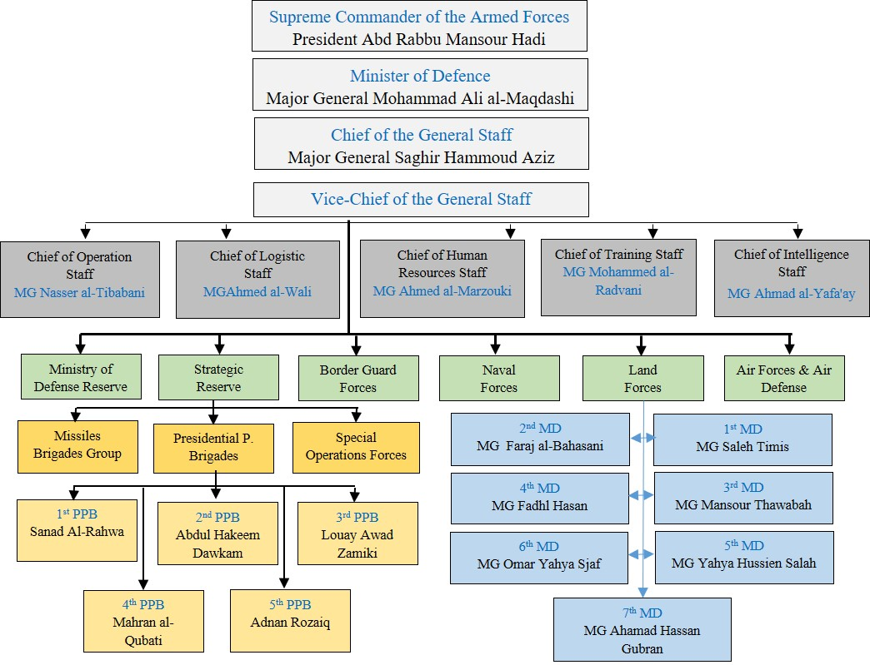

Appendix 2

De Facto Authorities Command and Control
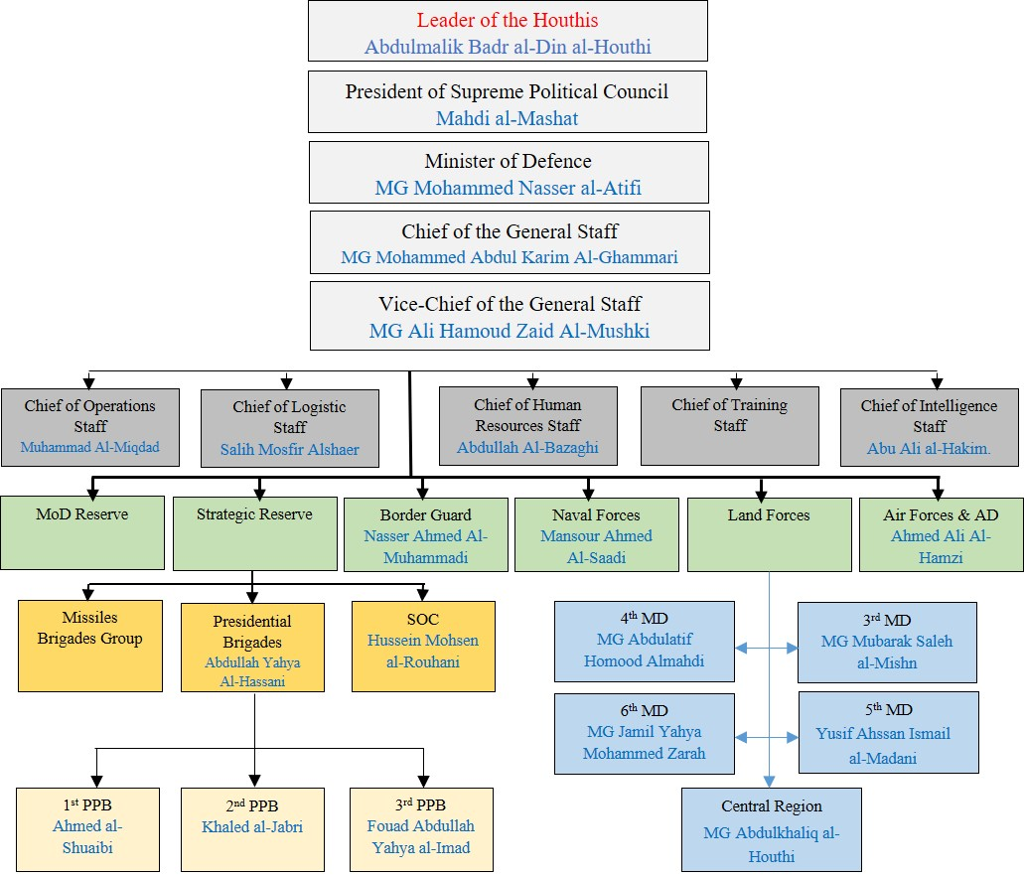

* The present report was submitted after the deadline so as to reflect the most recent developments.
** The annexes to the present report are circulated as received, in the languages of submission only.
That list is distinct from the mapping of main actors contained in annex IV.
A/HRC/45/6, paras. 10–13.
The term “de facto authorities” is used only to refer to the authorities based in Sana’a, where Ansar Allah as a political movement is the main actor, supported by an armed group referred to as the “Houthis”.
The de facto authorities, the coalition and the United Arab Emirates submitted observations on the previous report (A/HRC/45/6). Their observations will be made available at www.ohchr.org/EN/HRBodies/HRC/YemenGEE/Pages/Index.aspx.
According to the Yemen Data Project, a total of 8,772 civilians have been killed and 9,841 injured. Available at https://yemendataproject.org/. Information on airstrikes is also contained in annex I.
A/HRC/39/43, paras. 27–39; A/HRC/42/17, paras. 24–30; and A/HRC/45/6, paras. 26–31.
See the Coalition’s response, pp. 5–6, which will be made available at www.ohchr.org/EN/HRBodies/HRC/YemenGEE/Pages/Index.aspx.
A/HRC/39/43, paras. 40–45; A/HRC/42/17, paras. 31–42; and A/HRC/45/6, paras. 32–35. Information on shelling attacks is also contained in annex I.
See the Houthi’s response, which will be made available at www.ohchr.org/EN/HRBodies/HRC/YemenGEE/Pages/Index.aspx.
The “Joint Forces” in the west coast are backed by the United Arab Emirates, and are composed of the National Resistance/Guards of Republic, the Giants brigades and the Tuhamma brigades.
Office for the Coordination of Humanitarian Affairs, Humanitarian Response Plan: Yemen, March 2021, p. 5.
A/HRC/42/17, para. 53.
See the conference room paper containing the detailed findings of the Group of Eminent International and Regional Experts on Yemen on the situation of human rights in Yemen, including violations and abuses since September 2014 (A/HRC/45/CRP.7), available on the webpage of the Group (www.ohchr.org/EN/HRBodies/HRC/YemenGEE/Pages/Index.aspx), paras. 126–135.
See the conference room paper containing the detailed findings of the Group of Eminent International and Regional Experts on Yemen on the situation of human rights in Yemen, including violations and abuses since September 2014 (A/HRC/42/CRP.1), para. 364; and A/HRC/45/CRP.7, paras. 107 and 134.
A/HRC/39/43, annex II, paras. 25–30.
A/HRC/45/CRP.7, para. 145.
Ibid., paras. 117–121.
Safeguarding Health in Conflict Coalition, No Respite: Violence against Health Care in Conflict (May 2021), p. 78
A/HRC/42/CRP.1, para. 560.
A/HRC/39/43, para. 36.
A/HRC/42/17, para. 26.
A/HRC/45/6, para. 37.
A/HRC/39/43, paras. 65–80; A/HRC/42/17, paras. 57–68; and A/HRC/45/CRP.7, paras. 148–181.
See https://migration.iom.int/reports/yemen-%E2%80%94-flow-monitoring-points-migrant-arrivals-and-yemeni-returns-2020.
A/HRC/39/43, para. 34; and A/HRC/45/CRP.7, paras. 81–82.
See, for instance, A/HRC/45/CRP.7, paras. 194–204.
A/HRC/42/CRP.1, paras. 639–643 and 823–832; and A/HRC/45/CRP.7, paras. 304–309.
See www.smc.gov.ye/archives/14212 (in Arabic).
Available at www.ansarollah.com/archives/421005.
See www.almasirah.com/post/181849/%D9%83%D9%84%D9%85%D8%A9-%D8%A7%D9%84%D8%B3%D9%8A%D8%AF-%D8%B9%D8%A8%D8%AF%D8%A7%D9%84%D9%85%D9%84%D9%83-%D8%A8%D8%AF%D8%B1-%D8%A7%D9%84%D8%AF%D9%8A%D9%86-%D8%A7%D9%84%D8%AD%D9%88%D8%AB%D9%8A-%D9%81%D9%8A-%D8%A7%D9%84%D8%B0%D9%83%D8%B1%D9%89-%D8%A7%D9%84%D8%B3%D9%86%D9%88%D9%8A%D8%A9-%D9%84%D9%84%D8%B4%D9%87%D9%8A%D8%AF-%D8%A7%D9%84%D9%82%D8%A7%D8%A6%D8%AF (in Arabic).
A/HRC/39/43, paras. 76 and 81–85; A/HRC/42/17, paras. 69–73; and A/HRC/45/6, paras. 60–67 and 89.
A/HRC/45/CRP.7, para. 108.
Ibid., para. 356; and A/HRC/45/6, para. 89.
A/HRC/42/CRP.1, paras. 395–402 and 650–654; and A/HRC/45/6, para. 70.
The Zainabiyat are Houthi women’s security groups, trained to support the Houthis by, inter alia, maintaining order in detention facilities.
Office for the Coordination of Humanitarian Affairs, Humanitarian Needs Overview: Yemen, February 2021, p. 4.
A/HRC/42/CRP.1, para. 672.
Ibid., paras. 687–688; and A/HRC/45/CRP.7, paras. 260–263.
A/HRC/45/CRP.7, paras. 247–253.
Ibid., para. 270.
A/75/873-S/2021/437, para. 195.
A/HRC/42/CRP.1, para. 703.
Ibid., para. 624.
United Nations Children’s Fund, “Education disrupted: impact of the conflict on children’s education in Yemen”, July 2021, p. 6.
A/HRC/45/CRP.7, para. 283.
World Economic Forum, Global Gender Gap Report 2021: Insight Report – March 2021, p. 10.
A/HRC/42/CRP.1, para. 616.
A/HRC/42/17, para. 77; and A/HRC/45/CRP.7, paras. 194–204.
A/HRC/42/CRP.1, para. 633; and A/HRC/45/CRP.7, paras. 214–222.
A/HRC/45/6, para. 70; and A/HRC/45/CRP.7, paras. 205–213.
A/HRC/45/CRP.7, para. 346.
Yemeni Bar Association’s statement, 2 May 2021, available at www.sanaalawyers.org/modules.php?name=News&file=article&sid=1728 (in Arabic).
A/HRC/45/6, para. 70.
A/HRC/39/43, para. 86.
A/HRC/42/CRP.1, para. 635.
This annex represents the main actors in Yemen during the reporting period, and is separate and distinct from the strictly confidential list of alleged perpetrators that is provided to the United Nations High Commissioner for Human Rights.
Replaced General Abdulrahman bin Saleh al-Bunyan who had this post since 2014. See: https://www.spa.gov.sa/viewfullstory.php?lang=en&newsid=1729621.
On 31 August 2020, Prince Lieutenant General Fahad bin Turki was replaced by Lieutenant General Mutlaq, Deputy Chief of the General Staff, as Acting Commander of the Joint Forces. See: https://www.spa.gov.sa/viewstory.php?lang=en&newsid=2127629.
Replaced Prince Lieutenant General Fahad bin Turki bin Abdalazeez. See: https://saudigazette.com.sa/article/529303.
Replaced Major General Mohammed Saleh al-Outaibi. See: https://www.spa.gov.sa/viewstory.php?lang=en&newsid=1729618.
Replaced Admiral Abdullah bin Sultan bin Mohammad al-Sultan. See: https://www.tacticalreport.com/saudi-admiral-al-ghufaili-new-rsnf-commander/.
Replaced Lieutenant General Mohammed bin Awadh bin Mansour Suhaim. See: http://www.defense-aerospace.com/articles-view/release/3/191093/surprise-reshuffle-of-top-saudi-military-leaders.html.
See: http://www.saudpost.com/44415/ also, see: https://alwatanalan.com/?p=48620.
See: https://freedom-ye.com/tweet/5234.
Seeh :ttp://www.alriyadh.com/1815418.
See: https://almasdaronline.com/articles/179006. Also, see: https://www.spa.gov.sa/2005057.
See: http://www.saudpost.com/44415/.
Major General Yusef al-Shahrani was appointed to replace Major General Abdul Hameed al-Muzaini. See: http://www.ypagency.net/278376.
See: https://www.spa.gov.sa/viewstory.php?lang=ar&newsid=2020433.
See: http://www.masa-press.net/2018/11/11/%D8%A7%D9%84%D8%B3%D8%B9%D9%88%D8%AF%D9%8A%D8%A9-%D8%AA%D9%88%D8%B3%D8%B9-%D9%85%D9%86-%D9%85%D8%B7%D8%A7%D9%85%D8%B9%D9%87%D8%A7-%D8%A8%D8%A7%D9%84%D9%8A%D9%85%D9%86-%D8%A7%D9%84%D8%AC%D9%88%D9%81/.
On 3 March 2021 he retired. See: https://h2a1.com/%D8%A7%D9%84%D8%B9%D9%85%D9%8A%D8%AF-%D8%A7%D9%84%D8%B1%D9%83%D9%86-%D8%AD%D8%B3%D9%86-%D8%A8%D9%86-%D8%B9%D8%A8%D8%AF-%D8%A7%D9%84%D9%84%D9%87-%D8%A7%D9%84%D8%B4%D9%87%D8%B1%D9%8A-%D9%8A%D8%AA%D8%B1/.
See: https://ajel.sa/zNRrWb/.
See: https://uaecabinet.ae/en/details/news/ chief-of-staff-of-armed-forces-promoted-to-the-rank-of-minister.
Ibid.
See: https://wam.ae/ar/details/1395302915320
Ibid.
Ibid.
His rank Major General (Rear Admiral).
The leader of the Arab Alliance on the West Coast of Yemen talks about a qualitative operation for the “liberation of Hudaydah”, Middle East, https://arabic.cnn.com/middle-east/article/2018/09/18/saudi-led-coalition-launches-offensive-strategic-yemeni-port-city, September 2018. Also, Brigadier General Ali Al-Tanaiji. “Commander of major battles against Houthi coup in Yemen”, Al-Ain, 18 September 2018. See: https://al-ain.com/article/al-hodeidah-yemen-arab-alliance-al-taniji.
Hadi meets with coalition commander in Aden, stresses need for coordination, al-mawqea post, 18 July 2018. Available at: https://almawqeapost.net/news/32379. Also, see: Al-Islah leader detained by pro-Uae forces released in Aden, Alquds, 18 July 2018, available at: https://www.alquds.co.uk/%EF%BB%BF%D8%A7%D9%84%D8%A5%D9%81%D8%B1%D8%A7%D8%AC-%D8%B9%D9%86-%D9%82%D9%8A%D8%A7%D8%AF%D9%8A-%D9%81%D9%8A-%D8%AD%D8%B2%D8%A8-%D8%A7%D9%84%D8%A5%D8%B5%D9%84%D8%A7%D8%AD-%D8%A7%D8%AD%D8%AA%D8%AC.
In the presence of the leader of the Arab coalition. Emergency forces launch second phase of training year, al-ayyam, 16 July 2019. Available at: https://www.alayyam.info/news/7V89EB9O-3B9G6V-A58A. Also see: https://www.alwatanvoice.com/arabic/news/2019/07/15/1259578.html. Arab Coalition Commander Visits Facility Protection Brigade Camp, see: https://www.cratersky.net/posts/19296.
West Coast Coalition Commander Announces Complete Liberation of Hudaydah Airport, Sky news, 20 June 2018, see: https://www.skynewsarabia.com/middle-east/1065290.
See: https://www.alwattan.net/news/114450.
Presidential Decree 48 (2016). https://www.facebook.com/alimohsensalehalahmar/posts/1011971235550346/.
Presidential Decree 71 (2018). Available at: https://buyemen.net/news67338.html. Also available at https://almasdaronline.com/article/republic-decrees-appointing-minister-of-defence-chief-of-staff-and-governor-of-aden. Also, see UN document S/2019/83.
Replace Major General Abdullah Salem Ali Al-Nakhai.
Presidential Decree 10 (2020). Available at: https://almasdaronline.com/articles/178267.
Presidential Decree 182 (2018). Available at: https://www.almashhad-alyemeni.com/121600.
Presidential Decree 12 (2019). Available at: https://naba-ye.com/news1105.html.
See: https://almasdaronline.com/articles/212047.
Ibid.
Ibid.
Ibid.
Presidential Decree 154 (2016). Available at: https://www.almashhad-alyemeni.com/61690.
On 29 June 2017, President Hadi named Major General Faraj al-Bahasani, Governor of Hadramaut, to replace Major General Ahmed bin Breik, Presidential Decree 34 (2017) available at: https://buyemen.net/news48340.html. Also see: https://arabic.sputniknews.com/arab_world/201508161015325772.
See: https://almahriah.net/local/6166.
Yemen’s Southern Powder keg, Chatham House, Peter Salisbury, 2018. Presidential Decree 155 (2016).
Presidential Decree 20 (2018). Available at: https://www.almashhad-alyemeni.com/104230. Also, see: https://www.youtube.com/watch?v=tbu9zpVUNPM.
Replaced Major General Ameen al-Waeli who was killed on 26 March 2021 in the battle for Ma’rib. See: https://almashhadalkhaleeji.com/news27927.html.
Presidential Decree 10 (2020). See: http://aden-tm.net/NDetails.aspx?contid=114859.
The 1st Brigade was specifically named in the Military Arrangements annex of the Riyadh Agreement.
Before that it was based in the Presidential Palace in Aden’s Crater district.
The Presidential Protection Brigades: Hadi’s muscle in the south, 11 May 2020. Available at: https://al-masdaronline.net/national/771.
This brigade’s forces have been protecting the vice president since 2017, while some units in the brigade are fighting on the front lines between Ma’rib and Sana’a.
Presidential Decree 51 (2019). Available at: https://www.facebook.com/1784290338507592/photos/a.1795004187436207/2304017236534897/?type=3. Also, see: https://mandabpress.com/news55247.html.
See: Who rules the grip on the interim capital? Available at: https://almasdaronline.com/articles/168745.
The brigade suffered heavy losses in January 2020 when the Houthis fired a ballistic missile at the Reception camp, killing more than 110 people. See: https://almawqeapost.net/news/47339.
Military commanders appointed to merge southern resistance with army. See: http://www.al-mlab.com/news/437489.
See: https://almasdaronline.com/articles/171279.
Presidential Decree 67 (2019). Available at: http://alwattan.net/news/79294.
See: https://almasdaronline.com/articles/171279.
On 11 March 2017 appointed as a governor, Presidential Decree 20 (2017). Available at: https://almawqeapost.net/news/17543, also at: http://aden-tm.net/NDetails.aspx?contid=22963.
See: https://adengad.net/post/amp/288548
Presidential Decree 45 (2018). Available at: https://almandeb.news/?p=98572. Also see: https://www.eremnews.com/news/arab-world/yemen/1247463.
See: https://yemen-press.com/news116823.html.
Brigadier General Hamza al-Jadani assigned acting commander of 119th Infantry Brigade. See: http://www.marsad.news/news/31106 also see: https://golden.news/articles/28313/.
See: https://www.alminasapress.com/news266698.
Replaced Brigadier General Ali Mohammad al-Qamali who died in June 2020. See: https://www.alwattan.net/news/129124.
UN Document, S/2020/326, Annex 10. Available at: https://undocs.org/ar/S/2020/326.
Presidential Decree 6 (2017). Available at: https://aden-alhadath.info/news/17275, also available at: https://www.aden-tm.net/NDetails.aspx?contid=20035.
UN Documents, S/2020/326. Annex 10. Available at: https://undocs.org/ar/S/2020/326.
UN Documents S/2019/83, Annex 8. Available at: https://undocs.org/en/S/2019/83.
Ibid.
See: https://www.deeproot.consulting/single-post/2018/08/16/caught-in-the-middle-a-conflict-mapping-of-taiz-governorate.
See: http://newsyemen.news/new/60836.
Replacing Brigadier General Sadiq Sarhan. See: https://yemennownews.com/details/1147340.
Presidential Decree 33 (2020). See: https://www.almashhadalaraby.com/amp/199770.
See: https://almadaniya.net/articles/1150.htm.
See: http://yemeninews.net/show1471967.html.
Transport Brigade Commander Amjad Khalid promoted to Brigadier General. Available at: https://www.almashhad-alyemeni.com/150504.
S/2020/326. Annex 8. Available at: https://undocs.org/ar/S/2020/326.
See: https://www.almashhad-alyemeni.com/143979.
Replaced Zaid al-Shoumi who was killed in January 2020.
Presidential Decree 37 (2018). Available at: http://aden-tm.net/NDetails.aspx?contid=43845.
See: https://almawqeapost.net/news/49368.
He replaced Brigadier General Abdo al-Habaishi in February 2021. On 6 May 2021, he rejected the chief of staff’s orders to hand over the brigade to Brigadier General Sadiq Moawada. See: https://almashhad-alduali.com/news12330.html.
All brigades have deployed to Hajjah fronts, and belong to the 5th MD except Al Fursan brigade. These brigades are under the operational control of the Task Force 800, Saudi-led Coalition.
See: https://alarshnews.net/?p=6292.
See: https://yemen-press.net/news99470.html.
See: http://newsyemen.news/new/35983.
Ibid.
Replaced Brigadier General Bilal Shedawah.
See: http://newsyemen.news/new/35983.
See: https://sabanew.net/story/ar/63038.
Ibid.
Al-Fursan brigade is an independent brigade backed by Saudi Arabia.
These brigades are under the operational control of Task Force 1501, SLC. Some of these brigades are led by Salafist leaders backed by Saudi Arabia. Some of the brigades do not exceed 100 persons.
See: https://www.almashhad-alyemeni.com/125453.
See https://www.26sep.net/index.php/local/35-26sept/army/3603-40.
Al Fateh brigade is an independent brigade backed by Saudi Arabia.
Al Tawhid brigade is an independent brigade backed by Saudi Arabia.
See: https://www.youtube.com/watch?v=N2Cyo6F-Pew.
See: https://lahjpress.com/news/15498.
See: https://www.al-tagheer.com/news109622.html.
Presidential Decree 115 (2016). Available at: https://www.yen-news.net/news25103.html.
Presidential Decree 35 (2020). Available at: https://www.spa.gov.sa/viewfullstory.php?lang=ar&newsid=2115408.
Presidential Decree 7 (2020). Available at: https://www.sabanew.net/viewstory/69728.
Ibid.
Presidential Decree 5 (2020). Available at: https://www.spa.gov.sa/viewfullstory.php?lang=ar&newsid=2115408.
UN Document, S/2018/68. Available at: https://undocs.org/en/S/2018/68.
Presidential Decree 76 (2018). Available at: https://almawqeapost.net/reports/37080.
Presidential Decree 79 (2018). Available at: https://almawqeapost.net/news/37080.
Presidential Decree 96 (2016). Available at: https://suhail.net/news_details.php?lng=arabic&sid=5222.
See: https://adengd.net/news/294350/.
Presidential Decree 40 (2018). Available at: https://www.spa.gov.sa/1774040?lang=ar&newsid=1774040.
Presidential Decree 34 (2017). Available at: https://buyemen.net/news48340.html.
Presidential Decree 1 (2020). Available at: https://almahrahpost.com/news/15507#.Xv2C1SgzaUk.
Presidential Decree 30 (2018). Available at: https://www.sabanew.net/viewstory/31699.
See: https://aden24.net/news/74065.
See: http://aden-tm.net/NDetails.aspx?contid=17541.
See: https://imoyemen.com/news/7726.
Ministerial Decree 33 (2016). Available at: https://shabwaah-press.info/news/35417.
Presidential Decree 1 (2018). Available at: https://yemenshabab.net/locales/31572.
Presidential Decree 7 (2019). Available at: https://yemenpressapp.info/news106432.html.
See: https://www.almashhad-alyemeni.com/131767.
See: https://almawqeapost.net/news/50531.
See: https://almawqeapost.net/news/32281.
Presidential Decree 34 (2019). See: https://sahafahnet.com/show6492465.html.
See: https://www.alwattan.net/news/84397.
Replaced Brigadier General Abdul Ghani al-Sha’alan, who was killed at the Battle of Ma’rib. See: https://www.almashhad-alyemeni.com/196078.
The Southern Transitional Council was established in 2017, headed by Adroos Al-Zubaidi. His deputy is Sheikh Hani bin Brik. STC inherited the entirety of the military forces established by the UAE in Aden and other southern governorates.
Decree of the Southern Transitional Council President 13 (2021), which includes the transfer of the headquarters of the Support Brigade, its brigades outside Aden, and its incorporation within the southern armed forces under the Ministry of Defence. See: https://stcaden.com/news/15076.
Ibid.
Ibid.
Decree of the Southern Transitional Council President 14 (2021), which includes in article 4 that the Security Belt Forces carry out security and police tasks and operate within the Ministry of Interior. See: https://stcaden.com/news/15077.
Ibid.
Ibid.
See: https://almandeb.news/?p=245302.
The Daily Mail, 24 March 2015. http://www.dailymail.co.uk/wires/ap/article-3009836/In-south-Yemen-militia-leader-presidents-ally.html.
Nadwa Al-Dawsari, “The Popular Committees of Abyan: A Necessary Evil or an Opportunity for Security Reforms?” Middle East Institute, March 5, 2014, https://www.mei.edu/publications/popular-committees-abyan-yemen-necessary-evil-or-opportunity-security-reform.
See: https://www.4may.net/news/43846.
New appointments in the leadership of the Security Belt in Lahj, 22 December 2018, see: https://almashhadalaraby.com/news/58755 . Also, see: https://cratersky.net/posts/7810.
UN document S/2019/83 and UN document S/2018/68 annex 6. Also, see: https://www.marsad.news/news/77129. And https://almashhadalaraby.com/news/101775; https://almashhadalaam.com/posts/6593.
See: https://almandeb.news/?p=255528.
On 29 May, STC President Aidarous al-Zubaidi appointed Shallal as commander of the Counter-Terrorism Unit within the STC forces. See: https://stcaden.com/news/14826.
Press interview with commander of Shabwah Elite Forces, Al-Omana post, 2 November 2017, https://al-omana.com/news65261.html.
S/2020/326, Annex 10. Available at: https://undocs.org/en/S/2020/326.
UN document S/2018/68. Available at: https://undocs.org/en/S/2018/68.
Ibid.
See: https://www.alayyam.info/news/89YGUE54-DRXX6P-DF70.
Giants brigades are armed groups created between 2016 and 2019, emerging from the Southern Resistance in Aden, Lahj and Abyan. They are led by Abu Zar’a Abd al-Rahman Al-Muharrami Al-Yafei.
See: https://almasdaronline.com/articles/212047.
See: https://reliefweb.int/report/yemen/who-are-uae-backed-forces-fighting-western-front-yemen.
See: https://abaadstudies.org/news-59781.html. Also, see: https://almasdaronline.com/article/source-assignment-of-major-general-haitham-qassem-as-a-commander-of-a-military-council-leading-combat-operations-on-the-west-coast. Also see: https://reliefweb.int/report/yemen/who-are-uae-backed-forces-fighting-western-front-yemen.
Ibid.
UN document, S/2019/206. Available at: https://undocs.org/en/S/2019/206.
https://abaadstudies.org/news-59781.html. Also, see: https://almasdaronline.com/article/source-assignment-of-major-general-haitham-qassem-as-a-commander-of-a-military-council-leading-combat-operations-on-the-west-coast; https://reliefweb.int/report/yemen/who-are-uae-backed-forces-fighting-western-front-yemen.
UN document, S/2019/206. Available at: https://undocs.org/en/S/2019/206.
Ibid.
See: https://almawqeapost.net/reports/44483.
Ibid.
UN document, S/2019/206. Available at: https://undocs.org/en/S/2019/206.
Ibid.
See: https://almasdaronline.com/articles/212047.
United Nations Security Council, available at: https://www.un.org/securitycouncil/sanctions/2140/materials/summaries/individual/abdulmalik-al-houthi.
On 24 April 2019, the House of Representatives granted Mahdi Al-Mashat the rank of marshal. Available at: https://www.yemenipress.net/archives/143698.
See: https://almasdaronline.com/articles/165447.
See: https://ar-ar.facebook.com/ymmalshami/.
See: https://almasdaronline.com/articles/222905.
SPC decree 41 of 2019. See: https://www.ansarollah.com/archives/229061.
SPC Decree 6 (2020). Available at: http://althawrah.ye/archives/621176.
Replacing Major General Zakaria Yahya al-Shami who died on 21 March 2021. SPC Decree 31 (2021). See: https://www.saba.ye/ar/news3137707.htm.
SPC Decree 31 (2021). See: https://www.saba.ye/ar/news3137707.htm.
SPC Decree 11 (2018). Available at: https://laamedia.net/news.aspx?newsnum=18890.
SPC Decree 90 of 2019. Available at: http://en.althawranews.net/2019/05/president-al-mashat-appoints-minister-of-interior/.
UN document S/2021/79, para 46. Available at: https://undocs.org/en/S/2021/79.
SPC Decree 133 (2019). Available at: http://althawrah.ye/archives/583978. Also see: SPC Decree 201 (2019). Available at: http://althawrah.ye/archives/600344. Leadership of SCMCHA remains unchanged from its predecessor, with Abdul Mohsen Abdullah Qasim Attawoos continuing as secretary general, see: Sana’a Center, the Yemen Review, November 2019, Houthis Replace Aid Coordination Body, available at: https://sanaacenter.org/publications/the-yemen-review/8501#Houthis-Replace-Aid-Coordination-Body.
UN Documents, S/2020/326. Annex 7. See: https://undocs.org/en/S/2020/326.
See: https://sanctionssearch.ofac.treas.gov/Details.aspx?id=30623.
See: https://sanctionssearch.ofac.treas.gov/Details.aspx?id=30624.
Decree 56 (2016). Available at: https://yemen-nic.info/ministations/detail.php?ID=10028.
See: https://sanctionssearch.ofac.treas.gov/Details.aspx?id=31193.
UN documents, S/2018/68 and S/2019/83.
United Nations Security Council, available at: https://www.un.org/securitycouncil/sanctions/2140/materials/summaries/individual/abdullah-yahya-al-hakim.
See: https://al-ain.com/article/al-hakim-a-houthi-terrorist-with-the-rank-of-chief-of-intelligence.
See: https://sanctionssearch.ofac.treas.gov/Details.aspx?id=17386.
See: https://www.26sep.net/index.php/local/17860-2021-06-11-14-36-02.
UN document, S/2018/68, available at: https://undocs.org/en/S/2018/68.
See: http://althawrah.ye/archives/675475.
See: https://sanctionssearch.ofac.treas.gov/Details.aspx?id=31195.
See: https://www.yemenipress.net/archives/129814.
See: https://sanctionssearch.ofac.treas.gov/Details.aspx?id=31194.
See: https://www.yemenipress.net/archives/129814.
SPC Decree 25 (2017). Available at: https://www.ansarollah.com/archives/90120.
See: http://althawrah.ye/archives/608851.
See: https://adennews.net/100968.
See: https://www.26sep.net/index.php/newspaper/26topstory/6056-2021-01-10-19-24-44.
See: https://yemenisport.com/print/641626.
See: http://www.ypagency.net/362963.
See: https://www.almashhad-alyemeni.com/161287.
Ibid.
See: https://sanctionssearch.ofac.treas.gov/Details.aspx?id=31971.
See: https://yemenshabab.net/news/60419.
SPC Decree 171 (2018). Available at: http://yemen-tv.net/index.php?mod=contents&do=view&cid=51&id=13284.
Security Council 2140 Sanctions Committee amends two entries on its List. Available at: https://www.un.org/press/en/2016/sc12493.doc.htm.
See: https://sanctionssearch.ofac.treas.gov/Details.aspx?id=17368.
Security Council 2140 Sanctions Committee amends two entries on its List. Available at: https://www.un.org/press/en/2016/sc12493.doc.htm.
UN document, S/2017/81. Available at: https://undocs.org/en/S/2018/81.
See: https://www.saba.ye/ar/news3110811.htm.
See: https://www.26sep.net/index.php/newspaper/26topstory/6056-2021-01-10-19-24-44.
See: https://yemen-press.net/news50374.html.
See: https://www.saba.ye/ar/news3084419.htm.
See: https://www.saba.ye/ar/news3138232.htm.
See: https://yemenshabab.net/news/60419.
See: https://www.26sep.net/index.php/newspaper/26topstory/6056-2021-01-10-19-24-44.
See: https://adennews.net/100968.
See: https://aden24.net/news/91005.
How al-Qaeda leader Harith al-Azi escaped to the Houthis. What is the reality of appointing him to manage Ibb security (details), Taiz online, January 2019. Available at: https://taizonline.com/news13232.html.
See: https://www.saba.ye/ar/news3120317.htm.
See: https://www.saba.ye/ar/news481408.htm?utm=sahafah24com_D.
Decree 32 (2021). See: https://www.saba.ye/ar/news3137708.htm.
See: https://almahrahpost.com/news/18791#.YRNeKnnV7IU.
Decree 37 (2021). See: https://www.saba.ye/ar/news3142612.htm.
Decree 37 (2021). See: https://www.saba.ye/ar/news3142612.htm.
Ibid.
He is also the general supervisor of al-Saleh prison. See https://yemen-press.net/news111720.html.
See: https://almethaqnews.com/news51956.html.
“Ansar Allah” Chants (2/2): Prophecies of Hussein Fulfilled? Al-Arabi, May 2016. Available on: https://www.al-arabi.com/s/2062.
The appearance of “The Hodeidah Butcher” next to General Kamret sparks a lot of controversy, 25 December 2018, available at: https://mancheete.com/posts/3946. Also see: Arab coalition’s 39th wanted image angers Yemenis, Erem news. Available at: https://www.eremnews.com/news/arab-world/yemen/1620129.
Two Houthi leaders killed on west coast, Mandab press, 14 June 2018. Available at: https://www.mandabpress.com/news49514.html.

