A/HRC/49/CRP.5
25 March 2022

English only
Human Rights Council
Forty-ninth session
28 February–1 April 2022
Agenda item 10
Technical assistance and capacity-building
Situation of human rights in Ukraine:
1 August 2021 to 31 January 2022
Office of the United Nations High Commissioner for Human Rights
Conference room paper
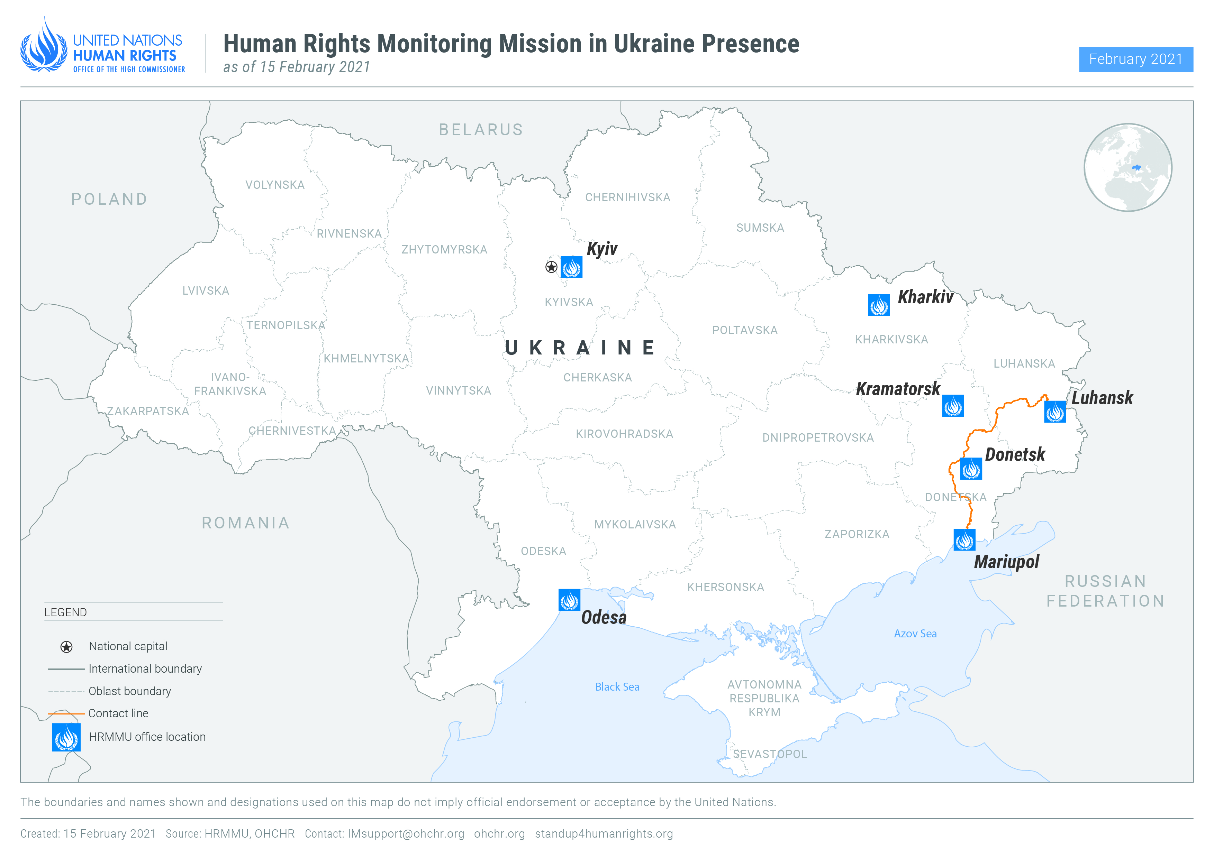
- Executive summary
- This thirty-third report by the Office of the High Commissioner for Human Rights (OHCHR) on the human rights situation in Ukraine covers the period from 1 August 2021 to 31 January 2022. It is based on the work of the United Nations Human Rights Monitoring Mission in Ukraine.
- The reporting period of this report predates the armed attack by the Russian Federation against Ukraine which commenced on 24 February 2022. The serious human rights violations and international humanitarian law violations arising out of that attack will be covered in other OHCHR publications including the thirty-fourth report on the human rights situation in Ukraine.
- During the reporting period, OHCHR recorded a total of 49 civilian casualties (11 killed and 38 injured), which was 21 per cent lower compared with the previous six months. Thirty-two civilian casualties resulted from armed engagements, with 78 per cent of these recorded in territory controlled by self-proclaimed ‘republics’, and 22 per cent in Government-controlled territory. The majority of these occurred from August to November 2021, with significantly less civilian casualties recorded in December 2021 and January 2022.
- The number of security incidents that affected civilian objects (both civilian infrastructure and civilian housing) also increased considerably, albeit with a significant fall during the period of December 2021 to January 2022. These incidents endangered civilian lives and also infringed their right to housing.
- The conflict continued to impact over 3.4 million civilians, including due to COVID-19 related movement restrictions, mostly imposed by armed groups. These restrictions resulted in a 95 per cent reduction in the number of crossings of the contact line in eastern Ukraine, compared with the same period in 2019. Restrictions on freedom of movement severely affected the rights to education, family life, health, work, social security, adequate standard of living, and access to judicial and civil documentation.
- OHCHR welcomes the Cabinet of Minister’s decision on the adoption of the IDP Integration Strategy until 2024. OHCHR is concerned, however, that the Law “On State Budget of Ukraine for 2022” does not envisage funding for durable housing solutions for the most vulnerable IDPs that live in collective centers.
- OHCHR welcomes the launch of the e-court system that should increase the accessibility of courts for residents of armed group-controlled territory. OHCHR continues to urge the Government of Ukraine to introduce an administrative procedure for the registration of births and deaths that occur in armed group-controlled territory.
- OHCHR welcomes the simplification of the procedure for civilians, whose housing in Government-controlled territory was destroyed by hostilities, to claim compensation. OHCHR regrets, however, the exclusion of residents of armed group-controlled territory and IDPs from the procedure, as it covers only residents of Government-controlled territory who have remained in the same settlement where their housing was destroyed. Similarly, OHCHR welcomes the registration of draft laws that introduce compensation for all lost property but regrets that they also exclude residents of armed group-controlled territory.
- OHCHR welcomes the decision of the Cabinet of Ministers on 25 January 2022 to withdraw the draft “On the principles of State policy of the transition period” from Parliament, and urges authorities to comply with international standards when further elaborating policies or legislation on transitional justice.
- OHCHR continues to enjoy unimpeded access to official places of detention in Government-controlled territory, with the exception of one case where access has been delayed to a conflict-related detainee held in the custody of the Security Service of Ukraine (SBU).
- While OHCHR was granted confidential access to two men and two women in Luhansk pre-trial detention facility (SIZO) in August 2021, in territory controlled by self-proclaimed ‘Luhansk people’s republic’, no further access was granted in subsequent months, with requests denied on the basis of COVID-related restrictions. OHCHR documented 12 cases of conflict-related arbitrary detention in self-proclaimed ‘republics’, including one that occurred in 2021. The absence of access to places of detention continues to be of grave concern to OHCHR in light of the credible allegations of torture and ill-treatment received by OHCHR in a number of facilities.
- OHCHR is concerned that investigations into allegations of torture remain generally ineffective. This is particularly so in relation to previously documented cases involving credible allegations that SBU officers perpetrated torture and ill treatment. Many investigations either have been closed or make no meaningful progress for years.
- OHCHR commends the Government’s efforts to prosecute war crimes. At the same time, OHCHR also regrets that the President of Ukraine has still not signed the law “On amendments to certain legislative acts of Ukraine concerning the implementation of provisions of international criminal law and humanitarian law”.
- OHCHR remains concerned that ‘courts’ of self-proclaimed ‘republics’ continue to ‘sentence’ individuals for conflict-related crimes in proceedings that do not meet international fair trial standards and the passing of sentences in these circumstances may amount to a war crime. During the reporting period, OHCHR documented such ‘sentences’ being passed against 22 men and 2 women.
- OHCHR is also concerned with over-reliance by Ukrainian courts on pre-trial detention in criminal proceedings in a manner which may constitute arbitrary deprivation of liberty.
- OHCHR continues to document cases of attacks and threats against journalists, including bloggers, and media workers, in relation to their professional activities. OHCHR also notes with concern the practice of detaining journalists in apparent retaliation for their professional activities.
- OHCHR has been monitoring the impact of sanctions imposed by Ukrainian authorities, which resulted in the closure of three TV channels. Whilst it is a legitimate aim from a human rights perspective for states to counter terrorism, protect national security and public order, OHCHR is particularly concerned that the decisions taken by the National Security and Defence Council of Ukraine (NSDC) during the reporting period amount to undue restrictions on the right to freedom of expression, as they were not taken by an independent authority and did not meet the requirements of necessity and proportionality. In self-proclaimed ‘republics’, OHCHR continued to observe a lack of media coverage critical of or different from the official position of the ‘republics’ on various matters.
- OHCHR is concerned about the complete lack of accountability for past attacks on Roma settlements, including those in the village of Loshchynivka, Odesa region in 2016 and Vilshany, Kharkiv region in 2017. While OHCHR welcomes the increased public reactions of the Ombudsperson’s Office condemning hate speech, it notes the continuing lack of any legislative framework to prohibit incitement to violence, hostility and discrimination.
- OHCHR remains concerned about the situation of homeless people throughout the country. Five regions in Ukraine still lack public shelters. The situation of
persons with intellectual and psychosocial disabilities in long-term care facilities is equally concerning, where violations inter alia of the right to private and family life are widespread.
- In the Autonomous Republic of Crimea and the city of Sevastopol, Ukraine, occupied by the Russian Federation (Crimea), Russian Federation authorities continue to place significant restrictions on the exercise of the right of peaceful assembly. During the reporting period, at least 184 individuals were arrested while engaging in peaceful assemblies and OHCHR documented cases of incommunicado detention, enforced disappearances, torture and other ill-treatment perpetrated by the Federal Security Service of the Russian Federation.
- During the reporting period, OHCHR engaged in technical cooperation to build the capacity of the Government of Ukraine to strengthen human rights standards in governance. OHCHR provided technical expertise to the Ombudsperson’s office, regional and local administrations, the military and law enforcement, and civil society including human rights defenders. OHCHR continued to assist persons with intellectual and psychosocial disabilities with restoration of their legal capacity and referred ten more cases to the Ombudsperson.
- OHCHR methodology
- The report is based on information gathered during 83 field visits, 11 visits to places of detention, 97 trial hearings, 23 public assemblies, 38 visits to care institutions and shelters, and 1,125 interviews with victims and witnesses of human rights violations, as well as relatives of victims and their lawyers, Government representatives, members of civil society and other interlocutors. It also draws from information obtained from court documents, official records, open sources and other relevant material. Findings are based on verified information collected from primary and secondary sources that are assessed as credible and reliable. They are included in the report where the “reasonable grounds to believe” standard of proof is met, namely where, based on a body of verified information, an ordinarily prudent observer would have reasonable grounds to believe that the facts took place as described and where legal conclusions are drawn, that these facts meet all the elements of a violation. While OHCHR cannot provide an exhaustive account of all human rights violations committed throughout Ukraine, it obtains and verifies information through a variety of means in line with its methodology, and bases its conclusions on verified individual cases.
- OHCHR applies the same standard of proof when documenting conflict-related civilian casualties. In some instances, documenting conflict-related civilian casualties may take time before conclusions can be drawn, meaning that numbers of civilian casualties are revised as more information becomes available.
- Information in this report is used in full respect of informed consent by all sources as to its use as well as OHCHR’s assessment of any risk of harm that such use may cause. This may entail removing identifying details to ensure the confidentiality of some sources.
- The report also draws on engagements undertaken by the Government of Ukraine to implement the Sustainable Development Goals (SDGs) stemming from the United Nations Sustainable Development Summit in September 2015.

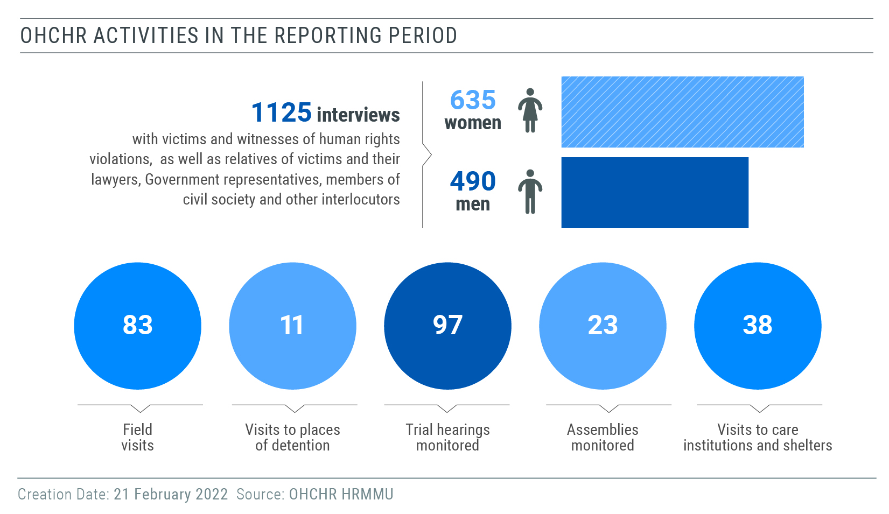
- Impact of hostilities
“We no longer hide in our basements when shelling takes place. What is the point? We are not alive anymore anyway.”
– an older resident of a village near the contact line
- Conduct of hostilities and civilian casualties
- The overall number of ceasefire violations during the reporting period was 57 per
cent higher than in the previous six months, as reported by the OSCE Special Monitoring Mission to Ukraine (SMM), the majority of which occurred from August to November 2021, with a considerable decrease in December 2021 and January 2022. Documented civilian casualties and damage to civilian objects caused by active hostilities followed the same pattern, with considerably lower numbers in December 2021 and January 2022.
- Civilian casualties
- From 1 August 2021 to 31 January 2022, OHCHR recorded 49 civilian casualties:
11 killed (6 men, 2 women and 3 adults whose sex is not yet known) and 38 injured (27 men, 8 women, 2 boys and 1 girl), a 21 per cent decrease compared with the preceding six months (63 civilian casualties: 15 killed and 48 injured).
- Thirty-two civilian casualties resulted from armed engagements: three killed (two
men and one woman) and 29 injured (20 men, 7 women, 1 girl and 1 boy), a 129 per cent increase compared with the preceding six months (14: 5 killed and 9 injured). Seventy-eight per cent of these (two killed and 23 injured) were recorded in territory controlled by self-proclaimed ‘republics’, and 22 per cent (one killed and six injured) in Government-controlled territory. For example, on 11 August 2021, a man was killed by shelling in Government-controlled Novoselivka Druha (Donetsk region) while he was in his garden, leaving his wife of 55 years a widow. On 17 August 2021, a woman was injured by shelling in Government-controlled part of Zolote (Luhansk region) while returning to her house. On 30 October 2021, one man was killed and two men injured by an explosive device dropped from an UAV in armed group-controlled Holmivskyi (Donetsk region). The victims were finishing their work on a farm and getting into a car when the incident occurred. On 30 November 2021, a man was hospitalized with multiple injuries from small arms fire in armed group-controlled Donetsk. The doctors had to amputate his one remaining leg, after he had already lost the other leg in 2015 in a mine-related incident.
- Eleven casualties resulted from mine-related incidents and handling of explosive
remnants of war (ERW): three killed (two men and one woman) and eight injured (seven men and one boy). Forty-five per cent (one killed and four injured) were recorded in territory controlled by self-proclaimed ‘republics’, and 55 per cent (two killed and four injured) in Government-controlled territory. For example, on 16 September 2021, a 14-year old boy, born in 2007, was injured as a result of having detonated a hand grenade fuse in armed group-controlled Luhansk. On 9 December 2021, a woman was killed and two men injured when one of the men detonated a hand grenade during a domestic dispute in Government-controlled Zvirove (Donetsk region).
- Other civilian casualties recorded during the reporting period (four killed and one
injured) resulted from the presence on a daily basis of armed actors among the civilian population (escalations of force incidents, road incidents with military, and killings of civilians by military outside of hostilities). For example, on 12 August 2021, three civilians were shot dead by an intoxicated member of armed groups in an apparent random episode of violence near armed group-controlled Sakhanka and Uzhivka (Donetsk region).
- Civilian casualties during the entire conflict period
- During the entire conflict period, from 14 April 2014 to 31 January 2022, OHCHR
recorded a total of 3,107 conflict-related civilian deaths (1,853 men, 1,072 women, 102 boys, 50 girls, and 30 adults whose sex is unknown). Taking into account the 298 people on board Malaysian Airlines flight MH17 which was downed on 17 July 2014, the total civilian death toll of the conflict has reached at least 3,405. The number of injured civilians is estimated to exceed 7,000.
- Damage to civilian objects as a result of hostilities
- OHCHR continued to record security incidents in the conflict zone that affected
civilian objects (both civilian infrastructure and civilian housing). From 1 August 2021 to 31 January 2022, OHCHR recorded 58 incidents in which civilian infrastructure was either destroyed, damaged or otherwise affected by shelling, small arms and light weapons fire (SALW) and improvised explosive devices dropped from UAVs: 47 (81 per cent), in armed group-controlled territory and 11 (19 per cent) in Government-controlled territory. This represented a 115 per cent increase compared with the preceding six months, when 27 such incidents were recorded. These incidents endangered civilians in and near these objects, and affected the population’s access to essential services.
- For instance, on 5 August 2021, SALW fire damaged the façade of a medical
facility in the Government-controlled part of Zolote (Luhansk region). On 13, 15 and 30 October 2021, a secondary school in the armed group-controlled part of Zolote (Luhansk region) sustained multiple damages from shelling and SALW fire, repeatedly putting students and teaching staff at risk. On 21 September 2021, shelling damaged a boarding school in armed group-controlled Yasynuvata (Donetsk region) and forced over 100 students and staff members to flee to a bomb shelter.
- From 1 August to 31 January 2022, OHCHR recorded 237 cases of civilian housing
damaged or destroyed by shelling and SALW fire: 123 (four destroyed and 119 damaged houses or residential apartment buildings) in armed group-controlled territory and 114 (six destroyed 108 damaged houses or residential apartment buildings) in Government-controlled territory. These incidents endangered civilian lives and negatively impacted their enjoyment of the right to adequate housing, which was particularly concerning in winter months. OHCHR notes the fact that the number incidents of damage to civilian housing decreased significantly in December 2021 and January 2022.
- For instance, on 14 and 17 November 2021, three houses were destroyed and 26
were damaged by shelling in Government-controlled Nevelske (Donetsk region), resulting in the displacement of 42 residents. On 17 September 2021, shelling damaged eight houses in in armed group-controlled Donetsk. On 29 November 2021, shelling damaged three houses and four residential apartment buildings in armed group-controlled Mykolaivka (Luhansk region).
B. Impact of the conflict and COVID-19 on the population in the conflict zone
1. Freedom of movement
36. During the reporting period, the Government continued to keep all seven entry-exit crossing points (EECPs) open for crossing the contact line. Self-proclaimed ‘republics’, however, maintained tight restrictions on freedom of movement, and limited crossings to those deemed eligible only through Stanytsia Luhanska EECP (pedestrian only crossing, open daily) and Novotroitske EECPs (open two days a week), negatively impacting civilians’ rights to family ﻿life, social security, employment and healthcare. During the reporting period, the monthly average number of crossings through EECPs remained comparable with the same period of 2020-2021, and was 95-97 per cent lower than during the pre-pandemic period.
37. Due to these restrictions, many civilians residing in armed-group controlled territory, and notably older women had to travel to Government-controlled territory and back through the Russian Federation, a distance of over 1,000 km over the course of 30 hours, at a cost up to UAH 4,000 ($143) which is more than the average monthly pension in Ukraine. OHCHR notes that the implementation of the law adopted in July 2021, which absolved civilians from administrative responsibility if they cross the contact line outside of official EECPs, has led to a significant decrease in the number of fines issued by the border guard service (253 fines during the reporting period compared with10,587 during preceding six months).
38. On 29 December 2021, the Government removed the obligation to self-isolate for those crossing the contact line, which had obliged civilians to download and install the ‘Act at home’ quarantine tracking mobile application. This change simplified crossing for older persons, some of whom did not have mobile phones or knowledge how to use the ‘Act at home’ application.
2. Right to social security
39. On 22 September 2021, the Cabinet of Ministers adopted a resolution that allows for remote identification of pensioners through the official Pension Fund website, including pensioners residing in armed group-controlled territory, by using a ‘Diia Signature’ in the ‘Diia’ state mobile application. This initiative, on its own, will not address the issues faced by pensioners in armed group-controlled territory because it still requires pensioners to have smartphones, an internet connection, basic IT skills and identification documents issued after 2015, which most do not currently possess. Moreover, once the COVID-19 quarantine period ends, residents in armed group-controlled territory who wish to access their pension payments will again be required to cross the contact line every 60 days to validate their IDP registration.
40. OHCHR is also concerned by the announcement of Oschadbank that the extension of IDP’s expired bankcards until 1 April 2022 will be the last such extension offered. This change will deprive an estimated 100 thousand pensioners from access to their pensions, mostly women resident in armed group-controlled territory, who have not yet been able to reach bank branches in Government-controlled territory to renew their bankcards (for a variety of reasons including the above mentioned restrictions on crossing the contact line). Pensioners with expired bankcards who are restricted from crossing the contact line may need to travel through the Russian Federation to Oschadbank branches in Government-controlled territory, facing all the hardships and costs described above.
3. IDP integration
41. OHCHR welcomes the decision by the Cabinet of Ministers, on 28 October 2021, to extend the IDP Integration Strategy until 2024. The Strategy aims to facilitate durable housing solutions for IDPs, registration of births and deaths in armed group-controlled territory, payment of pension arrears to IDP pensioners and their remote identification. In this context, OHCHR is concerned that the Law “On State Budget of Ukraine for 2022” does not envisage funding for durable housing solutions for around 7,000 of the most vulnerable IDPs, including older women, children, and people with disabilities that have lived in collective centers since 2014 and cannot afford even the low interest mortgages proposed by the Government.
42. During the reporting period, OHCHR, UNHCR and the Resident Coordinator’s Office jointly advocated for improving the living conditions of IDPs temporarily housed in collective centers in Kharkiv and Odesa. OHCHR welcomes the decision of the Odesa regional authorities to authorize approximately 100 IDPs, including persons with disabilities and children, to remain in the building occupied to date at Uspenska Street in Odesa. The regional authorities also requested all relevant institutions to work towards improving living conditions in the building, as the IDPs in question had been living there in overcrowded conditions, without electricity or heating, since September 2021.
4. Birth and death registration
43. OHCHR welcomes the roll out of the e-court system during 2020-2021, that aims to, inter alia, increase access to courts for residents of armed group-controlled territory. For example, residents of armed group-controlled territory now have the possibility to register a birth online and access court decisions, through the e-Maliatko electronic service. While an estimated 11,500 births occurred in armed group-controlled territory during 2021, OHCHR notes that approximately 1,300 were registered in Government-controlled territory and, out of those, only a few dozen were registered online. As in previous years, OHCHR continues to urge the Government of Ukraine to also introduce an administrative procedure for the registration of births and deaths that occur in armed group-controlled territory.
5. Housing, land and property rights
44. OHCHR welcomes the simplification of the procedure for civilians, whose housing in Government-controlled territory was destroyed by hostilities, to claim compensation. On 9 December 2021, the Cabinet of Ministers amended Resolution No. 947, decreasing the administrative burden on civilians applying for compensation, cancelling the requirement for prospective beneficiaries to waive their property rights before a decision on compensation is taken, and introducing compensation for destroyed housing that was fully or partially restored. Since the introduction of the compensation procedure in 2020, 573 individuals have been awarded compensation (74 in 2020 and 509 in 2021). In 2021, the portion of the Government budget allocated for such compensation was almost fully exhausted (UAH 114 million, approx. $ 4 million), leading to delays in issuing compensation payments. OHCHR regrets that the budget allocation for compensation in 2022 was significantly decreased, to UAH 81 million ($ 2.8 million) as the Government expects less applications for compensation, while those residents of armed group-controlled territory and IDPs remain excluded, as the procedure covers only residents of Government-controlled territory who stayed in the same settlement where their housing was destroyed. This exclusion means that IDPs and residents from armed groups-controlled territory, whose houses were destroyed, are de facto prevented from accessing adequate housing, infringing their right to an adequate standard of living.
45. Since the existing procedure provides for compensation only for housing that has been destroyed, OHCHR recommends extending compensation to residents of armed group-controlled territory and IDPs and covering housing that has been damaged and other moveable property lost or damaged due to the conflict. In this context, OHCHR welcomes the registration of draft laws that introduce compensation for all damaged housing and lost property (No. 5177 and 5177-1), but regrets that they continue to exclude residents of armed group-controlled territory.
6. Transitional justice
46. On 9 August 2021, the Cabinet of Ministers registered in Parliament draft law No. 5488 ‘On the principles of the State policy for the transitional period’, developed by the Ministry for Reintegration of the Temporary Occupied Territories of Ukraine. OHCHR and the United Nations Country Team raised several concerns on the draft law directly with the authorities and in public reports, including on its definition of transitional justice, the lack of a victim-centred approach, and the need to provide for women’s equal and meaningful participation in conflict prevention, resolution and post-conflict recovery.
47. On 18 October 2021, the European Commission for Democracy through Law (Venice Commission) issued its opinion on the draft law, which echoes the main concerns raised by OHCHR. The Venice Commission found that several important provisions of the draft law do not meet international standards. In particular, the definition of ‘transitional justice’, by referring “solely to human rights violations committed by certain actors involved in the armed conflict”, is too narrowly conceived and takes a one sided approach to transitional justice. The Venice Commission also noted that “the draft law apparently aims at determining a specific historic narrative of the past, thus excluding different narratives” and stressed “the importance of reconciliation in order to avoid deepening the conflict lines.” The Venice Commission also noted the draft law is not victim-centred, that it does not sufficiently integrate a gender perspective and that the provisions on remedy and reparation are too narrowly construed and do not include all the elements required by international standards.
48. In its Concluding Observations on the eighth periodic report of Ukraine adopted on 4 November 2021, the United Nations Human Rights Committee recommended the authorities reconsider the draft law and take into consideration the opinion of the Venice Commission.
49. OHCHR welcomes the withdrawal of the draft law from Parliament on 25 January 2022 by the Cabinet of Ministers, and urges that full consideration be given to international standards and the Venice Commission’s Opinion when further elaborating policies or legislation on transitional justice.
IV. Right to liberty and security of persons
- Access to places of detention
50. OHCHR continued to enjoy unimpeded access to official places of detention in Government-controlled territory, allowing for confidential interviews with detainees. The Security Service of Ukraine (SBU) has, however, delayed access to a conflict-related detainee held in its custody in Kyiv since November 2021. During the reporting period, OHCHR interviewed 25 detainees and prisoners (21 men and 4 women) in detention facilities in Bakhmut, Kharkiv, Kyiv, Mariupol, Starobilsk and Donetsk region.
51. On 5 August 2021, OHCHR was exceptionally granted confidential access to two men and two women in territory controlled by ‘Luhansk people’s republic’ at the Luhansk pre-trial detention facility (SIZO). However, no further access has been granted in subsequent months, with requests denied on the basis of COVID-related restrictions. In territory controlled by ‘Donetsk people’s republic’, OHCHR’s repeated requests for access continued to be denied on largely the same basis. The denial of access to detainees and places of detention continues to be of grave concern in light of widespread and credible allegations received by OHCHR of torture and ill-treatment in a number of facilities, and of detention conditions that do not meet international human rights standards.
B. Arbitrary detention, torture and ill-treatment
52. According to the Office of the Prosecutor-General, in 2019, 2020 and 2021, 140, 129 and 79 investigations were launched under article 127 (torture) of the Criminal Code. Since the beginning of 2019, 81 cases have been sent to court.
53. OHCHR commends the efforts of the Government to address torture committed by law enforcement agencies, but investigations into allegations of torture remain largely ineffective. In particular, OHCHR notes the lack of effective investigation into previously documented cases involving credible allegations of torture and ill-treatment in which SBU officers were alleged perpetrators. In at least one such case, the State Bureau of Investigation (SBI) decided not to launch an investigation but instead forwarded the case to the SBU for “verification” of the alleged violations committed by SBU officers and an internal investigation. Many investigations have either eventually been closed (officially due to lack of evidence of a crime having been committed), or have lingered on for years without progress. In an emblematic case involving an unofficial place of detention run by the Kharkiv SBU, even though the victims were released in December 2016, not one official has been charged to date.
54. In most cases known to OHCHR, victims have not been kept informed on progress in the investigation, which increased their distrust in law enforcement and justice system.
55. OHCHR welcomes the approval on 28 October 2021 by the Cabinet of Ministers of the Strategy on Prevention of Torture in the Criminal Justice System and the relevant Action Plan that, inter alia, envisages the unification of standards for documenting bodily injuries inflicted by law enforcement officers. The absence of documentation of physical evidence of torture and the disregard by investigators of psychological evidence have acted as significant barriers to ensuring effective investigations into complaints of torture. Regrettably, the Action Plan does not contain any specific reference to the Istanbul Protocol.
56. Despite the absence of access to detainees and places of detention in self-proclaimed ‘republics’, OHCHR continued to document cases of arbitrary detention and torture in that territory, although with considerable delays, usually only after victims were ‘sentenced’ or spent prolonged periods in detention.
57. During the reporting period, OHCHR documented 12 cases of arbitrary detention in self-proclaimed ‘republics’ (two in 2018, nine in 2019 and one in 2021), some of which are tantamount to enforced disappearances. In one case in territory controlled by ‘Donetsk people’s republic’, a man was detained for seven days without information being provided to his parents about his place of custody or well-being. They only learned of their son’s arrest when he was brought to the family home for a house search, at which time, he had signs of beating on his face which raises serious concerns of ill-treatment or torture. In another case in territory controlled by ‘Luhansk people’s republic’, a woman did not have any information about her son’s whereabouts for 45 days, until her son’s lawyer found out that he was being held in the premises of ‘ministry of state security’. The woman was a pensioner, who provided care for a relative in her 80s, and was unable to cover expenses related to her son’s detention, such as bringing parcels for him once a week, as well as meet the basic needs of the family. OHCHR also documented a case of torture by an officer of the ‘ministry of state security’ of ‘Luhansk people’s republic’.
58. During the reporting period, OHCHR received seven complaints from relatives of conflict-related detainees held in territory controlled by self-proclaimed ‘republics’ about lack of access to necessary medical care. For example, a 70-year-old man received inadequate medical treatment after a hip fracture in March 2021. He was not provided with the required surgery and, as a result, the bone did not heal properly. He now requires assistance when walking and has not been able to receive necessary medication.
59. From 1 August 2021 to 31 January 2022, the number of COVID-19 cases detected in penitentiary facilities in Government-controlled territory increased by 3,567 cases. Self-proclaimed ‘republics’ still do not test for COVID-19 in places of detention. In territory controlled by ‘Donetsk people’s republic’, COVID-related restrictions on visits to penal colonies were lifted from 11 January 2022, while in territory controlled by ‘Luhansk people’s republic’, all visits remained prohibited. In territory controlled by ‘Donetsk people’s republic’, OHCHR documented a case, when the ‘administration’ of a detention facility refused to accept a parcel for a detainee, justifying it by reference to COVID-19 preventive measures. In another two cases, the ‘administration’ arbitrarily refused to transfer parcels to conflict-related detainees. Due to poor detention conditions, detainees rely heavily on food and medicine parcels, and any restrictions significantly impacts their health and well-being.
- Administration of justice
- Administration of justice
60. During the reporting period, Ukrainian courts delivered 24 verdicts in absentia in conflict-related criminal cases against 26 individuals (all of them guilty verdicts). In 19 of the cases, the courts had no indication that the defendants had been duly notified of their trial dates and could not therefore reasonably conclude that they had renounced their right to be present in court. In these circumstances, proceeding with trials in absentia deprived defendants of their right to be present in court. Moreover, in 9 of the verdicts, courts simply quoted the indictments and concluded that the charges were proven, without providing independent analysis or addressing concerns about fairness. The verdicts also omitted references to objections or arguments from defence lawyers, which may indicate a lack of equality of arms.
61. OHCHR observed that after the Constitutional Court annulled article 176.5 of the Criminal Procedure Code, pre-trial detention of defendants in conflict-related criminal proceedings ceased to be imposed automatically and unconditionally. Since then, the courts have been ordering pre-trial detention in combination with financial bail conditions, which allowed for the release of some conflict-related detainees over the reporting period. OHCHR remains concerned that courts continued ordering pre-trial detention for defendants without due consideration of its appropriateness, reasonableness, necessity and proportionality, which even with the possibility of release on bail, may violate the right to liberty. Furthermore, the amount of bail set was not always commensurate with defendants’ financial capacities, and this was also evident in non-conflict related cases. For instance, in the case of an activist from Kharkiv region prosecuted for a non-violent crime, the court set bail at an amount which the defendant could not afford, without substantiating the grounds for such severe bail conditions. As a consequence, he remained in custody for almost a year.
62. OHCHR remains concerned that ‘courts’ of self-proclaimed ‘republics’ continue to sentence individuals for conflict-related crimes in proceedings that do not meet international fair trial standards and may thus amount to war crimes. During the reporting period, OHCHR documented sentences of up to 12 years imprisonment being passed against 22 men and 2 women.
B. Accountability for human rights violations
1. Accountability for grave human rights violations perpetrated in the context of armed conflict
63. OHCHR continues to monitor efforts to prosecute war crimes. Within the reporting period, local courts delivered two guilty verdicts against four individuals who were prosecuted, inter alia, for “violations of the laws and customs of war”. Notably, in one of the cases a local court in the Donetsk region sentenced a member of an armed group to ten years in prison for crimes, which included such violations, in the form of torturing detained Ukrainian soldiers (including mock executions), filming those acts and compelling detainees to work. This is only the second verdict for war crimes in eastern Ukraine against a defendant who has been present in court.
64. While noting progress in relation to the prosecution of war crimes, OHCHR still has concerns regarding accountability. For example, during the reporting period, a man charged with crimes, including violations of the laws and customs of war, for torturing detainees of the ‘Izoliatsiia’ detention facility in armed groups-controlled Donetsk absconded after his case was referred for trial to the Obolonskyi district court of Kyiv. On 18 January 2022, the court ordered that he be placed on the wanted list. OHCHR notes that the prosecution in this case adopted an unusually lenient approach towards the defendant by not requesting the court to apply pre-trial detention, home arrest or the obligation to wear a tracking bracelet.
65. OHCHR urges the President of Ukraine to sign the law “On amendments to certain legislative acts of Ukraine concerning the implementation of provisions of international criminal law and humanitarian law”, which he received on 7 June 2021. The law introduces criminal liability for genocide, crimes against humanity, war crimes and the crime of aggression in line with the Rome Statute and general principles of international criminal law. Aligning Ukrainian legislation with international law in this area would represent a positive step towards ensuring accountability for international crimes.
2. Accountability for killings and violent deaths during the Maidan protests and 2 May violence in Odesa
66. The reporting period was marked by little to no progress in Maidan-related criminal proceedings. In early August 2021, a former commander of a Berkut unit who was being prosecuted for abuse of authority, resulting in the killing of three and injuring of 107 protesters on 18 February 2014 absconded. Currently, he is on the wanted list as a fugitive.
67. On 18 November 2021, the Constitutional Court refused to review the constitutionality of the ‘immunity law’, referred by 50 members of parliament. Annulling the law would have opened the way to prosecute individuals who shot and killed 13 law enforcement officers on 18 and 20 February 2014, and would thus contribute to establishing the truth in relation to the Maidan protests.
68. OHCHR observed limited progress in proceedings related to the deaths of 48 people on 2 May 2014 in Odesa. In the case of the ‘pro-unity’ supporter accused of shooting and killing a ‘pro-federalism’ supporter, the court completed examination of documentary evidence and moved to hearing victims and witnesses.
69. OHCHR notes the completion of the in absentia investigation against former President Viktor Yanukovych and nine senior officials of his government. The investigation found that in order to stop the Maidan protests, between 18 and 20 February 2014, these officials organized terrorist acts and attacks against protesters, leaving 76 persons dead and more than 800 injured.
VI. Civic space and fundamental freedoms
70. During the reporting period, OHCHR documented eleven new cases of threats and attacks against media workers, human rights defenders, including one woman human rights defender, LGBTI people, individuals expressing opinions and representatives of national, religious, or other minorities. OHCHR monitored 23 public assemblies, and found that the vast majority were held peacefully and were sufficiently secured by the National Police and National Guard.
A. Freedom of peaceful assembly and association
71. OHCHR monitored 23 public assemblies, including three LGBTI events and three gatherings in front of courts during hearings in high-profile cases. OHCHR noted a decrease in large assemblies and assemblies on sensitive issues when compared to the previous reporting period.
72. Law enforcement agencies successfully secured and facilitated large, peaceful LGBTI and women’s rights assemblies on 28 August 2021 in Odesa, on 12 September 2021 in Kharkiv, and on 19 September 2021 in Kyiv. Hearings in several high-profile criminal cases attracted large assemblies of supporters of the defendants. During one of these assemblies, participants attacked a male journalist. The victim did not suffer injuries. The police initiated a criminal case, however, the attackers are yet to be identified.
73. During the reporting period, OHCHR documented a case involving a deadly attack by an unidentified individual against an anti-corruption activist. On 27 October 2021, an unknown individual shot and killed an anti-corruption activist in Sumy, Dnipropetrovsk region, known for his campaigning activities drawing attention to corruption that allows the smuggling of weapons, drugs and people across the Russian border. Police opened a criminal investigation under Article 115 of the Criminal Code of Ukraine (homicide). As of 31 January 2022, there had been no progress in this investigation.
74. In November 2021, a female workers’ rights activist at an industrial plant in ‘Luhansk people’s republic’ was forced to leave her job by the new management. In early December 2021 her former supervisor called and threatened her with negative consequences if she did not remove a social media post in which she accused the plant administration of corruption. The following day, a car parked near her house exploded, and a few days later, she was summoned to the ‘prosecutor’s office’ and questioned about her activism.
B. Freedom of opinion and expression
75. During the reporting period, the National Security and Defence Сouncil of Ukraine (NSDC) continued issuing sanctions that violate international human rights standards on legitimate restrictions of freedom of expression.
76. On 20 August 2021, the President of Ukraine endorsed several decisions by the NSDC resulting in the closure of online media outlets ‘Strana.ua’ and ‘Sharij.net’ and their sub-domains. Subsequently, on 28 December 2021, the President endorsed another decision of the NSDC which resulted in the closure of television channels UkrLive and First Independent.
77. The decisions of the NSDC did not provide the specific reasons for introducing such restrictions.
78. OHCHR is concerned that these decisions amount to undue restrictions on the right to freedom of expression, as they were not taken by an independent authority and did not meet the requirements of necessity and proportionality.
79. OHCHR continues to document cases of attacks and threats against journalists, bloggers and media workers, in relation to their professional activities. On 18 January 2022, in Kyiv, a male employee of a TV channel was attacked by participants of an assembly that he was live broadcasting. Even though the attack occurred in clear view of the National Guard and within 20 meters of police officers who were securing the assembly, they did not attempt to stop it and failed to apprehend the perpetrators on site. The police did, however, contact the victim without waiting for submission of his complaint. Meanwhile, in another documented case, a journalist for the Nash TV channel was repeatedly attacked for his professional activities, most recently on 31 October 2021 in Sumy.
80. In self-proclaimed ‘republics’, OHCHR continued to observe a lack of media activity critical of or different from the official position of the ‘republics’ on political or sensitive matters. OHCHR notes that there was little space to freely express opinions and social media can no longer be considered a safe space for expressing critical views due to the real risk of reprisals.
C. Right to participate in public affairs
81. On 23 December 2021, the Central Election Commission (CEC) again confirmed that local elections in 18 amalgamated communities in Donetsk and Luhansk regions would not be able to be held, this time in March 2022.
82. In this regard, OHCHR welcomes the CEC’s initiative to request the parliamentary committee to elaborate a law establishing criteria for decisions on disallowing the holding of elections. Despite several positive provisions included in the draft law, which has yet to be registered in Parliament, OHCHR notes that it does not provide clear criteria for taking such decisions, which is crucial to prevent arbitrary restrictions, ensuring transparency and fairness when restricting rights to participate in public affairs.
D. Discrimination, violence, and manifestations of intolerance
83. During the reporting period, OHCHR documented eight incidents of discrimination, violence and manifestation of intolerance targeting individuals belonging to minority groups or holding alternative or minority opinions.
84. In particular, OHCHR documented three cases of discrimination and harassment against male soldiers serving in the Ukrainian Armed Forces (UAF) by their peers, based on their sexual orientation. Following OHCHR advocacy, the UAF launched an internal investigation in two cases.
85. OHCHR notes the continuing absence of comprehensive legislative framework in Ukraine to address incitement to violence, hostility and discrimination.
86. Moreover, OHCHR documented one case, in which the personal data of a women rights’ activist who organized a silent protest to mark the 16 Days against Violence campaign in Kharkiv was shared on social media by groups that promote violence. As a result, she received threats, including death threats and threats of sexual violence, and offensive misogynistic comments on her Instagram account directed to her work on women’s rights. OHCHR notes that the State has the duty to take all necessary measures to ensure the protection of human rights defenders. OHCHR is concerned about the complete lack of accountability for past attacks on Roma settlements. On 6 December 2021, the Odesa district administrative court rejected the lawsuit filed by Roma individuals who were evicted from Loshchynivka village in August 2016, in which they sought compensation for the decision of the village head to order their eviction and the failure of police to protect the victims. The judgement rejecting the lawsuit was delivered following a retrial of the case after the Supreme Court quashed the April 2019 appeal court judgment granting partially the victims’ claims.
87. Similarly, no one has been held accountable for the 2017 attack in Vilshany, Kharkiv region, in which a Roma man was killed. OHCHR observed that the trial against the two men charged with the murder progressed slowly and the investigation of another alleged perpetrator by the Regional Prosecutor’s Office was closed for the fourth time.
88. OHCHR is concerned about the failure by local authorities to facilitate public participation in decision making on environmental issues in the village of Makukhivka, close to Poltava city. In particular, local authorities have not taken meaningful steps to resolve social and ethnic tensions, as well as address environmental damage and water pollution around an illegal landfill in the village. The landfill, which does not have any official documentation as required by Ukrainian law, allegedly pollutes ground waters and negatively affects the health of those living in the area. Due to low housing prices and income-generating opportunities from manual recycling, there have been increasing numbers of Roma moving to the area and increasing tensions between the local Roma and non-Roma villagers.
VII. Leave no one behind – economic and social rights
89. During the reporting period, OHCHR continued monitoring the difficulties facing individuals and vulnerable groups in the enjoyment of socio-economic rights. These include homeless persons, persons with disabilities, Roma, and persons living in rural and conflict-affected areas.
A. Homeless persons
“Ambulances and hospitals are often reluctant to accept homeless people who have health problems. Thus, shelters and heating points are sometimes the only places where they can get help in winter.”
– a volunteer assisting homeless people in Kyiv.

90. OHCHR welcomes the opening of a new shelter for homeless persons in Melitopol, Zaporizhzhia region, the second shelter accepting both women and men opened in this region following OHCHR advocacy on the issue. However, five regions in Ukraine still lack public shelters, and the public shelter in Mykolaiv continues to only accept men.
91. OHCHR observed that most heating points operating during winter started functioning only when the outside temperature dropped dramatically (below -10 °C) despite the risk to life and health of homeless persons at higher temperatures. OHCHR also observed cases when no mobile heating points were dispatched by the local or state authorities in January 2022 in contrast with previous years, or terminated their operations due to a temporary increase in outside temperatures, depriving homeless persons of heat and temporary shelter. In Kyiv, at least one death of a homeless man from hypothermia was reported by volunteers assisting homeless people. In Odesa, where no mobile heating points were installed by local or state authorities in December, the deaths of two homeless persons from hypothermia were officially recorded within the reporting period, whereas according to civil society, the number of deaths, including due to hypothermia, in Odesa region during the winter season 2021-2022 exceeded fifty people.

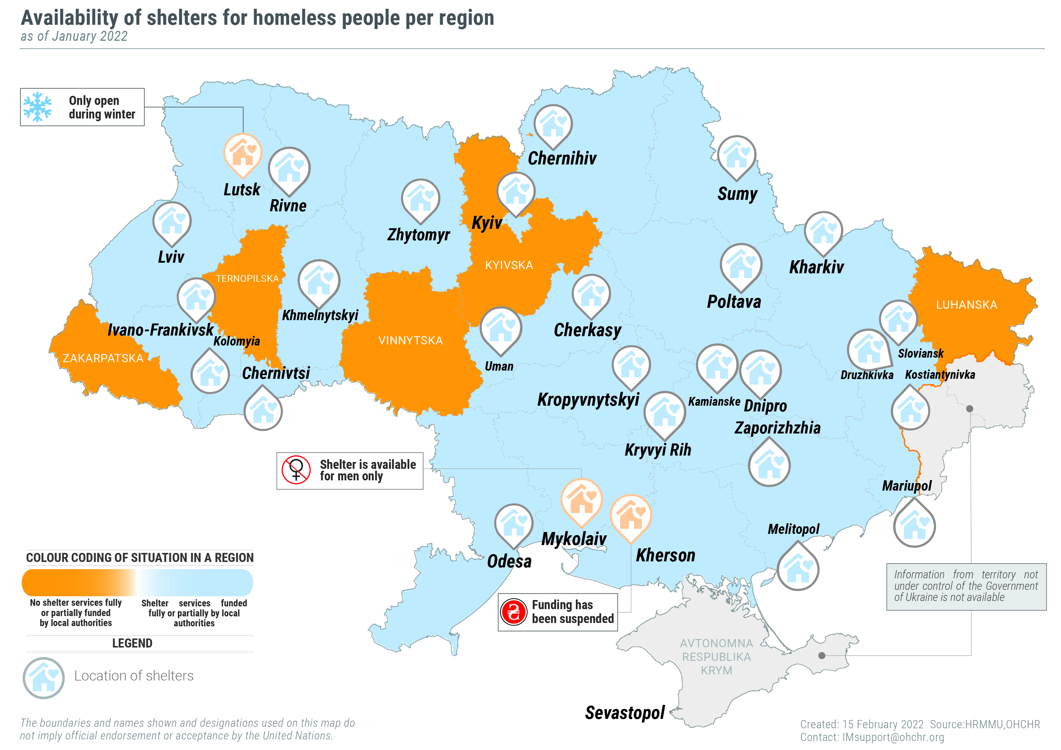

- Persons with intellectual and psychosocial disabilities
“The medial workers said that they will write a negative medical report [about me] because the [facility] director wants to keep me here so I can work on his property.”
– a resident of a long-term care facility about his attempts to be transferred to another facility to avoid forced labour.

92. During the reporting period, OHCHR conducted 38 monitoring visits to long-term care facilities for persons with intellectual and psychosocial disabilities and psychiatric hospitals. OHCHR regrets that all the institutions visited employed some form of arbitrary restrictions on the right to personal freedom: from prohibiting the residents to leave the facility to restricting freedom of movement within the facility. OHCHR documented credible allegations of torture, ill-treatment, and forced labour in 12 facilities. OHCHR documented three cases of ill-treatment of residents in two long-term care facilities and raised them to the attention of the directors of the facilities. OHCHR learned that the perpetrators were subsequently dismissed from employment. OHCHR is deeply concerned that although other staff should have witnessed these incidents, they did not report them and the incidents were discovered only because the residents or temporary workers recorded them on their phones. The lack of community inclusion results from a context in which social protection, human support, transportation, housing, legal capacity and support systems to prevent institutionalization in social care and mental health institutions have not been adequately addressed.
93. OHCHR noted that violations of the right to privacy and family life were widespread in some institutions. All long-term care facilities visited by OHCHR did not allow residents to have privacy in rooms, or in cabins in shared toilet and shower rooms. People in the same sex facilities were even more limited in their social interactions. OHCHR notes with concern that in three facilities for men and women with psychosocial disabilities, staff members reportedly compelled some female residents to take hormonal contraceptive injections, which amounts to a violation of the right to physical integrity. In addition, OHCHR documented two cases of retaliation against residents who shared information with HRMMU during the monitoring visits, including involuntary hospitalisation in a psychiatric hospital.
VIII. Human rights in the Autonomous Republic of Crimea and the city of Sevastopol, Ukraine, temporarily occupied by the Russian Federation
94. In Crimea, Russian Federation authorities continued to place significant restrictions on the exercise of the right of peaceful assembly and OHCHR continued to document cases of incommunicado detention, enforced disappearances, torture and other ill-treatment perpetrated by the Federal Security Service of the Russian Federation.
A. Right to liberty and security of persons
95. On 23 August 2021, Russian authorities reported damage to a gas pipe near Perevalne in Crimea. The Federal Security Service of the Russian Federation (“FSB”) qualified this incident as an act of sabotage and accused Ukrainian intelligence agencies of instigating it. During the reporting period, the FSB arrested at least eight Crimean Tatar men in connection with their alleged involvement in this incident. Although three individuals, including the First Deputy Head of the Mejlis Nariman Dzhelialov, were eventually accused of sabotage and unlawful storage of explosives, the remaining five were detained by FSB officers without formal charges, and later released. All victims were held incommunicado from 7 to 38 hours, and not less than five of them were denied access to lawyers of their choice. Additionally, the whereabouts of at least five persons were concealed from their families, which may qualify their arrests and detention as enforced disappearances.
96. In addition, OHCHR documented the torture or ill-treatment of at least five of the detainees, arrested in connection with the gas pipe incident. The victims provided consistent accounts of being electrocuted in the basement of an unknown building by FSB officers to coerce them to testify or to undergo a polygraph test. In most cases, the perpetrators tied the victims to chairs with adhesive tape, attached wires to their ears and administered multiple electric shocks. They also bragged to the victims about enjoying impunity for their actions and in, one case, referred to themselves as “those who untie tongues”. OHCHR recalls that torture as well as cruel, inhuman or degrading treatment is absolutely prohibited under international human rights and international humanitarian law.
97. On 25 October 2021, a Crimean Tatar lawyer, Edem Semedliaiev, who has represented clients in cases where human rights violations were documented by OHCHR, was arrested inside a police station in Simferopol while in the process of discharging his professional duties. He was attempting to record on his mobile phone what he believed to be the unlawful action of police officers and, in so doing, disobeyed their order to cease recording. Police officers subsequently brought Mr. Semedliaiev to an office and ordered him to completely undress to undergo a strip search. When he refused, police charged him with two counts of police disobedience, an administrative offence under Russian law. Following more than 26 hours in detention, the lawyer was released. On 11 November 2021, Mr. Semedliaiev was re-arrested on the same charges, sentenced to 12 days of detention and fined. The lawyer was released on 23 November 2021, having served his sentence in full.
B. Right to peaceful assembly
98. The Russian Federation authorities placed significant restrictions on the exercise of the right of peaceful assembly in Crimea, relying on exceptional measures related to the COVID-19 pandemic for justification. According to OHCHR monitoring, during September to November 2021, no less than 184 individuals (163 men, 18 women, 2 girls and 1 boy) were arrested either outside court buildings while seeking to attend public court hearings or in the vicinity of the police or FSB buildings. For example, a 32 year-old Crimean Tatar woman and her 14-year-old daughter were among 30 individuals arrested on 23 November 2021 near the Temporary Detention Facility in Simferopol, where they came to meet Edem Semedliaiev following his release from detention. The girl was released without charge, following almost nine hours in a police station, while her mother was detained overnight, fined and released having spent nearly 27 hours in detention.
99. In another example, a Crimean Tatar coordinator of the civic movement “Crimean Solidarity” was arbitrary arrested four times in less than two months. Three of these arrests followed his alleged participation in public assemblies, deemed by the Russian authorities to violate rules enacted to contain the spread of COVID-19. The police charged 116 defendants with ‘participation in a simultaneous mass gathering in a public place in violation of sanitary-epidemiological rules enacted in response to the COVID-19 pandemic’, an administrative offence under Russian law. At least 22 defendants (all men) were sentenced to administrative detention. In all documented cases, the victims and their lawyers believed that the real reason behind their arrests was to suppress dissenting views, instill fear and discourage public monitoring of high-profile trials in Crimea.
C. Freedom of Movement
100. In response to the pandemic, the Russian Federation continued to apply its general restrictions on entry into the Russian Federation for the purposes of crossing of the Administrative Boundary Line (ABL) into Crimea from mainland Ukraine. Generally, Ukrainian citizens without Russian Federation passports or residence permits in Crimea were prohibited from entering Crimea, with a regulated list of limited exceptions. Entry was, inter alia, granted to travellers visiting close family members in Crimea, provided that the latter held Russian Federation citizenship. No exception was provided to Ukrainian citizens who own land in Crimea and faced the risk of its forcible sale or nationalization due to Russian Federation restrictions on owning land plots by “foreigners” in “border areas”.
101. OHCHR documented cases of individual travellers who were unable to enter Crimea despite having family connections and humanitarian reasons to travel. In one case, a lesbian woman from mainland Ukraine was unable to reunite with her life partner in Crimea who holds Russian Federation citizenship and who had tested positive for COVID-19. For the purpose of the exceptions, same sex couples are not considered to be close family members under legislation applied in Crimea by the occupying power. In another case, a man, who was born in Crimea but resided in Kyiv, was denied entry into Crimea when he attempted to attend his father’s funeral. The man learned at the crossing point that he had been banned from entry into the Russian Federation, which de facto barred him access to Crimea until 2050. The document provided to the man did not specify reasons for the ban. The man, who works in the media, suspects the ban is connected to his pro-Ukrainian political position and the fact that he was previously subjected to an enforced disappearance in 2014. The victim is now unable to visit his mother, which negatively affects his enjoyment of the right to family life.
102. The effect of the pandemic and restrictions on movement is well-reflected in the number of ABL crossings, which remained much lower than pre-pandemic times. In August 2021, a month with typically highest number of crossings, this number was 120,804, down 75 per cent from 475,077 in August 2019.
IX. Technical cooperation and capacity-building
103. Over the reporting period, OHCHR provided technical assistance through the publication of one thematic report and two updates on civilian casualties, which contained targeted recommendations regarding measures to improve the protection of fundamental freedoms, empower civil society and protect civic space. OHCHR was also the main contributor to the Report of the Secretary General on the situation of human rights in the Autonomous Republic of Crimea and the city of Sevastopol, Ukraine published in August 2021. OHCHR also contributed significantly to the policy paper issued by the United Nations in Ukraine on persons with disabilities.
104. OHCHR developed an analytical paper on compliance with international standards of the law “On indigenous peoples of Ukraine” and shared it with the Ombudsperson and Parliamentary Committee on Human Rights. OHCHR also supported the United Nations Country Team in the implementation of the United Nations Human Rights Due Diligence Policy on support for Non-U.N. Security Forces.
105. OHCHR disseminated information on international human rights legal standards to Government representatives and civil society. In October, OHCHR organized a webinar on access to social housing of people in situations of vulnerability, with participation of the Special Rapporteur on the right to adequate housing, attended by Government representatives, local authorities and civil society (88 women and 47 men). OHCHR also conducted a regional training for young professionals (27 women and 9 men) on how civil society can engage with United Nations human rights mechanisms.
106. OHCHR conducted capacity-building trainings, including three trainings for the Ombudsperson’s office (13 women and 7 men) on human rights mechanisms, and two trainings for women human rights defenders to strengthen engagement with the United Nations Special Procedures (30 and 28 women, respectively).
107. OHCHR continued to assist persons with intellectual and psychosocial disabilities with restoration of their legal capacity, and brought ten more cases to the attention of the Ombudsperson. During the reporting period, as a result of assistance from the Ombudsperson’s Office, a local court restored the legal capacity of a man who had been previously denied restoration. OHCHR also worked with the National Police of Ukraine and civil society to raise awareness on investigations of hate crimes.
108. HRMMU issued one op-ed and 68 social media posts, and appeared in over 580 media articles.
X. Conclusions and recommendations
109. During the reporting period, OHCHR closely monitored the human rights impact on the ground of rising tensions, since November 2021, between Ukraine and the Russian Federation and amid speculations regarding military build-up in the region and forecasts for potential hostilities. Despite these tensions, the situation in the conflict zone of eastern Ukraine remained relatively calm from November 2021 to January 2022. OHCHR calls upon all actors to make the necessary efforts to de-escalate the situation through diplomacy and good faith dialogue, in line with obligations and principles enshrined in the United Nations Charter. OHCHR further calls on all parties to the conflict to uphold the July 2020 ceasefire commitments to ensure the greatest protection to civilians in the conflict zone. It is critical that the ceasefire is fully respected and that the sides prioritize measures that aim at protecting civilians from ongoing violence, particularly from the use of artillery and mortar fire in and around residential areas.
110. In territory controlled by self-proclaimed ‘republics’, persisting grave violations of human rights, including arbitrary detention, torture and ill-treatment, must be immediately halted. Widespread and credible allegations of torture and ill-treatment underline the urgency for OHCHR and other independent international human rights monitors to be granted access to detainees and places of detention in this territory.
111. In Crimea, the continuing violations of international humanitarian law and international human rights law by the occupying Power should cease and concrete steps should be taken to protect the right to freedom and peaceful assembly, the right to be free from torture and ill-treatment, and fair trial rights.
112. OHCHR conducted an assessment of the implementation of 364 measurable recommendations in its past 32 periodic and nine thematic reports (see below). In making these recommendations, OHCHR seeks to provide concrete, practical and actionable steps that, if implemented, would considerably improve the human rights situation of the population in Ukraine.
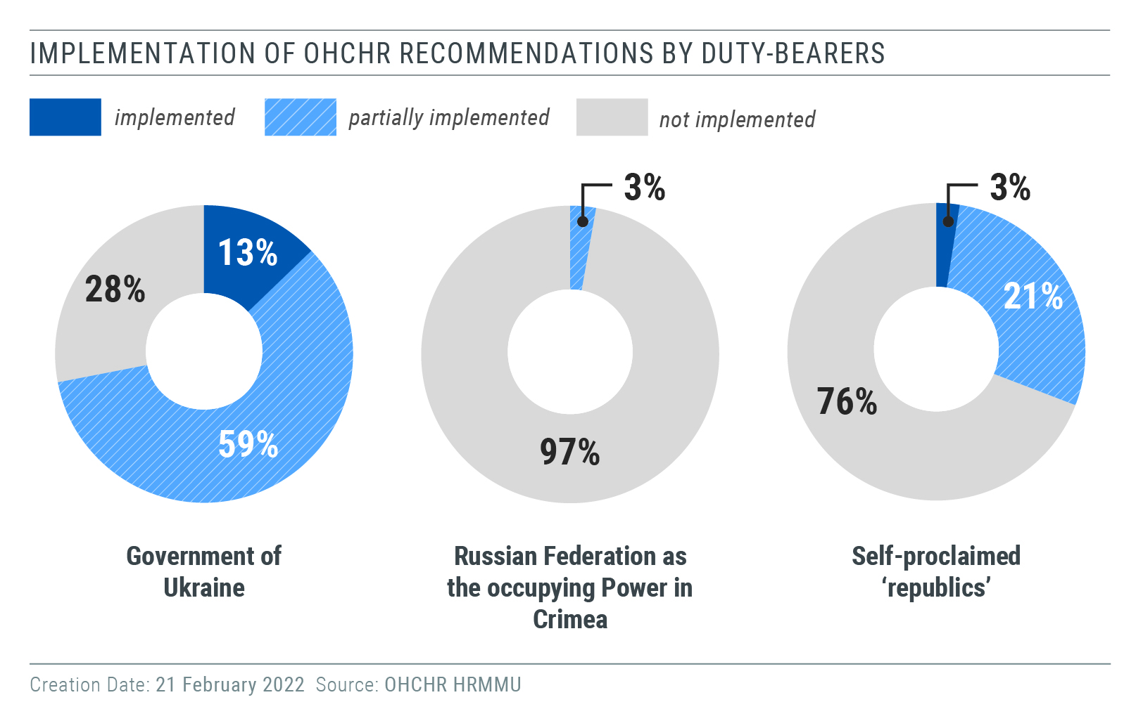

113. Based on its findings from the current reporting period, OHCHR urges the implementation of the following recommendations, some of which have been recommended in previous OHCHR reports:
1. To the Parliament and the Cabinet of Ministers:
(a) Establish a comprehensive compensation mechanism that covers all property lost due to the conflict, starting with the adoption of draft law 5177 or 5177-1 on protection of property rights of civilians;
(b) Establish an administrative procedure for the registration of births and deaths occurring in territory controlled by self-proclaimed ‘republics’ and in Crimea that is practical and responsive to the circumstances of families living there;
(c) De-link access to pension payments from IDP registration requirement;
(d) Propose and develop legislation that would prohibit advocacy of hatred which constitutes incitement to discrimination, hostility and violence in line with international human rights law;
(e) Amend national legislation to include hate crimes against LGBTI people by specifying sexual orientation and gender identity as grounds in article 161 (1) of the Criminal Code, as well as in all the aggravated forms of offences and the general provisions on aggravating circumstances under article 67 (1) (3);
(f) Ensure full compliance with international standards when elaborating policies or laws on transitional justice;
(g) Amend legislation on elections to ensure that responsible authorities use clear and transparent criteria for taking decisions on the impossibility of holding elections in certain localities, in accordance with international human rights law.
(h) Amend civil legislation to prohibit all arrangements allowing for the removal or limiting of legal capacity of persons with disabilities and introduce supported decision-making arrangements for them;
(i) Repeal the ‘immunity law’ in order to allow for prosecutions regarding the killing of law enforcement officers during Maidan protests;
2. To the President of Ukraine:
(a) Sign law No. 1164-IX “On amendments to certain legislative acts of Ukraine concerning the implementation of provisions of international criminal law and humanitarian law”.
3. To State and local authorities:
(a) Increase the number of public shelters for homeless people, ensure that shelters are gender-sensitive and safe for women.
(b) Consult and meaningfully involve local stakeholders in decision making regarding the right to a clean environment;
(c) Promptly and publicly condemn all instances of hate speech incitement to violence, discrimination and hostility against any group, expressed online and offline;
(d) Strengthen efforts towards deinstitutionalization reform and increase access of persons with intellectual and psychosocial disabilities to social housing and supported residential facilities, as well as a range of in-home, residential and other community support services;
(e) Immediately cease the practice of giving hormonal contraceptives to women living in long-term care facilities for persons with intellectual and psychosocial disabilities without their free and fully informed consent based on accessible information about the impact on their health, including sexual and reproductive health, and available alternative means of contraception;
(f) Enhance efforts to monitor, identify, report and investigate human rights violations in long-term care facilities for persons with intellectual and psychosocial disabilities, and ensure that residents have confidential access to complaint mechanisms;
4. To the National Security and Defence Council:
(a) Ensure the conformity of its decisions with international human rights standards and align previous decisions restricting the right to freedom of expression with international human rights law;
5. To the Office of the Prosecutor-General and State Bureau of Investigation:
(a) Proactively and efficiently investigate all cases of violent crimes, including hate crimes, threats and incitement to violence, with particular attention to those committed by members, affiliates or supporters of groups that promote violence, and ensure that all perpetrators, including the instigators, planners and organizers of attacks, are brought to account through a fair trial without undue delays;
(b) Ensure timely and effective investigations into all allegations of human rights violations perpetrated by military and law enforcement agents, including torture and ill-treatment, and ensure alleged perpetrators are duly prosecuted, including persons in positions of command;
6. To the Courts:
(a) Ensure that in absentia trials are held in line with the requirements of Article 14 of the International Covenant on Civil and Political Rights and only when defendants have been duly informed of the proceedings sufficiently in advance;
7. To the Command of the Joint Forces Operations:
(a) Continue strengthening the promotion of anti-discrimination in all activities of the Ukrainian Armed Forces, especially with regard to enhancing effective mechanisms of redress for victims of discrimination on grounds of sexual orientation and gender identity serving in the Armed Forces;
(b) Ensure civilians are provided with targeted mine and unexploded ordnance risk awareness raising activities;
8. To self-proclaimed ‘Donetsk people’s republic’ and self-proclaimed ‘Luhansk people’s republic’:
(a) Fully re-open all entry-exit crossing points with clear measures to reduce the spread of COVID-19. Delink residence registration and COVID-19-related restrictions on freedom of movement;
(b) Provide unimpeded confidential access to OHCHR and other independent international monitors to all places of detention, including the ‘Izoliatsiia’ detention facility;
(c) Release all those arbitrarily detained without delay and in conditions of safety;
(d) Cease the practice of arbitrary incommunicado detention, including practices of ‘administrative arrest’ and ‘preventive detention’;
(e) Immediately provide information on the whereabouts of all detainees to their families and lawyers;
(f) Treat all persons deprived of their liberty humanely, including those held in connection with the conflict, and ensure that their conditions of detention are compliant with international law;
(g) Refrain from implementing practices that unduly restrict the exercise of freedom of expression;
9. To the international community, including the Government of the Russian Federation:
(a) Use all available channels to influence self-proclaimed ‘republics’ to comply with international human rights and humanitarian law standards and, in particular, to implement the recommendation a) to g) above.
10. In the context of the Autonomous Republic of Crimea and the city of Sevastopol, Ukraine, temporarily occupied by the Russian Federation, to the Government of the Russian Federation:
(a) Uphold obligations as duty bearer under international human rights law in Crimea and respect its obligations as an occupying Power pursuant to international humanitarian law;
(b) Ensure full proper and unimpeded access of international human rights monitoring missions and human rights non-governmental organizations to Crimea, pursuant to United Nations General Assembly resolutions 71/205, 72/190, 73/263, 74/168, 75/162, 76/179;
(c) Comply fully with the absolute prohibition of torture and ensure the
independent, impartial and effective investigation of all allegations of
torture or ill-treatment;
(d) Ensure that persons deprived of their liberty benefit from all legal guarantees;
(e) Respect the right of a defendant to be assisted by a lawyer of one’s own choice;
(f) Ensure that lawyers are able to perform their duties without
intimidation, harassment or improper interference;
(g) Ensure that members of the public have access to court hearings and that hearings in camera are only used in exceptional circumstances;
(h) Refrain from prosecution of individuals for participation in peaceful
assemblies, regardless of the political or other views expressed by the participants, in accordance with human rights law;
(i) Ensure that any restriction on freedom of movement between Crimea and other areas of Ukraine for public health reasons is non-discriminatory, provided by law and proportionate;
(j) Broaden the scope of exceptions from the prohibition of entry into Crimea for those who do not hold Russian Federation citizenship;
(k) Refrain from relying on vague national security justifications as the basis for entry bans against Ukrainian citizens who seek access to the territory of Crimea

HRMMU was deployed on 14 March 2014 to monitor and report on the human rights situation throughout Ukraine, with particular attention to the Autonomous Republic of Crimea, eastern and southern regions of Ukraine, and to propose recommendations to the Government and other actors to address human rights concerns. For more information, see UN Human Rights Council, Report of the United Nations High Commissioner for Human Rights on the situation of human rights in Ukraine, 19 September 2014, A/HRC/27/75, paras. 7-8, available at www.ohchr.org/EN/HRBodies/HRC/RegularSessions/Session27/Documents/A-HRC-27-75_en.pdf.
Hereinafter ‘Donetsk people’s republic’ and ‘Luhansk people’s republic’, and collectively as self-proclaimed ‘republics’.
OHCHR notes that, pursuant to paragraphs 2 and 3 of article 94 of the Constitution, the law should have been signed and promulgated since the President did not return it to Parliament for reconsideration within fifteen days.
See OHCHR Human Rights in the Administration of Justice in Conflict Related Criminal Cases in Ukraine April 2014 – April 2020, para 33, available at: https://www.ohchr.org/Documents/Countries/UA/Ukraine-admin-justice-conflict-related-cases-en.pdf.
Bodies of the Russian Federation and their representatives in Crimea shall be considered as “occupation authorities of the Russian Federation”. General Assembly resolution 76/179, para. 12. All reference to organs and officials of the Russian Federation in Crimea in this report are to be understood as referring to the occupation authorities of the Russian Federation.
With 490 men and 635 women.
See OHCHR, Report on the human rights situation in Ukraine, 16 February to 15 May 2019, para. 20, available at www.ohchr.org/Documents/Countries/UA/ReportUkraine16Feb-15May2019_EN.pdf.
The SMM recorded 39,806 ceasefire violations from February to July 2021, and 62,562 ceasefire violations from August 2021 to January 2022.
Shelling, small arms and light weapons (SALW) fire, and explosive devices dropped by unmanned aerial vehicles.
Incidents in which civilians were killed or injured by mines (antipersonnel or anti-vehicle) or explosive devices triggered in the same way, such as booby traps.
Incidents in which civilians were killed or injured after they deliberately or inadvertently caused the detonation of ERWs by manipulating them (for instance, by trying to dismantle an artillery shell, or by triggering a hand grenade), or when civilians were near those, who manipulated ERWs.
Incidents in which military opened fire falsely perceiving civilians as a threat.
Educational institutions, electricity supply, water and sanitation facilities, gas supply, public buildings, industrial plants, medical facilities, public transport and telecommunication network.
For more information, see OHCHR, Report on the human rights situation in Ukraine, 16 February to 31 July 2020, para 49, available at https://www.ohchr.org/Documents/Countries/UA/30thReportUkraine_EN.pdf.
For more information, see OHCHR, Report on the human rights situation in Ukraine, 1 February to 31 July 2021, para 41, available at: https://www.ohchr.org/Documents/Countries/UA/32ndReportUkraine-en.pdf.
To use the e-court system, residents need to have an e-signature, access to the Ukrainian phone network, an internet connection and the ability to pay court fees remotely.
This follows the adoption of Cabinet of Ministers’ Resolution No 155 in February 2021.
The United Nations estimates approximately 50,000 residential buildings in Luhansk and Donetsk regions, on both sides of the contact line, have been damaged by hostilities since 2014, of which, approximately half have been repaired (80 per cent repaired in Government-controlled territory).
For more information, see OHCHR, Report on the human rights situation in Ukraine, 1 February to 31 July 2021, para 52, available at https://www.ohchr.org/Documents/Countries/UA/32ndReportUkraine-en.pdf. OHCHR, Update on the Human Rights Situation in Ukraine, 1 August — 31 October 2021, para. 4, available at https://www.ohchr.org/sites/default/files/2021-11/HRMMU-Update-2021-11-01-EN.pdf.
European Commission for Democracy through Law (Venice Commission), Ukraine Opinion on the draft law “on the principles of State policy of the transition period”, Opinion No. 1046/2021, 18 October 2021, (Venice Commission Opinion) available at https://www.venice.coe.int/webforms/documents/?pdf=CDL-AD(2021)038-e (Venice Commission Opinion).
Venice Commission Opinion, para. 36.
Ibid., para. 101.
In this respect, the Commission affirmed that “the added value of these rather vague provisions [in the draft law] remains unclear” and that article 11 [on the gender dimension of transitional justice] has “mainly symbolic significance” (Venice Commission Opinion, para. 62).
CCPR/C/UKR/CO/8, para. 24(e), available at https://tbinternet.ohchr.org/_layouts/15/treatybodyexternal/Download.aspx?symbolno=CCPR%2fC%2fUKR%2fCO%2f8&Lang=en.
From spring 2014 until the end of 2016, the premises of the Kharkiv SBU served as an unofficial place of detention for conflict-related detainees, perceived to be affiliated with local anti-Maidan movements, armed groups of self-proclaimed ‘republics’ or Kharkiv saboteur groups. They were held incommunicado there from a few days to several years. For more information, see OHCHR, Arbitrary detention, torture and ill-treatment in the context of armed conflict in eastern Ukraine, 2014-2021, Annex I, available at https://www.ohchr.org/Documents/Countries/UA/UkraineArbDetTorture_EN.pdf.
Manual on the Effective Investigation and Documentation of Torture and Other Cruel, Inhuman or Degrading Treatment or Punishment (the Istanbul Protocol), available at https://www.ohchr.org/documents/publications/training8rev1en.pdf.
OHCHR interview 17 November 2021.
OHCHR interview 16 August 2021.
OHCHR interview 27 January 2022.
OHCHR interview 31 January 2022.
At least in two penal colonies. OHCHR interviews 2 November 2021, 24 and 27 January 2022.
OHCHR interviews 24 November 2021).
OHCHR interviews 28 October and 9 November 2021.
These are criminal proceedings on prosecuting crimes against national security (articles 109-114, chapter I of the Special Part of the Criminal Code), certain crimes against public security (articles 258-258, chapter IX of the Special Part of the Criminal Code) and certain crimes against peace and humanity (articles 436-438 of the chapter XX of the Special Part of the Criminal Code).
Article 176.5 of the Criminal Procedure Code limited the courts’ powers to choose among a variety of preventive measures for individuals prosecuted for crimes against national security and public security. On 25 June 2019, the Constitutional Court found it unconstitutional.
See OHCHR Human Rights in the Administration of Justice in Conflict Related Criminal Cases in Ukraine April 2014 – April 2020, available at https://www.ohchr.org/Documents/Countries/UA/Ukraine-admin-justice-conflict-related-cases-en.pdf. See also common article 3 to the four Geneva Conventions of 1949.
Article 438 of the Criminal Code of Ukraine.
According to OHCHR’s monitoring in conflict-related criminal cases over the past eight years, defendants charged with terrorism are rarely released from pre-trial custody. In some cases, the courts have provided for home arrest, but only at a later stage of the trial or if a defendant was actively cooperating with the prosecution.
Article 94 of the Constitution of Ukraine requires the President, within fifteen days of the receipt of a draft law, to either sign it into law or to return it to the Parliament with alternative proposals for it to consider. In the event that the President does not return a draft law to the Parliament for its further consideration within these 15 days, it is deemed to have been be approved by the President and it must then be signed and officially promulgated.
He was detained on 16 October 2015 and released on 29 November 2019. According to the law that counts one day in pre-trial detention as two days in prison, he had served more than the minimum prison term for the charges that he was facing in detention, and was released pending trial.
The Law on prevention of prosecution and punishment of individuals in respect of events, which have taken place during peaceful assemblies and recognising the repeal of certain laws of Ukraine, adopted 21 February 2014, available at https://zakon.rada.gov.ua/laws/show/743-18.
The judgment available at https://ccu.gov.ua/sites/default/files/docs/266_y_2021.pdf.
Ruling of Malynovskyi district court of Odesa 30 November 2021, available at https://reyestr.court.gov.ua/Review/101858829.
See OHCHR Report Civic space and fundamental freedoms in Ukraine, 1 November 2019 – 31 October 2021, para 27, available at https://www.ohchr.org/en/documents/country-reports/civic-space-and-fundamental-freedoms-ukraine-1-november-2019-31-october.
OHCHR interview on 26 January 2022.
The man was a member of “Pravyi Sector”, an extreme right wing group, and as part of this group reportedly conducted anti-corruption activities in the region. OHCHR is not aware of any anti-human rights activities of this individual.
Decrees No. 376/2021 and 375/2021.
Decree No. 684/2021.
See OHCHR Report on the Human Rights Situation in Ukraine 1 February - 31 July 2021, para. 85, available at https://www.ohchr.org/Documents/Countries/UA/32ndReportUkraine-en.pdf. ; the communication of the Special Rapporteur on the promotion and protection of the right to freedom of expression and opinion to the Government of Ukraine, available at https://spcommreports.ohchr.org/TMResultsBase/DownLoadPublicCommunicationFile?gId=26403; and the Concluding Observations of the Human Rights on Ukraine’s report, adopted on 4 November 2021, (CCPR/C/UKR/CO/8, para. 48).
OHCHR interview, 26 February 2022
See OHCHR Report on the human rights situation in Ukraine, 1 February to 31 July 2021, para 90, available at https://www.ohchr.org/Documents/Countries/UA/32ndReportUkraine-en.pdf.
. See OHCHR Report Civic space and fundamental freedoms in Ukraine, 1 November 2019 – 31 October 2021, paras 35 and 45, available at https://www.ohchr.org/en/documents/country-reports/civic-space-and-fundamental-freedoms-ukraine-1-november-2019-31-october.
The first round of local elections took place in 25 October 2020, with the exception of 18 territorial communities in Donetsk and Luhansk regions. On 20 August 2020, the Central Election Commission issued its first decision on the impossibility to hold elections in ten territorial communities in Donetsk region and eight territorial communities in Luhansk region, based on the decision of regional military-civil administrations. For more information, see OHCHR, Update on the Human Rights Situation in Ukraine, 1 August – 31 October 2020, para. 4, available at https://www.ohchr.org/Documents/Countries/UA/HRMMU_Update_2020-11-01_EN.pdf; and OHCHR, Report on the human rights situation in Ukraine, 1 August 2020-31 January 2021, para. 87, available at https://www.ohchr.org/Documents/Countries/UA/32ndReportUkraine-en.pdf. As noted by the Office for Democratic Institutions and Human Rights (ODIHR) of the OSCE, this decision “effectively disenfranchised some 500,000 voters”. For more information, see ODIHR, Ukraine, Local Elections, 25 October 2020 Statement of preliminary findings and conclusions, 26 October 2020, p. 4, available at https://www.osce.org/odihr/elections/468249.
In its recent opinion on the draft law, the Venice Commission recommended, among other things, to establish clear criteria for taking decisions on the impossibility to hold election (Venice Commission - OSCE/ODIHR, Joint Opinion OSCE/ODIHR on the draft law “On improving the procedure for establishing the impossibility of holding national and local elections, all-Ukrainian and local referendums in certain territories and polling stations”, Opinion No. 1061/2021 (10-11 December 2021), para. 12 D, available at https://www.venice.coe.int/webforms/documents/default.aspx?pdffile=CDL-AD(2021)045-e.
The United Declaration on the Right and Responsibility of Individuals, Groups and Organs of Society to Promote and Protect Universally Recognized Human Rights and Fundamental Freedoms, adopted by the United Nations General Assembly on 8 March 1999, acknowledges the fundamental role of human rights defenders in the realization of the human rights enshrined in the Universal Declaration of Human Rights and in human rights treaties. Article 12 of the Declaration establishes that “The State shall take all necessary measures to ensure the protection by the competent authorities of everyone, individually and in association with others, against any violence, threats, retaliation, de facto or de jure adverse discrimination, pressure or any other arbitrary action as a consequence of his or her legitimate exercise of the rights referred to in the present Declaration.”
The court granted victims claims and deemed the decision of the head of the local council to be unlawful and found that the police had failed to protect the victims. The Court of Appeal ordered the respondents to pay UAH 10,000 ($ 357) to each of the seven victims instead of UAH 100,000 ($ 3,405) sought by each of them.
OHCHR interviews on 17 January and 3 February 2022.
See OHCHR Report on the human rights situation in Ukraine, 1 February to 31 July 2021, para. 100, available at https://www.ohchr.org/Documents/Countries/UA/32ndReportUkraine-en.pdf
Information provided by civil society for the period of 1 December to 4 February 2022.
.Ukrainian legislation makes no provision for such restrictions, even in relation to persons with removed legal agency.
See articles 15, 17, 23 and 25 of the Convention on the right of persons with disabilities.
Two individuals were released on the following day and re-arrested on administrative charges of police disobedience.
International Covenant on Civil and Political Rights, arts. 7 and 10; Convention against Torture and Other Cruel, Inhuman or Degrading Treatment or Punishment; and European Convention on Human Rights, art. 3.
See Fourth Geneva Convention, art. 32; International Committee of the Red Cross, Customary IHL, rule 90.
The United Nations Human Rights Committee noted that having to apply for permission from the authorities to hold any assembly “undercuts the idea that peaceful assembly is a basic right” (General comment No. 37 (2020) on the right of peaceful assembly, para. 70.)
Two more men were sentenced to administrative detention for “police disobedience”.
Under article 12 of the ICCPR, all those who are lawfully within the territory of a State must, within that territory, have the right to liberty of movement and freedom to choose their residence.
Decree № 635-р dated 16.03.2020, http://government.ru/docs/all/126728/. Alternative link at http://www.consultant.ru/document/cons_doc_LAW_347693/f62ee45faefd8e2a11d6d88941ac66824f848bc2/.
Decree of the President of the Russian Federation No. 201 of 20 March 2020. See also SG Report on Crimea, A/75/334, 1 September 2020, par. 38
He came to Crimea to do media work during the referendum in mid-March 2014. He was abducted, beaten, and kept in a basement in an unknown location before being released at the ABL.
Available at https://ukraine.un.org/en/151093-conflict-related-civilian-casualties-ukraine-8-october-2021 and https://ukraine.un.org/en/168060-conflict-related-civilian-casualties-ukraine.
OHCHR, Civic space and fundamental freedoms in Ukraine, November 2019 to October 2021, available at https://www.ohchr.org/en/documents/country-reports/civic-space-and-fundamental-freedoms-ukraine-1-november-2019-31-october.
See report of the Secretary General, Human rights situation in the Autonomous Republic of Crimea and the city of Sevastopol, Ukraine, (A/HRC/76/260) available at https://undocs.org/A/76/260.
For more information, see UN Ukraine, UN Policy Paper on Disability, 2021, available at https://ukraine.un.org/en/165090-un-policy-paper-disability.

