Submission on the Decriminalisation of Homelessness and Extreme Poverty

Submitted to the Special Rapporteur on the Right to Adequate Housing & the Special Rapporteur on Extreme Poverty and Human Rights by the Campaign to Decriminalise Poverty and Status

30 November 2021

About the Campaign to Decriminalise Poverty and Status

Around the world, States routinely deploy law enforcement, courts and prisons against the poor and most marginalized for reasons that have little to do with safety, but rather to protect the boundaries of wealth and privilege. The application of this power manifests in fundamental human rights violations including systemic discrimination, use of lethal force, torture, arbitrary, unlawful and excessive imprisonment, disproportionate sentencing, and inhumane conditions of detention. Compounding this, multiple, intersectional forms of oppression including combinations of gender, disability, race, ethnicity, nationality, and class, negatively inflect legal outcomes for marginalized constituencies caught up in the criminal justice system.

A key driver of this phenomenon is the set of vague and arbitrary offences, rooted in the age of empire law-making and enforced globally, used to arrest, and imprison thousands of poor or homeless people, people with disabilities, informal traders, racial and ethnic minorities, sex workers, members of the LGBTIQA+ community, drug users and migrants, for who they are rather than for what they have done. The retention of these laws is rarely raised in current law reform discussions, from which the most marginalized are routinely excluded. Moreover, colonial-era policing practices have become normative and have not evolved in line with modern human rights standards.

Recognizing this problem, and in particular the profound negative impact of these laws on the poorest and most marginalized, a group of 37 non-governmental organisations (NGOs) and national human rights institutions (NHRIs) are currently working together to decriminalise offences that target people based on their social, political and economic status. Using a combination of research, policy advocacy and strategic litigation, the Campaign seeks to repeal these laws and to develop alternatives to arrest and detention. Moreover, it challenges violations of the rights to freedom from discrimination, ill-treatment by the police and courts, arbitrary arrest and detention, and seeks to uphold the right to dignity of all people. The Campaign has its roots in Africa but membership has grown exponentially to include global partners and groups from other regions of the world with a shared colonial legacy of laws that punish people for being poor or for who they are rather than what they have done.

The Campaign supported the African Commission on Human and Peoples’ Rights’ Principles on the Decriminalisation of Petty Offences in Africa which provides an authoritative guide for African States to repeal outdated and discriminatory offences. In December 2020, the Campaign secured an Advisory Opinion from the African Court on Human and Peoples’ Rights which places an obligation on all States in Africa to review their criminal laws. Together, these provide a singular opportunity for an urgent review of these laws in Africa and in other regions with similar colonial legacies. These two documents are referred to throughout these submissions as setting the regional human rights standards for the decriminalisation of homelessness and extreme poverty.

Introduction

People move to cities for myriad reasons, including displacement from famine, disease and conflict; and to access the urban labour market. Insurgency, locusts, drought, and the Covid-19 pandemic has drastically affected food insecurity across Africa and continues to displace persons from their homes, driving many to urban centres to seek a living. The Democratic Republic of Congo, for example, shelters over 5.5 million internally displaced persons. Mali, Burkina Faso, Chad, Niger, Cameroun, Central African Republic, Congo, Senegal and Côte d’Ivoire combined, host approximately 3.2 million internally displaced persons. In the absence of communal and State support and employment opportunities, many people find themselves destitute, forcing them to undertake life sustaining activities in often over regulated, over policed public spaces, with many finding themselves at the mercy of overly broad, often outdated vagrancy laws and punitive policing practices. These laws do not correlate with the principle that all persons, irrespective of socio-economic status, should be entitled to inhabit and frequent cities and towns, including to access opportunities for livelihoods.

Overview of applicable laws and their enforcement

In 2002, the Ministry of Justice and Constitutional Affairs in Uganda commissioned a study on access to justice. The final report, entitled Participatory Poverty Assessment on Safety, Security and Access to Justice: Voices of the Poor in Uganda, noted that offences such as being idle and disorderly and rogue and vagabond were anti-poor and made the poor more vulnerable. A 2016 Kenyan criminal justice system audit found that the criminal justice system was skewed against the poor. The audit found that more poor people than rich people were arrested, charged, and sent to prison. The audit further found that economically driven and social disturbance offences such as those relating to lack of business licenses, being drunk and disorderly and creating disturbances comprise 70% of cases processed through the justice system. This is also reflected in the assistance a person is likely to get from the police – 64% of persons with severe lived poverty whom Afrobarometer surveyed, indicated that it is challenging to obtain assistance from the police, compared to 38% of persons who experienced no lived poverty.

The offence of having no means of subsistence
Vagrancy-related offences criminalise a person who does not have a means of subsistence and cannot give a good account of him or herself and entitles the police to arrest such a person without a warrant. Vagrancy-related offences can usually be found in colonial era Vagrancy Acts, Penal Codes and by-laws.

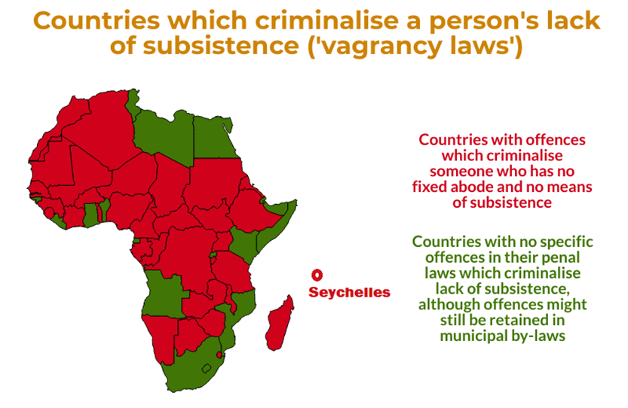At least 18 African Francophone countries’ Penal Codes define a vagrant as any person who does not have a fixed abode nor means of subsistence, and who does not practice a trade or profession.

In 7 African countries the offence of being an idle and disorderly person remains on the statute. This is defined as someone who loiters or is idle and who does not have a visible means of subsistence and cannot give a good account of him or herself.

In 8 Anglophone countries the ‘rogue and vagabond’ offence remains in force, and includes being a “suspected person or reputed thief who has no visible means of subsistence and cannot give a good account” of him or herself. Other laws then reinforce the arrest and detention powers related to these offences: In 6 countries, the criminal procedure laws specifically allow police to arrest someone without a warrant where the person has no ostensible means of subsistence and cannot give a satisfactory account of him or herself.

In countries that have retained the colonial Vagrancy Act, a vagrant is defined as a person with no settled or fixed place of abode or means of subsistence. Vagrancy Acts often empower the courts to send a vagrant who is a citizen to either a rehabilitation centre or their place of origin. A vagrant who is not a citizen can be detained in a place of detention. Some Francophone countries retained the French King’s Decree of 23 May 1896, which dealt with the suppression of vagrancy. The Decree was further elaborated by the Decree of 6 December 1950, which relates to vagrancy of children. Vagrancy laws are not only ubiquitous in Africa but can be found in former colonies across the Caribbean, and in South and Southeast Asia.

Nuisance offences
Some countries use the catch-all category of common nuisance or criminal nuisance in their Penal Code to arrest persons who are homeless or who carry out life sustaining activities in public spaces.

This offence originates from the English common law offence of public nuisance. Under common law, a person who a) performs an act not warranted by law, or b) omits to discharge a legal duty, if the effect of the act or omission is to endanger the life, health, property or comfort of the public, or to obstruct the public in the exercise or enjoyment of their rights, is guilty of a public or common nuisance. Under common law, an individual act causing nuisance to another may be liable for performing a private nuisance for which civil action is appropriate, but it does not amount to a criminal public nuisance. Interference with the public’s rights must be substantial and unreasonable.

For this offence to satisfy international human rights standards, observers contend that it should be invoked only in rare circumstances. For instance, when no other applicable statutory offence exists, where commission of the offence would have a sufficiently serious effect on the public, and/or where the defendant knew or should have known of the risk that his or her actions would result in a nuisance. In practice, police use this offence as a blanket offence to arrest and detain poor and marginalised persons. For example, on 16 January 2014 a transgender activist was arrested in Bulawayo after entering a female public toilet. At the police station she was forced to strip and was examined by medical doctors to verify her gender. After spending two nights in a holding cell, she was charged with criminal nuisance. The Zimbabwe High Court, in a subsequent damages case, held that “by any stretch of imagination the conduct [of the police] could not possibly have been justified by any fair-minded person...”.

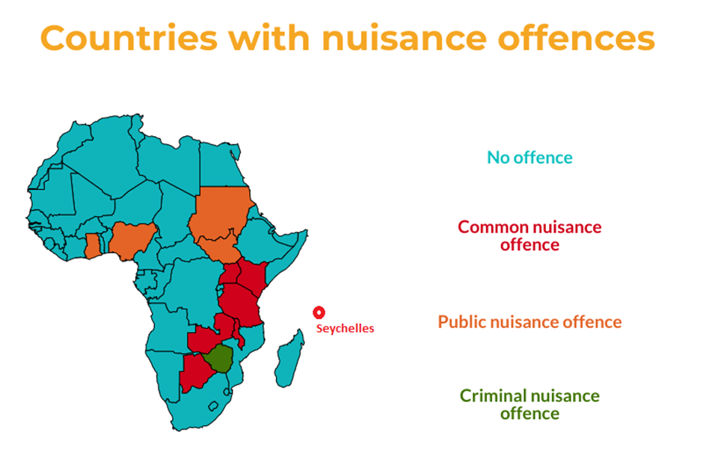

The offence of urinating in public
The offence of urinating in public places, is often prohibited in environmental management laws, public health laws and by-laws. For example, in the Gambia, a person who urinates in public commits an offence and is liable to a fine, and in default thereof to imprisonment for 3 to 6 months. In Tanzania, a person who urinates or spits in public faces a fine or imprisonment up to 6 months.

The offence of bathing or doing laundry in public places
In South Africa and Uganda, urination, doing laundry or bathing in public tends to be proscribed in municipal by-laws.

The offence of sleeping in public places
In South Africa, for example, by-laws exist which prohibit a person without a fixed abode from loitering or sleeping in a public amenity, public space or on the beach.

The offence of begging
Across the continent, and in many other former colonies, Penal Codes prohibit the act of begging. In some instances, the offence has been narrowed to only apply to cases where begging is accompanied by threats, or in cases of forced begging.

In Tanzania, the By-Laws of the Municipal Council of Ilala, of 2019, specifically deal with the control of persons who beg. The by-laws define a ‘beggar’ as anyone with or without a disability who begs for food or money from persons on the street. It is an offence to beg as well as to give someone who begs food or money. It is also an offence not to report someone who begs to the Council. The By-Laws allow the Council to designate someone to report persons who beg.

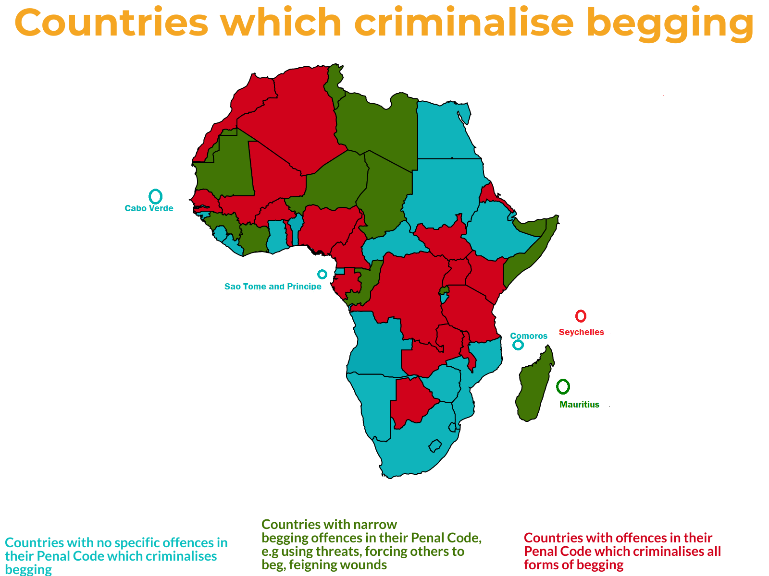
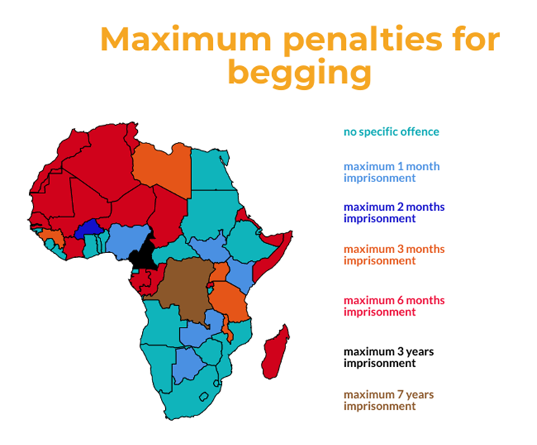

Arbitrary enforcement of petty offences

Throughout Africa, these offences are typically accompanied by arbitrary mass arrests by police. These so-called ‘sweeping’ or ‘swooping’ exercises are conducted by police over weekends and at night. Such sweeping exercises tend to have very general objectives, meaning that persons are arrested, for example, for being on the street at night, even when they have not committed a specific offence or engaged in suspicious activity. Sweeping exercises are targeted at whoever the police deem to be ‘undesirable’, including sex workers, informal traders, children who live or work on the streets, persons who beg and persons with disabilities.

Often the objective of a sweeping exercise is to assure the public that sufficient attention is paid to crime prevention. However, in reality people find themselves imprisoned or detained in potentially life-threatening conditions, especially in cases where they cannot afford bail or the fine, even when there is no proof of an actual offence having been committed, in violation of their rights. These arrests often violate the basic principles of criminal procedure laws which requires due process and limits arrests to specific circumstances and as a last resort:

- Uganda: Police conducted a ‘clean Kampala’ campaign in which they arrested 100 people in the market area “who could not explain their presence in the area”. The police spokesperson said that before being taken to court, suspects would be screened and “are supposed to produce evidence of employment or the Local Council Chairman to prove what they do in the area they were found”.
- Malawi: Police often arrest persons during sweeping exercises, sometimes up to 80 or 100 at a time, charging them under the rogue and vagabond or idle and disorderly laws.
- South Africa: Metro police frequently arrest a range of people on the premise of keeping streets and intersections clean. They are then accused of “loitering” instead of specific violations of by-laws or criminal laws.

Societal norms contain inherent biases that influence policing and the reporting of ‘offensive’ behaviour to the police. For example, unemployed youth, street vendors, sex workers, children who live and work on the streets, transgender persons, and persons with psycho-social or intellectual disabilities are often targeted by police in the absence of any criminal activity, because their mere existence somehow challenges the normative sensibilities of some residents and the police. Xenophobia and gender norms also permeate policing practices in the same way that they permeate society. Arrests expose marginalised groups to further rights violations.

- Malawi: On 12 December 2020, three teenagers set off for overnight prayers in Bvumbwe just outside the commercial city. The group, two girls and a boy, were stopped by the police who arrested them on charges of idle and disorderly conduct. One of the girls was raped in police custody.
- Nigeria: On 5 August 2021, the Federal High Court in Abuja handed down judgment in a case relating to the notorious raids conducted in April 2019, which resulted in the arrest and abuse of women. The Court held that the arrest of the applicants without cause, and the cruel and inhumane treatment they faced violated their constitutional rights. The Court criticised the Abuja Environmental Protection Board for exceeding its mandate and powers in initiating the raids. The Court further issued an injunction restraining the police and other law enforcement entities from arresting women in such circumstances. The case follows a similar successful judgment against the Abuja Environmental Protection Board in December 2019.
- Namibia: Street children are arrested and detained by police and subjected to exploitation, abuse, discrimination and stigmatisation both on the streets and by law enforcement officials. For example, the CRC Committee in its Concluding Observations on Namibia, called on the State to promptly investigate complaints concerning ill-treatment and abuse of children in street situations by police and staff in police custody or in the government detention facilities.
- There are frequent reports of mass arrests of street children for vagrancy, for example in, Democratic Republic of Congo, Uganda, Tanzania, Egypt, Kenya and Rwanda. These mass arrests violate the rights under the African Charter and the Child Rights Charter.

In our experience, it is useful to repeal these offences. However, without a simultaneous effort to change police practice, they will simply use alternative, broadly worded offences to achieve the same outcome, and not much will change.

There is ample evidence that persons who experience homelessness are often mistreated by police officials but if they lodge complaints with designated oversight agencies, these are seldom properly investigated, if at all. Legislation should ensure that complaints are properly investigated, feed-back given to complainants and perpetrators held accountable.

Continued use of imprisonment for petty offences

It has been almost two decades since the Ouagadougou Declaration and Plan of Action on Accelerating Prisons and Penal Reforms was endorsed in Africa. The 2002 Declaration recommended the decriminalisation of various offences including vagrancy-related offences in an effort to ameliorate the rights violations endured by thousands of people held in the continent’s prisons. In many countries, the penalty for vagrancy can be up to 6 months’ imprisonment, and in Cameroon a vagrancy charge can result in up to 2 years’ imprisonment. The immediate repeal of the vagrancy offence will support efforts to reduce the prison populations in these countries and to improve prison conditions. Such steps are critical at a time when new diseases threaten the lives of those in mandatory detention.

Detention for victim-less, minor offences have a direct negative impact on prison overcrowding, even if the person is only detained for a few days or months. It impacts both the person arrested, and the conditions faced by those already in detention. Repealing vagrancy-related offences will consequently reduce the prison population and improve conditions in prisons. Reducing the scope of arrest for minor offences could also increase the resources available to police for investigative work and decriminalising these offences could reduce the backlogs faced by the courts, and result in the speedier processing of pre-trial detainees.

It is the poor and most marginalised in society who bear the brunt of arbitrary arrests for minor offences, and who are least able to access legal representation to avoid imprisonment:

- Madagascar: A report by Amnesty International indicated the extent to which the criminal justice system is pitted against the poor: A mother-of-five spent over two years in Antsirabe prison awaiting trial. She used to wash people’s clothes and sell coal for a living until she was arrested for getting fake birth certificates made for her husband’s four children, born from another marriage. She had five children of her own but had agreed to take care of her husband’s young children when both he and his ex-wife passed away. With her in prison, the nine children have been left to fend for themselves. The Regional Director responsible for MC Manakara acknowledges the injustice of such practices. “We have a 12-year-old child who is here for stealing a duck. We don’t think this is normal.”
- Malawi: On 30 July 2021, the High Court declared the lower Court’s detention of children in police custody unlawful. The conditions which children endure in detention further violate their rights. In 2018, the High Court confirmed the constitutional provision which says that children in conflict with the law should be imprisoned only as a last resort, should be separated from adults, and should be treated in a manner that is consistent with their dignity and best interests.
- Kenya: Persons with intellectual and psychosocial disabilities are often arrested and then detained indefinitely in Mathare Mental Hospital, without trial. On 1 August 2021, a person had been detained for 2134 days for stealing a chicken, another person for 1031 days for undressing in public, and another for 3653 days using Cannabis Sativa.

Some countries have sought to reduce the number of persons in prison for minor offences to reduce overcrowding:

- South Africa: A policy was introduced that people sentenced to less than two years imprisonment will serve their time doing community service to curb overcrowding in prisons.
- Kenya: The Sentencing Policy Guidelines developed by the Kenya Judiciary recommend the avoidance of imprisonment of petty offenders, however the same Guidelines also allow for detention of persons with intellectual and psycho-social disabilities at the President’s pleasure.

Governments frequently release prisoners accused of petty offences when overcrowding worsens. However, these measures only temporarily address the symptoms of a much broader problem around the enforcement of these offences. Steps to reduce overcrowding in prisons were escalated during the Covid-19 crisis. In Malawi, 6727 persons were released from prison in response to the pandemic using various measures, including presidential pardons, releasing persons convicted of misdemeanours and persons with less than 3 months remaining of their sentence, granting 3 to 6 months’ reduction in all sentenced and commuting custodial sentenced to suspended sentences.

Ironically, despite attempts to reduce overcrowding of prisons during the pandemic, the strict enforcement of Covid-19 regulations also contributed to prison overcrowding. Within two months of the adoption of health regulations to address the Covid-19 pandemic, Morocco prosecuted 91,623 people for breaking the new health emergency law.

Important developments in regional human rights law and jurisprudence

International developments
At international level, several instruments support the decriminalisation of extreme poverty and homelessness and recommend changes in policing and incarceration practices.

- The United Nations Standard Minimum Rules for Non-Custodial Measures called on States to “rationalise criminal justice policies, taking into account the observance of human rights, the requirements of social justice and the rehabilitation needs of the offender”. The Rules emphasise that “pre-trial detention shall be used as a means of last resort in criminal proceedings, with due regard for the investigation of the alleged offence and for the protection of society and the victim.”
- In 2010, the United Nations’ Salvador Declaration again emphasised that crime prevention strategies should be based on the best available evidence and good practices.
- The Guiding Principles on Extreme Poverty and Human Rights adopted by Human Rights Council resolution 21/11 in September 2012 underline that States should “repeal and reform any laws that criminalize life-sustaining activities in public places, such as sleeping, begging, eating or performing personal hygiene activities”.
- In 2015, the United Nations’ Doha Declaration on Integrating Crime Prevention and Criminal Justice recognised the importance of effective, fair, humane and accountable crime prevention strategies as a central component to rule of law, which should be implemented “along with broader programmes or measures for social and economic development, poverty eradication, respect for cultural diversity, social peace and social inclusion” (section 3).
- The Guidelines for the Implementation of the Right to Adequate Housing specify that “States should provide, within their justice system, alternative procedures for dealing with minor offences of homeless people to help them break the cycle of criminalization, incarceration and homelessness and secure the right to housing.”
- Article 1 of ILO Convention No. 111 recognises “equality of opportunity”, which ought to extend to the ability of persons to be able to access work opportunities. Also, Article 2 of ILO Convention No. 190 states that the Convention includes protection for working persons irrespective of their contractual status, job seekers and job applicants, and applies to both the formal and informal economy. Article 8 requires States to “take appropriate measures to prevent violence and harassment in the world of work”, including by recognising the role public authorities play in the case of informal economy workers.
- The UN in its 2021 Common Position on Incarceration further seeks to tackle discriminatory carceral practices.

Regional developments
At regional level in Africa, several instruments further encourage the reform of penal laws and improvement in arrest practices:

- The Kampala Declaration’s Plan of Action has called on governments to review penal policies and reconsider the use of prisons to prevent crime. Given the inhumane conditions in prisons for both prisoners and staff, the Declaration concluded that the over-use of imprisonment does not serve the interests of justice, does not protect the public, and is not a good use of scarce public resources.
- The Ouagadougou Declaration and Plan of Action on Accelerating Prisons and Penal Reforms in Africa accordingly recommended the “decriminalisation of some offences such as being rogue and vagabond, loitering, prostitution, failure to pay debts and disobedience to parents.”
- The Luanda Guidelines on the Conditions of Arrest, Police Custody and Pre-Trial Detention established key principles on arrest in Africa.
- The African Commission on Human and Peoples’ Rights’ Principles on the Decriminalisation of Petty Offences notes that “petty offences are inconsistent with the right to dignity and freedom from ill-treatment on the basis that their enforcement contributes to overcrowding in places of detention or imprisonment.” It went further to note the Commission’s concern with the adverse socio-economic impact of the enforcement of petty offences, including: “the imposition of fines on persons without means to pay, prolonged or arbitrary pre-trial detention, harassment by law enforcement officials, the economic and social cost to the families of people in detention, adverse health consequences from conditions of detention, and potential criminal records, which further entrench the marginalisation and burden of people living in poverty.” defines “vulnerable persons” as “persons who are marginalised in society and the criminal justice system because of their status, or an intersection of one or more statuses”.

There are also discussions on the creation of a Model Law for Police in Africa, which includes provisions on the requirement for police to use alternatives to arrest for minor or petty offences, and to codify in law the requirements of the Principles on the Decriminalisation of Petty Offences in Africa.

The Advisory Opinion of the African Court
The African Court on Human and Peoples’ Rights was requested to provide an Advisory Opinion on whether vagrancy laws were contrary to the provisions of the African Charter on Human and Peoples’ Rights and other regional human rights instruments. The African Court concluded that laws which criminalise an individual based on their status enabled the discriminatory treatment of persons who are poor and marginalized, and deprived them of their right to equal treatment before the law.

The Advisory Opinion found that vagrancy laws fall within the prohibited ground of discrimination of “other status”. In doing so, the Court made several pronouncements: 1) vagrancy laws make a distinction between persons classified as vagrants and the rest of the population, based solely on their economic status; 2) laws with discriminatory effect towards marginalised groups are also in violation of the right to equal protection; and 3) arrests under these laws, solely based on underprivileged status, are also contrary to Articles 2 and 3 of the Charter.

The Advisory Opinion accordingly held that the enforcement of vagrancy laws is contrary to States’ obligation to protect the rights of women, children and persons with disabilities. The Court ordered all countries to “take all necessary measures, in the shortest possible time” to review and reform their laws and by-laws to bring them in line with the provisions of the African Charter. Having found that vagrancy laws violated the rights in the African Charter, including the rights to equality, dignity and freedom from cruel and inhuman treatment, the Court went further to question the way petty offences are enforced. The Court held that some crimes are so vague that it was hard to know what is prohibited, resulting in frequent arrests without warrants and illegal pre-trial detention. This finding places an obligation on all countries to review their policing practices to ensure that they meet the standards set out for arrests in national laws and regional human rights treaties. Whilst the review of laws and policing practices are in process; the Court emphasised that arrests for vagrancy-related offences would be unlawful.

Domestic developments
Finally, various national courts have contributed to jurisprudence in Africa on the need to reform offences which criminalise poor and marginalised groups:

- Malawi: The High Court of Malawi in the case of Mayeso Gwanda v State considered the constitutionality of the offence of being a rogue and vagabond and noted that “most of the colonies and protectorates have new constitutional orders and thus it is argued that these vagrancy laws are now dated.” The Court held that the offence was unconstitutional and violated a range of human rights.
- South Africa: The Supreme Court of Appeal of South Africa, in 2019, delivered a ruling on the removal of property of persons who were homeless. The applicants, who live on a traffic island under a bridge in the city, were deprived of their property during a clean-up exercise by the municipality. The Court held that the destruction of the applicants’ property was unconstitutional and unlawful and awarded them compensation.
- Kenya: In Feisal v Kandie nineteen people were arrested en masse and held in a police vehicle for three hours, without being told of the reason for their detainment. They were then taken to Ongata Rongai police station, where an advocate speaking on their behalf was also detained for creating a disturbance. The nineteen individuals were not told of the reason for their arrest until they were charged with being idle and disorderly. The Court commented on the arbitrary nature of their arrests, as the section of the Penal Code allows for any ambiguous behaviour to be deemed criminal.
- South Africa: In a High Court case relating to persons who had begged on private property, the applicant sought a permanent interdict restraining the respondents from accessing its property (a private commercial complex accessible to the public). The Court held that property rights must give way to the rights to life and dignity, holding that in the context of South Africa’s history, “the practice of excluding people from parts of a city, albeit for limited periods, may appear repugnant”.
- Kenya: In Anthony Njenga Mbuti & 5 Others v Attorney General & 3 Others, the High Court of Kenya viewed the practice of profiling by police as a violation of the right to equal protection before the law. They noted that the provisions of the Kenyan Criminal Procedure Code that allow for the profiling and arrest of individuals based on their economic or other status are arbitrary and discriminatory.

Law reform and its limitations

There has been some progress towards the decriminalisation of offences relating to poverty:

- South Africa: A recent report to the City of Cape Town recommended the review and amendment of all by-laws that criminalise homelessness.
- Rwanda and Angola recently removed vagrancy-related offences from their new Penal Codes in 2018 and 2019 respectively. The redrafting of Penal Codes has also been the basis for removing vagrancy offences in Cape Verde (2003), and Lesotho (2012) and Mozambique (2015).

Need to address both the substance and process of law reform
Good policy-making commences with a thorough understanding of the problem and society’s needs; attention is paid to the process, emphasising inclusivity while maintaining a forward- and outward-looking perspective that is outcome-focused and knowledge-based. In contrast, poor public policy-making is “an ad hoc or short-term policy response to an immediate problem. Poor policy making often results from unintended consequences that a piecemeal approach has not taken into account”. As States are urged to decriminalise extreme poverty and homelessness, it is important to ensure public participation in the law reform process. Too often, we see new laws and regulations enacted with the same punitive, criminalised response as the colonial laws they replaced.

It is accepted that some of the behaviours listed can have an adverse impact on other people. In identifying or sanctioning problematic behaviour it is important to describe the nature of this impact and on whom it is having an impact. This requires an objective analysis based on evidence. Supposedly problematic behaviour (e.g., urinating in public) is often the result of a lack of amenities, or inaccessibility (i.e., money is required to use a public toilet). Providing adequate resources and managing them properly will address some of the so-called problem behaviour.

If people are arrested in general, but specifically with regard to the minor offences under discussion here, there must be a real intention to prosecute. If persons who experience homelessness (or sex workers and other people active in public spaces) are arrested, detained overnight and released the next day, it amounts to nothing more than harassment and such arrests must be regarded as arbitrary and unlawful and arresting officials must be held accountable.

Law reform should focus on both substance and process. With regard to process, there must be meaningful opportunities for public participation, especially for the segment of the population affected by the particular law or its amendment.

Research from other parts of the world identifies nine features of good policy development which could equally apply to law reform in this context:

- Forward-looking: The policy-making process results in clearly defined outcomes that the policy is designed to achieve and takes a long-term view (five years), based on statistical trends and informed predictions of social, political, economic and cultural trends and the possible effect and impact of the policy.
- Outward-looking: National, regional and international influencing factors are taken into account, as are experiences from other countries. It also assesses how the policy will be communicated to the public and stakeholders.
- Innovative, flexible and creative: Flexibility and innovation characterises the policy-making process. Critically examining established ways of dealing with problems is encouraged as well as developing creative solutions. The process is open to comments and suggestions of others, and risks are identified and actively managed.
- Evidence-based: Decisions of, and advice to, policy makers is based upon the best available evidence from a wide range of sources, and all key stakeholders are involved at an early stage and throughout the policy's development. All relevant evidence, including that from specialists, is available in an accessible and meaningful form to policy-makers.
- Inclusive: The policy-making process directly involves key stakeholders to take account of the impact on and/or meet the needs of all people directly or indirectly affected by the policy. An inclusive approach may include the following aspects: consulting those responsible for service delivery and implementation; consulting those at the receiving end or otherwise affected by the policy; carrying out impact assessments; seeking feedback on the policy from recipients and front-line deliverers.
- Joined-up: The process takes a holistic view by looking beyond institutional boundaries to the government's strategic objectives and seeks to establish the ethical, moral and legal base for policy. There is consideration of the appropriate management and organisational structures needed to deliver cross-cutting objectives.
- Review progress: Existing and established policy is constantly reviewed to ensure it is really dealing with problems it was designed to solve, taking account of associated effects elsewhere.
- Evaluation: Systematic evaluation of the effectiveness of policy is built into the policy making process.
- Learns lessons: The process learns from experience of what works and what does not.

Recommendations

- The Special Rapporteurs should provide specific guidance on principles for law reform concerning the monitoring and policing of public space with a view to preventing problem behaviour.

- The SRs should direct that the responsible level of government respond constructively and avoid a criminal justice response as far as possible. It is in particular at the level of local government where by-laws run the risk of being driven by particular interests from the private sector and politicians, and not being pro-poor.

- A proactive approach would furthermore be reflected in the establishment of platforms for dialogue and cooperation between local authorities and representatives of affected groups and communities. Such a forum would also enable effective monitoring of performance against set standards and undertakings.

- Research should be supported and expanded about how in particular local government legislation impacts on poor and marginalised communities, and how such legislation may indeed present an impediment to the realisation of socio-economic potential and rights.

- The Special Rapporteurs should ensure that the UN review mechanisms, including the Universal Periodic Review, specifically and regularly enquire from States about the steps taken to reform laws which criminalise poverty and status, including local government laws.

- Reform of laws relating to the criminalisation of poverty and status should be accompanied by broader conversations about the purpose of criminal laws and alternatives to a criminal justice response.

African Criminal Justice Reform Punished for Being Poor: Evidence and Arguments for the Decriminalisation and Declassification of Petty Offences, Research Report, 2015. Southern Africa Litigation Centre No Justice for the Poor: A Preliminary Study of Enforcement of Nuisance-Related Offences in Blantyre, Malawi, Research Report, 2013. Commonwealth Human Rights Initiative, Decriminalising and Declassifying Petty Offences in Ghana, Research Report, 2018.
Afr. Comm’n Hum. & Peoples’ Rts., Principles on the Decriminalisation of Petty Offences, (2017).
Request for an Advisory Opinion by the Pan African Lawyers Union (PALU) on the compatibility of vagrancy laws with the African Charter on Human and Peoples’ Rights and other human rights instruments applicable in Africa, No 001/2018, Advisory Opinion, African Court on Human and Peoples’ Rights, 4 December 2020.
Advisory Opinion, No 001/2018, African Court on Human and Peoples’ Rights, 4 December 2020, para. 70. (“… vagrancy laws effectively punish the poor and underprivileged, including but not limited to the homeless, the disabled, the gender-nonconforming, sex workers, hawkers, street vendors, and individuals who otherwise use public spaces to earn a living. Notably, however, individuals under such difficult circumstances are already challenged in enjoying their other rights, including more specifically their socio-economic rights.”)
National Council on the Administration of Justice, Criminal Justice System in Kenya: An Audit (2016).
Africa: J Appiah-Nyamekye Sanny & C Logan, “Citizens’ Negative Perceptions of Police extend well beyond Nigeria’s #EndSARS” Afrobarometer (2020).
These countries include Algeria, Burundi, Burkina Faso, Cameroun, Chad, Comoros, Republic of Congo, Côte d’Ivoire, Gabon, Guinea, Madagascar, Mauritania, Mali, Morocco, Niger, Sahrawi Arab Democratic Republic, Senegal, and Togo.
These countries include the Central African Republic, Ethiopia, Eritrea, Mauritius, Sierra Leone, Sudan and South Sudan. Sierra Leone: Saffa B. Moriba “4-weeks in jail for Loitering” Awoko, 17 October 2018.
These countries include Botswana, the Gambia, Malawi, Nigeria, Seychelles, Tanzania, Uganda and Zambia. Uganda: “Uganda Police arrests more than 100 pickpockets in Kampala” Dispatch, 23 March 2018. The detainees were held on charges of theft, public nuisance, rogue and vagabond. Zambia: Chris Phiri, “Kitwe Man Dies After Alleged Police Brutality” Zambia Reports, 9 July 2018. The man was beaten up by police after being picked up for loitering. This offence was repealed in Kenya in 2003 by section 37 of the Criminal Law (Amendment) Act No. 5 of 2003.
These countries include the Gambia, Malawi, Nigeria, Tanzania, Uganda, and Zambia.
Anglophone countries which have retained colonial era Vagrancy Acts include Eswatini, Namibia, and Zimbabwe. Eswatini: Vagrancy Act No. 39 of 1963. A person was recently convicted under this Act in Mbabane, Eswatini in January 2019. He was sentenced to 6 months’ imprisonment. At the time of sentencing, he had already spent 5 months in prison. Namibia: Vagrancy Proclamation No. 25 of 1920 – the Act was repealed by the Repeal of Obsolete Laws Act No. 21 of 2018. Zimbabwe: Vagrancy Act No. 40 of 1960. Statutory Instrument 104 of 2018 assigned the functions under this Act to the Minister of Home Affairs and Cultural Heritage. The Vagrancy Act was repealed in Kenya in 1997 - Vagrancy Act No. 61 of 1968 repealed by section 2 of the Statute Law (Repeals and Miscellaneous Amendments) Act No. 10 of 1997.
Eswatini’s Vagrancy Act No. 39 of 1963, provides for the designation of centres where migrants can be detained. It subsequently designated the 3 main prisons as the official places of detention “for the accommodation of vagrants”.
This decree was specifically criticised by the ILO in relation to Rwanda. (“In its previous comments, the Committee noted that, pursuant to the Decree of 23 May 1896 on vagrancy and begging, read together with Presidential Decree No. 234/06 of 21 October 1975 establishing the Rehabilitation and Production Centres, the mere fact of living in a state of vagrancy can be sanctioned by a sentence of making available to the government during which the individual will have the obligation to work. The Committee had considered that these provisions, by defining too broadly the offence of vagrancy – the mere fact of not working which could be constitutive of this offence – and putting these people at the disposal of the Government, constituted a direct and indirect constraint forced labour, which is contrary to the Convention.”) Demande directe (CEACR) – adopted 2013, published 103rd ILC session (2014), Forced Labour Convention No. 29 of 1930 (as translated).
These Decrees have recently been repealed in Rwanda but are still enforced in the Democratic Republic of Congo.
J Richardson (ed) Archbold: Criminal Pleading, Evidence and Practice (2010) 2864.
D Ormerod et al (eds) Blackstone’s Criminal Practice (2008) 658.
JC Smith & B Hogan Smith and Hogan Criminal law 9 ed (1999) 755.
Rimmington [2006] 1 AC 459.
Zimbabwe: Nathanson v Mteliso, the Officer in Charge Bulawayo Central Police Station, Commissioner General of Police and the Minister of Home Affairs HB 176/19 HB 1873/14 [2019] ZWBHC 135.
See also Human Rights Awareness and Promotion Forum, Human rights abuses and violations against lesbian, gay, bisexual and transgender persons in detention and imprisonment in Uganda, Research Report, 2019.
Kenya: Nairobi City Municipal By-Laws: General nuisance - “General Nuisance: [m]aking any kind of noise on the streets; … [s]pitting on any foot path or blowing the nose aimlessly other than into any suitable clothe or tissue; … [c]ommitting any act contrary to public decency; …[d]efecating or urinating on a street or any other space; … [t]outing for passengers …”
National Environmental Management Act No. 13 of 1994, section 11.
Public Health Act No. 1 of 2009, section 39. Section 39(2) does place an obligation on the State to ensure provision of toilet facilities in public places, but the lack of such places, is not a defence to a charge.
Section 3 of the Nuisance By-Laws, Matatiele Local Municipality; Section 2 of the Nuisance By-Laws, Ulundi Local Municipality; section 4 of the Municipal Health Services By-Laws, West Rand District Municipality; section 19 of the Local Governments (Loro Town Council) (Sanitation and Public Health) By-Laws, 17 June 2019, SI 38, Uganda Gazette No. 28.
See for example, Ubuhlebezwe Local Municipality Public Amenities By-Laws, Municipal Notice No. 139 of 2009; Gordon’s Bay Municipality Sea-Shore Regulations, BN 68 of 1991. It should be noted that some municipalities have removed these offences post-Apartheid.
Tanzania (Swahili): Tangazo La Serikali Na 529 La Tarehe 19/7/2019, Sheria Ya Serikali Za Mitaa (Mamlaka Za Miji) (Sura Ya 288), Sheria Ndogo Za (Kudhibiti Omba Omba) Za Halmashauri Ya Manispaa Ya Ilala Za Mwaka 2019.
Southern Africa Litigation Centre ‘They Should Protect Us Because That Is Their Job’: A preliminary assessment of sex workers’ experiences of police abuse in Lusaka, Zambia, Research Report, 2016.
CHRI, “Decriminalisng and declassifying petty offences in Ghana”, Research Report, 2017. Quoting Mensa-Bonsu, p 15. (“The problem of detention at the pre-trial stage is a serious one that demands attention. This is so because the less serious crimes which are most frequently dealt with, often do not end up with custodial sentences. Thus, there is imposed upon the administration of criminal justice, a responsibility to ensure that the deprivation of an individual’s liberty is restricted to the minimum. The reason for this being the fact that whatever deprivation an individual suffers at the pre-trial stage cannot be compensated for, if the trial should end in the imposition of a non-custodial penalty, or worse, an acquittal… The offences that are dealt with here are those classified by the police as being the petty offences most frequently handled by them. These include assault (without grievous bodily harm), traffic offences, riot and unlawful assembly, gaming, prostitution, and other offences. (The latter are usually offences such as breach of the peace, nuisance, loitering and offences under section 296 of the Criminal Code, 1960 (Act 29).”)
Uganda: “Uganda Police arrests more than 100 pickpockets in Kampala” Dispatch, 23 March 2018. The detainees were held on charges of theft, public nuisance, rogue and vagabond. The local media referred to the arrest of 100 “pickpockets” even though there appeared to be no evidence in the article itself that the persons arrested were in fact pickpockets.
South Africa: Emily Corke, “277 Arrested for Loitering” EWN, 3 April 2015.
Human Rights Awareness and Promotion Forum, The impact of the legal framework on access to justice for transgender persons in Uganda, Research Report, 2019. Southern Africa Litigation Centre Laws and Policies Affecting Transgender Persons in Southern Africa, Research Report, 2016.
Ombudsman Namibia, 2013 Baseline Study Report on Human Rights in Namibia, p 65,
CRC Committee, Concluding Observations: Namibia, 2012, para 70.
Human Rights Awareness and Promotion Forum (2016) “The Implications of the Enforcement of ‘Idle and Disorderly’ Laws on the Human Rights of Marginalised Groups in Uganda”; Human Rights Watch (2014) “Where Do You Want Us to Go? Abuses against Street Children in Uganda”.
Mkombozi Centre for Street Children (2005) “Police Round-Ups of Street Children in Arusha are Unjust, Unconstitutional and Undermine the United Republic of Tanzania Constitution and the Rule of Law”.
Human Rights Watch (2003) “Charged with Being Children: Egyptian Police Abuse of Children in Need of Protection”.
Human Rights Watch (1997) “Juvenile Injustice: Police Abuse and Detention of Street Children in Kenya”; Cradle and Others (2004) “Street Children and Juvenile Justice in Kenya”.
Human Rights Watch (2006) “Swept Away: Street Children Illegally Detained in Kigali, Rwanda”.
Ouagadougou Declaration and Plan of Action on Accelerating Prison and Penal Reform in Africa, African Commission 34th Ordinary Session, November 2003.
Amnesty International, Punished for Being Poor: Unjustified, Excessive and Prolonged Pre-Trial Detention in Madagascar, Research Report, 2018,
Malawi: R and Children in Detention at Bvumbwe and Kachere Prisons, Review Case No. 21 of 2017 [2018] MWHC 3.
Southern Africa Litigation Centre, ADAT, An Exploratory Study of the Interaction Between the Criminal Justice System and Persons with Intellectual and Psychosocial Disabilities in Nairobi, Kenya, Research Report, 2021.
South Africa: “Community service for offenders with short sentences to alleviate prison overcrowding”, IOL, 7 December 2018.
Judiciary of Kenya, Sentencing Policy Guidelines (2017).
Malawi Inspectorate of Prisons, The Report of the Inspection of Prisons and Police Cells Conducted by the Malawi Inspectorate of Prisons in 2020 and 2021, February 2021.
United Nations General Assembly Resolution 45/110 of December 1990.
Rule 1.5.
Rule 6.1.
The Discrimination (Employment and Occupation) Convention (No. 111) Adopted: 25 June 1958 Entered into force: 15 June 1960.
The Violence and Harassment Convention (No. 190) Adopted: 21 June 2019 Entry into force: 25 June 2021.
United Nations System Common Position on Incarceration, April 2021. (“The focus of criminal justice responses should be shifted from imposing punishment and isolation to investing in longer-term strategies for crime prevention, rehabilitation, restorative justice and social reintegration, with an emphasis on the most vulnerable. This shift also requires a movement towards depenalization and decriminalization in appropriate cases, in line with international norms and standards.”. It commits the United Nations system to supporting “reform efforts aimed at ensuring proportionate and individualized sentencing policies and alternatives to conviction or punishment in appropriate cases, including for minor drug-related offences. It will equally advocate for the decriminalization of acts that are protected by international human rights law.”)
Adopted at the Kampala Seminar on Prison Conditions in Africa, September 1996, at para 3. (“In many developing countries, there is concern about an increased rate of crime. An understandable response is to send more people to prison, resulting in increased prison populations. This response has little effect on rates of crime. The majority of detainees are in pre-trial detention for petty crimes or serving short terms of imprisonment…” (para 3).)
The UN Standard Minimum Rules for the Treatment of Prisoners (Nelson Mandela Rules), United Nations General Assembly Resolution A/RES/70/175 of December 2015.
Ouagadougou Declaration and Plan of Action on Accelerating Prison and Penal Reform in Africa, African Commission 34th Ordinary Session, November 2003.
Section 7.
Afr. Comm’n Hum. & People’s Rts., Principles on the Decriminalisation of Petty Offences, (2017).
Advisory Opinion, No 001/2018, African Court on Human and Peoples’ Rights, para. 72.
Ibid., para. 73.
Ibid., para. 74.
Advisory Opinion, No 001/2018, African Court on Human and Peoples’ Rights, para. 139.
Malawi: Mayeso Gwanda v State [2017] MWHC 23, Per Mtambo J, at 6. (“Obviously, it could never be a crime for one to be merely dishonest or unscrupulous or a wandering person without a fixed place of abode and no more. This is so because for a criminal offence to be present, one must commit an unlawful act (actus reus) and have a guilty mind (mens rea).”)
Malawi: Mayeso Gwanda v State [2017] MWHC 23, Per Kalembera J. (“What evidence was there that the applicant intended to commit an offence?... there was no investigation, there was no evidence that the applicant intended to commit an offence or an illegality… His dignity was violated. He was presumed guilty until proven otherwise. All because he possibly appeared to be of no means. He was not treated as a human being. And where a person’s dignity is violated or compromised, it likely creates a chain reaction, that is, several of the individual’s human rights end up being violated.”)
South Africa: Ngomane and Others v City of Johannesburg Metropolitan Municipality and Another [2019] JOL 41680 (SCA).
Kenya: Mohamed Feisal & 19 Others v Henry Kandie, Chief Inspector of Police, OCS, Ongata Rongai Police Station & 7 Others; National Police Service Commission & Another (Interested Party) Constitutional Petition No. 14 of 2017.
Mohamed Feisal & 19 Others v Henry Kandie, Chief Inspector of Police, OCS, Ongata Rongai Police Station & 7 Others; National Police Service Commission & Another (Interested Party) Constitutional Petition No. 14 of 2017. (“From the perspective of the [State] we are not told what disorderly conduct any of the nineteen petitioners was involved in contravention of section 182 to warrant arrest and detention. The occurrence book extract relied upon by the [police] to justify their action remains vague and ambiguous as to which specific provision of the idle and disorderly offence was breached by the petitioners. What barometer did the police officers who arrested the [nineteen individuals] have to determine and read the difference between an idle thought from that of criminal thoughts[?] The question for me is whether the [State] acquitted themselves to prove to this court that the conduct of the [nineteen individuals] was incompatible with what is viewed by reasonable members of society to be good behaviour. The fact that they were found moving or, standing, or seated, in or in an open area, near a road, or premises within Ongata Rongai Township is no answer to the action taken by the arresting officers.”)
Victoria & Alfred Waterfront (Pty) Ltd and Another v Police Commissioner of the Western Cape and Others 2004 (5) BCLR 538 (C).
Constitutional Petition No 45 of 2014 [2015] eKLR.
James Stent, “Scathing report released on Cape Town’s homeless policies” Ground Up, 4 November 2021.
ILO Comments (107th ILC session; 2018). (“The Committee notes the Government’s information that the Presidential Order No. 234/06 of 21 October 1975 has been repealed by Law No. 01/2012 of 2 May 2012 instituting the Penal Code. However, the Government indicates that the rehabilitation and production centres are still in operation so that the vagrants and beggars are helped and re-integrated in their families and benefit from re-education and social services. The Committee also notes that, pursuant to section 687 of the Penal Code, four cases of vagrancy were prosecuted by the National Public Prosecution Authority. The Committee therefore requests the Government to indicate whether vagrants and beggars admitted at the rehabilitation and production centre are required to perform work or participate in production activities.”)
Angola passed a new Penal Code in January 2019. In addition, in October 2015, Angola passed the Social Protection Act, Law No. 7/04 which recognises the need to support persons who live in poverty: Article 5. (“(Persons covered) The basic social protection covers the resident population that is in a situation of lack or diminution of livelihood and cannot take in all your own protection, namely: a) persons or families in serious poverty situations; b) disadvantaged women; c) children and teenagers with special needs or in situation of risk; d) elderly in situations of economic or physical dependence and isolation; e) people with disabilities, at situation of risk or social exclusion; f) unemployed at risk of marginalization.”)
Vagrancy offences repealed in Legislative Decree No. 4/2003. (“Código Penal de Cabo Verde (2003) II. Special Part: 47. The Criminal Code enshrined another systematization that could correspond to the ordering of values included in the Basic Law. ([…] Criminal types have been eliminated where there is no legal good worthy of criminal protection or, if there is legal interest, if it does not show the need for criminal law intervention. From this point of view, types such as mourning, strike, lock-out, adultery, homosexuality, vagrancy, begging, and those constituting mere crimes against religion or good manners did not naturally appear in the Penal Code, and by the same orders the number of crimes against the State, the number of crimes attempted or of preparation, or the number of offenses such as “suicide propaganda”, “offense against the legal person” (Section 169), “outrage of foreign symbols” (Section 266), possession of a regulated weapon without a license (Section 295), infidelity.”))
New Penal Code (2010) does not contain vagrancy-related offences.
New Penal Code does not contain any vagrancy-related offences. However, the ILO comments in the most recent observations (CEACR 2017), refers to another piece of legislation in the past that de facto criminalized vagrancy. (“For many years, the Committee has been drawing the Government’s attention to the need to amend the Ministerial Directive of 15 June 1985 on the evacuation of towns, under which persons identified as “unproductive” or “anti-social” may be arrested and sent to re-education centres or assigned to productive sectors. The Government indicated previously that re-education centres no longer existed and that the 1985 Directive had become obsolete and would be repealed within the framework of the revision of the Penal Code. The Committee observes with regret that the new Penal Code adopted in December 2014 (Act No. 35/2014) does not repeal this Directive.”) The directive refers to the ministerial decree that marked the beginning of “Operação Produção,” a plan by the Ministry of Interior to identify unemployed persons and coerce labor on them.
H Bullock, J Mountford, and R Stanley, ‘Better Policy Making’ (London: Centre for Management and Policy Studies, 2001), https://gsdrc.org/document-library/better-policy-making/.
SWEAT v Minister of Safety and Security and Others 2009 (6) SA 513 (WC), the applicants sought to interdict police from unlawfully arresting sex workers only to harass, punish or intimidate them or for any other ulterior purpose. Because sex workers were released the day after their arrest without prosecution of the case, the judge concluded that the arrests were unlawful, as police had not arrested the sex workers for the purpose of bringing them before a court. The court held that unlawful arrests violated the applicants’ rights to dignity and security of person.

