February 7, 2022

H.E. Michelle Bachelet
United Nations High Commissioner for Human Rights
Palais Wilson
52 Rue de Paquis
CH-1201 Geneva, Switzerland

Via email: ohchr-registry@un.org

Re: Input to HRC Resolution 41/17

Dear High Commissioner Bachelet:

On behalf of the Southern Poverty Law Center, a leading US civil and human rights organization, I write to provide the below information in response to your recent call for input regarding HRC Resolution 47/17 on human rights in the context of HIV and AIDS. SPLC was founded in 1971. Since that time, SPLC’s mission has been to stamp out hate and extremism and to ensure that the rights of all persons are equally protected. Our work includes litigation and policy advocacy to advance the rights, dignity and freedom of the LGBTQ community in the Southern United States.

Unfortunately, many state legislatures within the United States have adopted laws that are very detrimental to the health and safety of persons living with HIV and AIDS, and that increase the risk of transmission of the virus. These include so-called “medical refusal’ laws that permit health care providers to refuse to provide treatment based on personal or religious beliefs, creating a substantial risk that patients living with HIV or AIDS could be denied care based on anti-LGBTQ sentiments and stigmas. In addition, at least 30 US states have laws criminalizing the transmission, or even the risk of transmission, of HIV. UNAIDS has recognized such laws as a threat to public health and urges governments to limit such laws only to intentional transmission. In addition, schools in many states do not provide adequate education on sexuality, and many states prohibit any instruction that relates to issues of sexual orientation. In some states, laws also prohibit educators from talking about any issues related to sexual orientation – some even require schools to notify parents if a student confides in a school employee about matters related to sexual orientation. The failure of schools to properly address issues relevant to LGBTQ youth or to make adequate resources available to them contributes to an increased risk of HIV infection.

Within SPLC’s core region of Alabama, Florida, Georgia, Mississippi and Louisiana, the following harmful laws are in force or currently under consideration in a state legislature:

- Alabama:
  - Alabama has a medical refusal law (Ala. Code 22-21B-4 (2018)) allowing healthcare providers to refuse medical care that is not in line with their personal or religious beliefs.
  - Although there is no transmission law specific to HIV, persons living with a “communicable disease” can be convicted of a felony offense punishable by up to 10 years in prison and/or a $15,000 fine for “knowingly caus[ing] or attempt[ing] to cause another person to come into contact with a bodily fluid.” (Ala. Code 13A-6-242 (2017).) Intent to transmit the disease is not required for conviction, nor is actual transmission. Individuals living with HIV have been prosecuted under this law.
  - In 2021, HB 385 was passed to update language in Alabama’s sex education law to make it more medically accurate and remove homophobic language. However, under Alabama Code Sec. 16-40A-2, sex education in Alabama remains non-compulsory and emphasizes abstinence. Local school districts decide whether and to what extent education on sexuality is provided.

- Florida:
  - Florida Stat. Ann. 775.0877 criminalizes HIV transmission risk, provides for sentencing enhancements, and may require sex offender registration.
  - In January 2022, a Florida House of Representatives committee passed HB 1557, the so-called “Parental Rights in Education Bill,” which seeks to ban discussion of sexual orientation and gender identity in schools. The bill would also require educators to notify parents of information “affecting a student's mental, emotional, or physical well-being,” effectively requiring them to “out” students who confide in them about issues relating to sexual orientation or gender identity.
  - In the current legislative session, legislators are also considering the following bills:
    - HB 747 would permit health care providers and payors to use a religious exemption to justify not participating in or paying for any health care service that they claim would “violate their conscience.”
    - SB1300 - “Sale or Distribution of Harmful Materials” - subjectively limiting the resources and information that counselors, librarians, and teachers could share with LGBT+ youth based on 1 parent’s objection.
    - HB 1557/SB 1834 “Don’t Say Gay” bills would block teachers from talking about LGBTQ issues or people and undermine existing protections for LGBTQ youth in schools.

- Georgia:
  - Current law criminalizes the risk of HIV transmission: Georgia Code 16-5-60, “Reckless conduct causing harm to or endangering the bodily safety of another; conduct by HIV infected persons; assault by HIV infected persons or hepatitis infected persons.”
  - Sex education is compulsory in Georgia schools pursuant to Georgia Code 20-2-143. Local school boards prescribe the content of the instruction. The law was amended in 2018 to require schools to provide “age-appropriate sexual abuse and assault awareness and prevention education.” There have been other attempts to require medically-accurate education on HIV/AIDS and other reproductive issues, but those have not been successful. There are some local, community-based efforts to provide comprehensive sex education, but for the most part any curriculum does not have to be comprehensive or include information about sexual orientation or gender identity, and must emphasize abstinence. Parents can op-out from any sex education.
  - During the current legislative cycle (2021-2022), the General Assembly has introduced SB 226 – “Sale or Distribution of Harmful Materials” – a bill to subjectively limit the resources and information that counselors, librarians, and teachers could share with LGBT+ youth based on 1 parent’s objection.

- Louisiana:
  - State law Louisiana Rev. Stat. Ann. 14:43.5 criminalizes HIV transmission risk, provides sentencing enhancements, and may require sex offender registration.
  - Louisiana’s state employee health care plan explicitly excludes transition-related care for transgender persons.
  - A broad “religious freedom” law provides exemptions to anti-discrimination requirements. Louisiana Rev. Stat. Ann. 13:5231.
  - Louisiana Revised Statute 17:281 does not require any sex education to be taught in schools, leaving this to local control. To the extent schools do choose to offer any sex education in grades 7-12, it must emphasize abstinence. Parents must be allowed to opt their children out of any such instruction. It may not include use of “any sexually explicit materials depicting male or female homosexual activity.”

- Mississippi:
  - HIV transmission risk is criminalized pursuant to Mississippi Code Ann. 97-27-14.
  - Mississippi law (Mississippi Code Ann. 11-62-5) also allows medical professionals to claim religious exemption to deny certain health care services to LGBTQ persons except with respect to emergency care.
- Mississippi Code Sec. 37-13-171, requires only that schools teach either “abstinence-only” or “abstinence-plus” sex education, focused on teaching sexual risk avoidance. Students report much of the instruction being shame-based. Sexual orientation and gender identity issues are not required to be included.

I hope that this submission will prove useful to you in connection with Resolution 47/17. Please do not hesitate to contact me if you have any questions or if there is any further information we can provide.

With best regards,
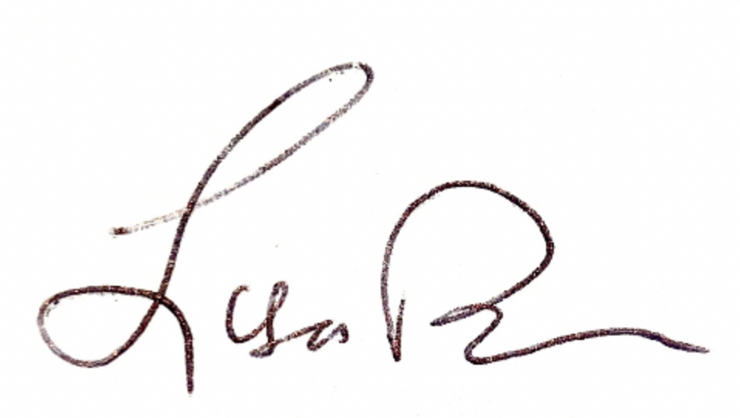
LISA W. BORDEN
Senior Policy Counsel, International Advocacy

