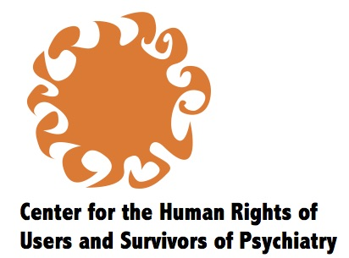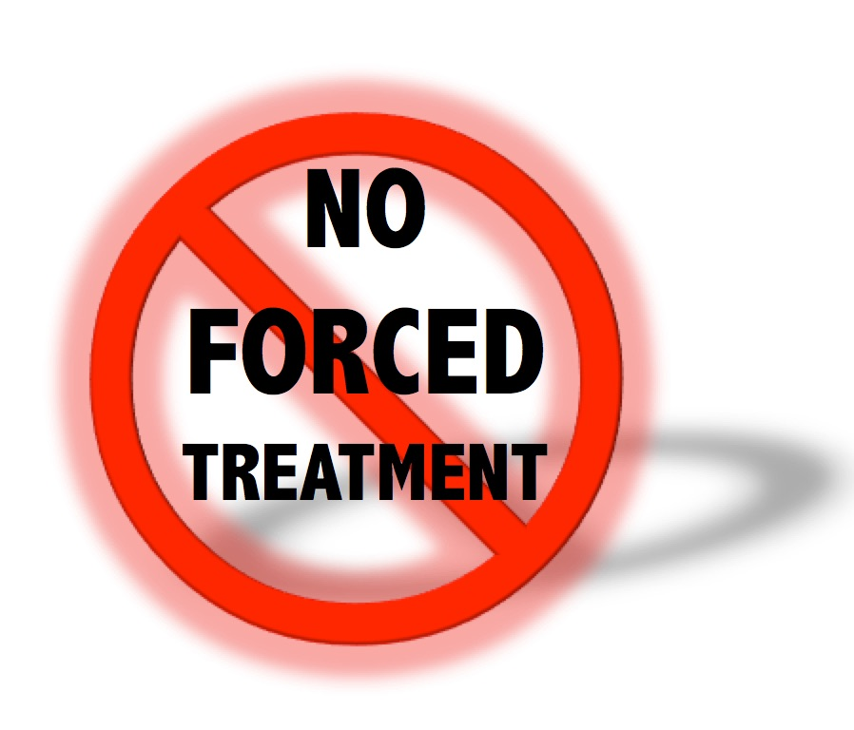
10 April 2018

Submission by Center for the Human Rights of Users and Survivor of Psychiatry (CHRUSP) and the Campaign to Support CRPD Absolute Prohibition of Commitment and Forced Treatment (Absolute Prohibition Campaign)*

Response to draft General Comment 7 on Article 4.3, paragraph 14(a) and (d) and transversal

Summary:
Persons with actual or perceived psychosocial disabilities are a distinct constituency that cannot be combined with persons with intellectual disabilities.
Only fully functioning DPOs can claim to represent people with actual or perceived psychosocial disabilities.
‘Organizations of self-advocates’ as defined in paragraph 14(d) do not pertain to us and the reference to persons with psychosocial disabilities in that paragraph should be removed.

- Definition

- We adopt a social-model definition of psychosocial disability as follows:
Psychosocial disability refers to a person’s experience of discrimination, which may include segregation, confinement, violations of autonomy and physical and mental integrity, and/or denial of desired supports and accommodations, based on their subjective distress or disturbance or others' attribution to them of distress or disturbance.**
- Psychosocial disability is a social construct and does not exist apart from social and political processes that systematically disempower individuals and violate their human rights. There is no biological, psychological or other impairment in functioning of the mind or body that corresponds to our singular subjectivity – only the different ways that we survive hardships and learn what it is to be human, including the human condition of being unique and not repeatable.
- Social and political processes that reify our subjective personal experiences, or others’ opinions of us, as ‘impairment’ can result in a limiting view of ourselves that is self-perpetuating.
- Subjective distress or disturbance may be experienced in the body and in some instances may be related to physical factors such as metabolism, hormonal imbalance or natural cycles, nutritional deficiencies, or neurological disorders. Nevertheless there is no objective physical correlate for psychosocial disability per se or for any particular kind of subjective distress or disturbance.
- We reject the hegemonic medical model of ‘mental illness,’ which does not take into account either our individual uniqueness or the discrimination and barriers that we confront.
- The construct of psychosocial disability can arise directly as discrimination based on subjective experience or attribution of distress or disturbance, or indirectly from other discriminatory responses to individuals’ behavior and ways of being, as when behavior is judged as disturbing because it challenges dominant social norms or political orders.
- Discrimination that underlies the construct of psychosocial disability runs rampant, and this is why we have organized ourselves and claimed our inclusion within the disability community.
- This discrimination includes deliberate segregation and confinement, rejection of our will and preferences on the pretext that we are ‘incompetent’, and torture masquerading as care.
- It also includes the failure to empathize and to provide support and accommodations, if desired, in relation to subjective experiences of distress or disturbance, or in relation to periods of life transition, heightened consciousness, natural cycles, illnesses and disorders of the body, sexual or other abuse, or traumatic occurrences. This is a systemic societal failure to embrace outliers – those who may in fact have the most to teach us about where the pain is and where we collectively need to grow.

- ‘Actual or perceived’

- The term ‘psychosocial disability’ was adopted by the World Network of Users and Survivors of Psychiatry as a way to position ‘users and survivors of psychiatry’ as defined in WNUSP statutes as a constituency of disabled people.
A user or survivor of psychiatry is self-defined as a person who has experienced madness and/or mental health problems and/or who has used or survived mental health services.
- Members of the constituency have continued to refine our understanding of psychosocial disability as a social construct.
- As indicated in the definition in paragraph 1, ‘psychosocial disability’ includes the concept of discrimination that may be experienced based on actual (subjective) or perceived (attributed) distress or disturbance. In referring to individuals, it is necessary to make explicit the fact that the constituency includes both experiences on an equal basis, i.e. to refer to ‘persons with actual or perceived psychosocial disabilities.’
- Alternatively we can refer to ‘people disabled by psychosocial norms,’ as a parallel to ‘disabled people’.

- Separate constituencies

- Persons with actual or perceived psychosocial disabilities are an entirely distinct constituency from persons with intellectual disabilities. It is incorrect to group us together, in phrases such as ‘persons with psychosocial and/or intellectual disabilities’ or in designing laws and policies. The diversity of persons with disabilities must be respected, in accordance with CRPD Article 3(d) and preamble paragraph (i).
- The construct of ‘mental disability’ is closely linked to that of ‘mental incapacity,’ which the Committee has rightly called into question in General Comment 1. ‘Mental disability’ has been used variously to mean intellectual disability, developmental disability (as a synonym for intellectual disability or a wider category), cognitive disability acquired in adulthood, and/or psychosocial disability.
- From a human rights standpoint, the perspectives, self-definitions, and self-organization of constituencies are the starting point. People with actual and perceived psychosocial disabilities have a distinct history of organizing and advocacy for liberation and justice. During the CRPD negotiations, the global organizations representing people with actual or perceived psychosocial disabilities (World Network of Users and Survivors of Psychiatry) and people with intellectual disabilities (Inclusion International) rejected the term ‘mental disability’ and insisted on the distinction between the two constituencies.
- As we understand the designations that are confused with our own, ‘intellectual disability’ refers to the situation of people who experience learning difficulties before the age of 18. ‘Developmental disability’ refers to disability that arises before the age of 18 related to childhood development; it includes intellectual disability, and is sometimes also understood to include autism and cerebral palsy. Cognitive disability acquired later in life can include brain injury, dementia, and other cognitive impairment that develops after the age of 18.
- We respect the right to self-definition of all disabled people. It is possible that other constituencies will define themselves in a way that overlaps with ours. Any overlap must be resolved by the constituencies themselves, and does not justify the use of terminology that merges or confuses them.
- There are individuals who experience more than one form of disability. A person with actual or perceived psychosocial disability may also be Deaf or blind or have a mobility impairment, may also be a person with intellectual disability, may be autistic, may also have experienced cognitive impairment resulting from psychiatric drugs or electroshock. Multiple experience of disability means that a person faces intersectional discrimination, similar to disabled persons who also experience discrimination based on factors such as sex, age, ethnicity and sexual orientation. Notwithstanding such diversity, the existence of each distinct constituency, and its right to self-organization and self-definition, must be respected.

- DPOs, not ‘organizations of self-advocates’

- People with actual or perceived psychosocial disabilities organize ourselves and maintain DPOs made up exclusively of our constituency or having a majority of our constituency, as defined in paragraph 14(a). We do not work in the manner described for ‘organizations of self-advocates’ in paragraph 14(d).
- Organizations purporting to represent people with actual or perceived psychosocial disabilities that do not meet the criteria in paragraph 14(a) for being DPOs, for example if they are run by staff members or leaders who are not themselves persons with actual or perceived psychosocial disabilities, are not adequate to represent the constituency.
- The right to self-representation through our own organizations mirrors the right to legal capacity held by individuals. In both cases, there must be one seamless standard. Just as the Committee has rejected any distinction in status between people who use support and those who do not use support in exercising their legal capacity, the Committee should reconsider whether it is necessary to create a separate category of organizations based on the actual or perceived need for support in self-representation.
- Members of any constituency of disabled persons may engage in peer support or use personal assistance or other support arrangements that enable their effective participation. The ability for members to use support to participate should be incorporated into the concept and functioning of DPOs, without making assumptions about the needs of particular constituencies or individuals, so as to uphold the right of all disabled persons to act as protagonists in advocacy, whether or not they have support needs.

- Conclusion and recommendations

- We request that the draft General Comment be revised accordingly. If the Committee considers it necessary to refer to ‘organizations of self-advocates,’ as in paragraph 14(d), the reference to persons with actual or perceived psychosocial disabilities should be removed. The document should refer to ‘persons with actual or perceived psychosocial disabilities’ independently throughout the text, and address the particular forms of discrimination that the constituency itself advocates to be redressed. Nomenclature that combines constituencies, such as ‘persons with intellectual and/or psychosocial disabilities,’ should be removed.

* This submission was developed through discussions in the Absolute Prohibition campaign with contributions by members including Diana Signe Kline (USA), Emily Sheera Cutler (USA), Emmy Charissa (Singapore), Evie Milonaki (Greece), Fleur Beaupert (Australia), Initially NO (Australia), Irit Shimrat (Canada), Jacqui Narvaez-Jimenez (UK), Judy Gayton (Canada), Leah Ashe (USA), Liz Brosnan (Ireland/UK), Lucila Lopez (Argentina), Olga Kalina (Georgia), Pink Belette (France), Tina Minkowitz (USA). The Center for the Human Rights of Users and Survivors of Psychiatry (CHRUSP) works for legal capacity for all, the abolition of committal, forced treatment and substitute decision-making, and the creation of supports that respect individual choices and integrity. CHRUSP is a non-membership DPO led by people with actual or perceived psychosocial disabilities and holds special consultative status with ECOSOC. Website www.chrusp.org. The Campaign to Support CRPD Absolute Prohibition of Commitment and Forced Treatment (Absolute Prohibition Campaign) brings together people persecuted for actual or perceived psychosocial disabilities, and allies who work for the abolition of commitment, forced treatment and substitute decision-making. Website http://absoluteprohibition.org. Contact for submission: Tina Minkowitz, info@chrusp.org. This submission is partial and deals with a preliminary issue, to be followed by a comprehensive response to the draft and consultation.
** This definition was developed and agreed in a conversation among Bhargavi Davar (Transforming Communities for Inclusion-Asia), Salam Gomez (World Network of Users and Survivors of Psychiatry), and Tina Minkowitz (Center for the Human Rights of Users and Survivors of Psychiatry), together with Michael Szporluk (MAS Consulting, LLC).

