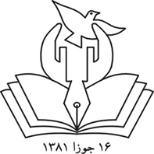
Afghanistan Independent Human Rights Commission
Prepared by: Ahmad Zia Langari
Commissioner
Email: langari@aihrc.org.af, zia.langari@gmail.com
Website: www.aihrc.orh.af
18 May 2015

Drug Problem in Afghanistan
History
According to historic records, poppy has been cultivated since the year 1100 in Afghanistan. It has been introduced by Arab merchants who were trading between Meddle East and China through the old Silk Road. In early nineteen century, Afghanistan was exporting opium to Iran. For the first time, the Government of Afghanistan banned poppy cultivation in 1927. Poppy cultivation was limited till 1979 in Afghanistan. In late seventies, opium production in Asia such as in Laos and Vietnam was reduced because of unrest situation, and on the other hand, Iran totally banned poppy cultivation and all related business of opium became illegal and perpetrators were severely punished. Therefore, due to these restriction on poppy cultivation in Asia and high market demand caused that poppy cultivation became wide spread in Afghanistan. Afghanistan was producing only opium before 1990, but afterward, when the government lost its control across the country, and vise versa, the local/tribal authorities controlled the local power, poppy cultivation grown up in nineties because it was one of the main sources of income for warlords and warring factions. At least one of the Islamic fundamentalist factions rationalized the production of opium and heroin is a retaliatory action of Afghan people, and was blaming that western states send rockets to Afghanistan to fuel the civil war, therefore, why Afghans should not send opium and heroin to their countries to suffer their people. At this time opium processors shifted their processing plants from other side of the border line in Pakistan to inside of Afghanistan.
Present situation
According to a joint report of the Anti-Drug Ministry and UNODC 12 November 2014), Afghanistan produced 90 % of the world annual opium in 2014. In 2014, total land covered by poppy was 226,000 Hectare, that produced 6400 tones.
The Article 7th of Afghanistan constitution reads: The Government prevents of any terroristic action, cultivation of all crops producing drug, its trafficking and production and use of intoxicating drinks.”
The government of Afghanistan launches annual destroying campaign of poopy land but so far it has given no considerable result. The Government encourages farmers not to grow poppy, instead encourages them and provided them with seed/bulb of cash crops such as saffron to replace poppy cultivation as well as free distributing of fruit tree saplings and free or loan-based agricultural input such as fertilizer, chemicals, improved seeds of other crop, but despite of these, still it has not reduced annual poppy cultivation. The government, due to insecurity, is able to destroy every year those poppy lands which are located nearby police headquarters. Anti-drug campaign brings casualties every year. In 2014, at least 13 policemen killed during the campaign.
One of the main causes of present insecurity in Afghanistan could be the very high beneficial drugs business. Local and international drug mafias, Taliban and other Islamist militants fight in Afghanistan, to a large extend, depend on drug business. In some areas where Taliban control the area, poppy cultivation is compulsory, Taliban force farmers to cultivate poppy,, but indeed, o other cash crop can compete poppy which meet the cash requirement of farmers . Taliban militants collect Islamic tax of farm land, called “Usher” , 10% of annual production” per unit of land. Ten percent of of income from one hectare of poppy land is very high comparing wheat.
Usage of opium in Afghanistan
Opium has been known as an important ingredient of traditional herbal medicines in Middle East, South Asian countries, including Afghanistan, The sap or the ovary of the poppy is used in herbal medicine, or some people drink the tea of dried ovary of poppy . In herbal medicine it is known as strong analgesic and stress reliever.
The number of addicted population in Afghanistan is estimated to be between 1.3-1.6 million people. The number of women addicted to heroin is very less than the number of addicted to opium.
According to UNODC surveys, every addicted person spend 1$ a day for accessing to heroin, while per capita income of every individual is around 50 $ per month.
The government has put efforts to help addicted people to discontinue drug usage, but it has not been sufficient. Totally 96 centers run by the government for treatment of addicted people with the facility of 2500 beds. Treatment duration is 2-3 months, but unfortunately with no follow-up program; most of recovered people resort again to drug due to poverty, joblessness and psychosocial problems.
The reason of addiction to narcotic material (Hashish, opium, heroin and morphine)
Generally, the main causes of resorting to drug are: trauma as a result of conflict, no or low education, joblessness, facing violence, no entertainment and relaxation facilities, poverty and very bleak future.
The Afghanistan Independent Human Rights Commission conducted a field survey in 2007 to find out the problem of women addicted to drug in Afghanistan.
Collected data of the survey show that those women addicted mostly were at the age of 26-60 year.
One of the problems of these women is caring high number of children, such as caring 1-9 children. 57.4% of addicted interviewees have married under 16-year old, while according to domestic law, the marriage age for girls is over 16 and for boy is over 18. Data also shows that a number of addicted women are very poor, 67.6% of them had income of less that 70% per month. Joblessness is another problem, 49.5% were jobless and 51% of them had job, who are mostly busy in family farming, carpet weaving and other handicraft making. Indeed, these women are unpaid family workers that thiier husband gain their income. Women in Afghanistan addicted to different drugs as: 83.2% to opium, 7.8% to heroin, 6.28% to hashish (marijuana), and 2% to other drugs.
Family member addicted to drug also can be one of the reasons for women addicted to drug. The Survey show that 37.9% of addicted women said that their husband are addicted to different herbal narcotics and their husband encouraged them to use narcotics for pain or stress relief.
Children are also not safe at home with addicted parents. 14.8% addicted women have said that their children also use opium. Babies are given opium to keeping them quite particularly by their carpet weaver mothers, and older children under 18 themselves take opium even these children provide opium for their parents, buy it or collect it from farms.
While using opium as herbal narcotic or pain reliever has been traditionally common among rural population, but in recent years due to hardship, Afghan migrant women have been addicted in neighbor countries. According to the AIHRC’s survey, among 827 addicted women, 10.5% of them in Pakistan and 6.3% in Iran have taken opium for the first time. According to the survey result, the main reasons for taking opium/drug by women in Afghanistan have been: 1) psychosocial problem (54.4%), 2) relaxation/entertainment and stress killing purpose (14.13%) and 3) for medical as pain reliever and coughing problems (26.93%).
xxxxxxx
Images of drug users in Afghanistan
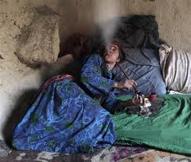
A woman smokes opium in a rural home
A man injects morphine
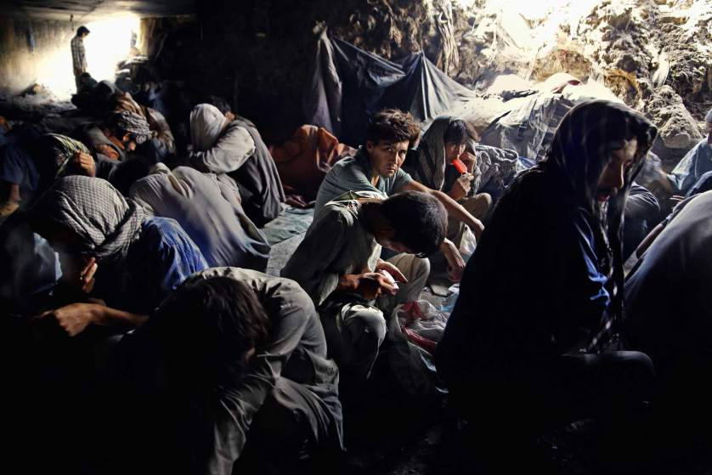
Group of drug users in abundant site
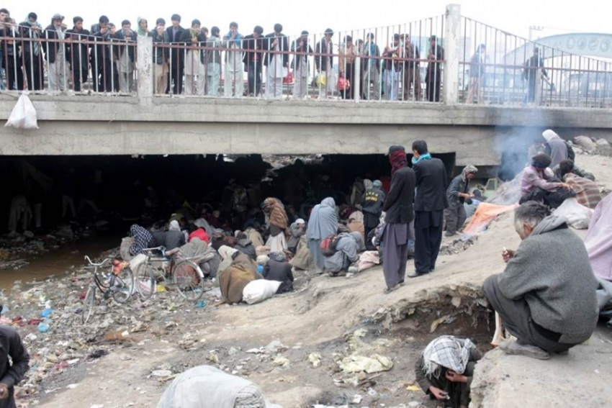
Young men are watching drug smokers under a bridge in Kabul
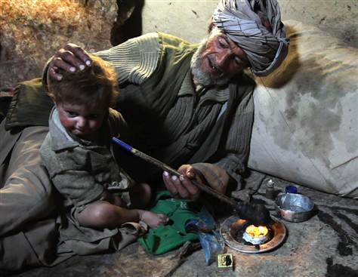
The father tries to force his child to breath opium smoke

