BIRTH REGISTRATION
LEGAL FRAMEWORK
- Right to Registration – Legal Framework
All births occurring in the Republic of Guyana are required by Law to be registered regardless of the parent(s) legal or marital status.
The registration of a birth can be effected by the Parent(s) of any child born in Guyana, the nurse, or anyone present at the birth of the child.
There is no time frame to register a birth; but different systems prevails for children under one year and another for one year and older.
(Reference: Sections 18, 25 & 26 of the Registration of Births and Deaths Act Chapter 44:01 of the Laws of Guyana)
Registrations are completed with the informant affixing his/her signature to the Registration Form. In cases where the informant is unable to affix his/her signature; the person may in the presence of the Registrar affix, a thumb print or an X.
Birth Registration is free

(Reference: Section 17, 21 & 34 (1) of the Registration of Births and Deaths Act Chapter 44:01 of the Laws of Guyana)

REGISTRATION OF BIRTHS AND DEATHS
The General Register Office is the office mandated to collect and secure all registrations of Births, Deaths and Marriages in the Republic of Guyana.
Guyana has two hundred centres throughout the country mandated to register births and deaths. These centres are: Public Hospitals, Private Hospitals and Health Centres.
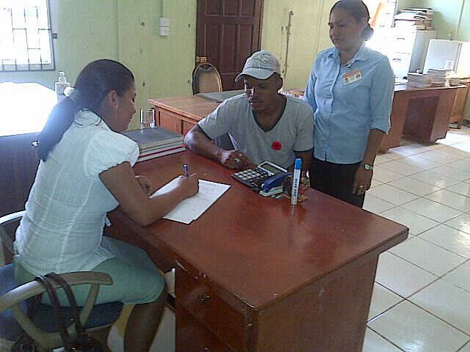
Births and Deaths occurring at Public/Private Hospitals are recorded at Place of Birth or Death.
Home Births and Deaths are recorded at the nearest Health Centre.
The staff effecting registration at the centres are referred to as
registrars and are Health Workers.
All registrars are required to send a monthly return of entries of Births and Deaths with the original registration forms to the General Register Office for retention.
Registrations of Deaths are free of cost.

(Reference: Sections 12, 37(1) and 38(1) of the Registration of Births and Deaths Act Chapter 44:01 of the Laws of Guyana)

REGISTRATION OF MARRIAGE
The Marriage Registration Forms are prepared by the Marriage Officer who solemnized the marriage.
Marriage officers are required by law to lodge the registration of marriages at the General Register Office.
(Reference: Sections 62(2) of the Marriage Act Chapter 45:01 of the Laws of Guyana)

BIRTH CERTIFICATES
The information reflected on a Guyana Birth Certificate is as follows:
- Name of Child
- Date of Birth
- Place of Birth
- Gender
- Name of Mother
- Name of Father.
- Date of Registration

BENEFIT AND ACTIVITIES THAT STRENGHTENED THE GENERAL REGISTER OFFICE
- Establishing of additional registration centres especially in rural areas to catch home births.
- Continuous training of Registrars to ensure they possess the necessary skills and knowledge to register births competently as they occur.
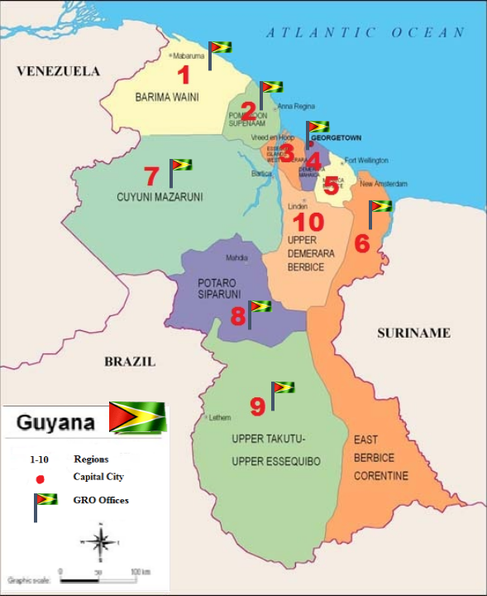
- Decentralization of the services offered at the General Register Office by establishing Sub Offices in Regions 1, 2, 6, 7, 8 & 9. To ensure citizens in our rural communities have access to our services without expending time and money travelling to the city to visit the only office. All adults are now registered this was done, by the General Register Office.
Children were registered in their villages by their Health Worker who will continue to ensure all new born are registered.

The Ministry of Amerindian Affairs who is responsible for our indigenous citizens assists the General Register Office by instructing every village Toashao (the person who heads the village) to assist and ensure their villagers are in possession of a birth certificate.

AWARNESS:
The General Register Office publishes and distributes booklets, posters, pamphlets, throughout the year to ensure the public is aware of birth registration its procedures and benefits.
Mothers- to- be are targeted at the pre-natal clinic with lectures, posters, and handouts on birth registration.
Special hand outs are given out in Maternity Wards to new mothers advising on birth registration process and benefits.
Visits to rural areas are done by the staff of the General Register, Main Office to ensure:-
- The staff at the Sub Offices are functioning effectively in the regions.
- To address issues affecting rural residents with a view of improving our services.

BEDSIDE BIRTH REGISTRATION
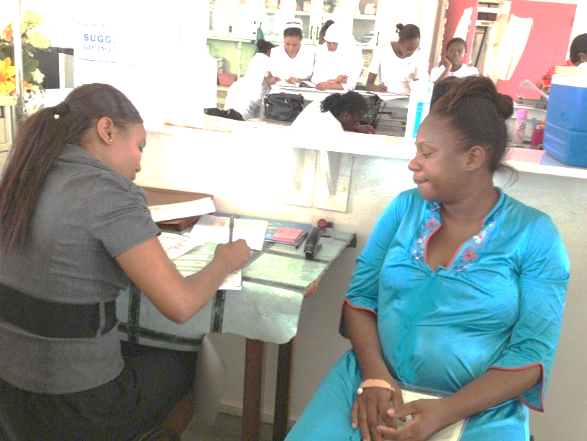
Bedside Birth Registration entails all births being registered at the hospital before the mother is discharged.

Guyana has re-introduced bedside birth registration in 2013 in an effort to achieve total birth registration.

DO CHILDREN NEED TO BE REGISTERED TO ACCESS
HEALTH SERVICES
The births of children do not have to be registered for them to access Health Services.

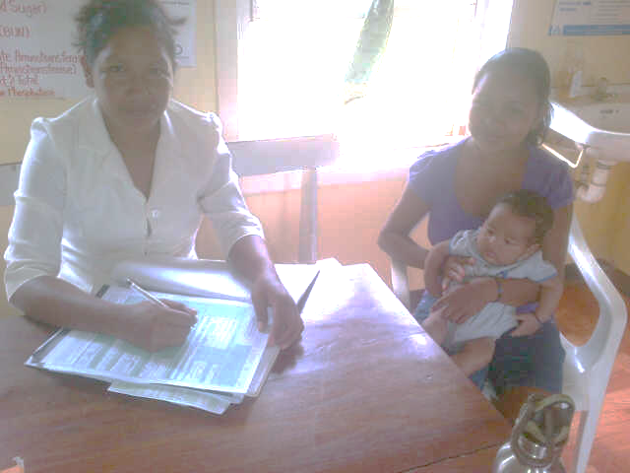
EDUCATION
Children entering the school system are required to have a birth certificate. This requirement ensures all births are captured contemporaneously or at admittance to school.
If the child’s birth was not registered the parent would be advised to effect a Late Registration.
IN DECENTRALIZING THE GENERAL REGISTER OFFICE SERVICES
Four of the new offices are located in our hinterland regions whose population is our indigenous people, who had little or no access to birth registration.
The decentralizing of the General Register Office was important to ensure citizens in our rural communities have access to our services without having to expense time and money travelling to the City to visit the only office.

Analysis of Birth Registration data over a five (5) year period.
 | Year
Region | 2008 | 2009 | 2010 | 2011 | 2012 | Total
1 | 701 | 652 | 536 | 543 | 576 | 3008
2 | 946 | 964 | 1055 | 969 | 974 | 4908
3 | 1184 | 743 | 1204 | 1475 | 1217 | 5823
4 | 7484 | 7041 | 7560 | 7201 | 7623 | 36909
5 | 321 | 387 | 136 | 349 | 419 | 1612
6 | 2344 | 2079 | 1446 | 1929 | 2094 | 9892
7 | 379 | 357 | 336 | 372 | 378 | 1822
8 | 245 | 244 | 201 | 292 | 226 | 1208
9 | 689 | 635 | 683 | 605 | 617 | 3229
10 | 783 | 654 | 648 | 738 | 950 | 3773
Total | 15076 | 13756 | 13805 | 14473 | 15074 | 72184
Gender | Year
 | 2008 | 2009 | 2010 | 2011 | 2012 | Total
Male | 7790 | 7093 | 7064 | 7440 | 7611 | 36998
Female | 7286 | 6663 | 6741 | 7033 | 7463 | 35186
Total | 15076 | 13756 | 13805 | 14473 | 15074 | 72184
Mother's Age | Year
 | 2008 | 2009 | 2010 | 2011 | 2012 | Total
Under 16 | 249 | 201 | 181 | 164 | 175 | 970
16-19 | 2896 | 2696 | 2678 | 2908 | 2973 | 14151
20-24 | 4452 | 4185 | 4268 | 4538 | 4629 | 22072
25-29 | 3086 | 3186 | 3140 | 3188 | 3377 | 15977
30-39 | 3659 | 3223 | 3288 | 3449 | 3461 | 17080
Over 40 | 256 | 258 | 208 | 216 | 458 | 1396
 |  |  |  |  |  | 71646

Persons between the ages of 16-18 years can marry but need parental consent. Persons over 18 years can marry without parental consent.
Reference: Sections 31(1), (2) of the Marriage Act Chapter 45:01 of the Laws of Guyana

