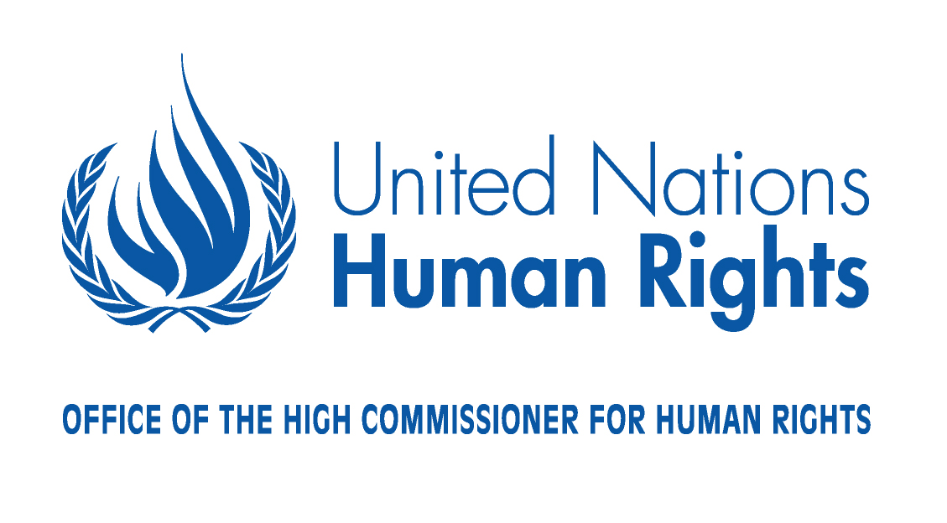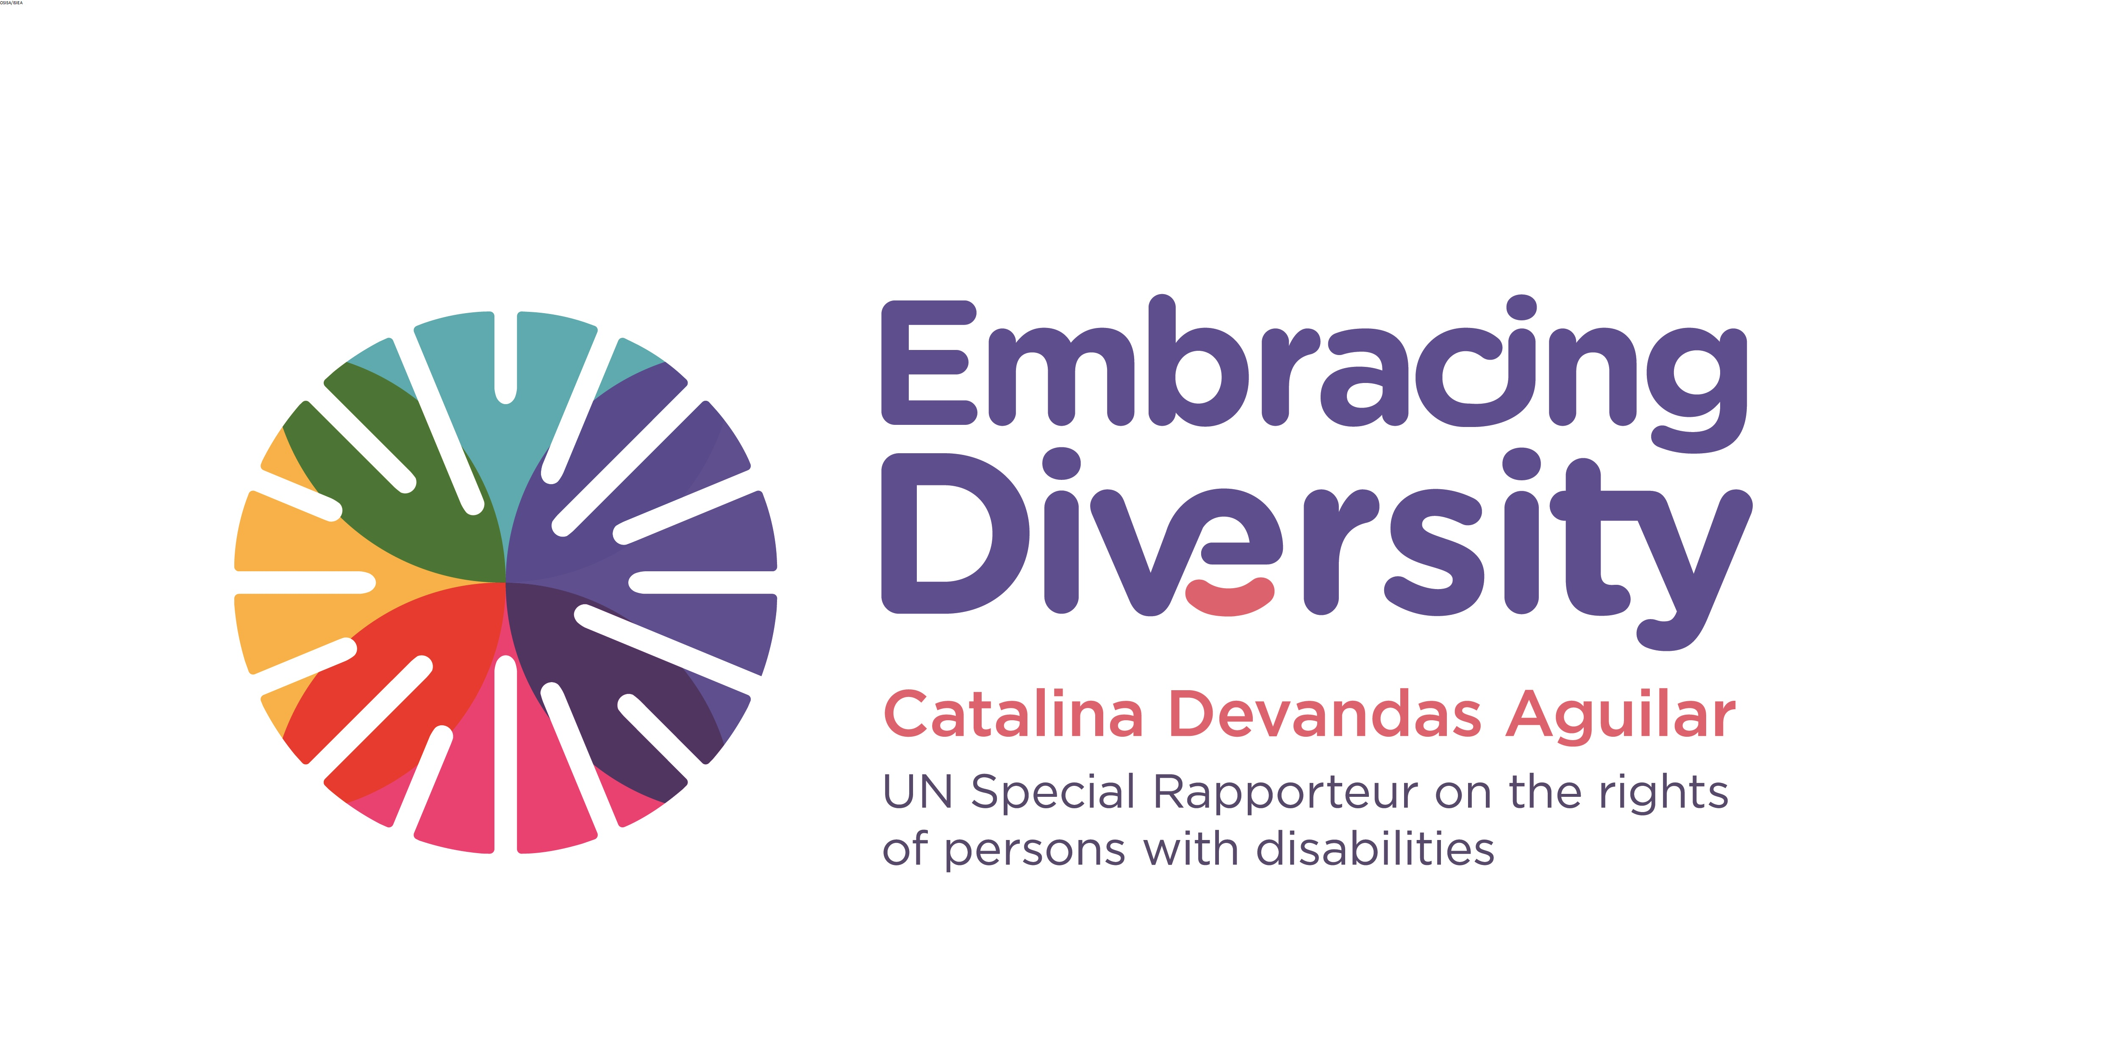

Regional Expert meeting on support services for persons with disabilities

6-7 September 2016
Addis Ababa- Ethiopia

List of Participants

- Ms. Catalina Devandas Aguilar, Special Rapporteur on the rights of persons with disabilities (Costa Rica)
- Ms. Maria Soledad Cisternas, Chair of the Committee on the Rights of Persons with Disabilities (Chile)
- Mr. Danlami Basharu, Member, Committee on the Rights of Persons with Disabilities (Nigeria)
- Mr. Benyam Dawit Mezmur, Chair of the Committee on the Rights of the Child (Ethiopia)
- Ms. Ikponwosa Ero, Independent Expert on the enjoyment of human rights by persons with albinism (Nigeria)
- Mr. Olawale Maiyegunm, Director of Social Affairs, African Union Commission (Ethiopia)
- Mr. Shuaib Chalken, Chair of the African Disability Forum (South Africa)
- Mr. Bob Ransom, Ethiopian Center for Disability and Development (Ethiopia)
- Mr. Samuel Kabue, Ecumenical Disability Advocates Network (Kenya)
- Mr. Stanfield Michelo, Ministry of Community Development and Social Welfare of Zambia (Zambia)
- Ms. Getrude Fefoama, Global Advocacy Advisor and Sightsavers (Ghana)
- Mr. Sindile Mhlanga, Lecturer and expert in inclusive education (Zimbabwe)
- Mr. Joseph Walugembe, ADD International (Uganda)
- Ms. Judith Ekaete Umoh, Joint National Association of Persons Living with Disabilities (Nigeria)
- Mr. Palwos Kasu, Federation of Ethiopian National Associations of Persons with Disabilities (Ethiopia)
- Mr. Idriss Alzouma Maiga, Nigerian Federation Persons with Disabilities (Niger)
- Mr. Ayassou Komvi, Togolese Federation of Associations of Persons with Disabilities (Togo)
- Ms. Fatma Wangare, Kenya Association of Intellectually Handicapped (Kenya)
- Ms. Ferozia Hoseneea, Down Syndrome Association Mauritius (Mauritius)
- Mr. Michael Njenga, Users and Survivors of Psychiatry (Kenya)
- Ms. Rachel Kachaje, Federation of Disability Organizations of Malawi (Malawi)
- Ms. Ekaete Judith Umoh, Women with Disabilities (Nigeria)
- Ms. Shitaye Astawes, Federation of Ethiopian National Associations of Persons with Disabilities (Ethiopia)
- Mr. Juan Borman, Centre for Augmentative and Alternative Communication, University of Pretoria (South Africa)
- Mr. Sylvester Katontoka, Mental Health Users Network of Zambia (Zambia)
- Mr. Robyn Beere, Inclusive Education South Africa (South Africa)
- Ms. Patience Kanguma, Zambia Federation of Disability Organisations (Zambia)
- Ms. Diana Msipa, Consultant on disability and human rights law and policy (Zimbabwe)
- Ms. Elizabeth Kamundia, Users and Survivors of Psychiatry (Kenya)
- Ms. Noela Msuya, Child Support Tanzania (Tanzania)
- Ms. Patricia Mwanyisa, Open Society Initiative for Southern Africa (OSISA) (Zimbabwe)
- Ms. Sabine Rehbichler, Light for the World (Austria)
- Ms. Yetnebersh Nigussie, Ethiopian Center for Disability and Development (Ethiopia)
- Mr. Lefhoko Kemasang, Senior Social Welfare Officer, Social Affairs Department, African Union Commission (Ethiopia)
- Mr. Alberto Vásquez, Research Coordinator, Office of the Special Rapporteur on the rights of persons with disabilities (Peru)
- Ms. Alina Grigoras, Associate Human Rights Officer, OHCHR (Moldova)

