Input to the call for contributions to the first draft of General Recommendation N° 37 on racial discrimination and the right to health under Article 5 (e)(iv) of the International Convention on the Elimination of All Forms of Racial Discrimination.
fra.europa.eu

The European Union Agency for Fundamental Rights (FRA) is set up to provide independent evidence-based assistance and expertise relating to fundamental rights. It does this by collecting and analysing comparative, objective and reliable information and data about the situation of fundamental rights across the EU and providing advice, based on evidence, about how to improve the situation.

The information compiled in this document draws on FRA data and evidence relevant to the call for contribution to a first draft of General Recommendation N° 37 on racial discrimination and the right to health.
Contents
Inequalities and multiple discrimination in access to and quality of healthcare (FRA, 2013) 1
Experiences of discrimination based on ethnic or immigrant background in the area of health and health care (different FRA surveys) 3
Roma and Travellers in the six countries (FRA, 2020) 4
Roma – Selected findings from FRA’s second EU Minorities and Discrimination Survey (FRA, 2016) 6
Getting the future right- Artificial intelligence and fundamental rights (FRA, 2020) 9
Fundamental Rights Report 2022 (FRA, 2022) 9
Compendium of practices for equality data collection 9

Inequalities and multiple discrimination in access to and quality of healthcare (FRA, 2013)
FRA’s report on Inequalities and multiple discrimination in access to and quality of healthcare sheds light on the experience of multiple discrimination in healthcare. Based on qualitative social research and legal analysis in five EU Member States, the report is a first effort to explore the nature, context and effects of unequal treatment based on ethnicity in combination with one or more protected grounds (age, sex and disability) in the area of healthcare. Selected key findings and FRA recommendations:
- Due to low compensation awards in discrimination cases, alleged victims of discrimination in healthcare often initiate other types of legal actions, such as tort actions on grounds of medical negligence. Compensation awarded in discrimination cases should be dissuasive and proportionate to the damage suffered, including in the area of healthcare. Generally, providing for higher compensation in multiple discrimination cases would constitute an incentive for victims and their lawyers to pursue multiple discrimination claims before courts and hence render anti-discrimination law more efficient.
- Institutionalising multi-dimensional equality in the healthcare system: EU Member States should adopt measures to further the right to health on an equal basis: free linguistic assistance – including translation and mediation services for those who do not speak or understand the language as well as ‘signed’ languages and other forms of support for people with sensory or intellectual impairments – should be made available in healthcare settings and when providing health information.
EU Member States should encourage positive actions for persons belonging to groups at risk of intersectional discrimination, as provided for by both the Racial Equality Directive and Employment Equality Directive. To do so, they should: accommodate the needs of women belonging to ethnic minorities who wish to be treated by female healthcare professionals; fund community based mobile outreach programmes targeting different ethnic communities and groups among them – including older people, women and persons with a variety of disabilities – to promote healthcare and raise awareness of entitlements and available health services; and allocate more time for medical consultations with persons belonging to these groups due to their special needs.
EU Member States should find appropriate ways of guaranteeing that all healthcare users are treated equally, and with dignity and respect. Training on discrimination and multiple discrimination, cultural competence and understanding disabilities should be provided to healthcare professionals, possibly in a mandatory fashion.
- Access to justice: EU Member States should take the necessary steps to increase healthcare users’ awareness of the existence and functioning of the available complaint mechanisms, both for healthcare and discrimination issues. Complaint bodies should facilitate access to the complaint system for healthcare users who have specific linguistic needs and for those who have a disability. This can be done through the enhanced provision of information in different languages, in braille and easy-to-read format.
- Improving data collection: Addressing health inequalities requires the collection and use of disaggregated data by the various individual grounds of non-discrimination and by those grounds in combination. There is a lack of reliable health statistics giving the full picture of the intersection of different grounds. In order to better reflect the monitoring of equality in EU cross-national surveys, data on ethnicity (recording both migrant status and ethnicity, where legal) and disability (taking into account the ‘social model of disability’) should be included in periodic national surveys. In order to capture multiple inequalities and disadvantages, survey sample sizes should be large enough to allow for further disaggregation.
- See also Supplementary data on patients’ rights, health outcomes and access to healthcare in five selected EU Member States

Experiences of discrimination based on ethnic or immigrant background in the area of health and health care (different FRA surveys)

According to FRA’s second European Union Minorities and Discrimination Survey (EU-MIDIS II), overall 3 % of respondents mentioned such experiences in the 12 months before the survey (EU MIDIS II main results, p. 34-35). The results on discrimination in access to health in the 12 months preceding the EU-MIDIS II survey show that, on average, discrimination is mostly experienced by Roma respondents (8 %); the highest rates in this area are observed for Roma in Greece (20 %), Romania (12 %), Slovakia (11 %) and Croatia (10 %). Apart from 10 % of the respondents with Turkish background in the Netherlands and 9 % of the respondents with South Asian background in Greece, no other groups indicated having experiences with discrimination when accessing healthcare services in the 12 months before the survey. Some 59 % of those respondents who experienced discrimination in access to health care services say that their skin colour or physical appearance was the main reason for such experiences.

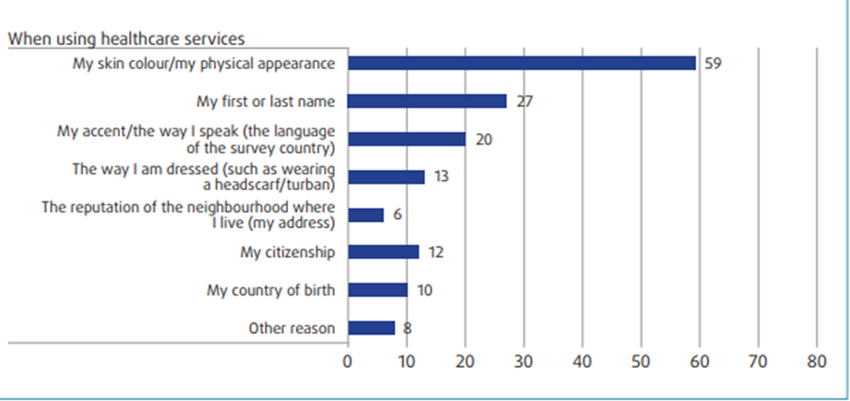

Notes: Out of all respondents, who felt discriminated against because of their ethnic or immigrant background, in the different domains of daily life, (‘healthcare’: n=1,003); weighted results.
Source: FRA, EU-MIDIS II 2016

Some 3 % was also the share of respondents with Sub-Saharan background (EU MIDIS II: Being Black in the EU, p. 42), as well as of Muslims (EU MIDIS II: Muslims – selected findings, p. 31). Some 2 % of Jewish respondents felt discriminated against in the same area, as reported under the Second survey on discrimination and hate crime against Jews in the EU (2018), (p. 61).

The rate is higher (9%) for respondents in the 2019 Roma and Travellers survey, as shown in Table 1, with 17 % of Roma and Travellers respondents having felt discriminated against the last five years before the survey when trying to access health care services.

Table 1: Discrimination experiences in access to healthcare services based on ethnic or immigrant background (including skin colour, ethnic origin or immigrant background, and religion or religious belief) in the 12 months before the survey, different FRA surveys (%)

Survey | Group | In access to healthcare services
 |  | In the past five years | In the past 12 months
EU MIDIS II (2016) | Main results (all groups, EU-28)ª | n.a.^{e} | 3
 | Muslims (in 15 countries) | n.a.^{e} | 3
 | Roma (in 12 countries) | n.a.^{e} | 8
 | Sub-Saharan Africa (in 12 countries) | n.a.^{e} | 3
 | North Africa (in 5 countries) | n.a.^{e} | 3
Second survey on discrimination and hate crime against Jews in the EU (2018)^{b} | Jews (in 12 countries) | n.a.^{c} | 2
Roma and Travellers survey (2019)^{d} | Roma and Travellers  (in 6 countries) | 17 | 9

Notes: a The rates for EU-MIDIS II -Main results are based on data for all groups surveyed: Roma/ Russian minority/ immigrants and descendants of immigrants from Sub-Saharan Africa/ Turkey/ North Africa/ Asia and South Asia/ recent immigrants.
^{b} The rates on discrimination experiences for the second survey on discrimination and hate crime against Jews in the EU are based on the ground ‘because of being Jewish’.
^{c}n.a. = not available for this period.
^{d} The rates on discrimination experiences for the Roma and Travellers survey are based on the ground ‘because of being Roma/Traveller’.
Source: FRA, EU-MIDIS II 2016, Second Antisemitism Survey 2018, Roma and Travellers Survey 2019.

Roma and Travellers in the six countries (FRA, 2020)

The Roma and Travellers in the six countries collected information from 4,659 respondents aged 16 years or older who self-identify as Roma or Travellers in Belgium, France, Ireland, the Netherlands, Sweden, and the United Kingdom. In addition, the survey collected information on 8,234 individuals living in the respondents’ households and about the infrastructure of their halting sites or neighbourhoods, and the respondents’ experiences in accessing healthcare.

Health and healthcare

- The Roma and Travellers surveyed in in the six survey countries have a lower life expectancy than the general population. Life expectancy at birth for Roma women is 9.8 years shorter than among women in the general population; for Roma men the gap is wider, at 10.2 years.

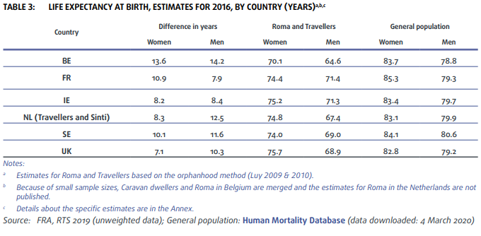
- In almost all surveyed groups, Roma and Travellers report worse health and more limitations in activities people usually do than the general population. Generally, health status worsens with age; given that Roma and Travellers are on average younger than the general population, the difference is even more notable.

- Medical insurance coverage is quite high (around or above 85 %) across almost all surveyed groups, except in Belgium for both Roma and Caravan dwellers (72 % and 78 %).

- Roma and Travellers encountered discrimination when accessing the health services in the 12 months before the survey in all surveyed countries, albeit there are some notable differences between survey groups. One in 10, or fewer, Travellers and Sinti from the Netherlands and Gypsies and Travellers from the United Kingdom reported that they were discriminated against because of being Roma or Travellers in the previous 12 months or five years. Roma and Travellers in Sweden, Travellers in Ireland and Roma in the Netherlands experience discrimination substantially more often when accessing health services.

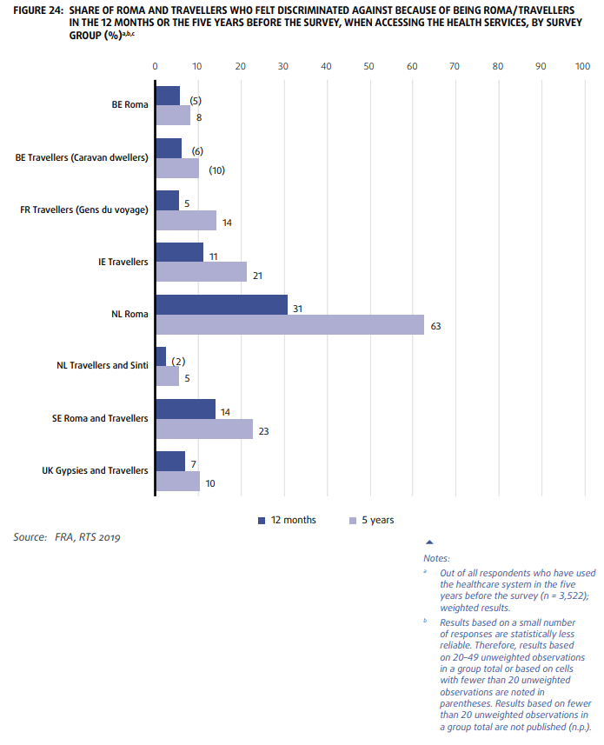

Roma – Selected findings from FRA’s second EU Minorities and Discrimination Survey (FRA, 2016)

The Second European Union Minorities and Discrimination Survey. Roma – Selected Findings report is based on a survey that collected information on almost 34,000 persons living in Roma households in nine European Union (EU) Member States, derived from nearly 8,000 face-to-face interviews with Roma.

Health insurance coverage and unmet medical care needs
Availability of health insurance is a major determinant of access to healthcare systems. EU-MIDIS II asked respondents whether the respective national basic insurance scheme currently covered their health care expenses and whether they had any additional health insurance. The results show that 95 % to 98 % of Roma in Spain, Portugal and Slovakia are covered either by the national basic health insurance scheme or additional insurance. In contrast, only 45 % of Roma in Bulgaria and 54 % of Roma in Romania indicated that this is the case. By comparison, according to the Organisation for Economic Cooperation and Development (OECD), health insurance coverage for the general population ranges from 94 % to 100 % in the Czech Republic, Hungary, Portugal, Slovakia and Spain; in Greece, 86 % of the general population is covered by public or private health insurance.

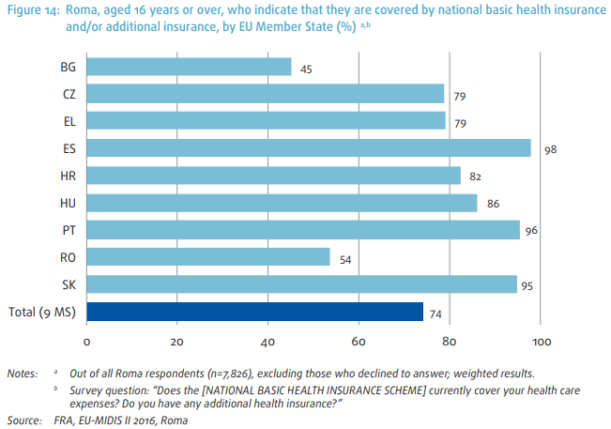

The survey also asked respondents if they needed a medical examination or treatment during the past 12 months; if so, whether they had that examination/treatment; and, in case they did not, why. Overall, depending on the country, between 1 % and 7 % of respondents indicated that it was not possible for them to get the necessary care or treatment.

Limitations in usual activity because of a long-term health problem

EU-MIDIS II asked respondents if they had been limited (severely or not severely) in their usual activities because of a long-term health problem. In four countries – Bulgaria, the Czech Republic, Croatia and Slovakia – the share of Roma facing long-term activity limitations is higher than the share of the general population experiencing similar problems. In Romania, this is the case with Roma men, and in Spain, for Roma women. Also, among Roma in six of the nine countries surveyed, women are more likely than men to say that they have been severely or somewhat limited in their everyday activities due to a health problem – a pattern that can also be seen in the general population. The biggest difference between women and men’s experiences is in Spain, where 17 % of Roma men say that they have been limited in their daily activities, while almost one in three women (30 %) feel that health problems have limited their activities in some way. On the other hand, in the Czech Republic, Greece and Hungary, there is little or no difference between Roma women and men.

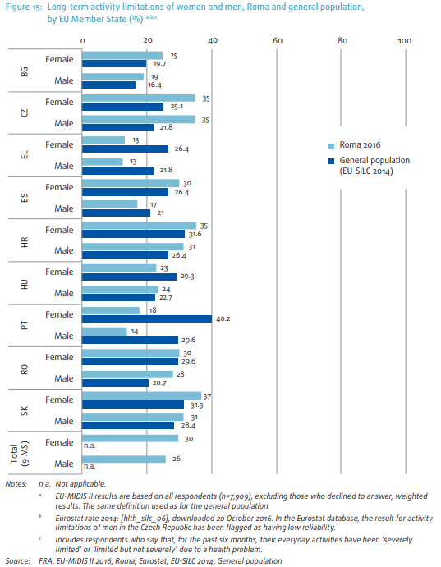

Other relevant FRA data and evidence relevant to the call for contribution can be found in the following publications.

Getting the future right- Artificial intelligence and fundamental rights (FRA, 2020)
The report looks into uses of AI systems in both private and public sectors through interviews of around 100 public and private entities that does use AI, including in law enforcement. It analyses the impact of these systems for fundamental rights, including discrimination in health and healthcare.

Fundamental Rights Report 2022 (FRA, 2022)
The COVID-19 pandemic brought to the surface existing racism, xenophobia and related intolerance and exacerbated them. The health crisis was increasingly used as a pretext to attack minorities – including migrants, people with immigrant backgrounds and Roma – who were already subject to racial and ethnic discrimination, hate speech and hate crime. The Fundamental Rights Report 2022 includes some national projects and civil society initiatives which tried to improve the situation of ethnic minorities during the pandemic and facilitate access to health services.

Compendium of practices for equality data collection
The Compendium of Practices on Equality Data covers practices on different discrimination grounds and areas of life in which discrimination, inequality and exclusion can occur. The compendium is linked to the Guidelines on improving the collection and use of equality data, developed by the Subgroup on Equality Data, and aims to provide inspiration and practical examples on how to implement them. In 2021, the Subgroup developed practical guidance to Member States on improving the collection of data disaggregated by racial or ethnic origin.

