51st session of the Human Rights Council
Information note for NGOs
(Last update: 31 August 2022 – Subject to change)
Contents
Introduction 1
NEW: Relocation of Pass & ID badging services (closing of Pregny Gate) 1
1) Dates and important information 2
General debates 2
2) Accreditation to HRC51 3
3) Oral statements 3
Recommended technical specifications for video messages 5
4) Online co-sponsoring of NGO statements 6
5) List of speakers on HRC Extranet 7
6) Confirmation of speaking slots 7
7) Side events 8
8) Reprisals 8
9) Programme of work, SCHED, additional information and useful contacts 8
ANNEX I – CHECKLIST FOR NGO ORAL STATEMENT 10

Introduction
The purpose of this document is to provide information to civil society representatives participating in the 51st session of the Human Rights Council. This is based on information available at this moment and will be revised and updated on a regular basis.
IMPORTANT: This document is subject to change.

NEW: Relocation of Pass & ID badging services (closing of Pregny Gate)
On 31 August, UNOG shared a Broadcast informing that the final phase of the renovation of the Pregny Pavilion would start the next week. To enable these extensive works, the building will be closed to pedestrians from Monday, 5 September 2022 until end of May 2023. Pedestrian exit via the turnstiles will remain operational.
During the entire renovation period, there will therefore be a different location to obtain access badges to the Palais des Nations. For conference participants, media, NGOs and members of Permanent Missions, the new location is as follows:
Villa Les Feuillantines
Avenue de la Paix 13, 1211 Genève 10
Weekdays from 8 a.m. to 4.45 p.m.
Following issuance of a badge, access to the Palais des Nations will be through the Peace Gate “bis”, a new temporary access screening point. Please refer to the following plans indicating the location of Villa Les Feuillantines and how to access the premises through the Peace Gate "bis".
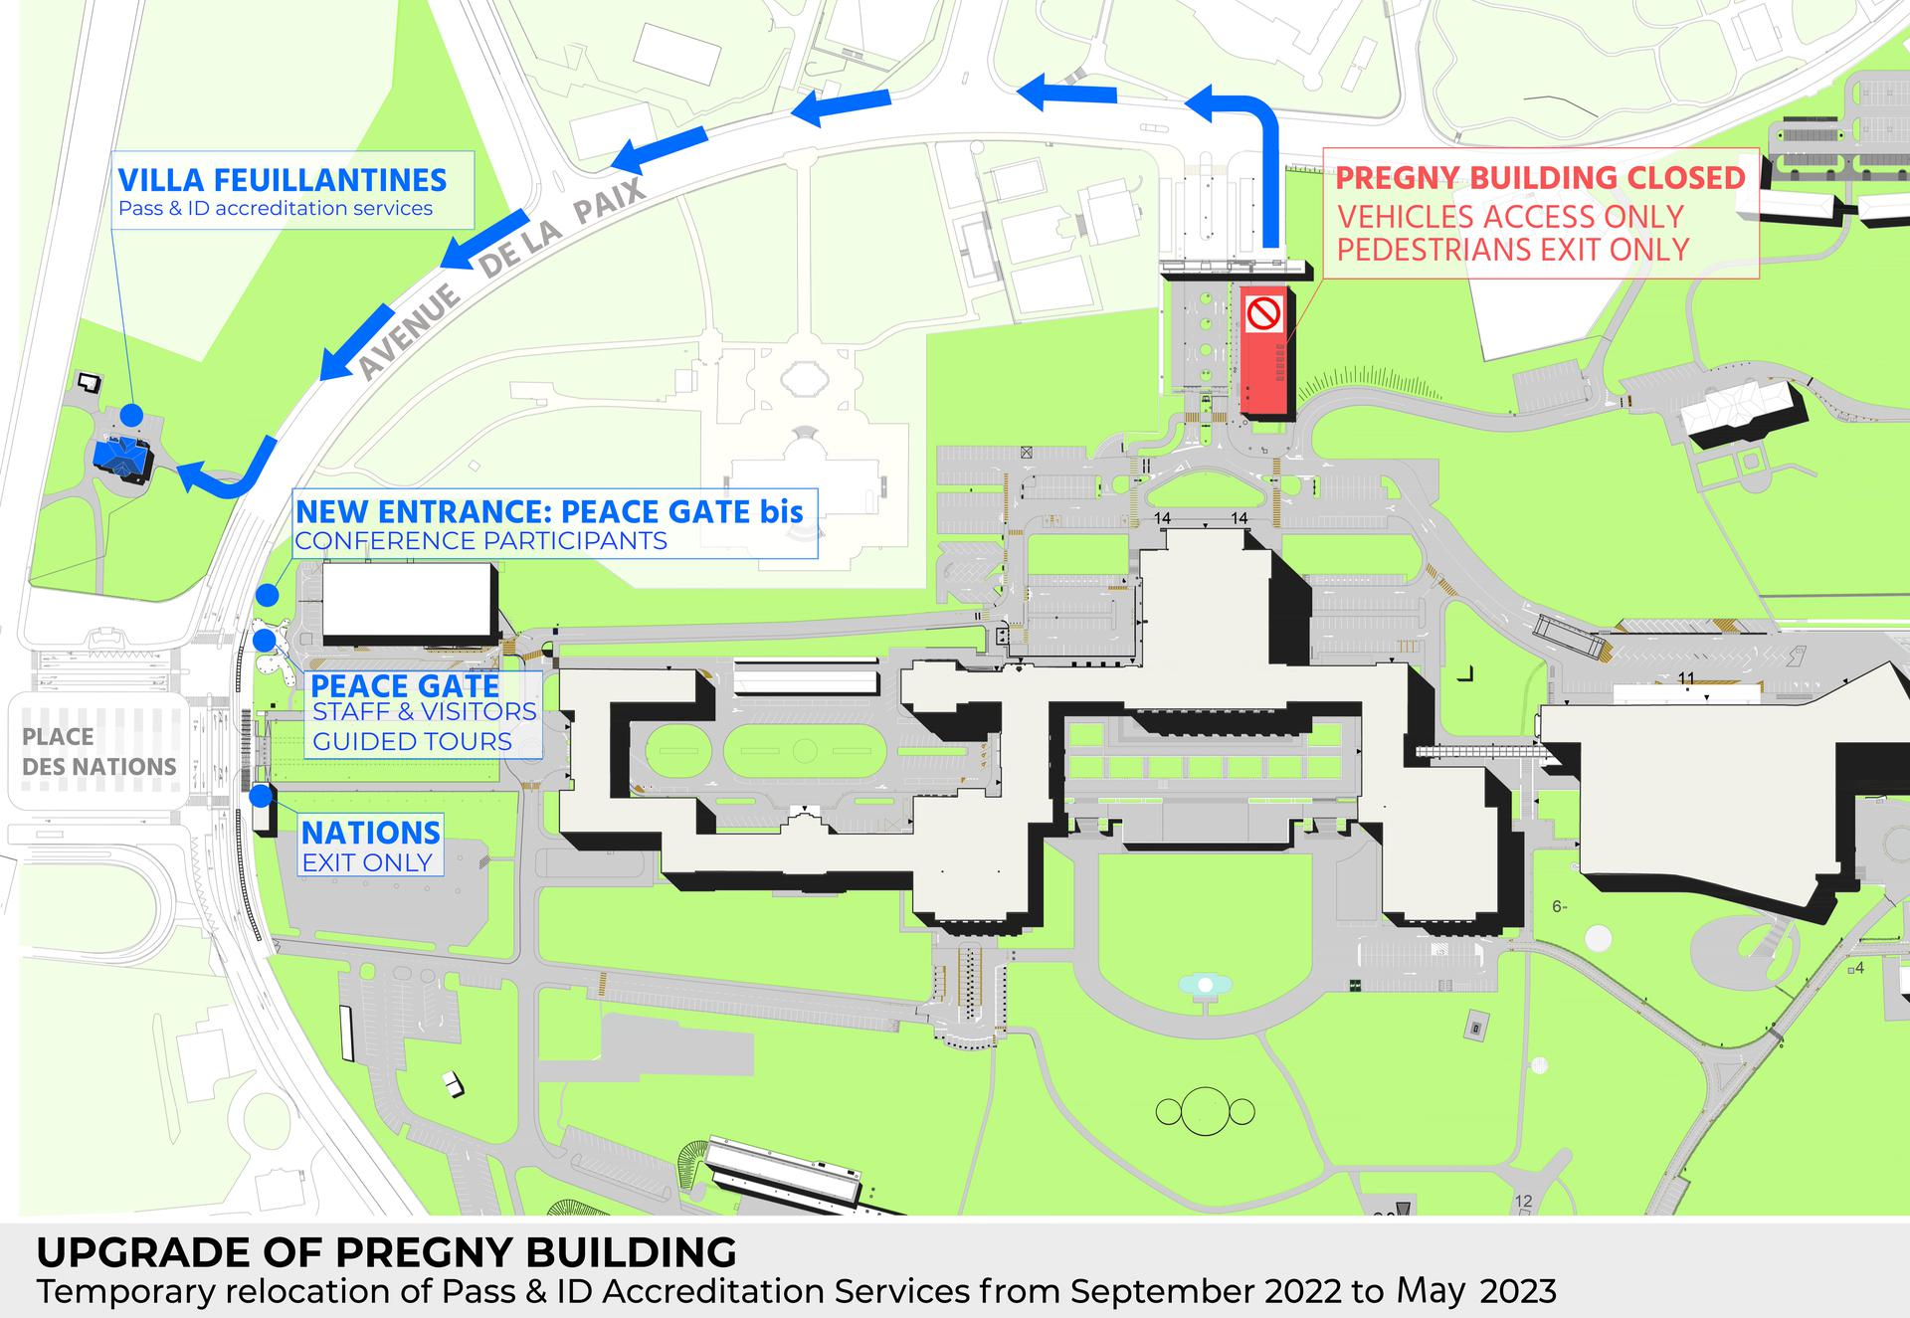
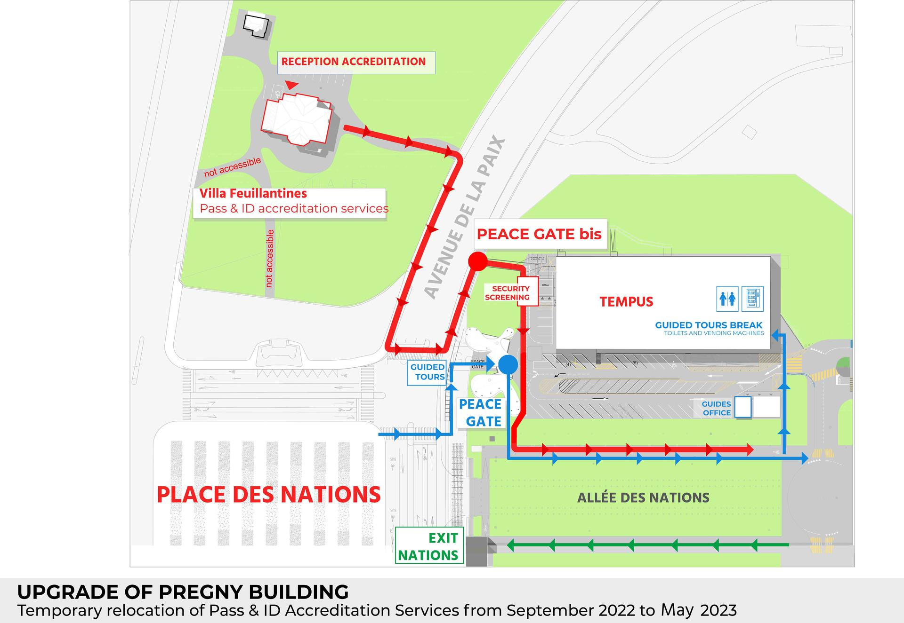

Dates and important information
The 51st session of the Human Rights Council is scheduled to take place from 12 September to 7 October 2022, in Room XX.
On 23 August 2022, the Bureau of the Human Rights Council agreed that NGOs in consultative status with ECOSOC would be able to participate in the session either in person from Room XX or virtually through pre-recorded video messages, and will have full access to room XX for the duration of the session.
Consequently, NGOs in consultative status with the ECOSOC and active Designations with UNOG wishing to participate in the session are invited to register and to indicate their method of participation (in-person or via video statement) for each debate through the online registration system https://ngoreg.ohchr.org and fulfil all the relevant requirements (see Annex I for a complete checklist for oral statements). All video messages should be uploaded via the same system. The method of participation can be amended at a later stage for interactive dialogues and panel discussions.

General debates
The Bureau of the Human Rights Council on 23 August 2022, highlighting that the capacity of room XX is no longer restricted, agreed that NGOs in consultative status with ECOSOC should be able to participate in the session either in person from room XX or virtually through pre-recorded video messages in all debates. In order to balance the importance of inclusivity and what is feasible in terms of time and resources, the list of speakers for NGOs for each of the General Debates would be set in line with the average number of NGOs that participated in each of the General Debates in the previous three September session (the 42nd, the 45th and the 48th sessions, respectively).
Moreover, NGOs would be provided the opportunity to indicate their priority when making their registration in order to ensure placement in their preferred general debates. The average number of NGOs that participated in each of the general debates in the previous three September sessions of the Council is as follows:

GD2 | 54
GD3 | 92
GD4 | 110
GD5 | 50
GD6 | 29
GD7 | 26
GD8 | 45
GD9 | 50
GD10 | 30

Accreditation to HRC51
All NGO representatives will have to be duly registered and approved through INDICO, here: https://indico.un.org/event/36052/. When submitting an accreditation request, NGO representatives are invited to indicate if they already possess an annual badge or a valid temporary ground pass at UNOG. If so, by uploading a picture of it in the relevant field in INDICO platform, this will be accepted in lieu of the accreditation letter, which remains mandatory for all temporary accreditations. It is mandatory, for all participants, to provide a valid phone number, possibly mobile phone, for contact tracing purposes.

Oral statements
The online registration system for the 51st session can be found on the usual website: https://ngoreg.ohchr.org. The system will open on Tuesday, 6 September at 2 PM.
NGOs will be able to choose their preferred method of participation, either in-person or by a video message, for all debates. NGOs will also be able to change their methods of participation for interactive dialogues and panel discussions (from in-person to video and vice-versa) at a later stage. Please note that this change will not affect the position on the list of speakers. However, this will not be possible, for technical reasons, for General debates.
IMPORTANT: Uploading a transcript is mandatory for both methods of participation.
After registering for a debate, NGOs can upload a video statement at a later stage. It is not necessary to upload it at the moment of registration.
The deadline to upload a video statement or to confirm the speaking slot in case of an in-person intervention is at 6 p.m. on the day before the debate is scheduled to start. Video-statements received past this deadline will not be displayed.
Once you have signed up for a debate, you will have to upload the relevant files through two separate fields: “Upload transcript” and “Upload video”, as showed below:

- By clicking on “Upload transcript”, you will have to insert the name of the speaker and upload the file with the transcript of the oral intervention in accessible format (Word or Accessible PDF). This is the version that will be used by UN interpreters, and that will be posted on the HRC Extranet.
- By clicking on “Upload video”, you will have to upload:

- A scanned copy of the passport of the speaker;
- The letter requesting the accreditation of the speaker;
- The video file (max 250MB); and
- The subtitles (optional).
Please note that both the steps mentioned above are mandatory. A video uploaded without the transcript will not be processed by the HRC Secretariat.
As recalled by the Bureau of the Human Rights Council, with the exception of an official representative of a UN Member State speaking in front of the national flag and/or the official picture of the Head of State/Government, the background of video-statements should be neutral without any flag, banner, flyer, picture or symbol.
The full official name of the NGO should be displayed within the video. Please note that the name displayed should be the one of the NGO delivering the statement only (no co-sponsors or non-ECOSOC NGOs), and it should in accordance with that registered in the database of NGOs in consultative status with ECOSOC.
As mentioned above, the video and the accompanying files can be uploaded at a later stage. Please note that the video file has to adhere strictly to the speaking time limits. Video that are longer than the allocated time will be rejected automatically by the platform. The same will happen with videos that exceed the weight of 250MB.
The speaking time limits are as follows:
​​​SPEAKING TIME MODALITIES HRC51 NHRIs/NGOs ​
Type of discussion | Speaking time per intervention | Time allocated per debate
General debates | 1 minute and 30 seconds | Depending on GD (see table above)
Interactive dialogues | 1 minute and 30 seconds | 15 minutes in total
Panel discussions | 2 minutes | Two speaking slots  1 NHRIs and 2 NGOs each slot
UPR outcomes | No UPR outcomes at HRC51 | No UPR outcomes at HRC51

Captioning of the video is strongly encouraged in order to ensure accessibility of persons with disabilities. In order to facilitate this procedure, NGOs are able to upload a specific file for subtitles directly in the online registration system. This is not a mandatory field, and it can be left empty.
REMINDER: The accreditation through INDICO is mandatory.
DISCLAIMER: By submitting a video statement to the HRC Secretariat for the purpose of screening it during an official meeting of the HRC, the video statement will become an official record of the HRC session and considered as a UN audio-visual asset that can be re-disseminated to media organizations worldwide on a non-commercial basis, in accordance with guidelines of the Department of Global Communications, and will be included in the webcast archive of the meeting on webtv.un.org.

Recommended technical specifications for video messages

Please note that video messages that do not comply with the speaking time limits or exceed the maximum weight of the file (250MB) will not be accepted by the system.

- MP4
The MP4 or MPEG-4 file format is a digital multimedia container format most commonly used to store video and audio, but it can also be used to store other data such as subtitles and still images.
  - video encoding: H.264
  - audio encoding: Min 44100Hz
  - video resolution: Min 640x480
Max 1920x1080
Frame rate 24, 30 fps

- MOV
MOV is the Apple Inc. Quicktime multimedia container file that contains one or more tracks, each of which stores a particular type of data: audio, video, effects, or text (e.g. for subtitles).
  - video encoding: H.264
  - audio encoding: Min 44100Hz
  - video resolution: Min 640x480
Max 1920x1080
Frame rate 24, 30 fps

- AVI/WMV
Audio Video Interleaved (AVI) is a multimedia container format introduced by Microsoft that can contain both audio and video data in a file container that allows audio-with-video playback.
Windows Media Video (WMV) is a video compression format for several proprietary codecs developed by Microsoft.
  - video encoding: WMV3 (Windows Media Video 9)
  - audio encoding: Min 44100Hz
  - video resolution: Min 640x480
Max 1920x1080
Frame rate 24, 30 fps

When using a smartphone, record the video in landscape (horizontal) mode.
Please note that no professional equipment is required to record video messages. Most modern consumer electronics (smartphones, laptops, etc.) are capable of recording video that complies with the specifications.
All files will be played using VLC Media Player. Please note that the Secretariat does not bear responsibility if files that do not comply with the recommended specifications cannot be displayed in our audio-visual system. Depending on the quality of the video-statement, interpreters may stop interpretation.

Online co-sponsoring of NGO statements
The Secretariat introduced a new feature that allows NGO to co-sponsor other NGOs’ statements directly through the online registration system https://ngoreg.ohchr.org. The previous method, i.e. sending the co-sponsorship form via email, remains valid for the time being.
Only NGOs with the ECOSOC status and a valid annual designation with the United Nations Office at Geneva can sponsor a statement made by other NGOs.
In order to co-sponsor the statement of other NGOs, you will have to login with your credentials in the online registration system https://ngoreg.ohchr.org and click on the new tab titled “Cosponsoring a statement by another NGO”:

In this tab, you will have to select the debate in which the NGO you are willing to co-sponsor is delivering its statement, and then select the name of the NGO from the drop-down menu. This menu will show all the NGOs registered to a specific debate listed in alphabetical order. If the NGO you are trying to co-sponsor does not appear, they have probably yet to register.
Once you have selected the NGO, you must click on “Co-sponsor”. A list of the statements you are co-sponsoring will subsequently appear below. You will also have the possibility to remove a co-sponsorship to any debate at a later stage.

List of speakers on HRC Extranet
The lists of speakers for the 51st session will be made available on the HRC Extranet on a weekly basis. All the posted lists will be constantly updated.

Confirmation of speaking slots
As per usual practice, all NGOs are requested to confirm their speaking slots. For participants through a video message, their participation will be confirmed once the video statement is uploaded on the online registration system as per the deadline set. Please note that the speaking slots of those NGOs that have not uploaded a video statement before the deadline will be removed from the list of speakers.
In-person participants are required to send an email in order to confirm your speaking slot(s) at the following email address: ohchr-ngoconfirmation@un.org as per the deadline set. Uploading a statement on NGOREG will also be considered as a confirmation.

Side events
In-person official side-events at Palais des Nations will be re-instated at the 51st session of the HRC. As a result of the impact of the Strategic Heritage Plan on the availability of rooms, the time slots for side events will be allocated according to availability and on a first-come, first-served basis. To accommodate as many requests as possible, only one side event per requesting organizer will be accommodated, and each side event will be limited to one hour in duration. Organizers are requested to strictly respect the allotted time and leave the room on time to ensure the smooth organization of the following side event. These measures will be implemented at the 51st session on a pilot basis.

Please be informed that the platform to request an NGO side event (https://ngoreg.ohchr.org/) for HRC51 opened on 26 August 2022, at 09:00 (Geneva time). The deadline for submitting such requests is 31 August 2022, at 17:00 (Geneva time).

Information on the NGO side-events will be made available on HRC Extranet and in the Sched application. For any questions, please do not hesitate to contact the Civil Society Team of the Human Rights Council and Treaty Mechanisms Division at: ohchr-hrcngo@un.org.

Participants wishing to participate exclusively in side events will have to register on the ad-hoc INDICO page related to side-event accreditation only, available here: https://indico.un.org/event/1002507/ . Organizing NGOs wishing to invite external participants to their side-event, may accredit up to 5 persons for the sole purpose of participation in the respective event.

Reprisals
Any act of intimidation or reprisal for cooperation in the context of the HRC session should be promptly reported to the HRC Secretariat.

Programme of work, SCHED, additional information and useful contacts
All relevant information on the 51st session is made available on the HRC website and the HRC Extranet. Credentials are no longer needed to access the Extranet.
The programme of work is subject to change. For updated information on the schedule, NGOs are invited to consult the SCHED meeting calendar of the session, which reflects all changes in the schedule of the debates, available through the following link: https://www.ohchr.org/en/hr-bodies/hrc/regular-sessions/session51/regular-session
Distribution of material by NGOs in ECOSOC consultative status is allowed in accordance with the relevant rules stated in the Practical guide, available here: https://www.ohchr.org/en/hr-bodies/hrc/ngo-participation. Please note that such material may be posted or displayed only on the tables and boards clearly marked for this purpose (i.e., outside plenary Room XX and in front of Serpentine Bar). Distribution of NGO material elsewhere in the Palais des Nations is not permitted.
For any further questions or information, please contact us through the usual e-mail address at ohchr-hrcngo@un.org. Questions relating to accreditation should be sent to the following address: ohchr-hrcaccreditation@un.org.
For updated information, consult the website: https://www.ohchr.org/EN/HRBodies/HRC/Pages/NgoParticipation.aspx.

ANNEX I – CHECKLIST FOR NGO ORAL STATEMENT

This checklist is designed to facilitate NGOs’ participation in the 51st session by summarizing the mandatory steps that they are required to take in order to deliver oral statements (in-person or via pre-recorded video messages). Please note that failure in following these steps will result in your request to not be processed.
Checklist:
- Your NGO is in consultative status with ECOSOC (http://csonet.org/)
- Your NGO has duly accredited Designated representatives with UNOG for 2022 (https://www.ungeneva.org/en/practical-information/civil-society)
- You have registered to deliver an oral statement through the online registration system (https://ngoreg.ohchr.org)
- You and/or the person who will deliver the statement on behalf of your organisation is/are accredited and approved for the session in INDICO (https://indico.un.org/event/36052/)
- You have checked your position on the list of speakers uploaded on the HRC Extranet: Pages - Draft lists of speakers from NGOs (ohchr.org)
- You have uploaded all relevant documents, including the video file in case of video statement, to the online registration system (https://ngoreg.ohchr.org) before the deadline of 6 pm on the day before the debate is scheduled to start. For updated information on the schedule, you can check SCHED here: https://www.ohchr.org/en/hr-bodies/hrc/regular-sessions/session51/regular-session. Please remember that uploading the transcript of your intervention is mandatory for both in-person and video statements.
- For video statements: You have made sure that your video statement(s) abide by the rules applicable for video statements, i.e. the background should be neutral without any flag, banner, flyer, picture or symbol and the full official name of the NGO in consultative status with ECOSOC should be displayed in the video.
- For in-person participants: You have sent a confirmation email for your speaking slot(s) to the following email address ohchr-ngoconfirmation@un.org or you have uploaded your statement in the online registration system before the deadline.

