 |  | A/HRC/51/45
 | Advance Edited Version |  | Distr.: General  17 August 2022  Original: English
Human Rights Council
Fifty-first session
12 September–7 October 2022
Agenda item 4
Human rights situations that require the Council’s attention

Report of the Independent International Commission of Inquiry on the Syrian Arab Republic*, **
Summary
During the period under review, the Independent International Commission of Inquiry on the Syrian Arab Republic continued to document grave violations of fundamental human rights and humanitarian law across the country. In government-controlled areas, arbitrary detention, including torture and ill-treatment in incommunicado detention, also leading to death, remained systematic. Appalling conditions in displacement camps in the north-west of the country have left many with little choice but to return to their homes in frontline areas where active hostilities and indiscriminate attacks against civilians have claimed countless lives and targeted food and water resources. In the north-east, fighting continued with frequent mutual bombings by Turkish and Turkish-backed forces and by the Syrian Democratic Forces. The attack on Al-Sina’a prison, the biggest military operation by Da’esh since its territorial defeat in 2019, caused hundreds of deaths. The worsening conditions for some 37,000 children in the Hawl and Rawj camps were exacerbated by an increase in the number of murders and recurring armed clashes. The dire situation for Syrian civilians was compounded by the worst economic and humanitarian crisis the country has faced since start of conflict. The Syrian Arab Republic is still not a safe place to return.

I. Mandate and methodology
1. In the present report, submitted pursuant to Human Rights Council resolution 49/27, the Independent International Commission of Inquiry on the Syrian Arab Republic presents its findings based on investigations conducted between 1 January and 30 June 2022.
2. Pursuant to its established methodology and guided by standard practices of commissions of inquiry and human rights investigations, the Commission relied primarily on 501 first-hand interviews, conducted in person and remotely. Documents, reports, photographs, videos and satellite imagery from multiple sources were collected and analysed. Communications from Governments and non-governmental organizations (NGOs) were taken into consideration, as were reports of the United Nations. The Commission also requested, in writing and during meetings, information on incidents, events and developments from the Government of the Syrian Arab Republic, parties to the conflict and States Members of the United Nations. The standard of proof was considered to be met when the Commission had reasonable grounds to believe that incidents occurred as described and, where possible, that violations were committed by the identified party.
3. The investigations of the Commission remained curtailed by the denial of access to the country and by protection concerns in relation to interviewees. In all cases, the Commission remained guided by the principle “do no harm”.
4. The Commission extends its thanks to all those who provided information, in particular victims and witnesses.

II. Political, military and humanitarian developments
5. In late February, the Syrian Arab Republic entered its eleventh year of conflict, with increased threats of further military operations and terrorist activity. The Office of the United Nations High Commissioner for Human Rights (OHCHR) reported that, from March 2011 to March 2021, 350,209 individual deaths were recorded as a result of the Syrian conflict, including 143,350 identified civilians.
6. On 23 May, the announcement by President Erdogan of Türkiye of another planned incursion was followed by episodes of military escalation, mutual bombardment and mobilization by all parties, including in Tell Ri’fat, Menbij, Ain Issa and Tel Tamer. An attack launched by Da’esh on Al-Sina’a prison, in the north-east, on 20 January, revealed the capacity of the terrorist group to launch complex attacks and the threat it continues to pose.
7. Insecurity continued in government-controlled areas, particularly in the south of the country. In Dar‘a, scores of killings of former opposition leaders, as well as military and security members of the Government, were recorded. The repositioning of Russian forces demonstrated the fragility of current security arrangements, as did the continued reliance on Government-affiliated militias and armed groups, who are implicated, among others, in a booming drug trade. In Idlib and western Aleppo, violence continued, with mutual shelling between pro-government forces and armed opposition groups including Hay’at Tahrir al-Sham, designated as a terrorist group by the United Nations. There was, however, a significant reduction in the number of airstrikes by pro-government forces.
8. As an example of the daily dangers faced by civilians, 12,350 explosive ordnance and landmine incidents were reported country-wide from 2019 until April 2022. Recently, a landmine explosion on 11 June in Dar‘a reportedly killed 10 and injured 28 people. The Syrian Government reported that it has removed “more than 50,000 explosive devices, 84,000 unexploded shells and 45,000 mines of various kinds, clearing some 735,000 ha of Syrian territory of mines and explosive ordnance”.
9. In addition to the continuing war, Syrians are facing the culmination of over a decade of economic decline, exacerbated by corruption, the coronavirus disease (COVID-19) pandemic, unilateral sanctions and economic crises in Lebanon and Türkiye. The economic and humanitarian situation is at its worst since the start of the conflict, with an estimated 14.6 million people in need of humanitarian assistance. The 800 per cent rise in food prices since 2020 has further limited the ability of humanitarian agencies to meet growing needs, as did the closure of Damascus airport after suspected Israeli airstrikes. In parts of the country there have been protests against the continued deterioration of living conditions.
10. The Security Council, in its resolution 2642 (2022) of 12 July 2022, belatedly reauthorized cross-border aid through Bab al-Hawa for a period of only six months. The current authorization will expire in mid-winter, when needs are typically at their highest, and appropriate arrangements must be put in place.
11. Despite some notable convictions in criminal proceedings in Europe, there was no comprehensive accountability for serious human rights violations and war crimes committed by the Syrian Government, armed groups, listed terrorist groups and foreign powers. On 27 April, footage was published in the media of executions by the Syrian Military Intelligence of at least 41 individuals in 2013 in Tadamon, serving as a sharp reminder of the atrocities that have been committed continuously throughout the conflict.
12. Three days later, on 30 April, President Assad issued Legislative Decree No. 7, granting a general amnesty for terrorism crimes committed prior to its promulgation. While the announcement was accompanied by the welcome release of a number of detainees, it was also characterized by a lack of transparency. Syrian families are still seeking information about detained or missing loved ones.
13. The Commission has continued to advocate for a body to consolidate claims filed with a wide variety of NGOs and humanitarian organizations in order to efficiently and effectively track and identify those missing and disappeared and to assist their families. At the time of writing, the Commission anticipates the imminent release of the report of the Secretary-General requested by the General Assembly in its resolution 76/228 “on how to bolster efforts, including through existing measures and mechanisms, to clarify the fate and whereabouts of missing people”.

III. Central, west and south-west of the Syrian Arab Republic
14. Insecurity prevailed across government-controlled areas, with security forces and local and foreign militias controlling checkpoints and detention centres and abusing their powers to extort income. These practices have also spread to criminal groups. On 10 June, suspected Israeli airstrikes on Damascus Airport impeded transportation of humanitarian supplies and related cargo.
15. Cases of arbitrary arrests, beatings, disappearances, harassment and extortion, including of returnees, continued to be documented. The risk of being detained, and subsequently ill-treated and tortured, remained pervasive for many Syrians. The arbitrary use of security clearances to restrict freedoms and housing-related rights, the loss of livelihoods and basic services and vulnerability to extortion and property seizure represented additional violations, as well as impediments for refugees seeking a safe, sustainable and dignified return to government-controlled areas.

A. Arbitrary detention, including ill-treatment, torture and death in detention, and enforced disappearances
16. Torture and ill-treatment in detention remained systematic, including in Sednaya prison and in several detention facilities operated by Syrian intelligence.
17. Survivors described overcrowded cells, widespread illnesses and diseases, including COVID-19, denial of medical care, food, water and sanitary facilities. Former detainees also reported that they had been subjected, including during the reporting period, to torture and ill-treatment, such as electric shocks, the burning of body parts, being folded into car tyres (dulab) and suspended by one or two limbs for prolonged periods (shabeh), often combined with severe beating with various tools, including sticks or cables. Detainees released during the reporting period also reported deaths in detention.
18. During the reporting period, Military Intelligence Branch 227 in Tadamon conducted house raids, during which individuals were beaten for several hours and then held incommunicado for several months in Kafr Sousa. Detainees were deprived of sanitation, food and medical care. One detainee witnessed several cases of death in detention, including the death of a Russian citizen, following ill-treatment and torture. Release of the individuals was eventually facilitated through the payment of bribes.
19. Nine men were similarly detained and suffered torture and ill-treatment for having failed to comply with, or having defected from, compulsory military service, including one man who was aged 17 at the time of his arrest. The cases included defectors returning following the issuance of an amnesty, only to be arrested. Former detainees recalled being held incommunicado from a few weeks to several months without access to their families or a lawyer. Those eventually brought before a court reported having been forced to sign written “confessions”, which they had no chance to read.
20. With regard to a number of deaths in detention, most relatives only learned about the deaths of their loved ones years later.
21. In February, a group of families from eastern Ghouta obtained death certificates from the civil registry office for more than 30 individuals who had gone missing after having been transferred to collective shelters in 2018. The certificates provided the alleged date of death without elaborating on the circumstances of the death. For several men, the death certificates gave the same date of death (in 2019), possibly indicating executions, as was alleged during the Government recapture of eastern Ghouta. The remains of those individuals were not returned to the families and there is no indication that the cases were subjected to any investigation.
22. At Rukban camp, on the Jordanian border, aid delivery continued to be impeded. Dozens of families were left with no choice other than to leave the camp, relying on smugglers in order to reach or cross government-controlled areas to access essential services, particularly health care. The Commission documented three cases of individuals arrested and detained by government forces after they had left the camp. The family of a young man who left the camp in 2018 was recently informed of his death in the Sednaya military prison in Damascus. Another man died in a detention centre in Homs in March 2022, weeks after being arrested. A third man who left the Rukban camp seeking medical care was arrested at a checkpoint in Aleppo in August 2020 and remains disappeared.
23. Torture is prohibited under the Syrian Constitution, and on 30 March 2022 the Government adopted Law No. 16/2022, formally criminalizing torture and providing significant criminal sanctions. The new law does not, however, address immunity granted to military and security agents or ill-treatment, per se, and makes only general reference to the ability of victims and survivors to file complaints and seek reparations or their right to be protected from reprisals.
24. Growing criticism on social media of official policies, also in areas traditionally supportive of the Government, was met in April 2022 by a new decree law on cybercrimes. The law criminalizes online statements deemed to undermine the Constitution and government policies, with sentences ranging from 7 to 15 years imprisonment as well as fines. In early June, the Ministry of Interior announced online that 11 individuals had been detained for disseminating “false information” on Facebook and interacting with users in areas beyond Government control. Nearly 200 subscribers to an instant messaging group relaying local news in Dar‘a governorate were summoned in early 2022, on the basis of an earlier arrest warrant, and were requested to pledge that they would not protest against the Government; two of the subscribers were detained for about two months.
25. The efforts of the Government to tightly control the activities of civil society organizations were also demonstrated by arrests of NGO workers, the confiscation of assets and the dissolution of organizations without due process.
26. To secure the release of their relatives, families of detainees have paid bribes to State officials, including judges, or to intermediaries who extorted money for either identifying the location of detainees or obtaining their release. The amounts of money at stake reached tens of thousands of dollars, pertaining to both the pretrial and trial phases, during which intermediaries collected bribes to influence judicial decisions. A torture survivor, released in 2022 after five years in intelligence agency detention said:
“My family had to sell our land to pay bribes for my release. I was released but I still owe 6,000 dollars that my family borrowed from a friend to pay bribes. I need lots of money to treat medical issues I have because of torture, and I don’t have anything anymore”.
The cases described above confirm continuing patterns of crimes against humanity and war crimes related to torture and ill-treatment in detention, including practices causing death in detention, as well as arbitrary detention and enforced disappearances.

B. “Security clearance”
27. The requirement to obtain a “security clearance” to safely enter and leave government-controlled areas, or even to move freely within such areas, has continued to hamper freedom of movement and represents yet another challenge for refugees and displaced persons seeking to return to their home areas.
28. Some activists and journalists were impeded from travelling abroad, while others who received clearance to travel were interrogated upon return. Security clearances were withheld from: former opposition members; those perceived as critical of the Government, including their relatives; and former inhabitants of neighbourhoods once considered as strongholds of the opposition, such as Yarmouk camp and Daraya.
29. Security clearances also constituted a precondition for access to basic property and housing rights. Former detainees who were unable to obtain security clearance were denied lease agreements within their former areas of residence, including, for example, in parts of the city of Homs. Clearance was also required to get a power-of-attorney, which is necessary to be represented by a lawyer in property matters when residing outside government-controlled areas, for example, to sell, inherit, rent or buy property.
30. People subjected to security clearance requirements, which may be applied in a discriminatory manner, have been denied their housing, land and property rights, freedom of movement and, in some cases, their freedom to leave and return to their own country.

C. Seizure of property
31. The Syrian Arab Army has continued to use previously seized private properties, including homes that are no longer close to the frontlines in Hama and Dayr az-Zawr governorates. New cases of seizure of property, including by the Fourth Division, were also documented during the reporting period in Dayr az-Zawr. Some homes have been used to house the families of military personnel. Investigations reveal that displaced Syrians perceived as opposing the Government have been affected by this practice, preventing their return home.
32. Recent information also emerged concerning widespread looting of private property by the Syrian Arab Army in May 2021 in areas retaken by the Government, namely in the northern countryside around Hasakah. Information collected suggests the involvement of the Fourth Division, which was in control of numerous checkpoints in retaken areas.
33. Owing to existing gender norms and discriminatory inheritance practices, property documents are often registered in the name of male family members, rendering women particularly vulnerable when attempting to secure tenure or to access inheritance rights. Women whose spouses have been detained or gone missing struggle to access family properties, including when seized or frozen, despite now being the sole breadwinners. On the rare occasions when women enquired about the fate of their detained spouse or to obtain a death certificate with the relevant authorities, they were harassed and verbally abused.
34. The seizure of private property by government forces described above may amount to pillage, which is a war crime. In areas where hostilities have ceased, Government seizure of property without due process or compensation may amount to violations of housing, land and property rights.

D. Continuing insecurity in Dar‘a
35. The persisting insecurity in the south of the Syrian Arab Republic was illustrated on 22 January when a government checkpoint in al-Maliha-al-Gharbiya in eastern Dar‘a was attacked by unknown assailants with light weapons. In possible retaliation, a ground attack, most likely a mortar attack, was launched by government forces on the nearby village of Al-Hirak, injuring two women and a girl in their home. The next day, government forces raided several houses in the town, arresting six men.
36. During the first six months of 2022, nearly 150 people were arrested, including by the Criminal Security Branch in eastern Dar‘a, several of whom had previously “reconciled” with the Government. Reports suggest that detentions lasted from a few days to several months, with no contact with families or lawyers. Many of these people are still unaccounted for. Torture, ill-treatment, including of women, and looting were documented during the arrests, with torture and ill-treatment persisting once individuals were moved to detention centres.
37. During the reporting period, over 100 individuals were killed, reaching a peak in April 2022, continuing a pattern of the targeting of members of former opposition and pro-government forces by unidentified perpetrators shooting with small arms from vehicles, most frequently motorcycles.
38. There are reasonable grounds to believe that, in the attack on the village of Al-Hirak, government forces did not direct the attacks at a specific military objective, which may amount to the war crime of launching indiscriminate attacks resulting in death or injury to civilians. Targeted killings of civilians, if perpetrated by parties, amount to the war crime of murder.

IV. North-west of the Syrian Arab Republic
39. In Idlib and western Aleppo, pro-government forces and armed opposition groups including Hay’at Tahrir al-Sham, designated by the United Nations as a terrorist group, continued mutual shelling. Attacks by pro-government forces, albeit at lesser intensity than previously, often damaged or destroyed civilian infrastructure, including objects indispensable to the survival of the civilian population, such as a water station. In the eight attacks investigated by the Commission (see annexes III and IV), at least 39 civilians were killed or injured. Living conditions in displacement camps continued to deteriorate, and many people were left with no choice other than to return to their homes in frontline areas, where hostilities continue to devastate communities.
40. At the same time, Hay’at Tahrir al-Sham both intervened in public life and the provision of services, including fuel, exacerbating civilian suffering amidst widespread poverty. In formalizing restrictions that limit civic space, the group continued to arrest journalists, activists and other individuals who criticized its rule, in a discernible pattern previously identified by the Commission.

A. Indiscriminate and direct attacks against civilians and civilian infrastructure by pro-government forces
41. Several attacks affecting food and water resources were documented. On 1 January, in the middle of the night, airstrikes on a makeshift camp near Jisr al-Shughour, where a group of displaced shepherds had settled, killed a woman and two young girls and injured at least 10 others, including 6 children. The attack also killed around 100 sheep, the main source of livelihood for the displaced families. Consistent with witness testimonies, visual material confirmed the damage to the tents and a concrete room where the bodies of two of the victims were later found. Satellite imagery indicated a possible military objective around 170 metres from the affected area.
42. On the following day, 2 January, at around noon, airstrikes partially destroyed the Arashani water station, injuring one person and forcing the station out of service, cutting off the water supplies for at least 225,000 residents for around 20 days. The facility was well known, located on a hill and easily identifiable. Visual material confirmed damage to the main buildings housing critical equipment for the functioning of the water station, as well as the complete destruction of a second building where machinery was held. No military objective was known to be located near the facility.
43. In another attack, on 3 January, in the early afternoon, airstrikes hit a three-story poultry farm and adjacent agricultural land on the outskirts of Kafr Takhrim. A woman and her 8-year-old son were injured as a result. Witnesses described how a first strike impacted an area some 50 metres away from the farm, while the second airstrike almost destroyed it, in addition to killing at least 5,000 birds. There were no apparent military objectives near the poultry farm. Visual material confirmed the large-scale destruction of the poultry farm and the damage to its surroundings.
44. More recently, on the morning of 12 May, airstrikes struck another poultry farm near the town of Bzabour, Jabal al-Zawiya, injuring one civilian and destroying the farm.
45. The reports of flight spotters and overflight data obtained by the Commission indicated that at least one Russian fixed-wing aircraft was observed in the affected areas at the approximate time of each of these attacks. There are reasonable grounds to believe that pro-government forces, in attacking a well-known water station and poultry farms, have intentionally targeted objects indispensable to the survival of the population (see paras. 41–44 above), which is prohibited.
46. Ground attacks affecting frontline villages, including Ma’arat al-Na’asan and Afes, were also documented. Residents had returned to these villages following the March 2020 ceasefire due to the inadequate living conditions in displacement camps in the north of the country. The respite was short-lived, however, as shelling incidents gradually increased and drones were often seen flying over Ma’arat al-Na’asan. Interviewees reported that no military objectives were located inside the villages.
47. In the early afternoon of 12 February, the yard of a residential house on the outskirts of Ma’arat al-Na’asan was struck by a ground attack, which killed a family of six, including two young children and two women, and injured two other girls. Witnesses recounted how one of the munitions struck the yard, killing the family, which had gathered outside for afternoon tea.
48. Visual material confirmed that the impact was consistent with the use of a mortar, likely an 82-mm calibre, part of an unguided artillery weapon system. The attack reportedly originated from the town of Miznaz, only 2.2 kilometres from Ma’arat al-Na’asan across the frontline, where government forces are known to be present. The distance is within the range of an 82-mm calibre mortar.
49. In the late morning of 4 April, a ground attack killed four boys, aged 12–14, as they were on their way to al-Amal school in a residential area of Ma’arat al-Na’asan. Interviewees recounted that a missile struck the children in front of the home of one of the victims on a main road used by school children daily. Al-Amal school, which serves around 540 girls and boys from first to ninth grades, was located around 500 metres from the affected location.
50. Interviewees stated that the attack originated from the town of Miznaz, known to be controlled by government forces, and that drones were often seen during shelling, suggesting that government forces would have been aware that the road was frequently used by children.
51. Photographs of remnants indicated the use of an anti-tank missile, with a line-of-sight guidance system enabling the identification of and the direct firing at a visible target. Topographic data showed the height and the distance between the frontline and the impacted site would have allowed government forces to view the potential target before firing at it. No apparent military objective was observed near the affected site.
52. On 27 February, around noon, shelling also struck a market in the nearby town of Afes: two civilian men died and three others were injured. Munitions were fired across the frontline, allegedly from the village of Duwair, east of Afes, where pro-government forces, including Russian forces and Iranian militia, were known to be present. Turkish military posts were also located nearby. Witness testimonies, as well as analysis of the damage and remnants, indicated the use of a mortar.
53. As regards the above-mentioned egregious incident that killed four children on their way to school (see paras. 49–51 above), there are reasonable grounds to believe that the victims were directly targeted by government forces, which may thus have committed the war crime of directing attacks against civilians. In the above-mentioned shelling of residential areas, hitting a home and a market and killing numerous civilians, there are also reasonable grounds to believe that pro-government forces have committed the war crime of launching indiscriminate attacks on residential areas, resulting in loss of life or injury to civilians.
54. Continuing a previous pattern of attacks disrupting economic activities, in the mid-morning hours of 16 February, shelling killed at least three men and injured two others, in addition to severely damaging a civilian vehicle and a farmhouse and almost destroying a nearby fuel depot located between the towns of Tarmarin and al-Dana and forcing it out of service. The affected locations were situated within a radius of around 500 metres from each other, near agricultural fields. Multiple munitions struck the area, allegedly consisting of Krasnopol guided artillery shells. Reports received by the Commission indicated that the munitions were fired by the 46th Regiment of the Syrian Arab Forces, stationed in the rural western part of Idlib governorate. A drone was also observed by one interviewee, prior and after the events.
55. There are reasonable grounds to believe that in attacking a fuel depot during the harsh winter months, government forces may have impeded access to objects indispensable to the survival of the civilian population.

B. Violations by Hay’at Tahrir al-Sham
56. Hay’at Tahrir al-Sham maintained control over Idlib governorate and parts of western Aleppo through seven local councils, including in areas where camps for displaced persons were located.
57. Hay’at Tahrir al-Sham also continued to monopolize the fuel market and the provision of other services. The Commission has previously reported how the group imposes levies on local businesses, and therefore also profits from economic activities in areas under its control. As the price of fuel and other commodities have drastically increased countrywide, acutely impacting the north-west of the Syrian Arab Republic, civilians have been bringing commodities from neighbouring areas to fulfil their basic needs. At crossing points, members of the group regularly confiscated or destroyed such goods and detained and beat individuals, including children. On 10 February, near a crossing point close to the Atmeh camp in Der Ballut, members of the group shot and killed a woman who was bringing fuel from northern Aleppo into Idlib. The shooting triggered a violent reaction among residents at the Atmeh camp. Hay’at Tahrir al-Sham responded with heavy machine gun fire, injuring one boy, and arrested one journalist for filming, and at least 10 other men.
58. Hay’at Tahrir al-Sham also sought to restrict media and press freedoms and continued to detain journalists and activists or other individuals who speak out against their rule. Through its organizational affairs directorate, the group imposed formal agreements restricting certain project activities of local organizations, resulting in the occasional withdrawal of funding and cessation of their work. Furthermore, organizations were pressured to coordinate their activities and public outreach with the group’s general security directorate or branch. Activists and local organizations have also received threats, prompting many to cease their activities. Others continued with their work on condition that they would no longer criticize the group.
59. As was the case in Afrin (see paras. 79–81 below), organizations dealing with gender-based violence or with gender-related issues more broadly, were disproportionally affected, including by the suspension of some activities, the prohibition of events gathering both women and men and the censoring of outreach activities, including in reference to gender-based violence.
60. In its attempt to curtail civic space, Hay’at Tahrir al-Sham also restricted the freedom of expression, notably of activists and journalists, including through arbitrary detention without due process and in inadequate conditions. Activists and media workers were often detained by its general security directorate. In detention, individuals were prevented from accessing medical care and were not allowed contact with families or lawyers. Hay’at Tahrir al-Sham established a communication line for families to inquire about detained relatives, but families reported that they were not informed as to where the victims were being held.
61. During the reporting period, the Commission continued to receive reports about the confiscation of property by members of Hay’at Tahrir al-Sham. Reports indicated that, through a general directorate for housing affairs (previously known as the committee on the spoils of war), the group allocated properties of absentee owners to its fighters or rented them out to displaced families. Several agents were allegedly appointed by the group across the governorate to collect rent, manage property contracts and identify newly vacated homes in the area. Properties owned by displaced individuals perceived to be supporting the Government or opposing Hay’at Tahrir al-Sham, including Christians, were primarily targeted for confiscation. The described confiscation of properties may amount to the war crime of pillage. Property rights of displaced persons are also specifically protected under customary international humanitarian law and must be respected by all parties, free from discrimination.

V. Northern Syrian Arab Republic (excluding Ayn al-Arab)

A. Conduct of hostilities
62. Hostilities escalated between January and February 2022, with several incidents involving shelling and attacks using improvised explosive devices. At least 92 civilians were killed and injured in northern Aleppo in the seven incidents investigated by the Commission, in addition to damage or destruction of civilian homes, schools, mosques, medical facilities and administrative buildings (see annex III and annex IV, paras. 33–49).
63. In the early afternoon of 2 February, at least eight rockets were fired from a BM-21 Grad multiple rocket launcher, probably from a location west of the city of Bab, such as the government-controlled al-Shalah radar military base or the village of Nirabiyah, which is controlled by Kurdish forces. They damaged multiple locations in Bab. They included residential areas, two markets, a mosque and a hospital. At least eight men and one girl were killed and 24 others were injured, including two women, as two rockets hit a shopping street, nearby al-Midani hospital and al-Nasr Mosque. In another incident, on 18 April, three rescuers were injured as they were called to assist victims of a shelling incident that had injured one man earlier in the day near the west bank of the Euphrates River (Jarablus area). The Syrian Democratic Forces issued a statement denying responsibility for both of the attacks.
64. The war crimes of directing attacks into densely populated areas, launching indiscriminate attacks resulting in death or injury to civilians and directing attacks against civilians and against medical personnel may have been committed in these incidents.
65. In another incident late in the evening of 1 June, two civilians, including a 10-year-old girl with physical disabilities, were killed and three others injured in Babesqa camp in a fire that erupted following an explosion of an ammunition depot controlled by the Falaq al-Sham brigade of the Syrian National Army, and located in between several displacement camps near the village of Babesqa in the area of Bab al-Hawa. Witnesses recalled how the body of the killed child was found completely burned, as she was not able to escape the fire that engulfed the tent she was living in. The presence of ammunition depots in such close proximity to a camp for internally displaced persons may amount to the violation of the principle of distinction by the Syrian National Army, which exposed civilians residing close to such military objectives to harm.
66. On 15 June, a vehicle-borne improvised explosive device killed a well-known humanitarian worker in Bab as the victim started his vehicle, which was parked in front of his home in a densely populated area. Such improvised explosive device attacks, where carried out by parties to the conflict, may amount to the war crime of murder and may also amount to launching indiscriminate attacks resulting in death or injury to civilians.

B. Arbitrary detention and conditions in detention, including death in detention
67. The Syrian National Army further centralized detention practices across areas under its control. The Commission was also informed that a number of members of the Syrian National Army were sentenced by Syrian National Army military courts or were being investigated on charges, including torture, murder, rape and property appropriation between 2018 and 2022, as part of the effort to ensure accountability for such violations.
68. Military police and brigades of the Syrian National Army continued to arrest individuals with alleged ties to the Kurdish People’s Protection Units, including those who had been forcibly conscripted by the Kurdish People’s Protection Units, the self-administration, or with the Government of the Syrian Arab Republic or Da’esh. Interviewees stated that such arrests have been increasing since 2021, following investigations by Syrian National Army military police into people’s alleged role in support of the self-administration, either in a military or civilian capacity, authorized by military courts in Afrin.
69. Many Kurdish civilians in areas now controlled by the Syrian National Army are being doubly victimized. Having first been forcibly conscripted by the Kurdish People’s Protection Units, including as children, or connected with the Kurdish self-administration without a choice when they controlled the area until 2018, they are now being arrested and detained by the Syrian National Army. In one such case, in early January, near Bab, the Hamza Division of the Syrian National Army (Division 23) arrested a former member of the Kurdish People’s Protection Units who had been forcibly conscripted. The family was only able to locate the victim three months after his arrest, by paying bribes to secure his transfer to Maratah prison in Afrin, controlled by the Syrian National Army military police.
70. While the Syrian National Army has informed the Commission that the legal system in place fully protects civilians against violations of the prohibition against arbitrary arrest and the right to a fair trial (including access to legal counsel and family), interviewees reported that: people arrested by factions and individual members of the Syrian National Army were held incommunicado for periods ranging from one month to three years; that family members were denied information about the whereabouts of detainees, including detainees transferred to Türkiye; that family members seeking information on the fate or whereabouts of loved one were also threatened or arrested; that detainees were not informed of the reasons for their arrest and not permitted access to legal representation; and that detainees were allowed to have contact with their relatives only after their relatives paid bribes or exerted pressure on members of the Syrian National Army, whereupon detainees were transferred to central prisons, such as Maratah prison. Only after such transfers did detainees finally appear before a court, including the military court in Afrin.
71. Family members who eventually succeeded in visiting their relatives in Maratah prison described seeing marks of severe beatings on their bodies.
72. New credible accounts were also gathered from both male and female survivors, including from minors, of beatings and other forms of torture by members of the Syrian National Army, including rape and other forms of sexual violence that took place in makeshift detention facilities between 2018–2021. One woman, a former detainee, described how she was subjected to rape and other forms of sexual violence in 2018 during interrogations by individuals wearing Turkish uniforms and speaking in Turkish.
73. Severe torture and other forms of ill-treatment inflicted by members of the Syrian National Army also led to the death of a number of detainees. One interviewee described how, on 24 February, a member of an Arab tribe was arrested in Afrin by the Falaq al-Sham brigade, brought to a military outpost under its control and beaten to death. The group issued a statement acknowledging responsibility for his death as a result of the torture that he endured while in their custody and announcing the arrest of the alleged perpetrators, whom they handed over to the military judiciary.
74. In another case, a man who was briefly detained by a brigade of the Syrian National Army was released with signs of severe beatings on his entire body; he died shortly afterwards.
75. The Commission has reasonable grounds to believe that elements of the Syrian National Army have arbitrarily deprived persons of their liberty. Some cases have been tantamount to enforced disappearances. Consistent with an established pattern, elements of the Syrian National Army may have committed torture, cruel treatment and outrages upon personal dignity, including through forms of sexual violence, which constitute war crimes. In some instances, the treatment inflicted led to the death of detainees, which may amount to murder, another war crime.

C. Measures affecting property rights
76. The arrest and detention of individuals were often carried out by brigades of the Syrian National Army in conjunction with property appropriation, including of agricultural lands, which ultimately forced many people to leave the area and continue to prevent their return. Although some people have reported cases of property restitution, many others remain unable to reclaim their homes and lands. One displaced man of Yazidi origin explained that he and his family were unable to return because he cannot gain access to his house and land, which have been occupied since 2019 after the family fled hostilities during Operation Peace Spring. Others described similar situations of being deprived of access to their properties, years after they had fled, and expressed a general reluctance, due to fear of arrest and detention, to claim their properties back. Interviewees described how they had been threatened with arrests or otherwise forced to withdraw complaints they had submitted to various informal local grievances committees, composed of individuals from religious and tribal entities and from the Syrian National Army, about extortion, property appropriation and the imposition of levies, including due to the risk of reprisals by brigades of the Syrian National Army against whose members complaints were submitted, as those brigades were themselves involved in the complaint and restitution process. Owing to pre-existing gender inequalities, women faced additional challenges and were reluctant to seek redress for property-related violations from such all-male committees. One woman whose spouse had passed away was pressured to leave her house to another family, due to the stigma attached with living alone in the family house, but refrained from complaining, fearing intimidation and expecting an unfavourable outcome.
77. Confiscation of private property by parties to the conflict may amount to pillage, which is a war crime, and is in any case prohibited when carried out based on discriminatory grounds.
78. In Dawouydia village (Ras al-Ayn), located less than 10 kilometres from active frontlines where fighting between the Syrian Democratic Forces, Türkiye and the Syrian National Army recently intensified, brigades of the Syrian National Army and Turkish ground forces continued to use civilian properties for military purposes. Recent satellite imagery confirmed the continuous presence of a Turkish military base inside the village, including a possible expansion of the facility to the north (annex VI). Kurdish residents have been prevented from returning to Dawoudiya since at least 2020, and homes have been destroyed. Since that time, they have also been unable to cultivate adjacent agricultural lands, while requests for compensation are, to date, being denied. The failure of Turkish forces to provide payment for the requisitioning of private property may amount to a violation of international humanitarian law.

D. Restrictions on fundamental freedoms
79. Members of the Syrian National Army, including the military police, also restricted freedom of expression and assembly in several areas in Aleppo. Women’s rights activists, both male and female, were specifically targeted by violence and threats of violence by members of the Syrian National Army and official religious figures when attempting to engage in public life, undermining their ability to meaningfully participate and contribute to their communities.
80. Fearing for their safety, some women’s rights activists avoided speaking publicly about their work or have withdrawn from local organizations that advocate for gender equality. Women activists of Kurdish origin were particularly affected, with some ceasing all engagement in public life as they also feared arrest and detention by the Syrian National Army (see sect. B above). Against this backdrop, organizations working on gender-based violence, providing, for example, legal aid or protection, are exceedingly isolated. Adding to the social stigma attached to sexual violence, there were no shelters to accommodate survivors, who were also reluctant to seek redress before the above-mentioned all-male grievances committees due to their ineffectiveness.
81. In relation to the violations identified in the present report, the Commission notes that, in areas under effective Turkish control, Türkiye has the responsibility, as far as possible, to ensure public order and safety and to afford special protection to women and children. Türkiye remains bound by applicable human rights obligations with regard to all individuals present in such territories.

VI. North-east of the Syrian Arab Republic

A. Conduct of hostilities
82. The population in the north-east of the country continued to experience insecurity and hostilities along the front lines in the areas of Operation Peace Spring and Operation Euphrates Shield and along the Turkish border (see annex II). In the light of increasing attacks by Da’esh, including the 20 January attack on Al-Sina’a prison, the Syrian Democratic Forces and Asayish continued to pursue Da’esh cells in combing operations in the city of Hasakah and its surrounding countryside, sometimes in cooperation with coalition forces.
83. In the context of a potential Turkish incursion into the north-east of the Syrian Arab Republic, fighting continued in several areas, including in and around Abu Rasayn in Hasakah governorate. Frequent mutual bombings between the Syrian National Army and Turkish forces and the Syrian Democratic Forces occurred, and the use of Turkish drones is on the increase.
84. Among the above incidents, the Commission documented three shelling attacks and a drone strike (see annexes III and IV). For example, on 8 January, at around noon, three locations in the centre of Ayn al-Arab were simultaneously shelled, along with villages to the east of Ayn al-Arab along the Turkish border. One civilian man was killed, and 12 civilians injured (4 men, 5 women and 3 children), including a 4-year-old child, who lost his leg. Civilian property was also severely damaged, affecting a market and food production facilities. Photographs of remnants from one of the villages where civilians were injured indicates the use of unguided 120 mm mortars, which, given the range of the weapon, may have been fired from Türkiye. There are reasonable grounds to believe that the use of unguided explosive weapons to strike urban areas and villages amounts to the war crime of launching an indiscriminate attack causing death and injury to civilians.
85. In another example, consistent with previous findings, a Turkish drone strike on 24 February on the road between Amuda and Qamishli, possibly targeting a nearby military checkpoint or vehicle, landed close to a civilian bus on the road. At least three women and one man on the bus, all civilians, were injured. Photographs of remnants examined indicate that a Turkish-manufactured missile (MAM-L type) was used in the attack. Given that the presence of a civilian bus at the time of the attack should have been observable through the use of a drone, the Turkish Armed Forces may have failed to take all feasible precautions during this attack.
86. Al-Sina’a military prison, located in the south-east of the city of Hasakah, is considered the largest prison holding suspected Da’esh fighters and other individuals allegedly affiliated with the group in the north-east of the Syrian Arab Republic. Close to 4,000 male individuals, including approximately 700 boys of multiple nationalities (predominately Iraqi and Syrian), were held there by the Syrian Democratic Forces at the time of the 20 January attack (see annex V).
87. The attack by Da’esh triggered a prison mutiny and an unknown number of Da’esh fighters and detainees escaped to residential areas around the prison, where fighting ensued. By 23 January, approximately 6,000 civilians had fled from the neighbourhoods of Al-Zuhour and Al-Taqaddum/East Ghuwayran. A counter-offensive, called the “People’s Hammer”, launched by the Syrian Democratic Forces and supported by United States ground troops and by air support from the international counter-Da’esh coalition, eventually succeeded in taking back full control of the prison and adjacent areas on 30 January. In addition to the prison complex, several civilian facilities were impacted by airstrikes and intense violence, including through the use of T-62 tanks by the Syrian Democratic Forces and F-16 fighter jets, Apache helicopters and Bradley Fighting Vehicles by the United States. Almost all neighbourhoods around the prison witnessed clashes. Satellite imagery confirmed damage or destruction to 40 civilian buildings in neighbourhoods adjacent to the prison, including by military grade bulldozers.
88. Witnesses reported seeing scores of bodies of detainees being placed in a truck and transported towards the desert as well as bodies of dead children in prison clothing. The Syrian Democratic Forces reported that close to 500 people had died, including some 120 prison staff and members of the Syrian Democratic Forces, 374 “Da’esh terrorist detainees and combatants” and four civilians. In a statement, Da’esh claimed responsibility for killing more than 200 prison staff. Several sources confirmed that staff inside the prison were killed by Da’esh and their bodies mutilated. A man searching for a relative who had been employed as guard in Al-Sina’a prison said “I spent three days looking at mutilated bodies to identify him. Several were burned, and some had no heads, hands or feet. It was a terrible experience”.
89. There are reasonable grounds to believe that Da’esh committed the war crime of murder in wilfully killing prison staff, which included beheadings, as well as the mutilation of bodies, as well as civilians in residential areas. The mutilation of dead bodies is prohibited by international humanitarian law and may amount to a war crime.
90. While Da’esh fighters sought shelter in residential areas, thus exposing civilians to risks, possibly in contravention of international humanitarian law, significant destruction of civilian property was caused by the Syrian Democratic Forces and by the international counter-Da’esh coalition during the operation. Families have not yet received any assistance in reconstructing and repairing their damaged property or compensation.
91. Furthermore, holding hundreds of children in violation of their most basic rights within a military facility that was likely to be attacked may have amounted to a failure to take all feasible measures to ensure protection and care of children affected by armed conflict. The death toll among the children has not yet been determined.

B. Arbitrary deprivations of liberty, including enforced disappearances
92. More than 10,000 suspected Da’esh fighters and other men allegedly affiliated with the group remain detained in the north-east of the Syrian Arab Republic, many of them incommunicado. This includes up to 1,000 detainees who were apprehended as boys, although some have since turned 18. Foreign detainees, many of whom are Iraqi, have no legal recourse.
93. Some of these foreign detainees have had no external contact with their families or legal counsel, with the exception of letters passed on by humanitarian actors, which are sporadic, at best. One family received a letter in May 2022, dated October 2021, in which the detainee indicates he has learned of “a new disease called COVID-19 … which must be having a big impact on the world”.
94. Furthermore, families who believe that their missing relatives, initially abducted by Da’esh, may be held in the custody of Syrian Democratic Forces reported that the self-administration refused to confirm or deny the detention of their missing family members.
95. Up to 1,000 detainees who were apprehended as boys, although some have since turned 18, are held in at least 10 detention centres, including two – Al-Sina’a prison in Hasakah city and Alaya prison in Qamishli – that are military detention centres run by the Syrian Democratic Forces. The detainees are mostly Iraqis and Syrians, but include 20 other nationalities. Sources reported that the self-administration aims to build 15 to 16 new detention (“rehabilitation”) centres for Iraqi and other non-Syrian boys, pending their repatriation.
96. Detained boys suffering from mental illness, malnutrition and tuberculosis were held in overcrowded conditions, without access to adequate medical care. By May, several wounded boys still required essential medical treatment, including for injuries sustained during the attack on Al-Sina’a prison in January. In mid-July, one Australian adolescent was reported to have died. Investigations are ongoing.
97. Nearly 58,000 individuals, including some 17,000 women and 37,000 children, remain unlawfully held in the Hawl and Rawj camps. More than 17,000 of the children are Iraqi. Compounded by the COVID-19 pandemic and the economic collapse across the Syrian Arab Republic, humanitarian conditions in the camps have plummeted. There is no regular water supply; insufficient sanitation; lack of adequate nutrition, health care and housing; and tents in the camps are in need of repair after years of exposure to the elements. In some areas, 10 families share one latrine. Everyday survival for children continues to be a struggle.
98. Insecurity is worsening at the Hawl camp. The Commission is aware of at least 26 murders (at least 9 men and 13 women identified) committed between 1 January and 19 July, including one male nurse from the Kurdish Red Crescent who was shot to death. A male doctor working with the International Committee of the Red Cross (ICRC) was stabbed but survived. Deadly clashes have been reported in the camp, including between internal security forces and camp residents on 7 February, and between internal security forces and members of Da’esh on 28 March, leaving 3 civilians dead and at least 13 injured, including 5 children. At times, insecurity has led to temporary lockdowns and the suspension of humanitarian assistance to camp residents. The situation of children in the camps is particularly concerning. They lack sufficient health care and access to education and many are traumatized by the violence within the camp. Young boys in the camps risk being transferred to military detention centres alongside adult alleged former Da’esh fighters once they enter puberty, doomed to indefinite detention without legal recourse. Scores of boys aged between 10 and 12 held in the Hawl camp annex have been separated from their mothers, with some placed in military detention, where adult men are also detained.
99. As a result of the conditions in the camps, a number of individuals have died, including adult women. On 15 December 2021, a French woman, the mother of a 6-year-old daughter, died in the Rawj camp of complications due to diabetes because of a lack of adequate medical care. Other women, including women from Australia and Canada, who suffer from serious and even life-threatening health concerns, are unable to access the medical care they need.
100. The Commission commends those countries that have repatriated their nationals among the foreign women and children since the beginning of 2022 (see annex VII) and urges the continuation of such efforts.
101. There are reasonable grounds to believe that the Syrian Democratic Forces are violating the obligation to treat humanely all individuals who do not – or no longer – take part in hostilities as well as due process rights, in holding suspected Da’esh fighters incommunicado without access to adequate health care. In some instances, the Syrian Democratic Forces may have perpetrated acts tantamount to enforced disappearances.
102. Hundreds of children are held in detention centres run by the Syrian Democratic Forces, in violation of international law and their best interests. Furthermore, the decision to move boys from internment in the Hawl camp to military detention and other facilities, which appears to take place on the sole basis of their gender and age, without consideration for their status as children, and without any apparent imperative security reasons, is, as such, contrary to international humanitarian law and also amounts to discrimination on the basis of gender. While improving their daily lives, the relocation of children to so-called “rehabilitation” centres does not provide a remedy to their unlawful detention.
103. The continuing blanket internment of nearly 58,000 individuals in the Hawl and Rawj camps cannot be justified and amounts to unlawful deprivation of liberty. The 37,000 children in this group are deprived of their most basic rights as children. There are reasonable grounds to believe that the conditions in both camps may amount to cruel or inhuman treatment, further compounded by the deteriorating security situation inside the camps and the related increasing risks to internees. The Syrian Democratic Forces must also take more steps to prevent and investigate killings within the camps. In some cases, particularly where there is a lack of access to adequate health care, this may not only amount to a violation of the right to health, but – given the reported imminent risk to the life of some interned women – also of the right to physical integrity and to life.

C. Restrictions on fundamental freedoms
104. Against a backdrop of intra-Kurdish tensions, journalists, media outlets and political parties were arrested or attacked, either by the self-administration or by unidentified individuals or faced restrictions in their work.
105. On 5 February, the media department of the self-administration’s executive council suspended the licence of the Rudaw Media Network, accusing it of misinformation and inciting hate, which led to the immediate closure of its offices in the Syrian Arab Republic. This followed the September 2021 arson attack on its offices and the brief arrests of its journalists in December 2021. Rudaw’s licence had been revoked once before, between 2014 and 2018. Rudaw had been reporting on protests against the self-administration in the north-east of the Syrian Arab Republic.
106. Furthermore, in mid-March, the media department of the self-administration issued an oral decision stating that it was now mandatory for journalists who wish to report in the region to join the Union of Free Media (Yekîtiya Ragihandina Azad), purportedly in implementation of a new media law No. 3 of 2021 approved by the general council of the self-administration on 18 May 2021. This raises concerns about the impact that the decision may have on the independence of media workers.
107. At least two journalists were abducted by unidentified individuals in February, amidst reports of other similar incidents. One was held for two months, including in incommunicado detention in what appears to have been a secret detention facility.
108. The offices of the Syrian branch of the Kurdistan Democratic Party, the Kurdish National Council and the Yekiti Kurdistan Party in Dirbasiyah, Al-Malikiyah, Ayn al-Arab, Hasakah city and Tall Tamr, were all attacked between 18–21 April 2022. A total of seven different party premises were set on fire, and in one case, party staff were forced out of the office at gunpoint by unknown assailants.
109. There are reasonable grounds to believe that the Syrian Democratic Forces have unduly restricted the freedom of expression of journalists, including the revocation of licences leading to the closure of a media outlet, and other measures affecting independent journalism.

VII. Recommendations
110. The Commission reiterates its previous recommendations and, in particular, calls on all parties to the conflict:
(a) To respect international humanitarian law, to cease, in particular, all indiscriminate and direct attacks on civilians and civilian objects, in particular attacks on objects indispensable for the survival of the civilian population, and to take all feasible precautions to minimize harm to the civilian population;
(b) To conduct independent, impartial and credible investigations into incidents entailing civilian casualties in which their forces are implicated to ensure that those responsible for violations are held accountable and to ensure non-repetition and to make their findings public;
(c) To cease torture and other cruel, inhuman or degrading treatment or punishment, including sexual and gender-based violence, in all places of detention, cease all forms of incommunicado detention and other infringements on the due process of law, release those arbitrarily detained and ensure that perpetrators of such violations are held accountable through fair trials;
(d) To cease all enforced disappearances and take all feasible measures, in line with Security Council resolution 2474 (2019), to locate all those detained and/or disappeared, establish their fate or whereabouts and ensure communication with their families;
(e) To ensure rapid, safe, unimpeded and unconditional access to humanitarian relief and expand critical humanitarian aid to already destitute civilian populations in the Syrian Arab Republic, in particular to internally displaced persons;
(f) To simplify administrative procedures to process civil documentation, such as procedures related to property registration and inheritance, in an equally accessible and affordable manner to all Syrians, including women whose spouses are missing, disappeared or have been killed;
(g) In areas under their control, to respect and protect the fundamental rights of persons, including their right to life, liberty and security of person, freedom of expression, peaceful assembly, association and movement, without discrimination on grounds such as sex, origin, religion or political or other opinion.
111. The Commission calls upon Member States supporting or otherwise influencing parties to the conflict to take action to ensure rights-respecting and law-compliant action by the parties they support, deterring their commission of violations, in line with their obligations under customary international humanitarian law and article 1 common to the four Geneva Conventions of 12 August 1949 and other relevant treaties, including:
(a) Conditioning any support to the parties public announcement and respect of rules of conduct that are in line with international human rights law and international humanitarian law standards;
(b) Refraining from providing arms, military support, funding or other forms of support to parties to the conflict when there are reasonable grounds to believe that such parties have committed violations of international humanitarian law, including war crimes, or where there is an expectation that such support may be used to commit or enable further violations of international humanitarian law;
(c) Ensuring that any support to parties is conditioned on verifiable internal measures of compliance with international humanitarian law, such as regular individual reviews for internment for continued “imperative reasons of security”, and ensure that individuals are not unlawfully deprived of their liberty.
112. Furthermore, the Commission recommends that States Members of the United Nations:
(a) Facilitate the creation of an independent mechanism with an international mandate to coordinate and consolidate claims regarding missing persons, including persons subjected to enforced disappearance;
(b) Repatriate their nationals held in the north-east of the Syrian Arab Republic for alleged association with Da’esh, in particular children with their mothers, in accordance with the best interests of the child, in the light of the dire living conditions; repatriations may not happen where individuals risk arbitrary detention or physical harm, including the death penalty;
(c) Continue seeking accountability, including by ensuring and investing in effective legislative, investigative, judicial and prosecutorial infrastructure;
(d) Ensure that the return of Syrian refugees is voluntary, safe and without risk of physical harm or violation of their fundamental human rights;
(e) Conduct independent assessments of the impact of sanctions, with a view to mitigating unintended consequences on the daily lives of the civilian population, including by streamlining cumbersome humanitarian exemption procedures.

Annex I

Map of the Syrian Arab Republic
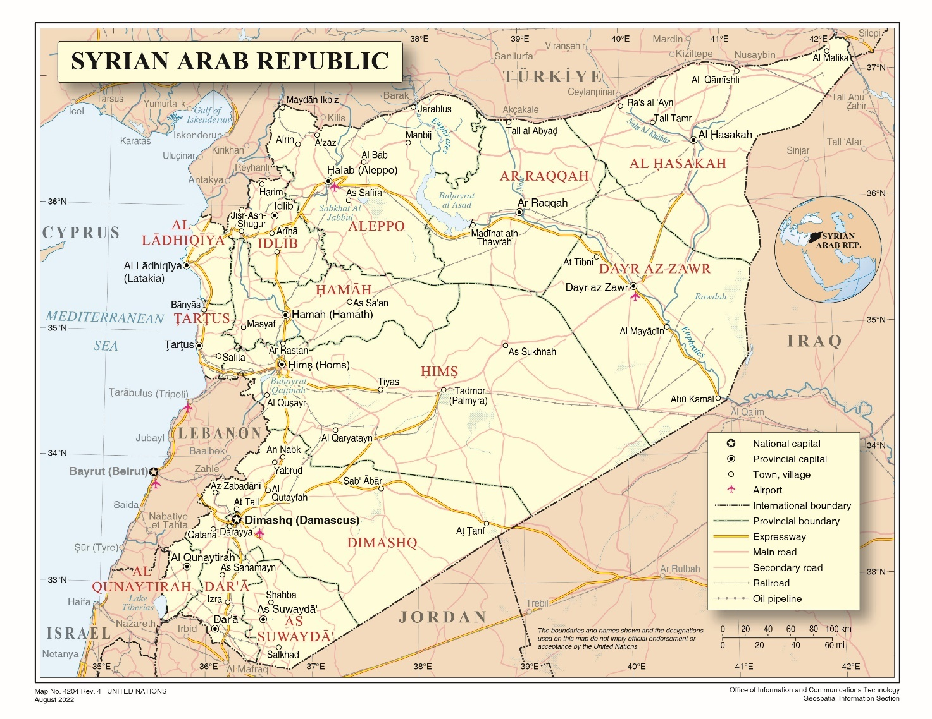

Annex II Approximate areas of influence: July 2022
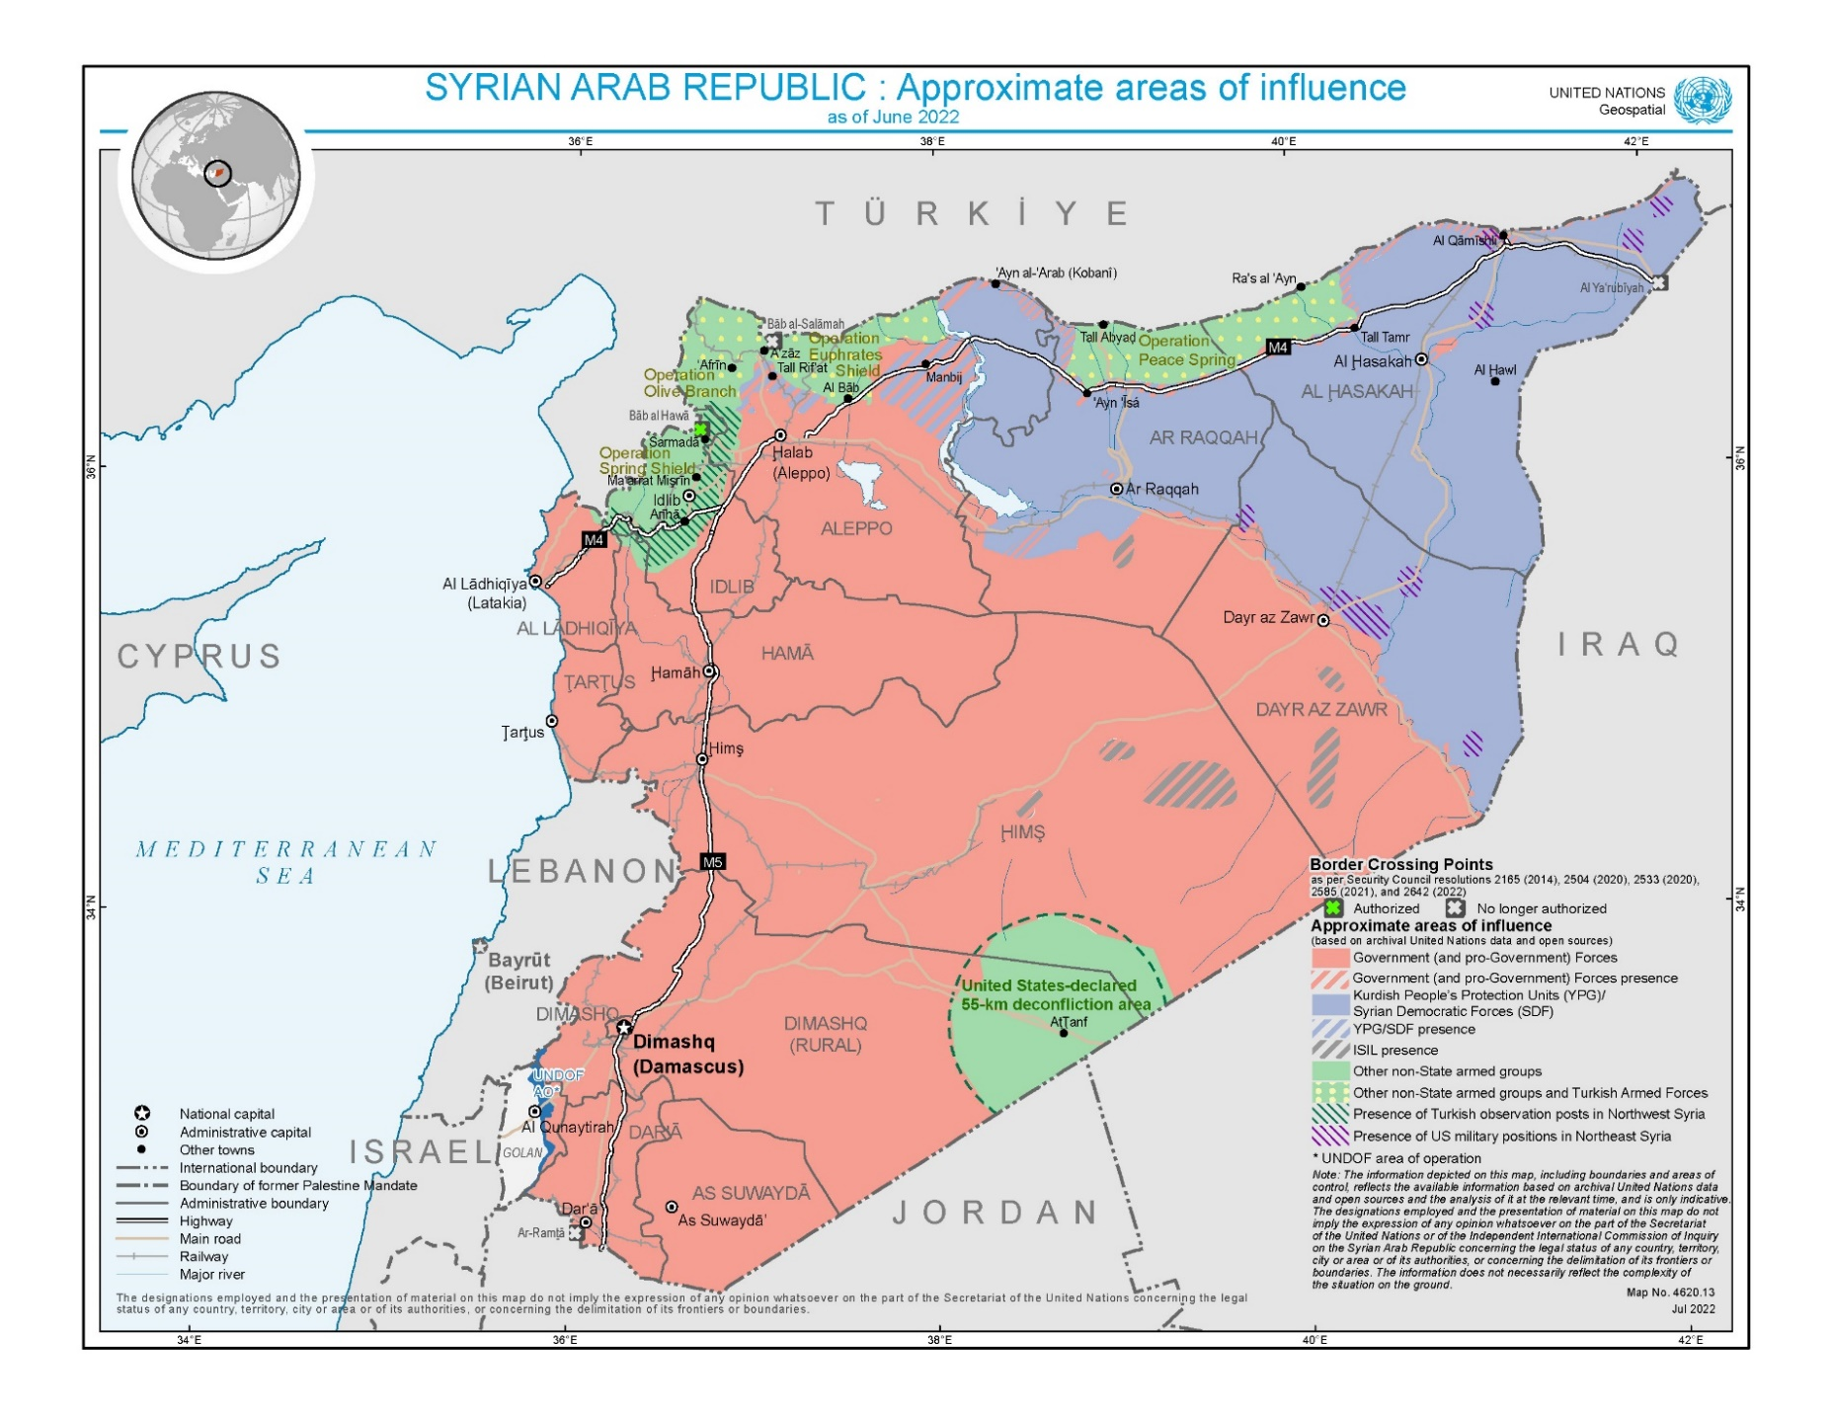

Annex III Conduct of hostilities incidents and intensity in the north: January–June 2022
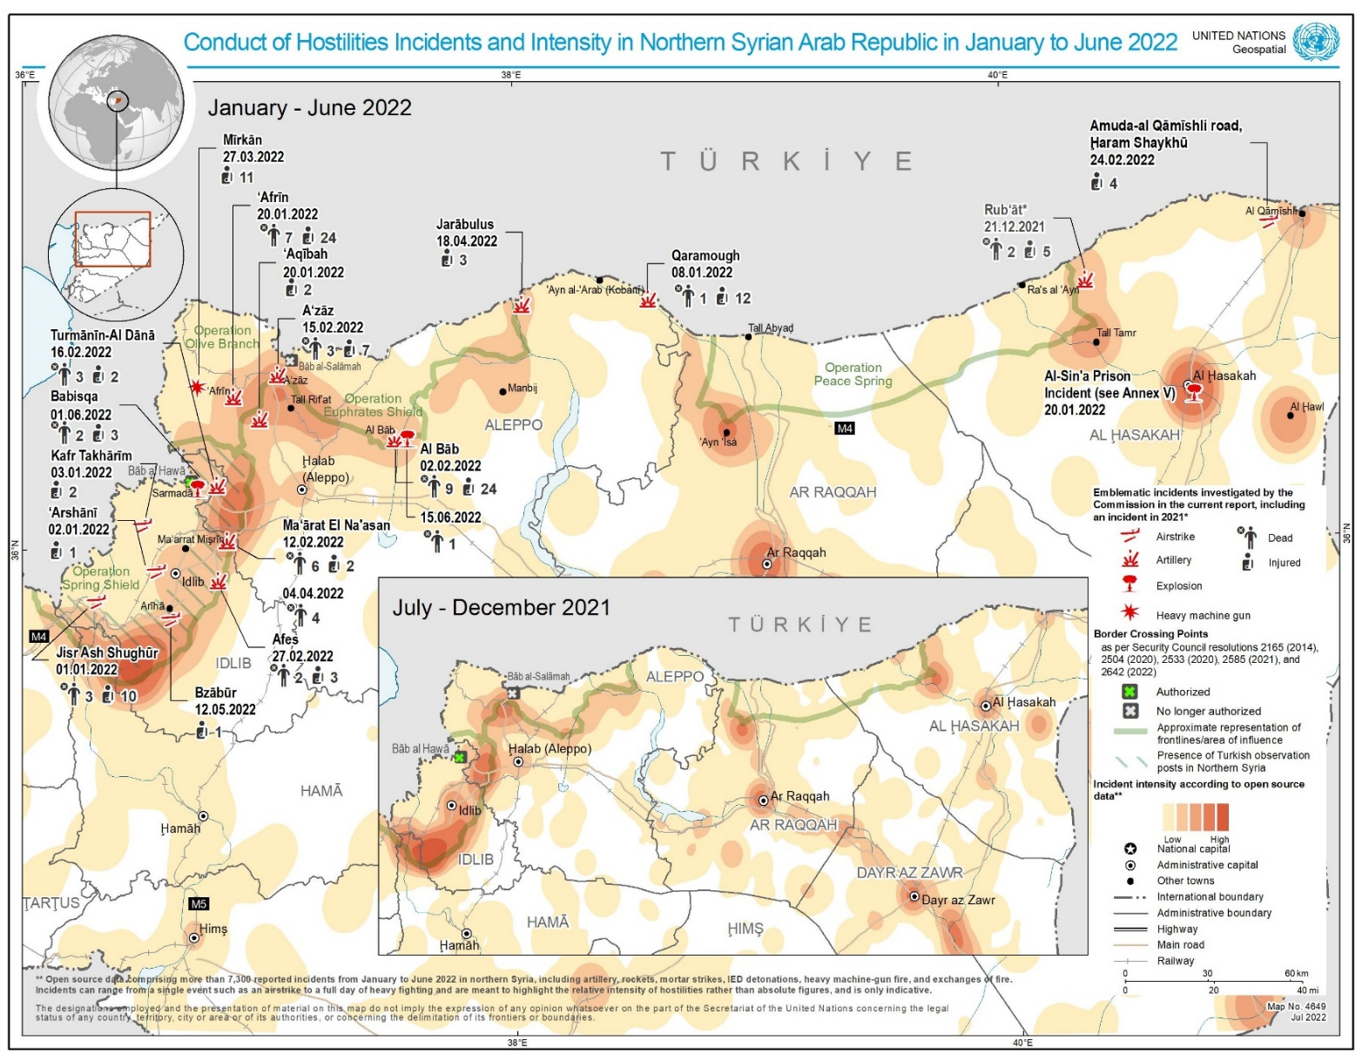

Annex IV

Details of emblematic civilian casualty incidents in the north of the Syrian Arab Republic

A. Idlib governorate

Airstrikes affecting civilians and civilian infrastructure, including objects indispensable to the survival of the civilian population

Makeshift displacement camp, Jisr al-Shugour area, 1 January 2022
1. On 1 January, between 1:30 a.m. and 2 a.m., airstrikes landed at a makeshift camp in the area of Nahr Al-Abyad, Jisr al-Shughour, where a small group of shepherds, displaced from rural Aleppo, had settled. The families were living in some 10 tents scattered in a squared-off area, some 10 to 15 meters from each other, amidst open fields. One of the displaced families had moved into an abandoned concrete room, situated between the tents, to keep themselves and their children warm from the cold weather.
2. One woman, a mother of four, and two girls aged seven and two years and a half were killed during the attack, and at least 10 others were injured, including six children. The majority of the tents were subsequently destroyed, in addition to the concrete room that collapsed over a child victim. One interviewee told the Commission how, as the munitions exploded, fragments flew at him, while he was rushing to bring his children to safety. Another witness described how his family was awoken in the middle of the night by the sound of explosions, leaving his small children terrified and screaming in fear. Also killed in the attack were around 100 sheep, which were the main source of livelihood for the displaced families.
3. Consistent with witness testimonies, photographs and video footage obtained and analysed by the Commission confirmed the damage to the tents, in addition to the destruction of the concrete room where the bodies of two of the victims, including the child, were later found. No impact was observed near the affected locations where the tents used to stand.
4. Satellite imagery, taken two days after the attack and analysed by the Commission, indicated a possible military objective, likely a fighting position, around 170 meters from the affected area.
5. Flight spotters’ reports obtained by the Commission indicated that at least one Russian fixed-wing aircraft was observed in the affected area at the time of the attack.

Arashani water station, Idlib city, 2 January 2022
6. On 2 January, at around 12 p.m. airstrikes partially destroyed the Arashani water station, injuring one person, and forcing the station out of service. One witness described how the first airstrike caused significant damage to the building, including to the main water pump and a generator, while the second strike destroyed the well’s control system, thus cutting off supplies to at least 225,000 residents in Idlib city for around 20 days. The electronic boards and wires at the station were also destroyed as a result of the explosion.
7. The facility was well known, located on a hill and easily identifiable. Information received by the Commission suggested that, although aircraft were approaching the facility, interviewees could hardly believe that such a well-known water station would be attacked.
8. Consistent with witness testimonies, photographs and video footage showed damage to the main buildings housing critical equipment and machinery. Satellite images collected prior to and after the attack, as well as audiovisual material, confirmed that the attack struck two monolithic structures, in addition to a tin shed erected on one of the impacted buildings.
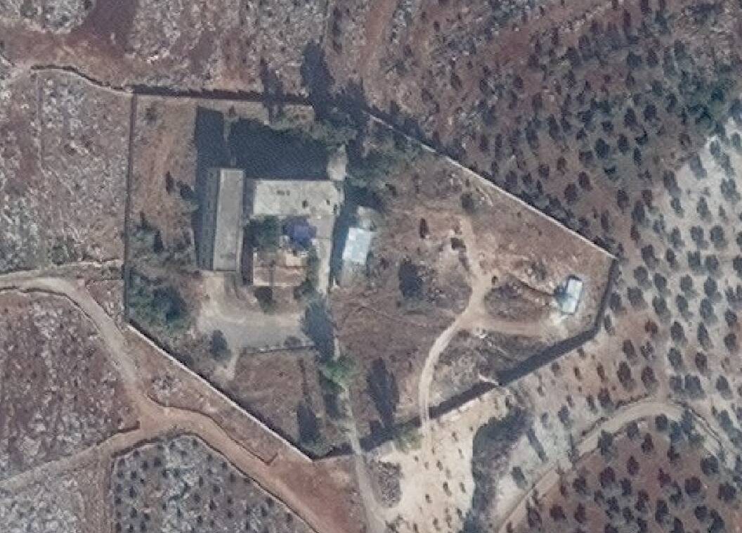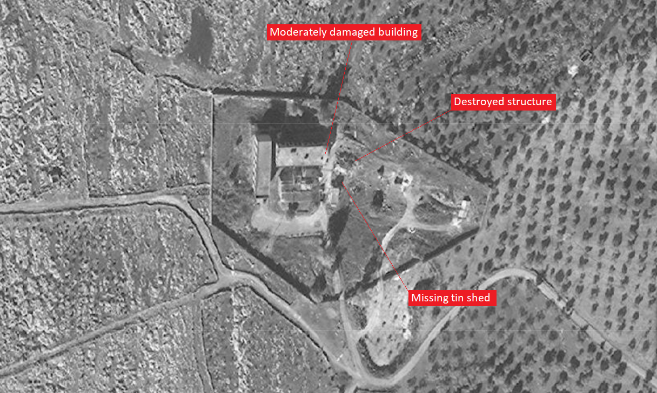
Top: Satellite image of the Al-Arashani water station, 12 November 2021©2021 Maxar Technologies.
Bottom: Satellite image showing the damaged water station, 16 January 2022©2022 Maxar Technologies.
9. While the main structures appeared to remain standing after the attack, one, housing critical technical equipment, was partially damaged, leading to the collapse of its (inner) eastern wall. A smaller concrete room and the tin shed under which equipment and machinery was held were completely destroyed in the attack.
10. Consistent with witness testimonies, historical satellite imagery of the compound showed what appeared to be civilian vehicles regularly parked in the yard of the facility. A recently collected satellite image (taken less than two months before the attack) did not reveal the presence of military vehicles or unusual activities in the area.
11. Flight spotters’ reports obtained by the Commission indicated that at least one Russian fixed-wing aircraft was observed in the affected area at the time of the attack.

Poultry farm, Kafr Takhrim, 3 January 2022
12. On 3 January, at around 2:30 p.m., airstrikes hit a three-story poultry farm and adjacent agricultural lands on the outskirts of Kafr Takhrim, less than 20 kilometres from the Arashani water station. One woman and her 8-year-old son were injured as a result.
13. Witnesses recalled how the first strike impacted an area some 50 meters away from the farm, causing partial damage to a nearby house where a family of displaced persons was living. Minutes later, as people were running outside the farm, a second airstrike hit the farm building directly, almost destroying it, along with surrounding olive threes, in addition to killing at least 5,000 birds.
14. Consistent with interviewee statements, satellite imagery taken earlier on the day of the attack showed no signs of military activity or apparent military objectives located near the poultry farm. The farm was situated near a road that was often used for the transportation of food items from the farm to the town. Consistent with witness testimonies, photographs and video footage confirmed the large-scale destruction of the farm, as well as the damage to the house.
15. Flight spotters’ reports and overflight data obtained by the Commission indicated that at least one Russian fixed-wing aircraft was observed in the affected area at the time of the attack.
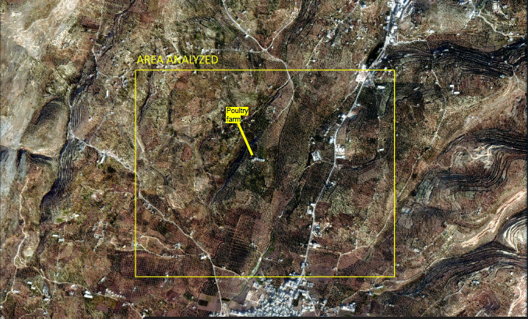
Satellite imagery of Kafr Takharim area (3 January 2022 Jilin-1 © CGSTL). Analysis by UNOSAT.

Poultry farm, Bazbour, 12 May 2022
16. On 12 May, between 9 a.m. and 10 a.m., airstrikes struck another poultry farm near the town of Bzabour (near Ariha), Jabal al-Zawiya, injuring one civilian and destroying the facility. The victim was reportedly in a nearby house when the airstrike occurred. At least 250 birds were also killed in the attack. Video footage published on the internet as well as satellite imagery from before and after the attack showed the destruction of the farm, as well as debris and the impact on the building, in line with a witness interview. No military objective was seen nearby and one interviewee described the facility as civilian.
17. Flight spotters’ reports and overflight data obtained by the Commission indicated that at least one Russian fixed-wing aircraft was observed in the affected area at the time of the attack.
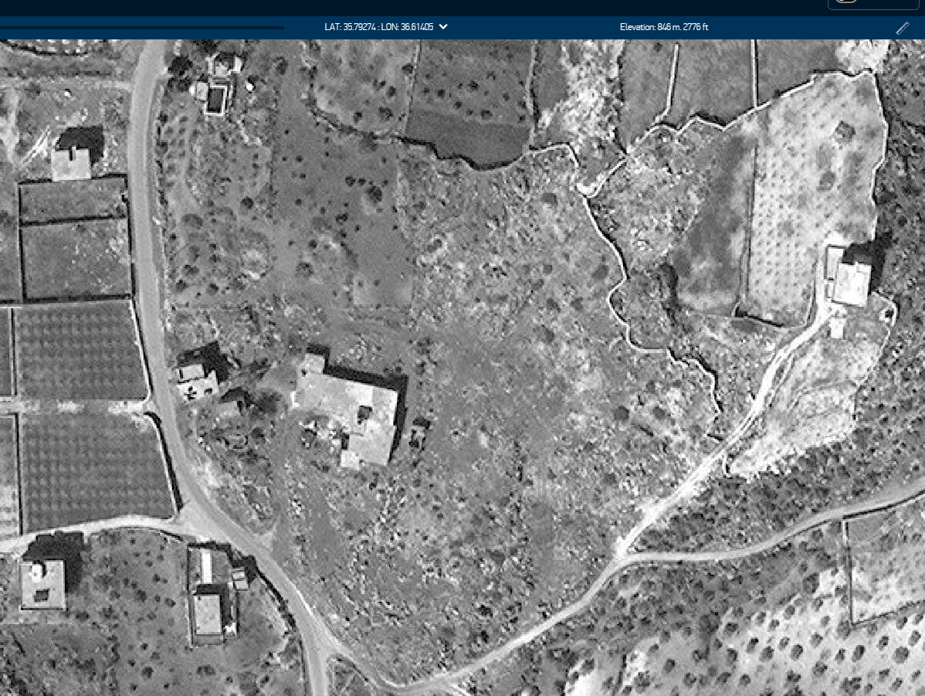
Satellite imagery of the farm, showing building intact, 3 April 2022©2022 Maxar Technologies.
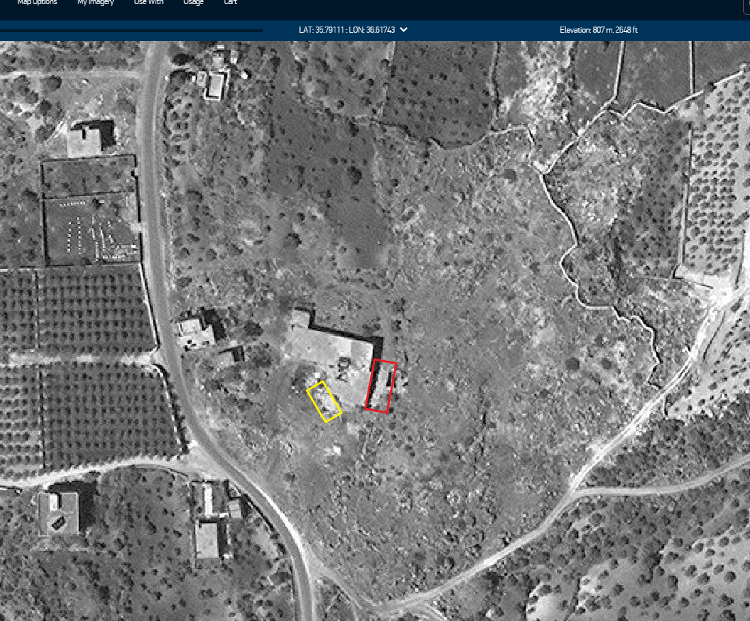
Satellite imagery showing damage to the building, 19 June 2022©2022 Maxar Technologies.

Ground attacks affecting frontline villages

Residential house, Ma’arat al-Na’asan, 12 February 2022
18. On 12 February, there was a ground attack on the yard of a residential house on the outskirts of Ma’arat al-Na’asan, close to frontlines, killing a family of six, including two children, aged between 5 and 6 years, and two women, and injuring two other girls. Residents had returned to Ma’arat al-Na’asan during the March 2020 ceasefire because of the inadequate living conditions in the displacement camps in the north of the Syrian Arab Republic. The respite was, however, short-lived, as shelling incidents gradually increased, and drones were often seen flying over Ma’arat al-Na’asan.
19. Witnesses recalled that the first munition hit agricultural land behind the house, while the second exploded in the yard, killing the family who had gathered outside for afternoon tea.
20. Witnesses described seeing the headless body of one of the female victims in front of the house, as well as children’s clothing and blood-stained teacups scattered across the yard. Witnesses also told the Commission how, as they were approaching the house, residents were calling on people to come help them transport the wounded. One interviewee recalled the overwhelming scent of blood and gunpowder as he entered the house, while also seeing the body of one of the victims next to the jacket of a child left on the ground.
21. Interviewees told the Commission that no military objectives were located inside the village. Photographs and video footage obtained by the Commission indicated an impact consistent with the use of a mortar, likely an 82-mm calibre, part of an unguided artillery weapon system. The attack reportedly originated from the town of Miznaz, only 2.2 km from Ma’arat al-Na’asan across the frontline, where government forces are known to be present. The distance is within the range of an 82-mm calibre mortar.

Market area, Afes village, 27 February 2022
22. On 27 February, around noon, a market was shelled in Afes, between Miznaz and Saraqib (a strategic town at the junction of the M4 and M5 highways), both controlled by the Government. Two civilian men were killed as a result, including one who was the primary income earner in a household of six, and three others were injured.
23. One interviewee described how the first munition struck a house, while another fell on the market, 1.5 meters away from him. The explosion caused multiple shrapnel wounds to his body and a nerve injury to his left arm. The body of one of the victims was found inside his shop at the market, one hour later, after he had bled to death from a shrapnel injury to his heart.
24. As with the situation in Ma’arat al-Na’asan, many people had returned to Afes despite frequent shelling and the recurrent presence of drones flying over the village. Interviewees reported that no military objectives were located inside the village, and that the munitions were fired across the frontline, allegedly from Duwair village, east of Afes, where pro-government forces, including Russian forces and Iranian militia, were known to be present. Turkish military posts were also located nearby, while drones were often seen flying over the village. Consistent with witness testimonies, military analysis of damage and remnants found at the affected location revealed the use of a mortar weapon.

Residential area, near a school in Ma’arat al-Na’asan, 4 April 2022
25. On 4 April, at 11:15 a.m., a ground attack impacted another residential area in Ma’arat al-Na’asan, killing four boys aged 12–14 as they were on their way to al-Amal school. Interviewees recounted that one missile struck the children as they had gathered in front of the home of one of the victims on a main road frequently used by civilians, including by school children on a daily basis. Al-Amal school, which serves around 540 girls and boys, from first to ninth grade, was located around 500 meters from the affected location.
26. Witnesses, including family members, described seeing the dismembered bodies of the children scattered on the ground, some unrecognizable due to multiple shrapnel injuries to their face and body. Blue United Nations Children’s Fund (UNICEF) school bags, books and notebooks were found dispersed along the road. One interviewee recalled seeing the severed limbs of the dead children that the explosion had thrown into different directions as he was desperately looking for the body of his own son. When he eventually found the body of his child, it was covered with shrapnel wounds but he was able to recognize him. Another man was seen kissing the feet of his deceased son, as this was the only part of his body that had remained intact. A number of the victims’ classmates also went, as rescuers, as family members were removing the bodies of the boys.
27. Interviewees told the Commission that the attack originated from the town of Miznaz, known to be controlled by government forces, around two km away from Ma’arat al- Na’asan. Drones were often seen during shelling, suggesting that government forces would have been aware that the road was frequently used by children.
28. Consistent with witness testimonies, satellite imagery that was taken the day before did not reveal any apparent military objective or military activity in the area impacted by the guided missile. Photographs of remnants obtained by the Commission indicate that the weapon used was an anti-tank missile, with “line-of-sight” guidance that allows for the identification of and direct firing at a visible target. Topographic data analysed by the Commission showed that the altitude at the impact site was around 332 meters, while the possible firing position was 376 meters. The height and the distance of around two km between the frontline and the impacted site would have allowed government forces to view the potential target before firing at it.
29. While the exact source of fire could not immediately be identified, the positioning of the point of impact at the edge of an open field, with multi-story buildings to the south and south-west, provided a clear line of sight from the direction of government-controlled areas, to the north and north-east.

Farmhouse near a fuel depot near the towns of Tamarin and Dana, 16 February 2022
30. On 16 February, at around 10 a.m., shelling killed at least three men and injured two others, in addition to severely damaging a civilian vehicle and a farmhouse. In addition, it almost destroyed a nearby fuel depot between the towns of Tarmarin and Dana, forcing it out of service. The affected locations were situated within a radius of around 500 meters from each other, near agricultural fields. The Sham al-Khair camp, run by Hay’at Tahrir al-Sham and known to be hosting widowed women as well as children, was also located nearby.
31. One interviewee recalled how, after he lost consciousness when a munition hit his vehicle, he woke up to see the dismembered body of one of his friends cut in half and the burnt body of another, propelled at least five meters away as a result of the explosion. It took at least 10 hours for the rescuers to extinguish the fires ignited when the remaining munitions hit the fuel depot.
32. Multiple munitions struck the area, allegedly consisting of Krasnopol guided artillery shells. Reports received by the Commission indicated that the munitions were fired by the 46th regiment of the Syrian Arab Forces, stationed in western rural Idlib. A drone was also observed by one interviewee, before and after the events.
33. Interviewees reported that the fuel depot was used to process, refine and store oil from the north-east of the Syrian Arab Republic for transportation to Idlib governorate through the northern Aleppo countryside. The facility is allegedly owned by the Watad petroleum company, through which Hay’at Tahrir al-Sham maintains a monopoly over the import and distribution of fuel in the area. Its affiliation notwithstanding, interviewees stated that the fuel facility was serving civilian purposes and being operated by civilian staff only, and it could not therefore be solely viewed as a legitimate military target.

B. Northern Aleppo and the Ra’s al-Ayn and Tall Abyad regions

Residential areas, including a school and a market, Afrin city, 20 January 2022
34. On 20 January, at around 4 p.m., at least six rockets struck several residential areas in the centre of Afrin, killing one man, one woman, two girls and three boys, and injuring at least 24 others, including three women, and at least three girls and one boy. Interviewees reported that the majority of casualties occurred when three rockets hit areas known to be densely populated, including the Zaydiya neighbourhood, al- Siyasiyah Street and a popular market on Rajo Street. At least three other rockets impacted al-Ittihad school, an electricity company and the health directorate, causing significant material damage.
35. Witnesses described how, when the shelling hit al-Siyasiyah Street, at least three people were killed and a nearby building was also struck. The affected location was well-known among the residents and was frequently crowded with people as it led to Rajo market and other main streets in Afrin. One child and two men were also injured at the same location.
36. Photographs and video footage of both the damage and weapon remnants indicated the use of an unguided rocket artillery system with wide-area effects, such as a BM-21 Grad type multiple-barrelled rocket launcher. Consistent with open-source analysis and satellite imagery, the direction of fire, as well as the range of the weapons used, indicated that the rockets may have been fired from the area of Tell Rif’at, located some 20 km from Afrin, where Kurdish forces, as well as Syrian and Russian forces, were present. The distance is within the range of a multiple-barrelled rocket launcher.

Residential areas, including markets, a hospital and a mosque, Bab, 2 February 2022
37. On 2 February, at around 3 p.m., at least eight rockets damaged multiple locations in Bab (Aleppo), including residential areas, two markets, a mosque and a hospital. At least eight men and one girl were killed, and 24 others were injured, including two women, as two rockets hit a shopping street, al-Midani hospital and al-Nasr mosque. Witnesses recalled how many of the casualties occurred near a shopping street, with damage so significant that it took almost two days to remove the rubble from affected areas.
38. Analysis of the damage and remnants indicated that, as was the case of Afrin, rockets were fired from an unguided rocket artillery system, a BM-21 Grad multiple-barrelled rocket launcher. Satellite imagery, open-source analysis and footage of impact sites suggest that the rockets were likely fired from a location west of Bab. Interviewees told the Commission that both government forces (al-Shalah radar military base) and Kurdish forces (Nirabiyah village) were located to the west, around 11 km from Bab. The distance is within the range of a multiple-barrelled rocket launcher.
39. The Commission notes that, later the same day, Syrian Democratic Forces issued a statement denying responsibility for the attack.

Residential areas, including a clinic, in A’zaz, 15 February 2022
40. On 15 February, at around 4 p.m., at least four projectiles struck several locations in western A’zaz, including a public park, as well as the area adjacent to the city council, where a shopping mall, a dental clinic and one administrative building were located. At least three civilian men were killed and seven others injured, including one boy.
41. Interviewees told the Commission that the first two munitions struck a public park and a street between the A’zaz shopping mall and the city council, less than 200 meters away, causing minor damage to a minivan and the road. A few minutes later, a third explosion hit the entrance of the dental clinic and an empty electrical facility. Consistent with witness testimonies, closed circuit television footage obtained by the Commission showed civilians escaping the area of the shopping mall and attempting to hide inside the clinic. Two of the victims were subsequently killed inside the clinic.
42. Analysis of weapon remnants indicated the use of rockets, likely unguided, allegedly fired from a location south or south-east of A’zaz, possibly Tell Rif’at, where the Syrian and Russian forces as well as Kurdish forces were present. Open-source analysis suggested that the latter operate a large military facility south of A’zaz, some five km from the affected locations.

School, Mirkan village, 27 March 2022
43. At around 4 p.m. on 27 March, 11 children, aged 6–12 years, were injured when a munition impacted near a school in the village of Mirkan, near Afrin. One interviewee described how, as he was picking his daughter up from school, he heard a loud explosion and saw another girl who was bleeding near the school.
44. Photographs and video footage of unexploded munitions analysed by the Commission indicated the use of a heavy machine gun with a calibre of 12.7 mm and a range of up to two km, likely located within areas controlled by the Syrian National Army.

Babesqa camp for displaced persons, Bab al-Hawa area, 1 June 2022
45. On 1 June, at around 11 p.m., two civilians, including a 10-year-old girl with physical disabilities, were killed and three others injured in the Babesqa camp, amid a fire that erupted following an explosion of an ammunition depot located in between several displacement camps in the Bab al-Hawa area.
46. Interviewees reported that Babesqa camp comprised some 10 to 15 sites, accommodating between 1,000 to 3,000 displaced persons who lived in tents or blocks with plastic roofs. Satellite imagery analysed by the Commission showed an apparent military site north-west of Babesqa village, consisting of at least two compounds, one of which is wedged between nearby displacement camps. Interviewees reported that the facility was indeed an ammunition depot, controlled by the Falaq al-Sham division of the Syrian National Army, which is also in control of the area. Historical satellite imagery, moreover, indicated that the site construction began in 2016, while the camps surrounding it were built in 2020. Temporary tents were also built in 2018, some 100 metres away. Heavy military equipment and tanks were present when the facility was being built, along with armoured vehicles parked inside the compound once construction work was finished.
47. Consistent with witness statements, satellite imagery confirmed damage to several house structures inside the camp caused by the explosion and flying shrapnel. Witnesses recalled how the body of the killed child was found completely burnt, as she was not able to escape the fire that engulfed the tent she was living in. Interviewees who helped evacuating the displaced to nearby villages recalled consecutive explosions and flying shrapnel, with fires erupting shortly thereafter, damaging tents and living blocks. The body of a man was found later in one of the damaged tents, bearing multiple shrapnel injuries.

Humanitarian worker, city of Bab, 15 June 2022
48. On 15 June, at around 9 a.m., a vehicle-borne improvised explosive device killed a well-known humanitarian worker in Bab. Interviewees reported that the victim’s vehicle, parked in front of his home, exploded as he started the engine. A witness to the incident recalled how the victim had lost his legs as a result of the explosion. He later succumbed to his wounds in a hospital in Bab.

C. North-east of the Syrian Arab Republic

Shelling of Rub’āt village, 21 December 2021
49. On 21 December 2021, at approximately 4 p.m., an attack was made on Rub’āt village, located 3 km from Ras al-Ayn in Hasakah governorate, under the control of the Syrian Democratic Forces control. The attack affected multiple members of the same family, killing a mother and her daughter and injuring five other members of the family, one man, one woman and three children, including one girl, by shrapnel from a shell that fell in front of the family home. The village is located on the frontlines, and the attack occurred during ongoing fighting between the Turkish Armed Forces, the Syrian National Army and the Syrian Democratic Forces. Other civilian casualties in Asadiya village were reported but could not be confirmed.
50. One person who saw the bodies of those who died tried to remove them, but struggled as, in his words, “they were falling apart in my hands”.
51. Because of the shelling on the village, many households were displaced. The shelling also affected the ability of families to provide for themselves: the insecurity impeded access to agricultural land; their farm animals were killed; and the long-term impact of their injuries made physical labour difficult.

Shelling of multiple locations and villages in Ayn al-Arab on 8 January 2022
52. On 8 January, at 12:30 p.m., three locations in the centre of Ayn al-Arab, Aleppo governorate, were simultaneously shelled by unguided 120 mm projectiles, including the Road of Industry, Bank Square and the road that leads to the south of the city. The villages of Qaramogh, Tall Hajib, Sarzouri, Al-Khane and Koltaba along the Turkish border were also hit. One civilian man from Al-Khane was killed, while four men, five women and three children were injured, including a 4-year-old boy in Qaramogh, who lost his leg. Civilian property was severely damaged by the shelling, including a food production company. A shell also fell close to a vegetable market. Analysis of the damage and photographs of the remnants from one of the villages where civilians were injured indicated that 120 mm unguided mortar ammunition was used.
53. Victims of the incident describe how the shelling came quickly and struck close to their family dwelling. One described how a boy who was present during the shelling has been left traumatized: “When we take him to the yard, he is still horrified and when he sees the place in front of the house, he screams: ‘here it is, it is coming … the bomb!’. He is afraid”.
54. The range of the weapon and distance from other front lines indicate that the shelling may have been fired from Türkiye.¹¹

Drone strike hits bus near Qamishli on 24 February 2022
55. On 24 February, between 10 a.m. to 10.30 a.m., a civilian bus carrying 14 passengers from Amuda to al-Qāmishli was damaged by an explosion that occurred while it was close to the village of Haram Shaykhü in Hasakah governorate, an area under the control of the Syrian Democratic Forces. The strike was possibly targeting a nearby military checkpoint or vehicle. At least four individuals (one man and three women) on the bus, which was carrying 15 people, were injured by shrapnel in the incident. The bus was also damaged.
56. Analysis of photos of the remnants of the weapon used indicate that a Turkish manufactured air-to-surface MAM-L missile fired from a Turkish drone caused the injuries and damage. This type of attack is in line with the Commission’s findings that drone attacks by Türkiye are on the increase in the north-east of the Syrian Arab Republic controlled by the Syrian Democratic Forces.

Annex V

Attack on Al-Sina’a prison

Introduction
1. On the evening of 20 January 2022, Da’esh launched a coordinated and multipronged assault on Al-Sina’a military prison, located to the south-east of Hasakah city. The attack unleashed by Da’esh triggered a prison mutiny and an unknown number of Da’esh fighters and detainees escaped to residential areas around the prison, where fighting ensued. The final number of escaped detainees has not been made public, although a spokesperson for the Syrian Democratic Forces stated they had recaptured approximately 3,500 “terrorist detainees”.
2. A counter-offensive, called the “People’s Hammer”, launched by the Syrian Democratic Forces, supported by United States ground troops and with air support from the international counter-Da’esh coalition (henceforth the “coalition”), involving severe clashes, eventually took back full control of the prison and adjacent areas on 30 January. The final casualty figures released by the Syrian Democratic Forces indicated that 4 civilians, 40 Syrian Democratic Forces soldiers and 77 prison staff were killed, in addition to 374 “Da’esh terrorist detainees and combatants”. The number of Syrian Democratic Forces soldiers killed was updated to 43 on 6 February.
3. In addition to the prison complex itself, several civilian facilities were damaged by airstrikes and intense violence, namely the Technical Institute and the Faculty of Civil Engineering and Economics of Euphrates University, a petrol station, the Ghuwayran minibus station and grain silos. Almost all the neighbourhoods around the prison witnessed clashes. Satellite imagery confirmed damage or destruction to 40 civilian buildings in neighbourhoods adjacent to the prison, including by military grade bulldozers. Approximately 6,000 people from the neighbourhoods of Al Zuhour and Al Taquaddom/East Ghuwayran were displaced.

Al-Sina’a prison and its population
4. Al-Sina’a prison, a former vocational training college, is considered the largest prison holding suspected Da’esh members and other individuals allegedly affiliated with the group detained by the Syrian Democratic Forces in the north-east of the Syrian Arab Republic. Close to 4,000 male individuals, including boys (predominately Iraqi and Syrian), are believed to have been held there at the time of the attack.
5. In 2019, when the Syrian Democratic Forces last provided figures, some 700 boys, 400 Syrians, 200 Iraqis and other foreign nationals, were detained at the prison. Some have since turned 18. At the time of the attack, the youngest children were only 12 years old.
6. Prior to the attack, the prison was overcrowded and failed to meet international standards. The juvenile wing was run down and illness, such as tuberculosis, was rife. Children were malnourished and had limited access to fresh air and outside contacts.

Attack by Da’esh
7. The attack commenced at approximately 7 p.m. on 20 January when two suicide bombers detonated an explosive-laden truck at the entrance and another next to a prison wall. Da’esh fighters were then able to break into the inner parts of the prison and take control of whole sections. After taking over the prison armoury, Da’esh fighters attacked and destroyed other parts of the prison, including setting fire to a medical facility, as well as an administrative building, showers and cleaning facilities and parts of a newly built prison block not yet in use. Meanwhile, fierce battles involving light and heavy weapons took place by the prison walls. Da’esh members also reportedly took over four 4x4 vehicles equipped with heavy machine-guns and burned 25 other vehicles.
8. In a statement, Da’esh claimed responsibility for killing more than 200 prison staff during the initial stages of the operation. The Syrian Democratic Forces reported that 77 prison staff and guards were killed by “Da’esh terrorist detainees” inside the prison. Several sources confirmed that prison staff inside the prison were killed by Da’esh and their bodies mutilated. A man searching for a relative who had been employed as guard in the prison said “I spent three days looking at mutilated bodies to identify him. Several were burned, and some had no head, hands or feet. It was a terrible experience”.
9. Outside the prison, Da’esh fighters launched a series of ground attacks. Fuel tankers at a petrol station were set on fire by Da’esh on 20 January. By 22 January, they had embedded themselves in nearby civilian areas surrounding the prison, notably the Technical Institute and the Faculty of Civil Engineering and Economics, both part of Euphrates University. The Syrian Democratic Forces managed to retake those locations on 24 January, after fierce clashes involving the use of heavy weapons and airstrikes by the coalition. The nearby grain silos also fell under Da’esh’s control.
10. According to the Syrian Democratic Forces, Da’esh fighters and escaping detainees hid in houses in residential neighbourhoods adjacent to the prison, namely Al-Zuhour, Al-Taqaddum, 16 Tishreen, Al-Thawra and Al-Madina Al-Riyadhiya. Clashes in those areas ensued between Da’esh groups and the Syrian Democratic Forces.
11. Interviewees described the fear and terror that the attack and subsequent arrival of fighters and detainees caused to the local population, evoking memories of previous Da’esh attacks on civilians. Da’esh fighters summarily executed at least one resident who had remained in his home.

Syrian Democratic Forces and coalition operations
12. The Syrian Democratic Forces sought to retake control of the prison and surroundings as well as nearby civilian neighbourhoods, establishing a security cordon and new checkpoints throughout the city. Clashes continued for days. On 23 January, the General Command of the Syrian Democratic Forces announced that their forces were in control of the perimeter of the prison. On 24 January, the Syrian Democratic Forces sent T-62 tanks into Hasakah city to support operations, a rare occurrence.
13. The coalition supported the Syrian Democratic Forces with intelligence, surveillance and reconnaissance assistance and air support, including the use by the United States of F-16 jets, Apache helicopters and the deployment of Bradley Fighting Vehicles. The coalition also stated that it had provided medical treatment for injured “Da’esh affiliates” who had surrendered.
14. Airstrikes by the coalition on the prison and civilian areas occurred over several days. On 21 January, the coalition carried out airstrikes in Hasakah city in support of the Syrian Democratic Forces, reportedly destroying the building of the Technical Institute, part of the Euphrates University located close to the prison complex. On 25 January, airstrikes again targeted the prison. Satellite imagery confirms that airstrikes impacted Da’esh positions at the Faculty of Civil Engineering and Economics and the Technical Institute during the counter-offensive launched by the Syrian Democratic Forces and the coalition.

Retaking of the prison
15. Fierce fighting occurred in the effort to take back control of the prison, leading to casualties: witnesses described seeing scores of bodies driven out of the prison on trucks. Some 50–80 dead bodies were later observed being moved between vehicles by the Syrian Democratic Forces. Some wore orange prison jumpsuits while others were dressed in civilian clothing, also worn by prisoners at the prison. Two witnesses reported almost all the corpses were intact and unbloodied, many of their faces and bodies black with soot. They were placed into a gravel truck and driven to an unknown location towards the desert.
16. The Syrian Democratic Forces and the coalition stated that different precautions were taken when retaking the prison, including the use of non-lethal methods such as tear gas and water to prevent casualties, and ongoing negotiations with those resisting. Large groups of detainees, including boys, were seen being rounded up following surrender. The Syrian Democratic Forces referred to the long duration of the operation as an indication of the attempts made to negotiate the surrender of Da’esh fighters and to avoid civilian casualties.
17. Both the Syrian Democratic Forces and the coalition stated that child detainees had been killed inside the juvenile wing, alleging they were being used as human shields by Da’esh. Audio testimony from one Australian 18-year-old reviewed by the Commission indicated that he had been injured and witnessed at least two boys being killed during fighting in the juvenile wing.
18. Sources reported that the bodies of two adolescent boys, identifiable as detainees through their clothing, were found in a neighbourhood in eastern Ghuwayran district on 30 January. The circumstances of their death remain unclear.
19. Neither the Syrian Democratic Forces nor the coalition have released the numbers of dead and injured adult detainees, or child detainees, although the Syrian Democratic Forces informed the Commission that an investigation was under way.

Operations outside of the prison
20. By 23 January, some 6,000 civilians had fled the Al-Zuhour and Al-Taqaddum/East Ghuwayran neighbourhoods, some of them at the request of the Syrian Democratic Forces, and also out of fear of being used as human shields by Da’esh.
21. In view of the presence of Da’esh in civilian areas, the Syrian Democratic Forces carried out clearance and screening operations and raids in residential neighbourhoods surrounding the prison, which led to arrests and seizure of personal identification documents. According to Syrian Democratic Forces commanders, hundreds of people were arrested during such combing operations following the prison break.
22. Multiple sources, including returning internally displaced persons, reported the destruction of civilian property in 16 Tishreen, Al-Taqaddom/East Ghuwayran and Al- Zuhour neighbourhoods near the prison. Satellite imagery confirmed damage or destruction to 40 civilian buildings, including by military grade bulldozers. Significant damage occurred in proximity to an area referred to locally as “Cemetery Street” in Al-Taqaddom/East Ghuwayran, as well as near Al-Aghawat Street in the 16 Tishreen neighbourhood. Several multi-story buildings, a pharmacy and a bakery were all reportedly affected.
23. Despite reports that a committee had been established by local authorities to assess damage to civilian property in the area, at the end of June, residents informed the Commission that they had not yet received compensation for the damage to their homes.

Annex VI

Property destruction in the north of the Syrian Arab Republic: satellite imagery

1. Dawoudiya village, Ras al-Ayn

Expansion of the military base, north of Dawoudiya, between late 2021 and early 2022
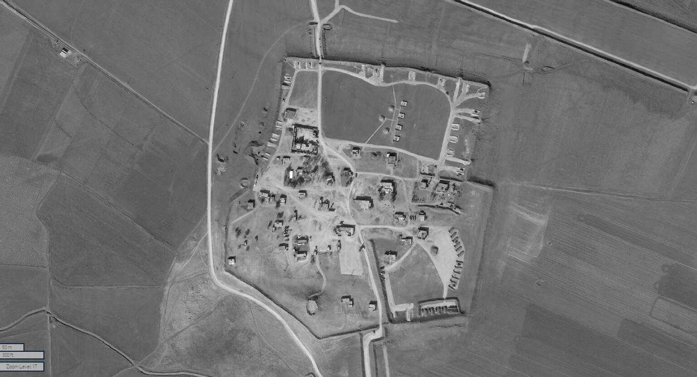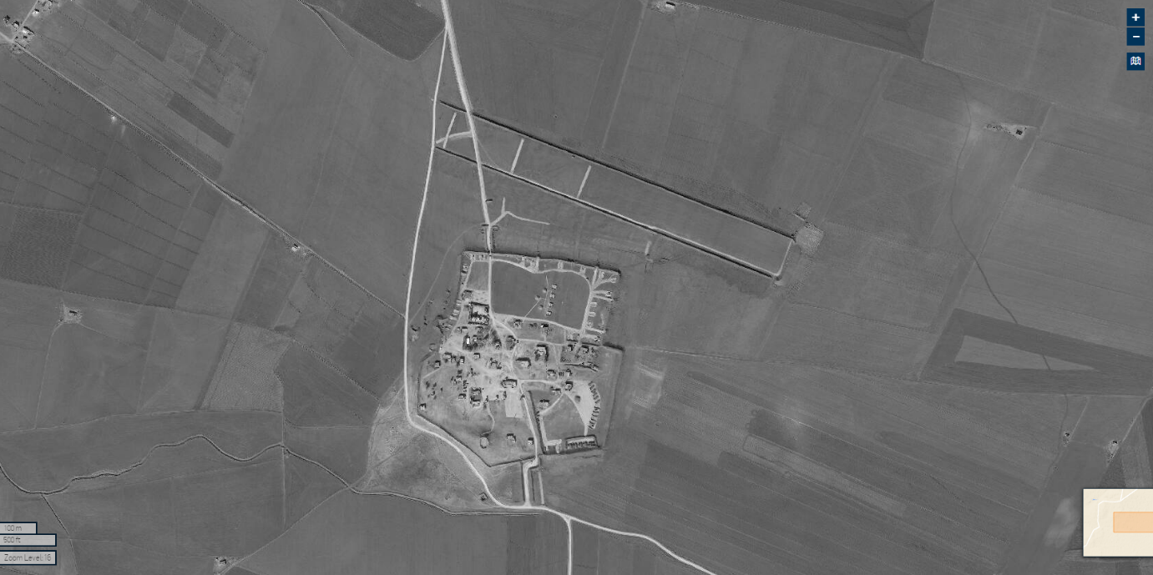
Satellite image of the military base, 3 February 2022©2022 Maxar Technologies.

2. Ayn al-Hissan, Ras al-Ayn

Destruction of a farm in March 2022, with indication of missing structures
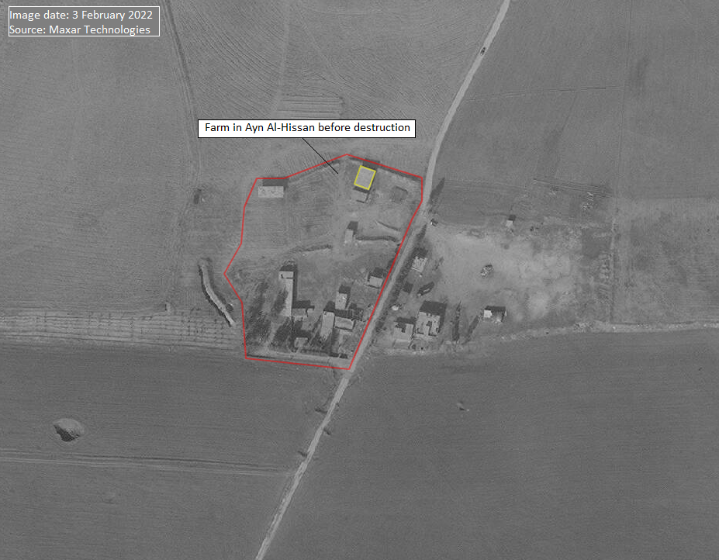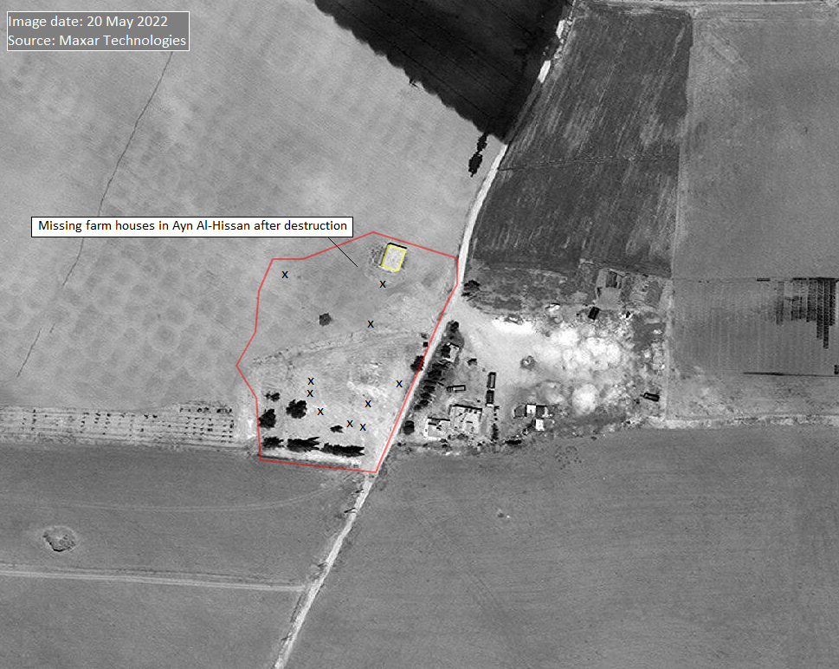
Satellite imagery of the farm:3 February 2022 and 20 May 2022 ©2022 Maxar Technologies.

Annex VII

Table of repatriations of foreign children and women

Repatriation of foreign children and women from camps run by the Syrian Defence Forces in the north-east of the Syrian Arab Republic (as of June 2022)
Countries and areas | Repatriated  children  (range)ª | Countries and areas | Repatriated  women  (range)ª
Kazakhstan, Russian Federation,^{d, g} Uzbekistan^{d} | 201–500 | Not applicable | 201–500
Not applicable | 101–200 | Kazakhstan, Uzbekistan | 101–200
Germany,^{g} Kosovo | 51–100 | Not applicable | 51–100
Albania,^{g} Belgium,^{g} France, Sweden^{g} | 26–50 | Not applicable | 26–50
Denmark, Finland,^{d} Netherlands^{g} | 16–25 | Germany^{g} | 16–25
Australia, Bosnia and Herzegovina, North Macedonia, Norway, Sudan,^{d} United Kingdom of Great Britain and Northern Ireland,^{g} United States of America,^{d} Ukraine^{d} | 6–15 | Belgium,^{g} Netherlands,^{g} Russian Federation, Sweden^{g} | 6–15
Austria,^{g} Canada, Italy, Maldives,^{g} Nigeria, Trinidad and Tobago, South Africa, Switzerland, State of Palestine | 1–5 | Afghanistan, Albania,^{g} Denmark, Finland,^{d} Maldives,^{g} North Macedonia, Norway, Sudan, United States of America, Ukraine | 1–5
Indonesia, Morocco,^{e} Tajikistan | To be determined^{b} | Morocco^{e} | To be determined^{b}
Afghanistan, Algeria,^{f} Azerbaijan, Bangladesh, China, Egypt,^{f} Estonia,^{f} Georgia, India, Iran (Islamic Republic of), Kyrgyzstan, Lebanon, Libya, Malaysia, Pakistan, Philippines, Poland, Portugal, Romania,^{f} Saudi Arabia,^{f} Senegal, Serbia, Somalia, Tunisia, Turkey, Viet Nam,^{f} Yemen | None^{c} | Algeria,^{f} Australia, Austria, Azerbaijan, Bangladesh, Bosnia and Herzegovina, Canada, China, Egypt,^{f} Estonia,^{f} France, Georgia, India, Indonesia, Iran (Islamic Republic of), Italy, Kyrgyzstan, Lebanon, Libya, Malaysia, Nigeria, Pakistan, Philippines, Poland, Portugal, Romania,^{f} Saudi Arabia,^{f} Senegal, Serbia, Somalia, South Africa, Switzerland, Tajikistan, Trinidad and Tobago, Tunisia, Türkiye, United Kingdom of Great Britain and Northern Ireland, Viet Nam,^{f} Yemen, State of Palestine, Kosovo | None^{c}
ª Figures are based on information submitted by States in response to communications by United Nations special procedures (https://spcommreports.ohchr.org/Tmsearch/TMDocuments), submissions to the Commission (see ft. 4) and a compilation of open-source data by the United Nations (until 30 June 2022).
^{b} Repatriations have reportedly occurred, without indication of the number of individuals.
^{c} The countries listed here are those for which the Commission received information that citizens were held and for whom there is no indication of any repatriation.
^{d} Based on an average value due to differing information between sources.
^{e} Eight individuals were reportedly repatriated, without specification as to the number of children and women.
^{f} According to information submitted by States in response to communications by United Nations special procedures (https://spcommreports.ohchr.org/Tmsearch/TMDocuments), the national authorities have no indication as to the presence of citizens in north-east of the Syrian Arab Republic or are still trying to determine such presence.
^{g} Repatriations reported during the reporting period, 1 January–30 June 2022.

Annex VIII

Correspondence with the Government of the Syrian Arab Republic
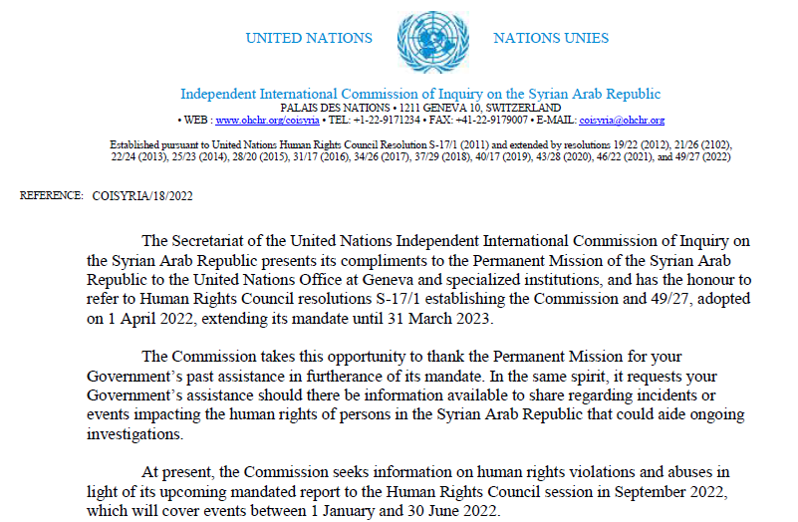
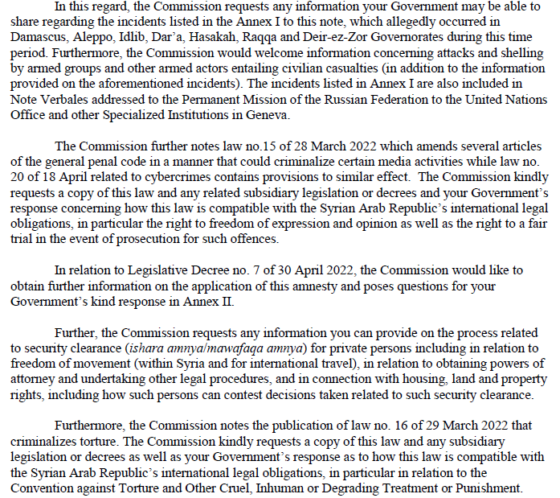

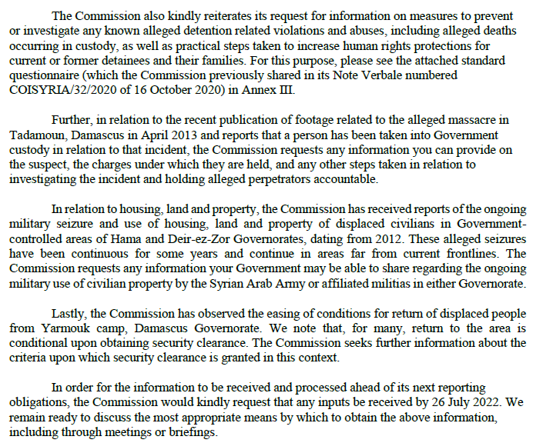
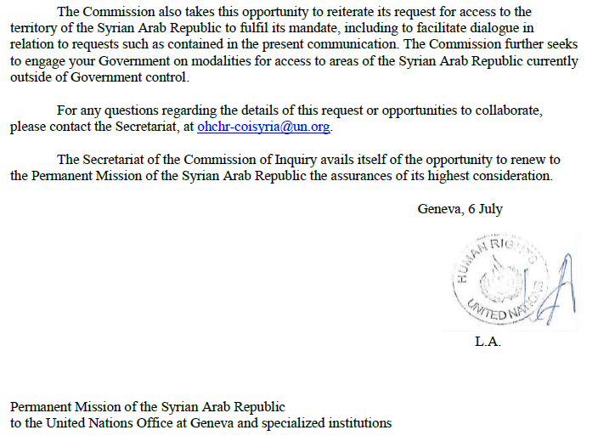

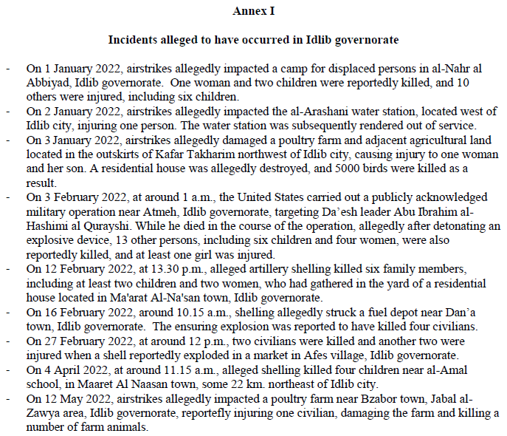
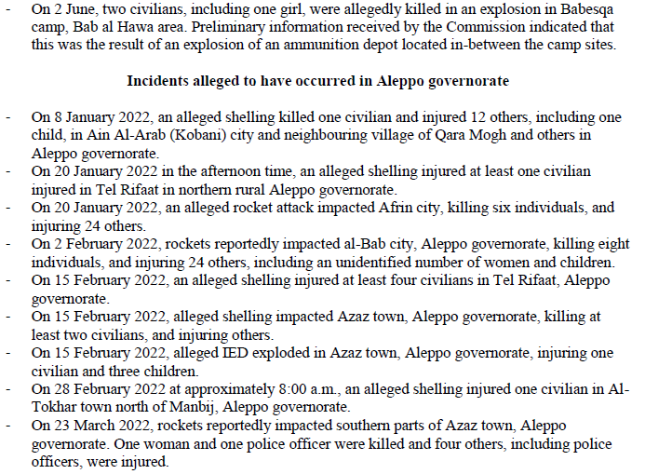

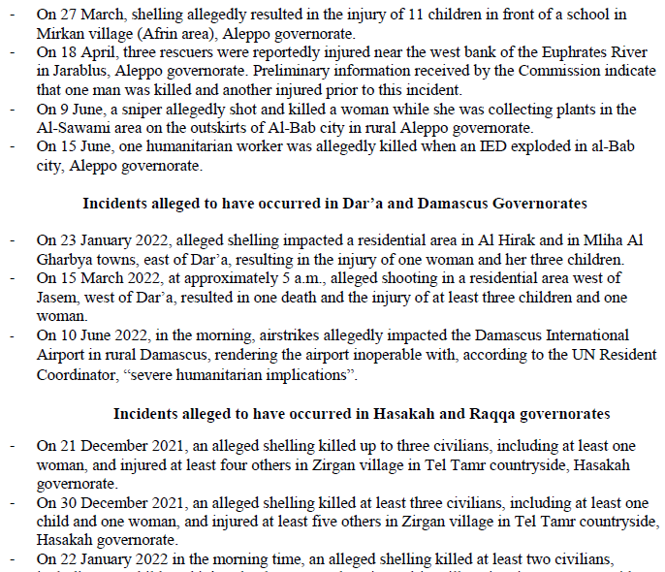
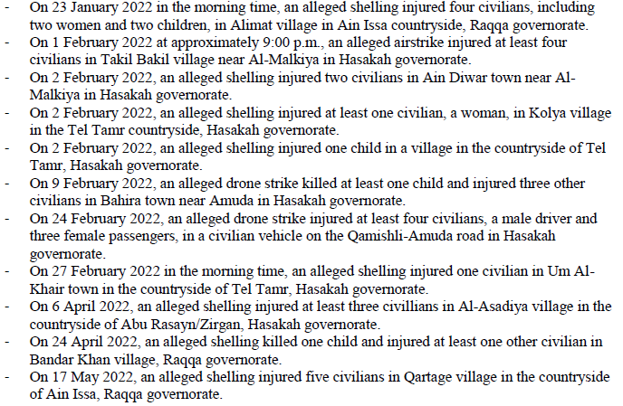

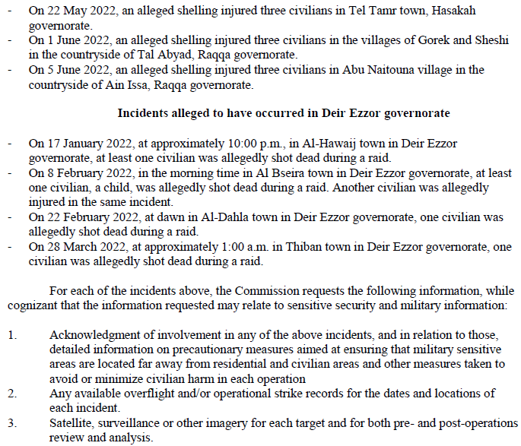
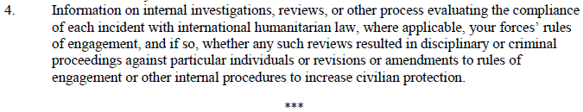

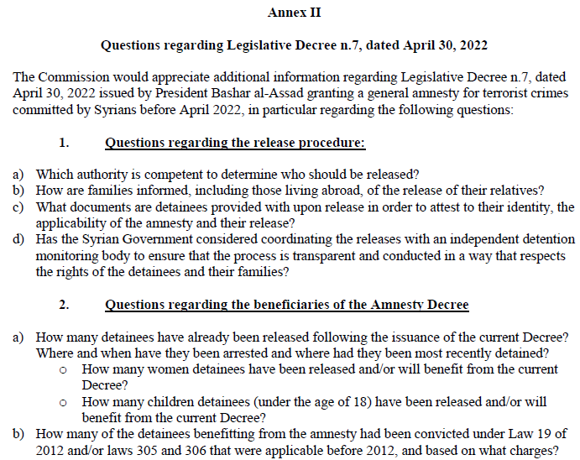
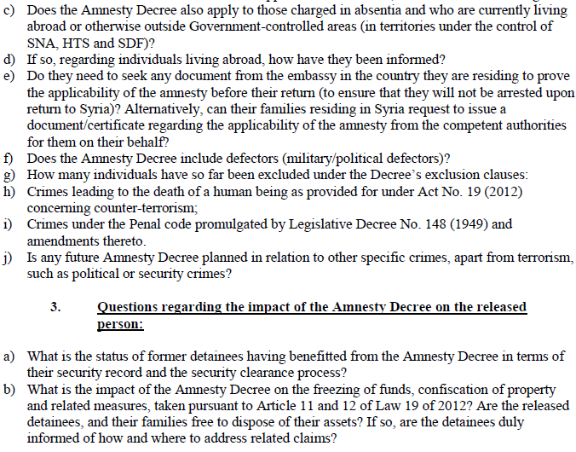

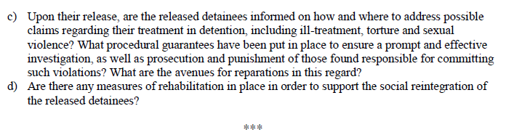

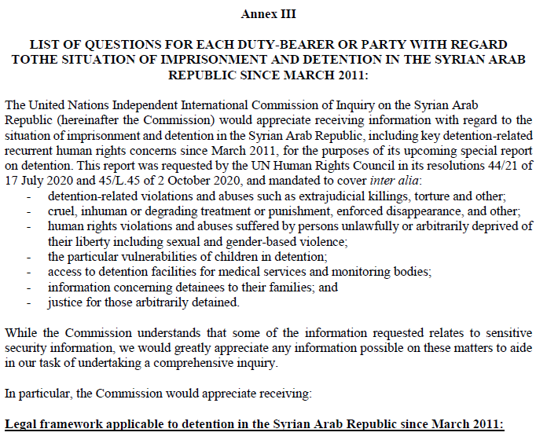
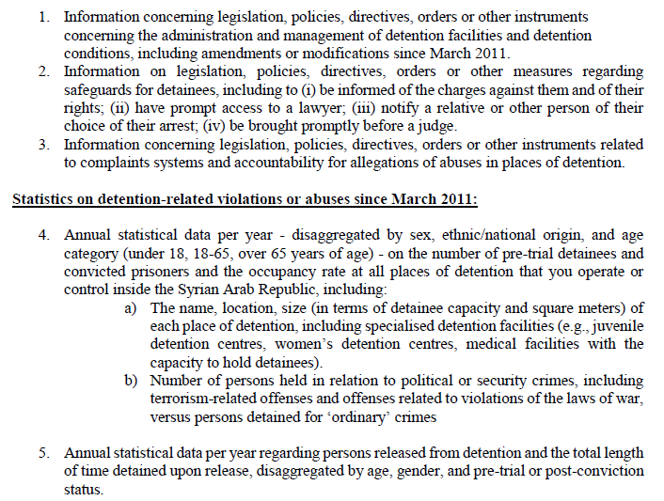

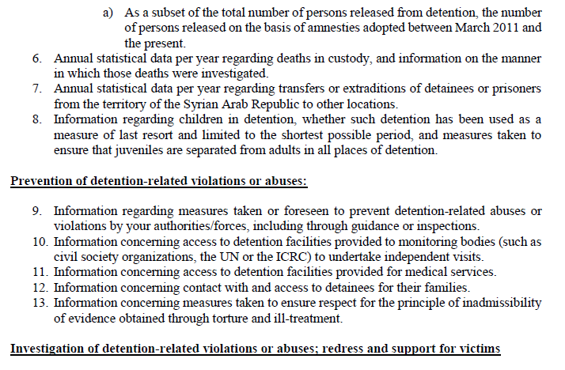
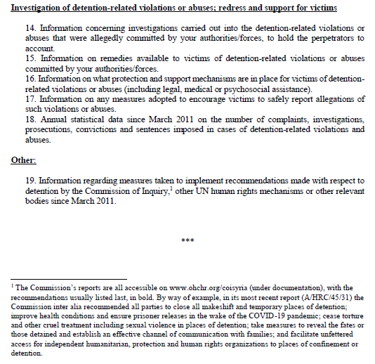

* Agreement was reached to publish the present report after the standard publication date owing to circumstances beyond the submitter’s control.
** The annexes to the present report are circulated as received, in the language of submission only.
The commissioners are Paulo Sérgio Pinheiro (Chair), Hanny Megally and Lynn Welchman.
The Government of the Syrian Arab Republic periodically addresses identical letters to the Secretary-General, the President of the Security Council and others in relation to situations of concern. The commission analysed 16 such letters submitted by the Government between 1 January and 30 June 2022.
In a communication dated 6 July 2022, the Commission sought information from the Government of the Syrian Arab Republic on issues and incidents (see annex VIII) but received no reply. The Commission also addressed 10 requests for information to other parties to the conflict and other States Members of the United Nations and is thankful for the responses received and other exchanges.
See A/HRC/21/50, annex II, paras. 1–3.
While the Syrian Government has control of approximately 70 per cent of the territory, supported by Russian, Iranian and other foreign forces, non-State armed groups control significant territory and population centres in the north and north-west of the Syrian Arab Republic, while Israel, Türkiye and the United States of America each retain effective control over parts of Syrian territory (see annex II).
Notwithstanding its change in name from “Jabhat al-Nusra” to “Jabhat Fatah al-Sham” in July 2016 and to “Hay’at Tahrir al-Sham” by early 2017, the Commission continues to regard the group as a terrorist entity as designated by Security Council resolution 2170 (2014), with links to Al-Qaida globally (see A/HRC/46/54, para. 7, ft. 13).
See https://reliefweb.int/report/syrian-arab-republic/united-nations-country-team-syria-statement-landmine-explosion-daraa-enar.
Letter of 5 July 2022 (see ft. 2 above).
See https://www.wfp.org/news/11-years-conflict-hunger-historic-levels-millions-syrians-hang-thread.
See https://reliefweb.int/report/syrian-arab-republic/united-nations-resident-coordinator-and-humanitarian-coordinator-syria-imran-riza-statement-closure-damascus-airport-enar.
See, for example, https://www.domstol.se/en/nyheter/2022/03/kvinna-doms-till-sex-ars-fangelse-for-grovt-folkrattsbrott-och-grov-krigsforbrytelse/ (in Swedish).
See http://www.parliament.gov.sy/arabic/index.php?node=5516&cat=22968& (in Arabic).
While no comprehensive data is available, civil society organizations reported the release of around a few hundred detainees, including women and individuals who had been detained as children.
OHCHR, “UN Syria Commission of Inquiry on Syria: Member States must seize moment to establish mechanism for missing persons”, 17 June 2022.
See S/2022/545; see also https://reliefweb.int/report/syrian-arab-republic/united-nations-resident-coordinator-and-humanitarian-coordinator-syria-imran-riza-statement-closure-damascus-airport-enar.
The Commission notes that the Government of the Syrian Arab Republic does not recognize the right to conscientious objection, contrary to article 18 of the International Covenant on Civil and Political Rights; see also CCPR/CO/84/SYR, para. 11.
A/HRC/45/31, ft. 37.
A/HRC/46/55, paras. 33–34.
See the conference room paper of the Independent International Commission of Inquiry on the Syrian Arab Republic on the siege and recapture of eastern Ghouta (available at www.ohchr.org/en/hr-bodies/hrc/regular-sessions/session38/list-reports), para. 63.
Ibid., para. 61.
See CAT/C/SYR/CO/1, para. 5. Prior to the adoption of the law, the Syrian Government referred to article 391 of the Penal Code on the imposition of violence or hardship (al-shidah), a misdemeanour, as covering the criminalization of torture.
Law 20/2022; see also الرئيس الأسد يصدر قانوناً لتجريم التعذيب (parliament.gov.sy).
See (توقيف ( 11 ) #شخص في حلب يتعاملون... - وزارة الداخلية السورية | Facebook).
A/HRC/45/31, ft. 37.
A/HRC/46/55, para. 82.
A/HRC/49/77, para. 48, namely the reference to the circular issued on 15 September 2021.
A/HRC/45/31, para. 32.
General Personal Status Law, art. 268.
A/HRC/42/51, para. 92.
A/HRC/40/70, paras. 80–82.
See, for example, “Death notifications in the Syrian Arab Republic”, 27 November 2018, para. 6, https://www.ohchr.org/sites/default/files/Documents/HRBodies/HRCouncil/CoISyria/DeathNotificationsSyrianArabRepublic_Nov2018.docx.
A/HRC/49/77, para. 33.
See International Committee of the Red Cross (ICRC), study on customary international humanitarian law, rules 11, 12 and 156, available at https://ihl-databases.icrc.org/customary-ihl/eng/docs/home.
See A/HRC/44/61, sect. V.
A/HRC/43/57, para. 33; A/HRC/44/61, paras. 90–91; and A/HRC/49/77, para. 69.
ICRC study, rule 54.
ICRC study, rule 156.
ICRC study, rules 11, 12 and 156.
See also A/HRC/48/70, paras. 53–62.
A/HRC/43/57, para. 33, A/HRC/44/61, paras. 90–91; A/HRC/49/77, para. 69; and S/2021/68, para. 16.
A/HRC/44/61, para. 5.
See art. 3 common to the Geneva Conventions of 12 August 1949: and International Covenant on Civil and Political Rights, arts. 6, 7, 9 and 19.
ICRC study, rule 133; and art. 3 common to the Geneva Conventions.
A/HRC/42/51, para. 56.
See A/HRC/46/54, para. 12.
See SDF, Press release regarding the shelling on the Al-Bab City, 2 February 2022; and ANHA, “SDF: We did not target Jarablus”, 18 April 2022.
A/HRC/42/51, para. 16.
ICRC study, rules 23–24.
A/HRC/46/55, para. 41.
The sister of the victim, a former employee of the self-administration, has been detained since May 2022, having been arrested at a Syrian National Army military police-staffed checkpoint near Afrin.
A/HRC/45/31, para. 57.
A/HRC/43/57, para. 12.
Ibid., para. 41, and A/HRC/49/77, para. 91.
ICRC study, rule 52.
A/HRC/45/31, para. 51, annex II.
Ibid.
Convention (IV) respecting the Laws and Customs of War on Land, article 52, and its annex: Regulations concerning the Laws and Customs of War on Land, The Hague, 18 October 1907.
The Commission has previously reported on how armed groups with extremist ideologies have made efforts to remove women from public life; see for example, A/HRC/43/57, paras. 88–90.
See also A/HRC/43/57, paras. 88–90.
A/HRC/45/31, paras. 67–69.
See also A/HRC/49/77, para. 97.
On the same day, the Turkish Ministry of Defence announced that it had launched an attack where “terrorists were neutralized”, although the location was not clear, see Turkish Ministry of National Defence (@tcsavunma), available at https://twitter.com/tcsavunma/status/1479902333387649024.
A/HRC/49/77, para. 99.
See www.inherentresolve.mil/Home/Article/2908322/desperate-attacks-make-daesh-weaker-coalition/.
See https://sdf-press.com/en/2022/01/the-sdf-general-command-statement-regarding-the-last-terrorist-attack-on-al-sinaa-prison-by-daesh/.
ICRC study, rule 113.
ICRC study, rule 15 and 23.
ICRC study, rule 135; and Convention on the Rights of the Child, art. 38, para. 4.
A/HRC/49/77, para. 108.
A/HRC/45/31, para. 77; A/HRC/48/70, para. 109; and A/HRC/49/77, para. 109; see also North Press Agency, “Trial of ISIS detainees under discussion with global collation – AANES”, 23 June 2022, available at https://npasyria.com/en/79449/.
Not all locations are known to the Commission, but this reportedly includes Al-Sina’a prison, holding the largest number of children, as well as Alaya prison, Derik (Al-Malikiya) women’s prison and the Helat and Al-Houri centres; see also A/HRC/49/77, para. 108; and A/HRC/48/70, para. 108.
See A/HRC/49/77, para. 108.
OHCHR, “UN experts appalled by death of young Australian boy in Syrian detention facility”, 25 July 2022.
A/HRC/49/77, para. 109.
See also OHCHR, “Syria: UN experts urge 57 States to repatriate women and children from squalid camps.
Art. 3 common to the four Geneva Conventions.
Ibid.
ICRC study, rules 118 and 135; Convention on the Rights of Children, arts. 3 and 37 (b).
A/HRC/49/77, para. 113. Of note, in February 2022, the Committee on the Rights of the Child found that the failure of France to repatriate French children who had been held in Syrian camps in life-threatening conditions for years violated their right to life, as well as their right to be free from inhuman and degrading treatment. The Committee found that France was obliged – and had the power – to take positive action, hence to repatriate the children, in order to protect them against an imminent risk to their life and an effective violation of their right not to be subjected to inhuman and degrading treatment (CRC/C/89/DR/77/2019-CRC/C/89/DR/79/2019-CRC/C/89/D/109/2019) Although it made no reference to the Committee’s decision in official statements, on 5 July, France repatriated 35 children and 16 mothers from the north-east of the Syrian Arab Republic. See https://www.diplomatie.gouv.fr/en/country-files/syria/news/article/repatriation-of-children-and-mothers-from-north-east-syria-05-jul-2022.
Common art. 3 to the four Geneva Conventions of 1949; ICRC study, rule 118; and International Covenant on Civil and Political Rights, art. 6.
See A/HRC/49/77, para. 105.
See, for example, A/HRC/36/55, A/HRC/42/51 and A/HRC/46/55, para. 113.
As documented in annex III.
See also https://www.savethechildren.net/news/response-killing-four-children-idlib-syria.
Artillery shells with a guidance system of the Krasnopol or Krasnopol-type are launched from a standard artillery gun and are then guided to the precise target by a laser aimed at the target by a drone; see A/HRC/49/77, para. 58.
Incidents described in sects. B and C may pertain to the same conflict between the authorities in control of northern Aleppo and the Ra’s al-Ayn and Tall Abyad regions on the one hand and the authorities in the north-east of the Syrian Arab Republic on the other hand.
A/HRC/42/51, para. 56.
See annex II to the present document; see also A/HRC/49/77, para. 78.
Press release on the shelling of the city of Bab (see https://sdf-press.com/en/2022/02/press-release-regarding-the-shelling-on-the-al-bab-city/).
A/HRC/42/51, para. 56.
The incident occurred before the current reporting period, but investigations were finalized within the period. ¹⁰ The Ministry of Defence of Türkiye announced the same day that it had launched an attack where “terrorists were neutralized”, although the location was not made clear (see https://twitter.com/tcsavunma/status/1479902333387649024) (in Turkish).
See map of the incident under para. 30 below.
Syrian Democratic Forces, Press Centre, “Sweep operations and gathering of information are ongoing in Al-Sina’a prison in al-Hasaka”, 27 January 2022 (see https://sdf-press.com/en/2022/01/sweep-operations-and-gathering-of-information-are-ongoing-in-al-sinaa-prison-in-al-hasaka/).
In 2014, an international coalition of more than 60 Member States joined together to combat Islamic State in Iraq and the Levant (ISIL) through a variety of means, including air strikes.
See https://sdf-press.com/en/2022/01/the-sdf-general-command-statement-regarding-the-last-terrorist-attack-on-al-sinaa-prison-by-daesh/.
Al-Zuhour, Al-Taqaddum/East Ghuwayran, 16 Tishreen, Al-Thawra and Al-Madina Al-Riyadhya/Sports City neighbourhoods.
A/HRC/49/70, para. 108; see also report of the Lead Inspector General to the United States Congress, May 2022, p. 68–69 (https://media.defense.gov/2022/May/03/2002988582/-1/-1/1/OIR_Q2_MAR2022_GOLD_508.PDF).
The satellite images analysed by the United Nations Satellite Centre show clear destruction of these two civilian facilities with heavy weapons.
International Committee of the Red Cross (ICRC), study on international humanitarian law, rule 23.
According to the Pentagon, the United States “provided some support, real time surveillance, some airstrikes, and some ground support, mostly in the form of Bradley Fighting Vehicles positioned to help assist security in the area”, 25 January 2022, statement by Pentagon spokesperson (see https://www.defense.gov/News/Transcripts/Transcript/Article/2911445/pentagon-press-secretary-john-kirby-holds-an-off-camera-press-briefing/).
Operation Inherent Resolve, “Regarding the situation in Hasakah, Syria”, 30 January 2022 (see https://www.inherentresolve.mil/Media-Library/Article/2917023/regarding-the-situation-in-hasakah-syria/).
See statement by Pentagon spokesperson, 21 January 2022 (see https://www.defense.gov/News/Transcripts/Transcript/Article/2908195/pentagon-press-secretary-john-kirby-holds-a-press-briefing/)
See coalition statement on 30 January 2022 (see https://www.inherentresolve.mil/Releases/News-Releases/Article/2917023/regarding-the-situation-in-hasakah-syria/).
See Save the Children Press release of 24 January 2022 (see https://www.savethechildren.net/news/save-children-calls-evacuate-700-boys-syria-s-guweiran-prison-due-intense-fighting). On 17 July 2022, Human Rights Watch reported that the child had died (see https://www.hrw.org/news/2022/07/17/detained-australian-teenager-dies-northeast-syria).
See present report, para. 78: to be compared with A/HRC/45/31, annex II, sect. D.
See present report, para. 78.
The table does not reflect the repatriation of Iraqi nationals, who form the largest group of foreigners in camps in the north-east of the Syrian Arab Republic.
References to Kosovo shall be understood to be in the context of Security Council resolution 1244 (1999).

