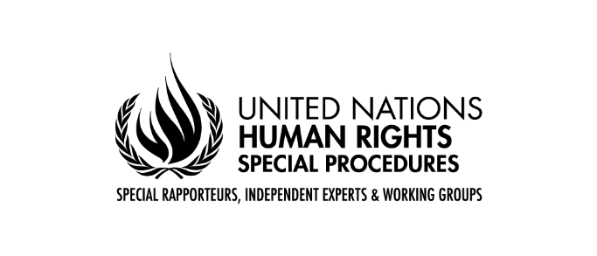

Call for Contributions

Mandate of the Special Rapporteur on the human rights to safe drinking water and sanitation

Thematic Report to the Human Rights Council 54th session: “Fulfilling the human rights of those living in poverty and restoring the health of aquatic ecosystems: two converging challenges”.

Questionnaire

Key information sought

To facilitate the reception of inputs, the Special Rapporteur prepared a list of key information which he considers essential for the report. The list could be answered entirely or partially according to the expertise and experience of those actors willing to contribute to the Report. Please find the list of topics here:

The global, regional, national or local legal and/or policy framework that:
- Protects the conservation of aquatic ecosystems, including groundwater and promotes the sustainable use of aquatic ecosystems.
- Recognizes the importance of aquatic ecosystems for fulfilling the human rights to safe drinking water and sanitation.
- Establishes the linkages between the human rights to safe drinking water and the health of aquatic ecosystems.
- Recognizes and/or protects community-based water governance mechanisms such as the ones of peasants, indigenous peoples, afro-descendants, and local communities.
- Determines a framework or standards to protect aquatic ecosystems from overexploitation and pollution.
- Determined accountability and monitoring mechanisms to guarantee/promote transparency on the uses of water by large water users (large-scale agriculture, industries (including extractive industries), and commercial uses).
- Establishes procedural obligations and mechanisms to protect aquatic ecosystems as safe drinking water sources.
- Incorporates a rights-based approach to the management of aquatic ecosystems.
- Environmental and/or social safeguards to guarantee that the health of aquatic ecosystems is not affected by external interventions.
- Guarantee rights holder access to justice if the health of the aquatic ecosystems they depend on is affected.
- Regional or national mechanisms that protect water in the framework of the human rights to a clean and healthy environment.
- Protect water rights defenders from retaliation and criminalization based on their activism.
- Minimizes/reduces the requirements or high standards to protect aquatic ecosystems, allowing the pollution and depletion of aquatic ecosystems.
The global, regional and national court rulings that:
- Determined linkages between the human right to safe drinking water and the health of aquatic ecosystems.
- Established linkages between the pollution of aquatic ecosystems and the lack of access to safe drinking water and sanitation.
- Urged states to protect aquatic ecosystems to guarantee the human rights to safe drinking water and sanitation.
- Established the legitimacy of an indigenous or non-indigenous community to manage a water source according to their governance mechanisms.
- Obliged a state to restore an aquatic ecosystem.
- Obliged a private company to compensate/remedy right holders for damaging the aquatic ecosystems they depend on.
- Recognized a river, lake, spring, creek or another water source as a right-holder.
- National and regional cases framed in the right to a clean and healthy environment.
- Applied at the national level the regional legal frameworks protecting water rights defenders (for instance Escazú agreement)
- Implemented at national or local levels regional directives or rules that protect water sources (for instance, the EU directives on water).
Statistics and Data sources
- Available independent and official data on the health of aquatic ecosystems to assess the need for restoration or conservation.
- Good experience in applying non-state or state community-based monitoring of aquatic ecosystems.
Institutions and governance mechanisms
- State and non-state actors involved in the governance of aquatic ecosystems.
- Governance mechanisms of aquatic ecosystems by state (including local authorities) or non-state actors (including community-based organizations).
- Financial means and budget allocation to state aquatic ecosystems' governance and accountability frameworks (including environmental safeguards to avoid water contamination and overexploitation of water sources).
To right holders
- Examples of how aquatic ecosystems are linked to fulfilling the human rights to safe drinking water and sanitation in your personal experience or collective community experience.
- Provide examples on how the recognition of legal personhood of aquatic ecosystems has contributed to promote democratic governance and their restoration.
- Describe experiences that reflect the intersectionality among the degradation of aquatic ecosystems, poverty and lack of access to safe drinking water and sanitation.
- Examples on how degraded aquatic ecosystems impact groups and population in situations of vulnerability, such as: Persons living in poverty, women and girls, children, persons with disabilities, black people, and Indigenous Peoples.
- Describe how the governance mechanisms of the river, lake, spring, or other aquatic systems provide safe drinking water for personal consumption and use. Kindly provide examples.
- Examples of how the unhealth of an aquatic ecosystem has affected the fulfilment of the human rights to safe drinking water and sanitation of you or your community.
- Examples of restoration of aquatic ecosystems with a human rights perspective.

